Employee Attrition Analysis
Executive Summary | IBM HR Analytics Dataset
Summary
Attrition is concentrated in a few clear areas. Sales has the highest department-level attrition rate at 20.63%, while Sales Representative is the highest-risk role at 39.76%. Employees who left also earned less on average than those who stayed, with a monthly income gap of $2,046, and the highest attrition appears in the 0–1 year tenure band. Work-life balance is another strong signal, with the lowest rating showing the highest churn.
For prediction, the best model was Logistic Regression, achieving the highest ROC-AUC score in the model comparison. The most influential signals were overtime, frequent business travel, and the Laboratory Technician role. The EDA and the model agree on the same story: attrition risk is highest where workload, compensation, tenure stage, and job context combine.
Key Findings
- Sales department: highest attrition at 20.63% | Sales Representative role: highest at 39.76%
- Income gap of $2,046/month between employees who left vs. stayed
- Attrition peaks in the 0–1 year tenure band — the riskiest stage of employment
- Lowest work-life balance rating corresponds to the highest churn rate
- Best model: Logistic Regression (highest ROC-AUC); top drivers: OverTime, frequent travel, Lab Technician role
Visual Breakdown
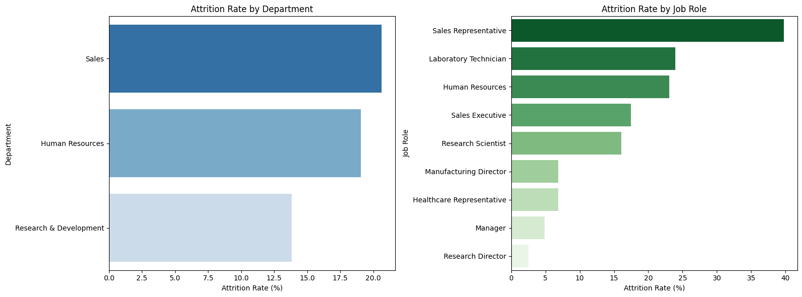
Attrition Rate by Department and by Job Role
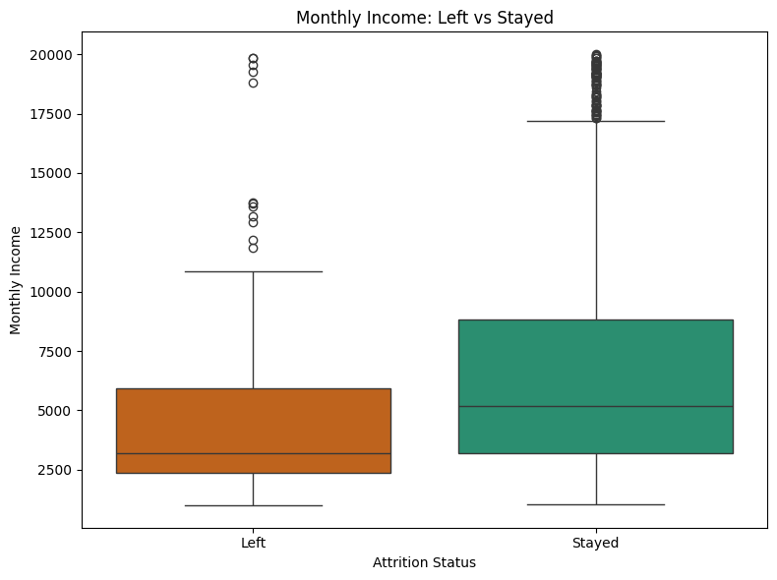  Monthly Income: Left vs Stayed | 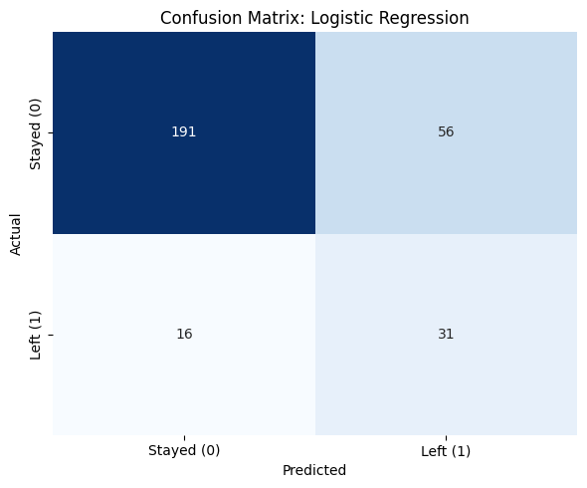  Confusion Matrix — Logistic Regression | 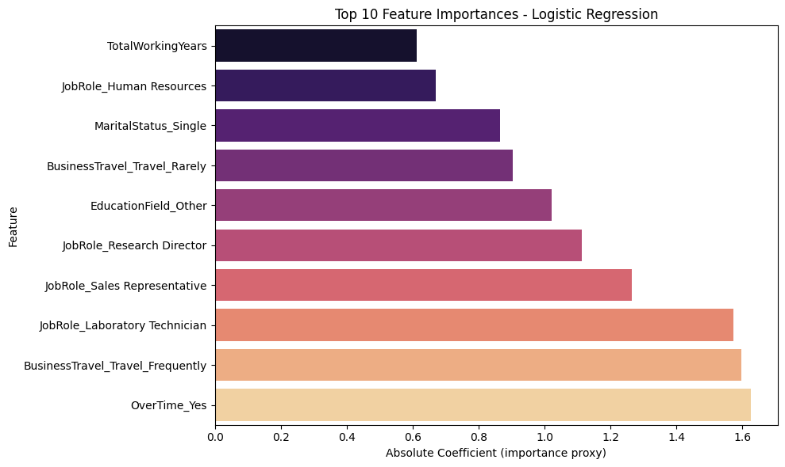  Top 10 Feature Importances
HR Recommendations
- Prioritize retention efforts in the Sales function, especially Sales Representatives, where exit risk is highest.
- Target employees with weak work-life balance ratings and those in their first year of tenure for proactive retention conversations.

