Your starting point will undoubtedly depend on your background and goals. However, an excellent first step for everyone to understand how the web and webpages work. This book teaches you the basics of designing yourself. Once you've learned the basics, there are many resources on the web where you can further your learning in specific areas.

There are different levels of involvement in web design sites here, from building a small site for yourself to turning it into a full-fledged career. You may enjoy being a full-service website developer or specialize in just one skill. There are many ways you can go.

If you're into web design purely as a hobby, or if you only have one or two web projects you'd like to publish, you may find that a combination of personal research like reading this book, taking advantage of existing templates, and maybe even investing in a visual web design tool like adobe Dreamweaver It's all you need to do it. Many continuing education programs offer introductory web design and production courses. These sites can be the result of class assignments, personal projects, or a simple site for a small business or organization. What is important is that they look professional and possess HTML Well, clean, style sheets, and possibly backend scripts. Getting an entry-level job and working as part of a team is a great way to learn how to build larger sites and can help you decide which aspect of web design you want to pursue.

What does a Web designer do?

Over the years, the term " Web Design "Becomes a challenge for you happened spans a number of different disciplines, from user experience design, to document markup and serious programming. This section describes some of the most common roles. If you are designing a small website on your own, you should use a lot of techniques.

There are also professionals you can hire to supplement the skills you lack.

If you're looking into web design or production as a career, you need to hone your skills to a professional level. Employers may not require a web design degree, but they will expect to see sample sites that demonstrate your skills and experience.

Great websites and professionals are almost always created by a team of people, ranging from a handful to hundreds. in this state, each team member participated in the construction process. If so, you may be able to improve your current skill set(Writing, Photoshop, programming, etc.)And simply adapt your interests to the new media.

User experience, interaction, and user interface design

Often, when we think of design, we think of how something looks. On the web, the first matter of business is designing how the site works. The purpose of interaction designers using the site is as easy, efficient, and enjoyable as possible. It is closely related to interaction design interface design, which focuses more on the functional organization of the page as well as specific tools (Buttons, links, menus, etc.) It is focused on what users use to navigate content or perform tasks.

Plan

This sounds relatively simple, but even this simple requirement is divided into a number of specialties when creating sites. There are some new job descriptions for web design, but keep in mind that the disciplines often overlap, and the person who "designer" may call.

Before choosing colors and fonts, it is important to determine the goals of the site, how it will be used, and how visitors will move through it.

A newer job title in the field of website design is user experience design. The designer unit has a more comprehensive view. It ensures that the entire experience with the site is optimal. UX It is based on a thorough understanding of users and their needs based on observations and interviews. According to Donald Norman (who coined the term), user experience design included "All aspects of user interaction with the product: How to understand, learn and use it». For a website or application, which includes:

User research and testing reports

Understanding the needs, demands, and limitations of users plays a fundamental role in the success of website or web application design. This design process is based on user requires as User-centered design(UCD)And it is central in contemporary design. Website designing often begins with user research, including interviews and observations, to gain a better understanding of how the site can solve problems or how people use it.

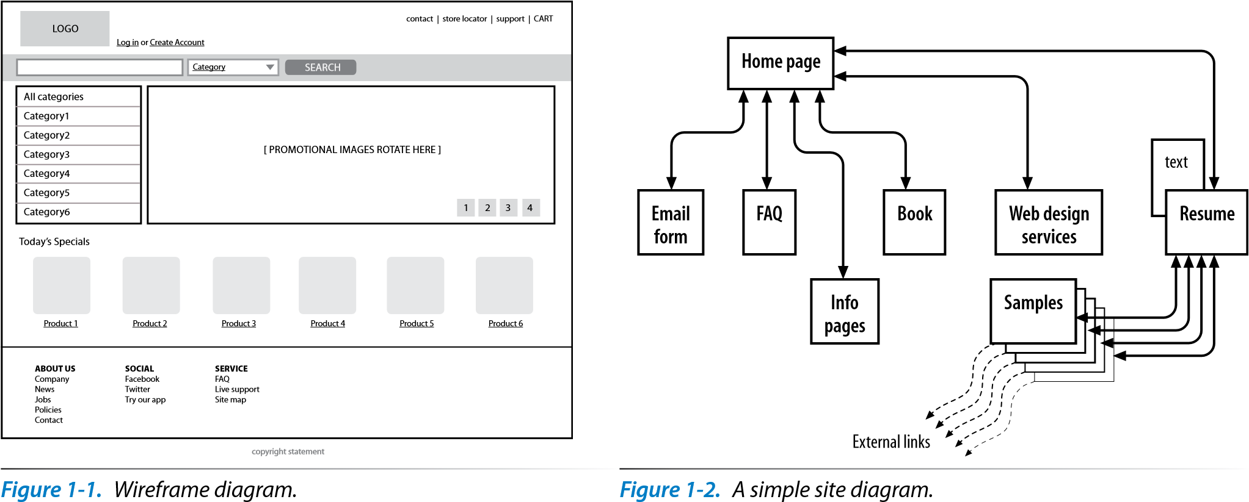

One of the great things about the web is that you can add multimedia elements to a site, including audio, video, animation, and even interactive games. You may decide to add multimedia skills such as audio and video editing or Flash development. If you are not interested in becoming a multimedia developer, you can always hire one. Web development companies are usually looking for people who have mastery of standard multimedia tools and sensitivity visual have good and have an instinct for visual and creative multimedia.

A brief history of the web

Web at a physics laboratory (CERN) in Geneva, Switzerland in 1989 Creation became. There, a computer expert named Tim Berners-Lee first proposed a system for managing information that used a “hypertext” process to link related documents over a network.