LiveSessionUnit11Assignment

M Nepal

July 30, 2017

## Introduction

This is R markdown document for keeping track of assignment submitted for **MSDS-6306@SMU** as an example of **Forecasting: principles and practice(FPP)**.

The **hsales** data is used for following analyis.

### Library and packages

Install and load fpp package using following code chunk in R.

#install.packages("fpp")  
#Once installed, comment above line as you don't need to install package for each execution  
library(fpp)

# Questions for the assignment

#### a) Plot the time series. Can you identify seasonal fluctuations and/or a trend?

data(hsales)  
plot(hsales)

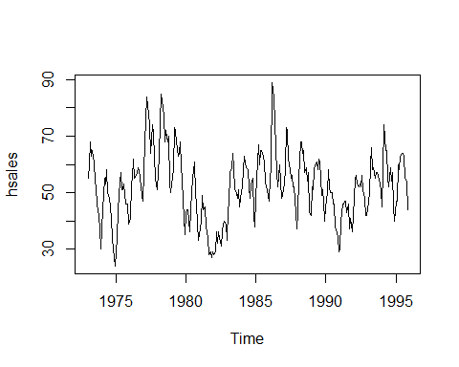

Looking the plot, we can see the presence of both seasonal and trend fluctuations in the hsales data.

#### b) Use a classical decomposition to calculate the trend-cycle and seasonal indices.

fitd <- decompose(hsales)  
plot(fitd)

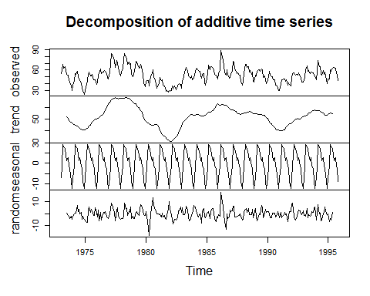

#### c) Do the results support the graphical interpretation from part (a)?

Yes they do, If we see the Decomposition of additive time series plot, the decomposition clearly shows both seasonal and trend fluctions.

#### d) Compute and plot the seasonally adjusted data.

hsadj <- seasadj(fitd)  
plot(hsadj)

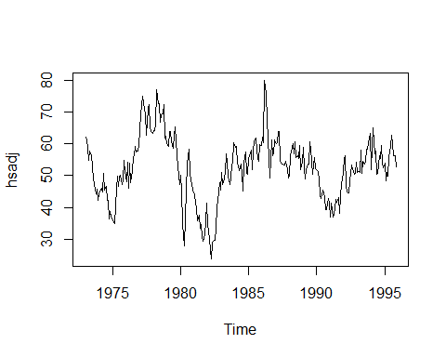

#### e) Change one observation to be an outlier (e.g., add 500 to one observation), and recompute the seasonally adjusted data. What is the effect of the outlier?

hsales2 <- ts(c(hsales[1:54],hsales[55]+200,hsales[56:191]),start=c(1996,1),frequency=12)  
plot(hsales2)

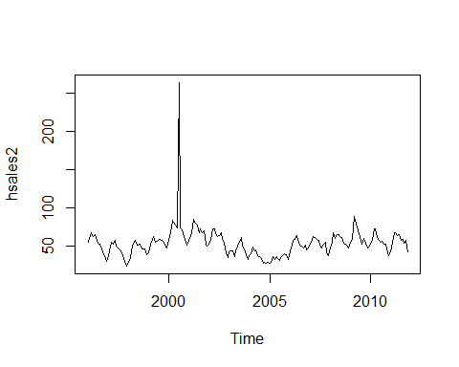

fitd2 <- decompose(hsales2)  
plot(fitd2)

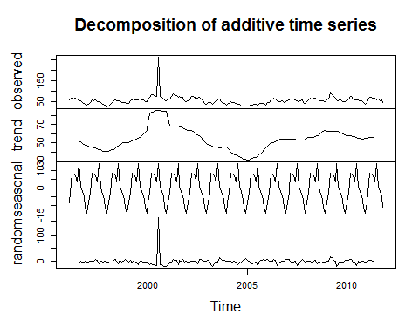

hsadj2 <- seasadj(fitd2)  
plot(hsadj2)

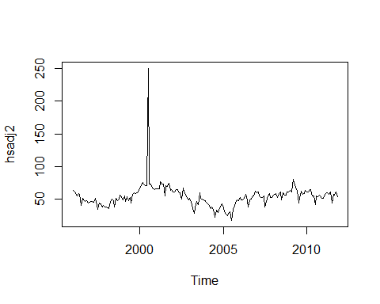

The added outlier causes the house sales to change abruptly sharp at the middle where the outlier was added.

#### f) Does it make any difference if the outlier is near the end rather than in the middle of the time series?

hsales3 <- ts(c(hsales[1:269],hsales[270]+500,hsales[271:275]),start=c(1973,1),frequency=12)  
plot(hsales3)

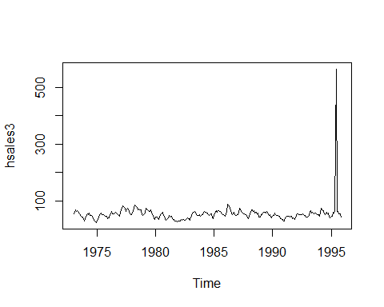

Yes, it does. If we see the plot, the abrupt sharp changes also moved to end as outlier moved to end.

#### g) Use STL to decompose the series

fit <- stl(hsales, s.window=5)  
plot(fit)

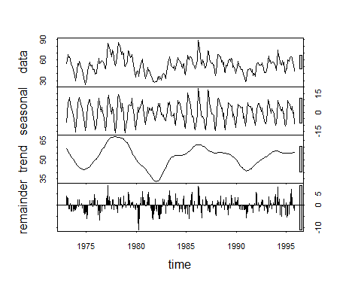

#### one more plot

plot(hsales, col="gray",  
 main="Sales of new one-family houses in the USA",  
 ylab="Number Sold", xlab="")  
lines(fit$time.series[,2],col="red",ylab="Number Sold")

