SIMATS ENGINEERING
ASSESSMENT TOOL 1
EXPERIMENTS
COURSE NAME: OBJECT ORIENTED ANALYSIS AND DESIGN
COURSE CODE: CSA1105
Course Outcome Covered: CO3: Analyze system requirements using object-oriented techniques to identify classes, attributes, and relationships and develop use case models. (BL4)
Assessment Tool Weightage: 40%
Questions: 4 Total Marks: 40
Experiments Submitted
Exp. No. | System Developed Using UML
1 | Passport Management System
4 | Stock Maintenance System
5 | Online Course Reservation System
7 | Credit Card Processing System

Student Details
Particular | Details
Name of the Student | M Nishanth
Register Number | 192511154
Department / Year | B. Tech / 2nd Year
Date of Submission | 29-10-2026

Code of Conduct
EXPERIMENTS
I __________M Nishanth (192511154) ______ (Name / Reg No) certify that this submission is my original work and that I have adhered to the guidelines specified for this assessment.
I understand that any violation of academic integrity rules will result in disciplinary action.
Signature of the student: _____M Nishanth_________________________
Date: ______29-10-2026________________________

1. Introduction

1.1 Aim
To analyse the requirements of four systems using object-oriented techniques, to identify their classes, attributes and relationships, and to develop use case models and class diagrams for them using the Unified Modeling Language (UML). This meets Course Outcome CO3.

1.2 Experiments Selected
Four of the ten systems listed in the assessment were developed (4 experiments × 10 marks = 40 marks). They were chosen because each has a different kind of central system and different relationships.
Exp. | System | Central System in the Problem | Marks
1 | Passport Management System | Central computer verifies and approves | 10
4 | Stock Maintenance System | Central stock system verifies orders and updates stock | 10
5 | Online Course Reservation System | Central management system checks seats and enrolls | 10
7 | Credit Card Processing System | Central system authorizes payment | 10
 | Total |  | 40

1.3 Tools and Techniques Used
Tool or Technique | Use in the Experiments
UML 2.5.1 notation (Object Management Group, 2017) | Standard notation for the use case and class diagrams.
Noun–verb analysis (Abbott, 1983) | Nouns in the problem statement give candidate classes and attributes; verbs give use cases and methods.
Use case modelling (Jacobson et al., 1992) | Actors, use cases and the include, extend and generalization relationships.
Class modelling (Booch, Rumbaugh, & Jacobson, 2005) | Classes, attributes, methods, relationships and multiplicities.
Python with Matplotlib | Drawing the diagrams in UML notation.
Microsoft Word | Preparing this document.

1.4 Procedure Followed in Every Experiment
- Step 1: Read the problem statement and underline the nouns and verbs.
- Step 2: Decide which nouns are classes, which are attributes and which are rejected, and give the reason.
- Step 3: Identify the actors and the use cases, and define the include and extend relationships.
- Step 4: Draw the use case diagram.
- Step 5: Define the attributes, methods, relationships and multiplicities of each class.
- Step 6: Draw the class diagram.
- Step 7: Validate the models against the problem statement and analyse the result.

2. Experiment 1: Passport Management System

2.1 Aim
To develop a UML model of the Passport Management System, in which the central computer verifies the applicant's passport details, approves the application to the office, and the office issues the passport.

2.2 Problem Statement
Develop a system using UML for a Passport Management System. It should verify the passport details of the applicant by the central computer. The details regarding the passport will be provided to the central computer and the computer will verify the details of the applicant and provide approval to the office. Then the passport will be issued from the office to the applicant.

2.3 Requirement Analysis
Noun–verb analysis. The nouns in the problem statement were examined as follows.
Noun | Decision | Reason
Applicant | Class and actor | Person who applies; has identity and contact data.
Passport | Class | The document issued; has a number and dates.
Central computer | Class and actor | Performs verification and approval.
Office | Class (PassportOffice) and actor | Receives approval and issues the passport.
Application | Class (PassportApplication) | Links the applicant, documents and result; needed to track status.
Details, documents | Class (Document) and attributes | Proof submitted for verification; kept as a separate class.
Approval, fee | Attributes or methods | Approval is the result of verification; fee is a value of the application.
System | Rejected | It is the whole system, not a class inside it.

Main flow of the system (taken from the problem statement):
- The applicant submits the application and documents.
- The details are sent to the central computer.
- The central computer verifies the details and either approves or rejects the application.
- The approval is sent to the passport office.
- The office issues the passport to the applicant.

2.4 Use Case Model
Actors
Actor | Type | Responsibility
Applicant | Primary | Applies for a passport, tracks status and collects the passport.
Central Computer | Secondary (system) | Verifies details, approves or rejects.
Passport Office | Secondary | Receives the approval and issues the passport.

Use cases
ID | Use Case | Actor | Description
UC1 | Submit Passport Application | Applicant | Applicant fills in and submits the application.
UC2 | Upload Documents | Applicant | Applicant uploads the proof documents.
UC3 | Pay Application Fee | Applicant | Applicant pays the passport fee.
UC4 | Send Details to Central Computer | System | Application details are passed to the central computer.
UC5 | Verify Passport Details | Central Computer | Details and documents are verified.
UC6 | Reject Application | Central Computer | An invalid application is rejected.
UC7 | Approve Application | Central Computer | A verified application is approved.
UC8 | Receive Approval | Passport Office | Office receives the approval.
UC9 | Issue Passport | Passport Office | Office issues the passport.
UC10 | Print Passport | Passport Office | The passport booklet is printed.
UC11 | Track Application Status | Applicant | Applicant views the progress.
UC12 | Collect Passport | Applicant | Applicant receives the passport.

Relationships between use cases
From | Relationship | To | Reason
Submit Passport Application | «include» | Upload Documents | Documents are always needed.
Submit Passport Application | «include» | Pay Application Fee | Fee is always paid.
Submit Passport Application | «include» | Send Details to Central Computer | Details must reach the central computer.
Verify Passport Details | «include» | Send Details to Central Computer | Verification uses the sent details.
Approve Application | «include» | Verify Passport Details | Approval needs verification first.
Reject Application | «extend» | Verify Passport Details | [details are invalid]
Issue Passport | «include» | Receive Approval | The office issues only after approval.
Issue Passport | «include» | Print Passport | Issuing always includes printing.

The Use Case Diagram is given as Figure 1 on the next page.

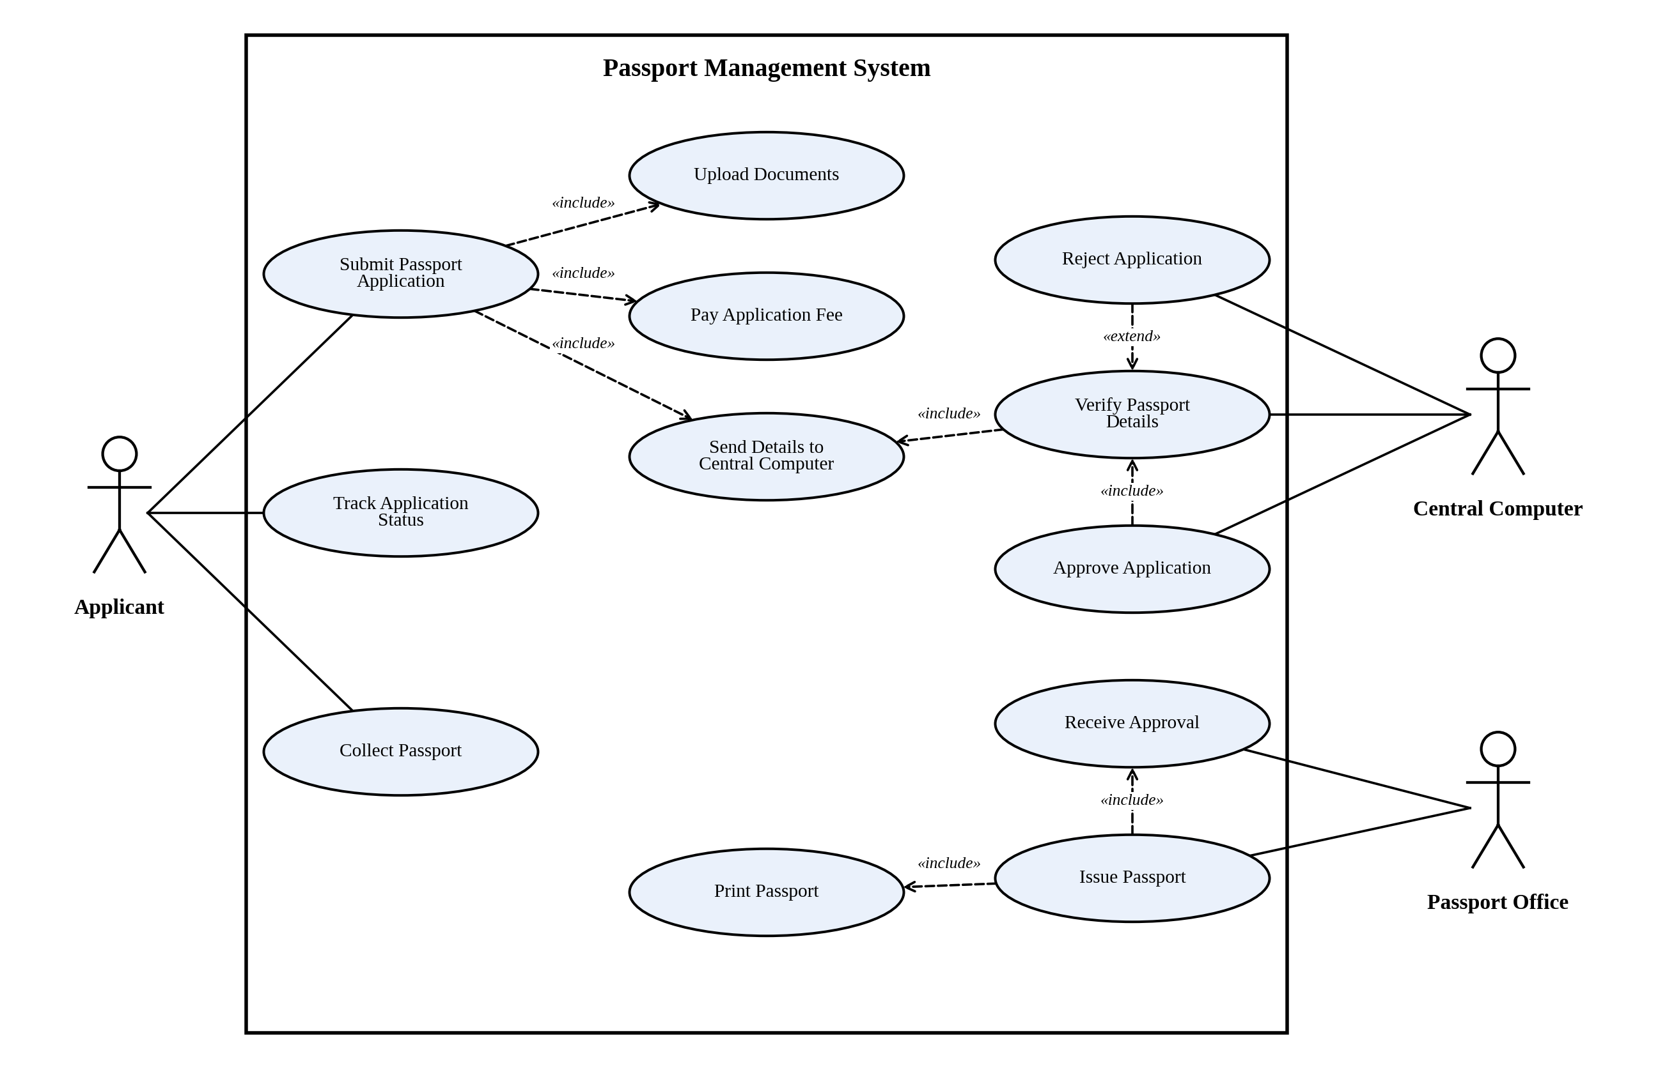
Figure 1: Use Case Diagram of the Passport Management System

2.5 Class Model
Classes, attributes and methods
Class | Attributes | Methods
PassportApplication | - applicationId: String  - applicationDate: Date  - status: String  - fee: double | + submit(): void  + updateStatus(s): void
Applicant | - applicantId: String  - name: String  - dateOfBirth: Date  - address: String  - phone: String | + submitApplication(): void  + trackStatus(): String  + collectPassport(): void
Document | - documentId: String  - type: String  - fileName: String | + upload(): void  + validate(): boolean
CentralComputer | - systemId: String  - version: String | + verifyDetails(a): boolean  + approveApplication(a): void  + rejectApplication(a): void
PassportOffice | - officeId: String  - location: String | + receiveApproval(a): void  + issuePassport(a): Passport
Passport | - passportNumber: String  - issueDate: Date  - expiryDate: Date | + print(): void

Relationships and multiplicity
From | Relationship | To | Multiplicity (first : second)
Applicant | Association (submits) | PassportApplication | 1 : 0..*
PassportApplication | Association (verified by) | CentralComputer | 0..* : 1
CentralComputer | Association (approves to) | PassportOffice | 1 : 0..*
PassportOffice | Association (issues) | Passport | 1 : 0..*
PassportApplication | Association (results in) | Passport | 1 : 0..1
PassportApplication | Composition (includes) | Document | 1 : 1..*

The Class Diagram is given as Figure 2 on the next page.

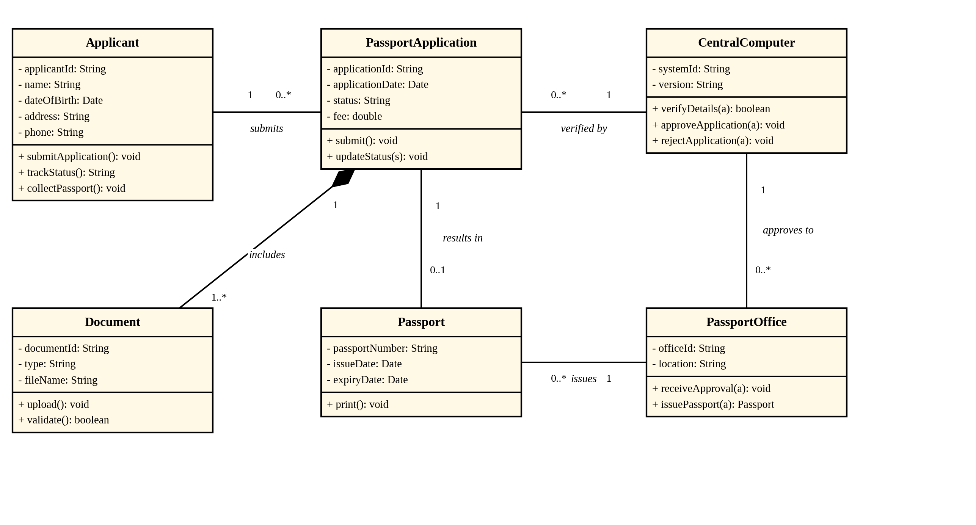
Figure 2: Class Diagram of the Passport Management System

2.6 Results and Analysis
Traceability from the problem statement
Requirement in the Problem Statement | Realised By
The central computer verifies the passport details. | UC5 Verify Passport Details; CentralComputer.verifyDetails()
The computer provides approval to the office. | UC7 Approve Application, UC8 Receive Approval; association CentralComputer–PassportOffice
The passport is issued from the office to the applicant. | UC9 Issue Passport; association PassportOffice–Passport; UC12 Collect Passport

Validation of the models
Check | Result
All nouns in the problem statement are classes, attributes or rejected with a reason. | Satisfied
Every verb in the main flow appears as a use case or a method. | Satisfied
The extend relationship carries a condition, and include arrows point to the included use case. | Satisfied
Every association has a name and multiplicity, and the composition diamond is at the whole. | Satisfied

Observations
- Every application has its own set of documents, so Document is a composition of PassportApplication: documents are deleted with the application.
- The central computer is the only class that verifies and approves, so a single rule set controls the whole decision.
- A rejected application ends at the central computer, and no Passport object is created, which is why the multiplicity of Passport is 0..1.
- Limitations: police verification and renewal are outside the problem statement and are not modelled.

3. Experiment 4: Stock Maintenance System

3.1 Aim
To develop a UML model of the Stock Maintenance System, in which customers place orders and purchase items with the aid of a stock dealer and a central stock system, orders are verified, items are delivered and stock details are updated.

3.2 Problem Statement
Develop a system using UML for implementing a Stock Maintenance System. In this system, the customer can place orders and purchase items with the aid of the stock dealer and central stock system. These orders are verified and the items are delivered to the customer. Then the stock details are to be updated accordingly.

3.3 Requirement Analysis
Noun–verb analysis. The nouns in the problem statement were examined as follows.
Noun | Decision | Reason
Customer | Class and actor | Orders and buys items.
Order | Class | Holds the request, its status and total.
Items | Class (Item) and (OrderItem) | Stock items; each order line links an item and a quantity.
Stock dealer | Class and actor | Assists the customer and delivers items.
Central stock system | Class and actor | Verifies orders, generates bills and keeps stock.
Stock details | Attributes of Item | Quantity in stock and reorder level.
Bill | Method (generateBill) | Produced by the central system from the order.
Delivery | Method (deliverItems) | An action of the stock dealer.

Main flow of the system (taken from the problem statement):
- The customer places an order with the help of the stock dealer.
- The central stock system verifies the order against stock.
- The bill is generated and paid.
- The stock dealer delivers the items.
- The stock details are updated.

3.4 Use Case Model
Actors
Actor | Type | Responsibility
Customer | Primary | Places orders, buys items and may cancel.
Stock Dealer | Secondary | Assists customers and delivers items.
Central Stock System | Secondary (system) | Verifies orders, updates and reorders stock.

Use cases
ID | Use Case | Actor | Description
UC1 | Purchase Items | Customer | Customer buys items through an order.
UC2 | Place Order | Customer | Customer places an order.
UC3 | Cancel Order | Customer | Customer cancels an order before delivery.
UC4 | Generate Bill | System | The bill is created from the order.
UC5 | Make Payment | Customer | Customer pays the bill.
UC6 | Check Item Availability | System | Stock is checked for each item.
UC7 | Assist Customer | Stock Dealer | Dealer helps the customer choose items.
UC8 | Deliver Items | Stock Dealer | Dealer delivers the verified order.
UC9 | Update Stock Details | Central Stock System | Stock quantities are reduced.
UC10 | Reorder Stock | Central Stock System | New stock is requested when low.
UC11 | Verify Order | Central Stock System | The order is verified.

Relationships between use cases
From | Relationship | To | Reason
Purchase Items | «include» | Place Order | A purchase always starts with an order.
Purchase Items | «include» | Make Payment | A purchase is always paid.
Purchase Items | «include» | Generate Bill | A bill is always produced.
Place Order | «include» | Check Item Availability | Stock is always checked.
Place Order | «include» | Verify Order | Every order is verified.
Deliver Items | «include» | Update Stock Details | Stock changes after every delivery.
Cancel Order | «extend» | Place Order | [order not yet delivered]
Reorder Stock | «extend» | Update Stock Details | [stock below reorder level]

The Use Case Diagram is given as Figure 3 on the next page.

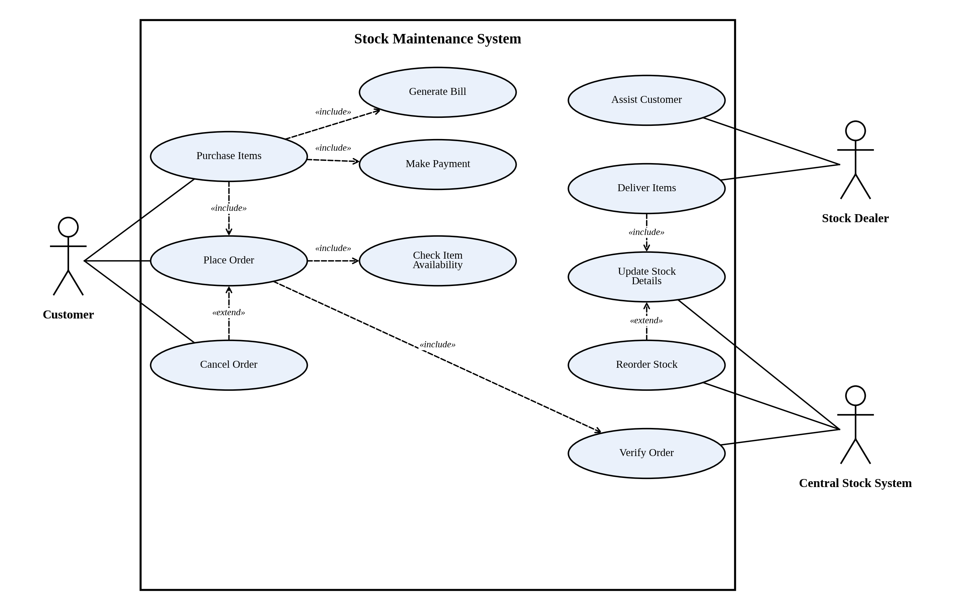
Figure 3: Use Case Diagram of the Stock Maintenance System

3.5 Class Model
Classes, attributes and methods
Class | Attributes | Methods
Customer | - customerId: String  - name: String  - address: String  - phone: String | + placeOrder(): Order  + makePayment(): void  + cancelOrder(): void
Order | - orderId: String  - orderDate: Date  - status: String  - totalAmount: double | + verify(): boolean  + calculateTotal(): double  + cancel(): void
OrderItem | - quantity: int  - unitPrice: double | + getSubtotal(): double
Item | - itemId: String  - name: String  - price: double  - quantityInStock: int  - reorderLevel: int | + isAvailable(): boolean  + updateQuantity(n): void
StockDealer | - dealerId: String  - name: String  - phone: String | + assistCustomer(): void  + deliverItems(o): void
CentralStockSystem | - systemId: String  - lastUpdated: Date | + verifyOrder(o): boolean  + updateStock(o): void  + generateBill(o): void

Relationships and multiplicity
From | Relationship | To | Multiplicity (first : second)
Customer | Association (places) | Order | 1 : 0..*
Order | Association (verified by) | CentralStockSystem | 0..* : 1
Customer | Association (assisted by) | StockDealer | 0..* : 1
StockDealer | Association (handles) | Order | 1 : 0..*
Order | Composition (contains) | OrderItem | 1 : 1..*
OrderItem | Association (refers to) | Item | 0..* : 1
CentralStockSystem | Aggregation (maintains) | Item | 1 : 0..*

The Class Diagram is given as Figure 4 on the next page.

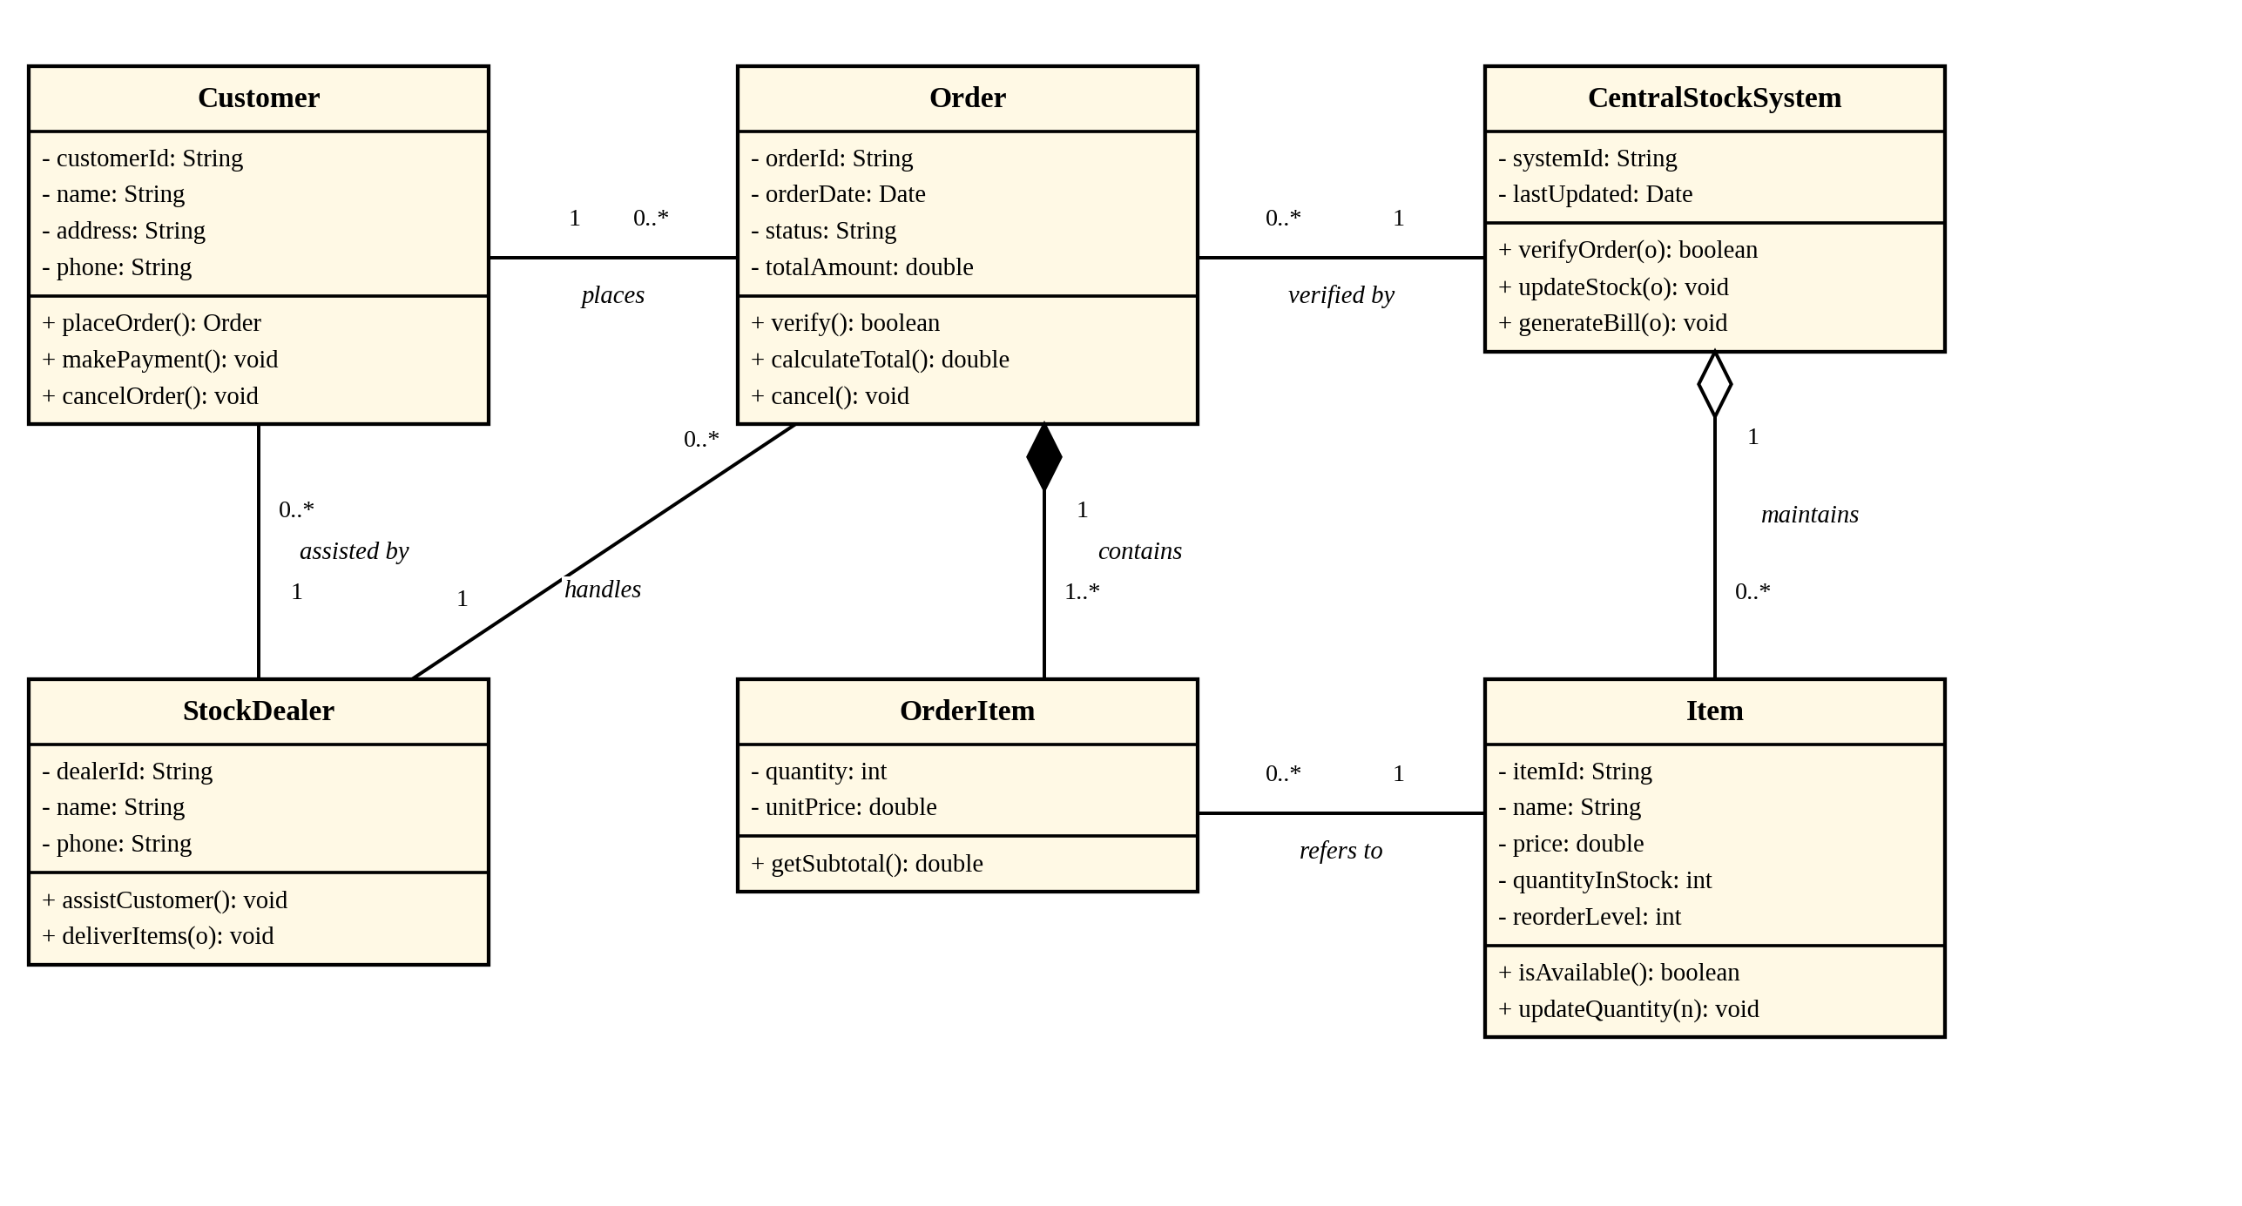
Figure 4: Class Diagram of the Stock Maintenance System

3.6 Results and Analysis
Traceability from the problem statement
Requirement in the Problem Statement | Realised By
The customer places orders and purchases items with the aid of the stock dealer. | UC2, UC1, UC7; associations Customer–Order and Customer–StockDealer
The orders are verified. | UC11 Verify Order; CentralStockSystem.verifyOrder()
The items are delivered to the customer. | UC8 Deliver Items; StockDealer.deliverItems()
The stock details are updated accordingly. | UC9 Update Stock Details; Item.updateQuantity()

Validation of the models
Check | Result
All nouns in the problem statement are classes, attributes or rejected with a reason. | Satisfied
Every verb in the main flow appears as a use case or a method. | Satisfied
Include and extend arrows are drawn in the correct direction. | Satisfied
The composition diamond is filled and at Order; the aggregation diamond is hollow and at CentralStockSystem. | Satisfied

Observations
- OrderItem is needed because one order has many items and each line has its own quantity and price; without it the many-to-many link between Order and Item could not carry this data.
- OrderItem is a composition of Order (lines are deleted with the order), but Item is only aggregated by the central system, because items exist even when no order refers to them.
- Reorder Stock is an extension of Update Stock Details, so normal updates stay simple and reordering happens only when stock is low.
- Limitations: supplier and payment details are not part of the problem statement and are not modelled.

4. Experiment 5: Online Course Reservation System

4.1 Aim
To develop a UML model of the Online Course Reservation System, which is organised by the central management system, where a student selects a course, the university checks the availability of seats, and the student is enrolled if a seat is available.

4.2 Problem Statement
Develop a system using UML for implementing an Online Course Reservation System. This system is organized by the central management system. The student first browses and selects the desired course of their choice. The university then checks the availability of the seat; if it is available, the student is enrolled for the course.

4.3 Requirement Analysis
Noun–verb analysis. The nouns in the problem statement were examined as follows.
Noun | Decision | Reason
Student | Class and actor | Browses, selects and reserves courses.
Course | Class | Offered course with total and available seats.
University | Class and actor | Offers courses and approves enrolment.
Central management system | Class and actor | Organises the system: checks seats and enrolls students.
Seat, availability | Attributes of Course | totalSeats and availableSeats.
Reservation, enrolment | Class (Reservation) | Records the student's request and its status (reserved, enrolled, cancelled).
Choice | Rejected | Not a thing in the system; it is the act of selecting.

Main flow of the system (taken from the problem statement):
- The student browses the courses and selects one.
- A reservation is made for the selected course.
- The seat availability is checked.
- If a seat is available, the student is enrolled and the seat count is reduced.
- A confirmation is sent to the student.

4.4 Use Case Model
Actors
Actor | Type | Responsibility
Student | Primary | Browses, selects, reserves and cancels.
University | Secondary | Manages the courses that are offered.
Central Management System | Secondary (system) | Enrolls students and updates seats.

Use cases
ID | Use Case | Actor | Description
UC1 | Browse Courses | Student | Student views the courses offered.
UC2 | View Course Details | Student | Student sees the details of a course.
UC3 | Select Course | Student | Student chooses a course.
UC4 | Reserve Course | Student | Student reserves the chosen course.
UC5 | Check Seat Availability | System | Seats left are checked.
UC6 | Login | Student | Student logs in.
UC7 | Enroll Student | Central Mgmt System | The student is enrolled when a seat is free.
UC8 | Update Seat Count | Central Mgmt System | Available seats are reduced.
UC9 | Send Enrollment Confirmation | Central Mgmt System | The student is told of the enrolment.
UC10 | Cancel Reservation | Student | Student cancels a reservation.
UC11 | Join Waiting List | Student | Student waits if no seat is free.
UC12 | Manage Courses | University | University adds or changes courses.

Relationships between use cases
From | Relationship | To | Reason
Browse Courses | «include» | View Course Details | Browsing always shows details.
Reserve Course | «include» | Select Course | A reservation needs a selected course.
Reserve Course | «include» | Check Seat Availability | Seats must always be checked.
Reserve Course | «include» | Login | Only a logged-in student can reserve.
Reserve Course | «include» | Enroll Student | A successful reservation ends in enrolment.
Enroll Student | «include» | Update Seat Count | Each enrolment reduces seats.
Enroll Student | «include» | Send Enrollment Confirmation | The student is always informed.
Cancel Reservation | «extend» | Reserve Course | [student changes mind]
Join Waiting List | «extend» | Reserve Course | [no seat available]

The Use Case Diagram is given as Figure 5 on the next page.

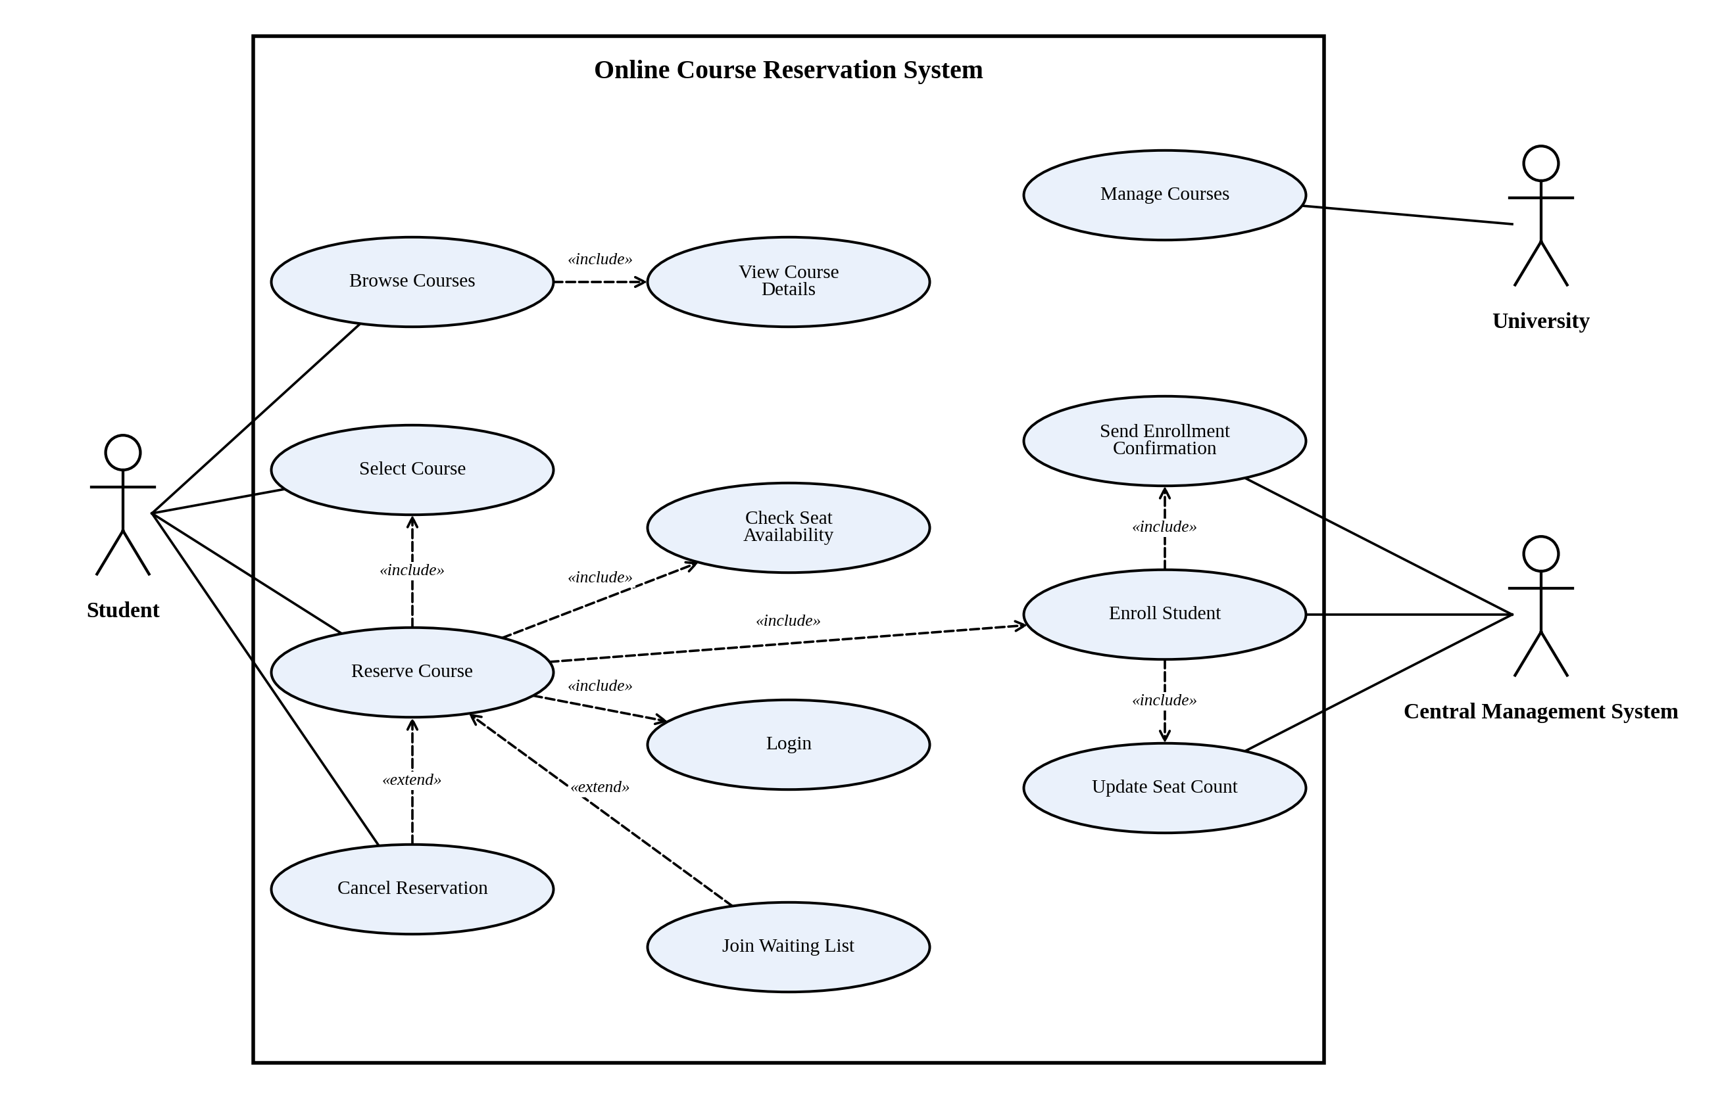
Figure 5: Use Case Diagram of the Online Course Reservation System

4.5 Class Model
Classes, attributes and methods
Class | Attributes | Methods
Student | - studentId: String  - name: String  - email: String  - program: String | + browseCourses(): List  + selectCourse(c): void  + cancelReservation(r): void
Reservation | - reservationId: String  - reservationDate: Date  - status: String | + confirm(): void  + cancel(): void
Course | - courseCode: String  - title: String  - credits: int  - totalSeats: int  - availableSeats: int | + isSeatAvailable(): boolean  + reduceSeat(): void
University | - universityId: String  - name: String | + manageCourses(): void  + approveEnrollment(r): void
CentralManagementSystem | - systemId: String  - academicYear: String | + checkAvailability(c): boolean  + enrollStudent(r): void  + updateSeats(c): void

Relationships and multiplicity
From | Relationship | To | Multiplicity (first : second)
Student | Association (makes) | Reservation | 1 : 0..*
Reservation | Association (processed by) | CentralManagementSystem | 0..* : 1
Reservation | Association (reserves seat in) | Course | 0..* : 1
University | Aggregation (offers) | Course | 1 : 1..*
CentralManagementSystem | Association (organizes) | University | 1 : 1
Student | Association (browses) | Course | 0..* : 0..*

The Class Diagram is given as Figure 6 on the next page.

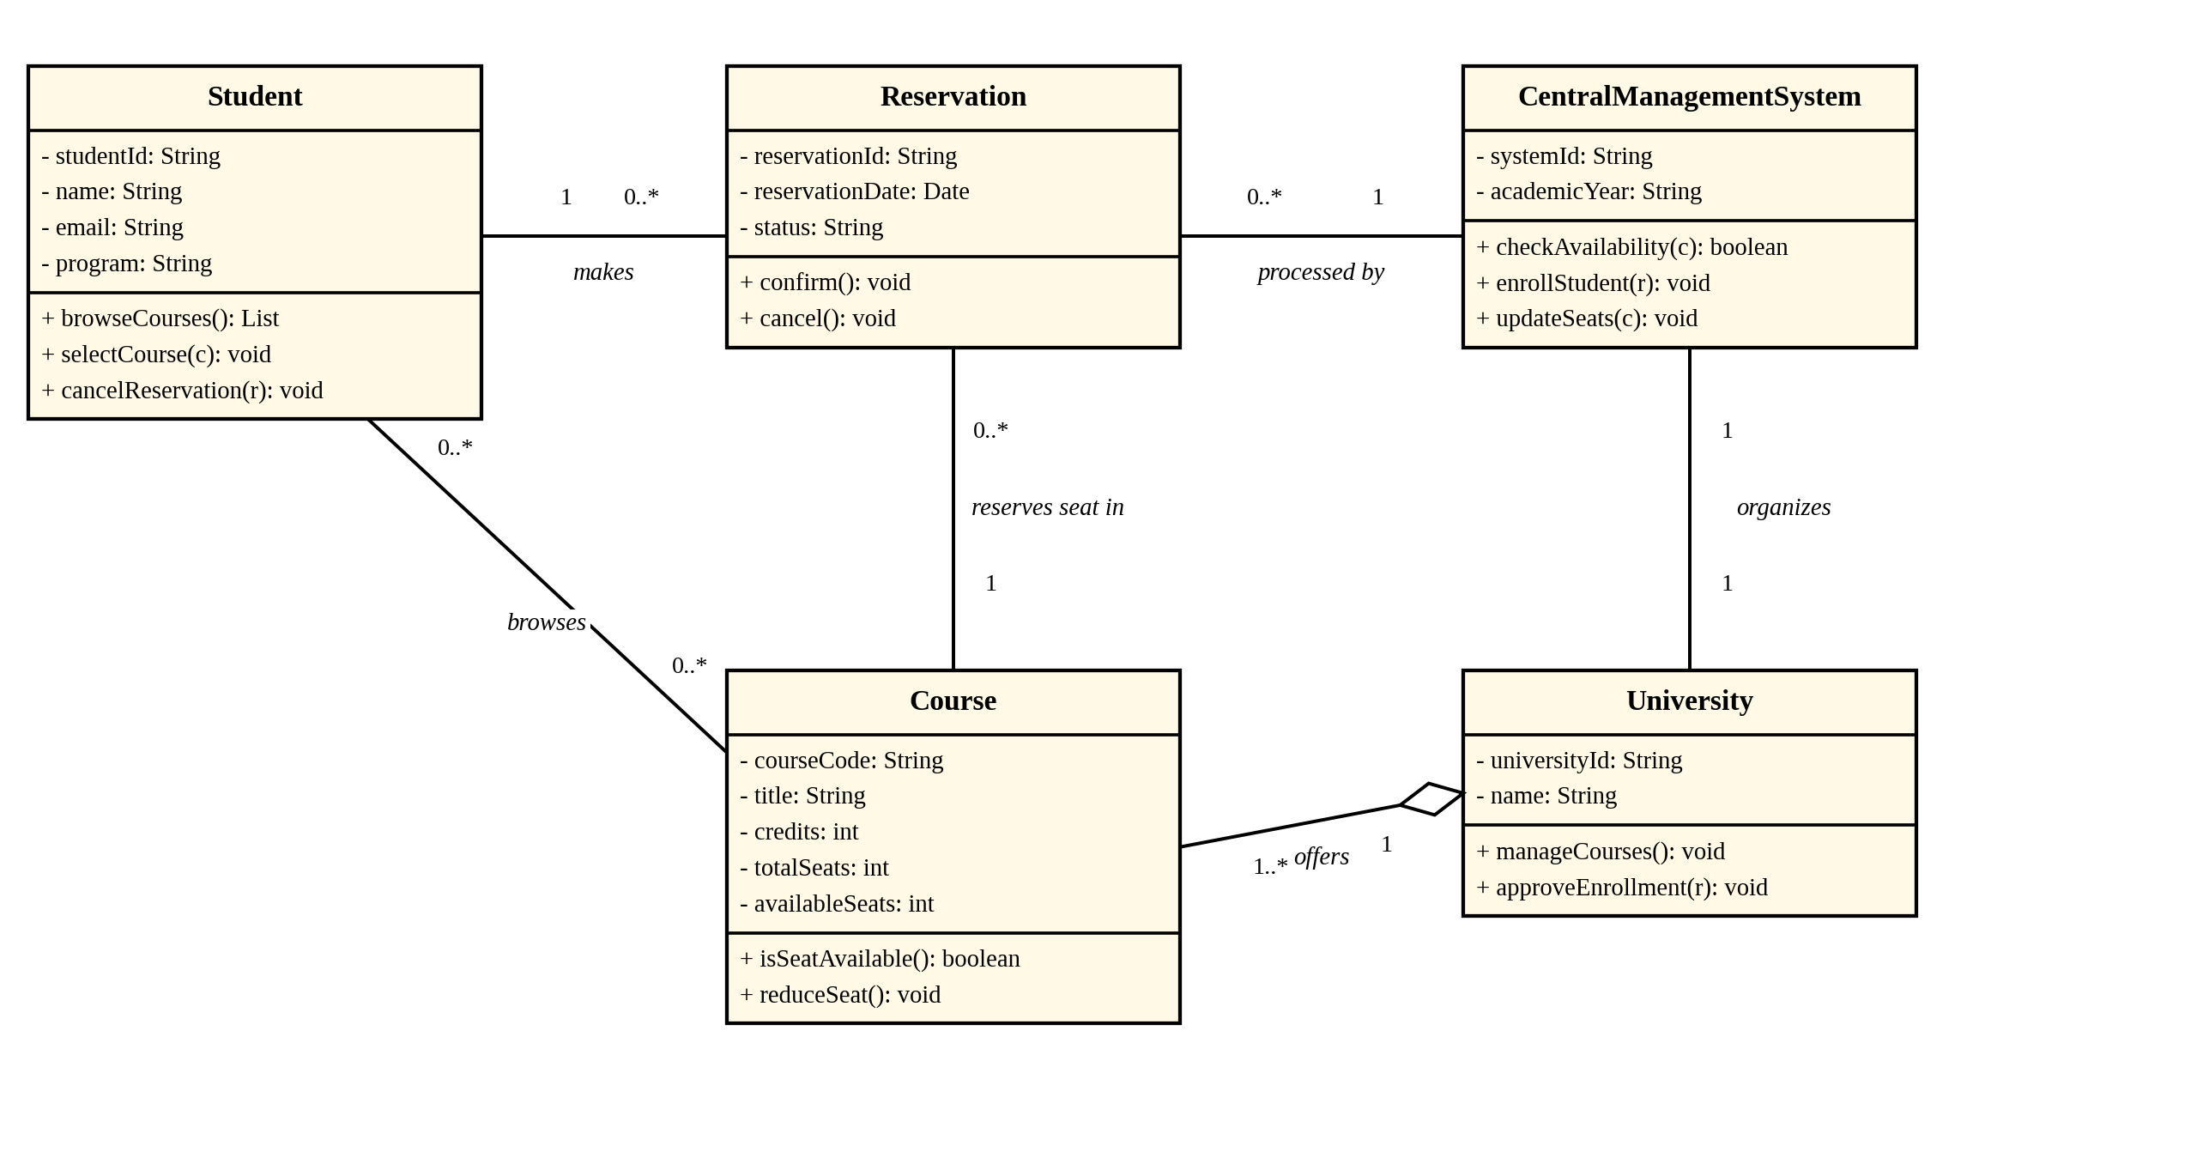
Figure 6: Class Diagram of the Online Course Reservation System

4.6 Results and Analysis
Traceability from the problem statement
Requirement in the Problem Statement | Realised By
The student browses and selects the desired course. | UC1, UC3; Student.browseCourses(), selectCourse()
The university checks the availability of the seat. | UC5 Check Seat Availability; Course.isSeatAvailable()
If it is available, the student is enrolled. | UC7 Enroll Student; CentralManagementSystem.enrollStudent()
The system is organised by the central management system. | Association CentralManagementSystem–University; CentralManagementSystem processes every Reservation

Validation of the models
Check | Result
All nouns in the problem statement are classes, attributes or rejected with a reason. | Satisfied
Every verb in the main flow appears as a use case or a method. | Satisfied
Include and extend arrows are drawn in the correct direction. | Satisfied
Every association has a name and multiplicity. | Satisfied

Observations
- Reservation sits between Student and Course because a student reserves many courses and a course is reserved by many students; the class stores the status of each request.
- Join Waiting List is an extension, so the main reservation flow is unchanged when seats are available.
- University aggregates Course because a course may continue to exist if the university re-organises its programmes.
- Limitations: fees, prerequisites and timetable clashes are not in the problem statement and are not modelled.

5. Experiment 7: Credit Card Processing System

5.1 Aim
To develop a UML model of the Credit Card Processing System, in which the cardholder purchases items and pays the bill with a credit card, the cashier accepts the card and processes the transaction through the central system, and the verified bill is followed by delivery of the items.

5.2 Problem Statement
Develop a system using UML for implementing a Credit Card Processing System. In this system, the cardholder can purchase items and pay the bill with the aid of a credit card. The cashier should accept the card and proceed with the transaction using the central system. The bill is to be verified and the items are delivered to the cardholder based on it.

5.3 Requirement Analysis
Noun–verb analysis. The nouns in the problem statement were examined as follows.
Noun | Decision | Reason
Cardholder | Class and actor | Buys items and pays.
Credit card | Class (CreditCard) | Has a number, expiry date, limit and status.
Cashier | Class and actor | Accepts the card and processes the transaction.
Central system | Class (CentralSystem) and actor | Verifies the card, checks the limit and authorizes payment.
Bill | Class | Lists the items and the total; is verified.
Items | Class (Item) | Things purchased; have a price.
Transaction | Class | Records one payment attempt and its result.
Credit limit | Attribute of CreditCard | Maximum amount allowed.

Main flow of the system (taken from the problem statement):
- The cardholder purchases items and receives a bill.
- The cashier accepts the credit card.
- The cashier processes the transaction using the central system.
- The central system checks the credit limit and authorizes the payment.
- The bill is verified and the items are delivered.

5.4 Use Case Model
Actors
Actor | Type | Responsibility
Cardholder | Primary | Purchases items, presents the card and pays the bill.
Cashier | Secondary | Accepts the card, verifies the bill and processes the transaction.
Central System | Secondary (system) | Authorizes payment after checking the credit limit.

Use cases
ID | Use Case | Actor | Description
UC1 | Purchase Items | Cardholder | Cardholder buys items.
UC2 | Pay Bill | Cardholder | Cardholder pays the bill by credit card.
UC3 | Present Credit Card | Cardholder | Cardholder hands over the card.
UC4 | Verify PIN or Signature | Cardholder | Cardholder confirms identity.
UC5 | Receive Items | Cardholder | Cardholder receives the items.
UC6 | Print Receipt | System | A receipt is printed.
UC7 | Accept Card | Cashier | Cashier takes the card.
UC8 | Verify Bill | Cashier | Cashier checks the bill.
UC9 | Process Transaction | Cashier | Cashier sends the transaction to the central system.
UC10 | Authorize Payment | Central System | The payment is authorized.
UC11 | Check Credit Limit | Central System | The card's limit is checked.
UC12 | Decline Transaction | System | The transaction is declined.

Relationships between use cases
From | Relationship | To | Reason
Purchase Items | «include» | Pay Bill | A purchase always ends in payment.
Pay Bill | «include» | Present Credit Card | The card must be presented.
Pay Bill | «include» | Verify PIN or Signature | Identity is always confirmed.
Process Transaction | «include» | Verify Bill | The bill is always verified.
Process Transaction | «include» | Authorize Payment | Every transaction needs authorization.
Authorize Payment | «include» | Check Credit Limit | Authorization needs the limit check.
Receive Items | «include» | Print Receipt | A receipt goes with the items.
Decline Transaction | «extend» | Process Transaction | [card invalid or limit exceeded]

The Use Case Diagram is given as Figure 7 on the next page.

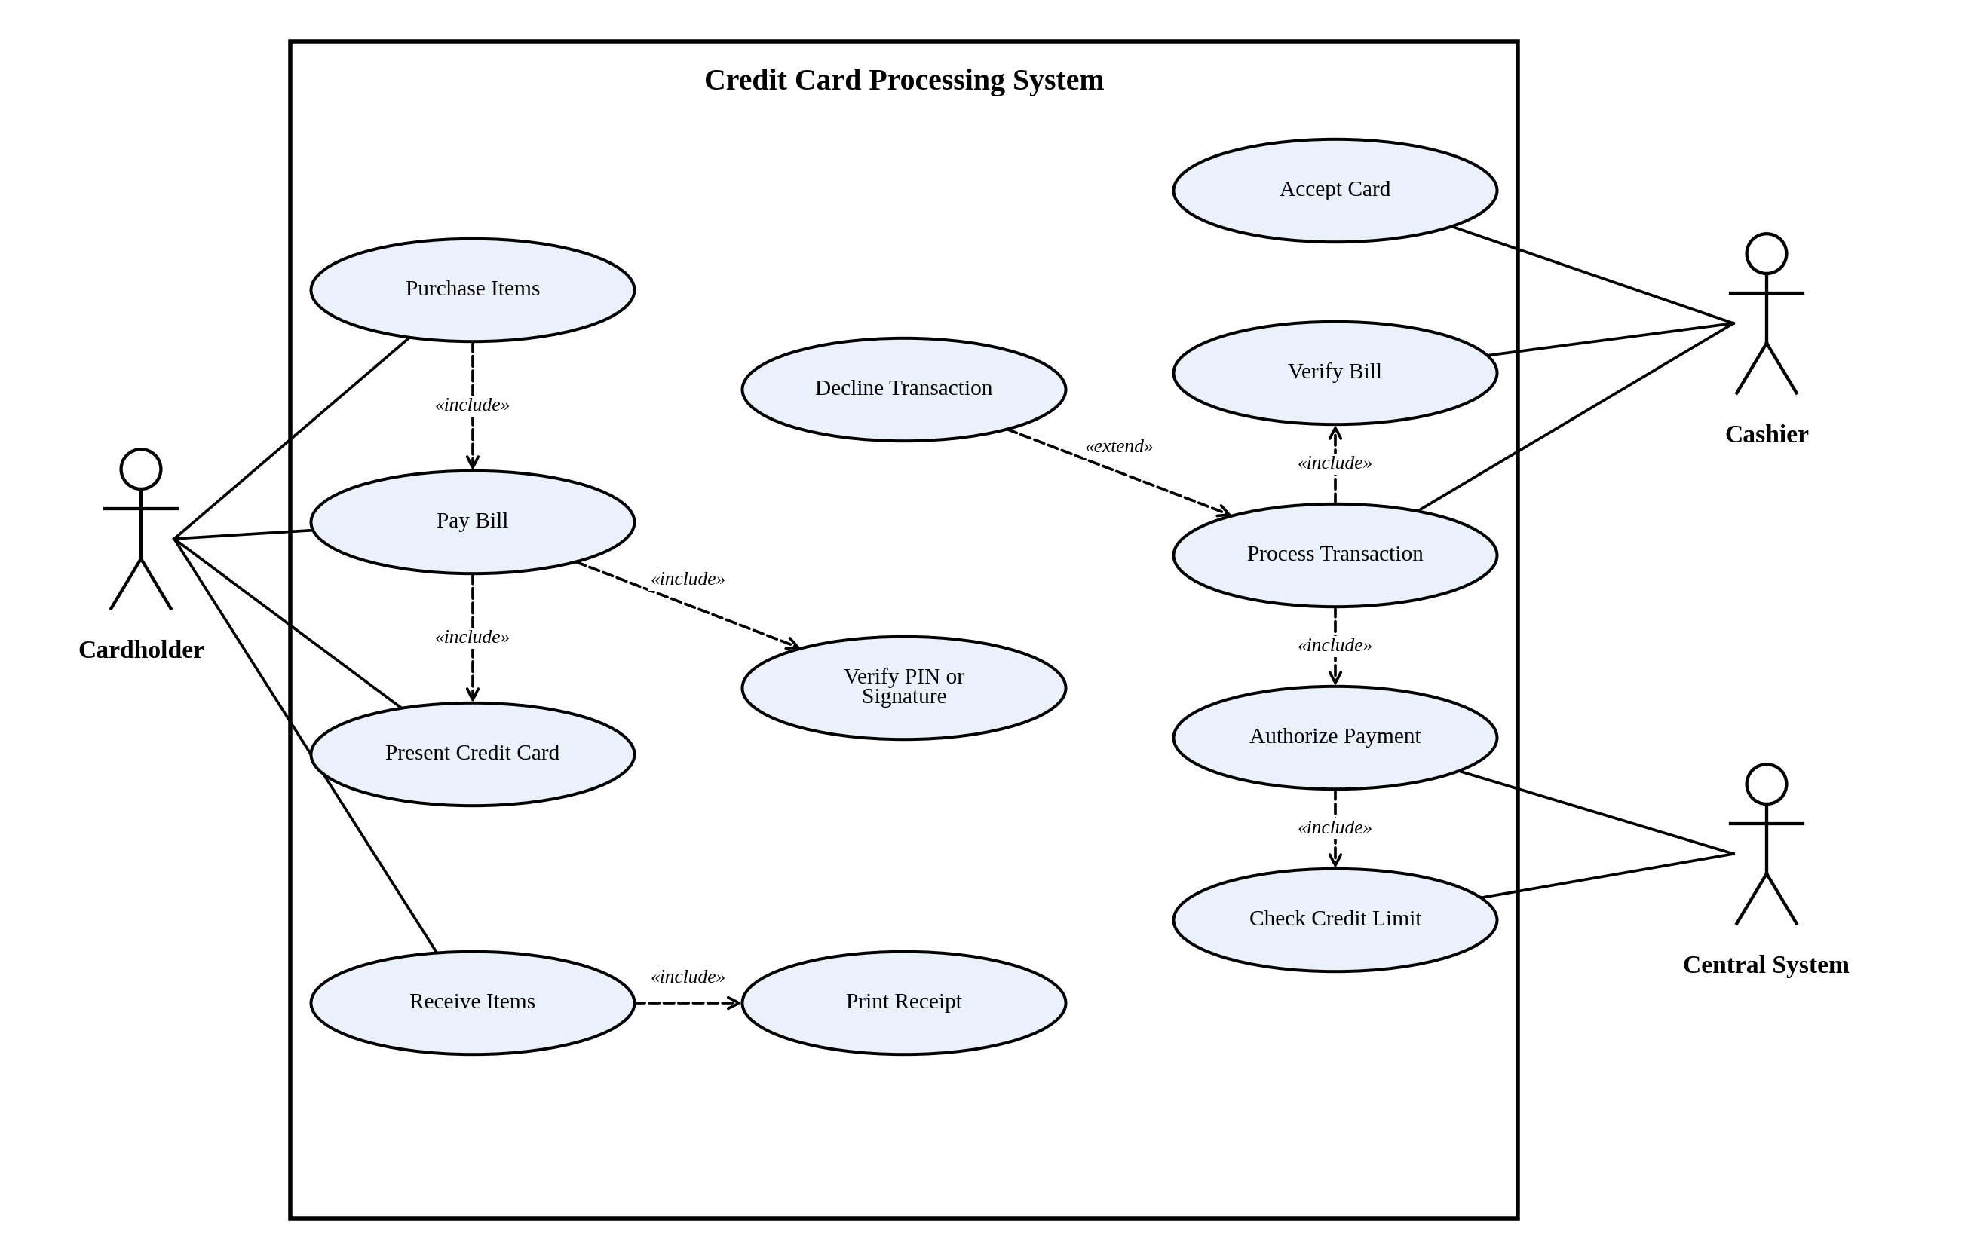
Figure 7: Use Case Diagram of the Credit Card Processing System

5.5 Class Model
Classes, attributes and methods
Class | Attributes | Methods
Cardholder | - holderId: String  - name: String  - address: String  - phone: String | + purchaseItems(): Bill  + payBill(b): void
CreditCard | - cardNumber: String  - expiryDate: Date  - creditLimit: double  - status: String | + isValid(): boolean  + availableCredit(): double
Bill | - billNo: String  - billDate: Date  - totalAmount: double  - status: String | + calculateTotal(): double  + verify(): boolean
Item | - itemCode: String  - name: String  - price: double | + getPrice(): double
Cashier | - cashierId: String  - name: String  - counterNo: int | + acceptCard(c): void  + processTransaction(b): void  + handOverItems(b): void
Transaction | - transactionId: String  - amount: double  - timestamp: Date  - status: String | + authorize(): boolean  + decline(): void
CentralSystem | - systemId: String  - networkName: String | + verifyCard(c): boolean  + checkCreditLimit(c, a): boolean  + authorizePayment(t): boolean

Relationships and multiplicity
From | Relationship | To | Multiplicity (first : second)
Cardholder | Association (owns) | CreditCard | 1 : 1..*
Cardholder | Association (pays) | Bill | 1 : 0..*
Bill | Association (prepared by) | Cashier | 0..* : 1
Item | Association (listed in) | Bill | 1..* : 0..*
Bill | Association (paid by) | Transaction | 1 : 1
CreditCard | Association (charged in) | Transaction | 1 : 0..*
Transaction | Association (authorized by) | CentralSystem | 0..* : 1
Cashier | Association (uses) | CentralSystem | 0..* : 1

The Class Diagram is given as Figure 8 on the next page.

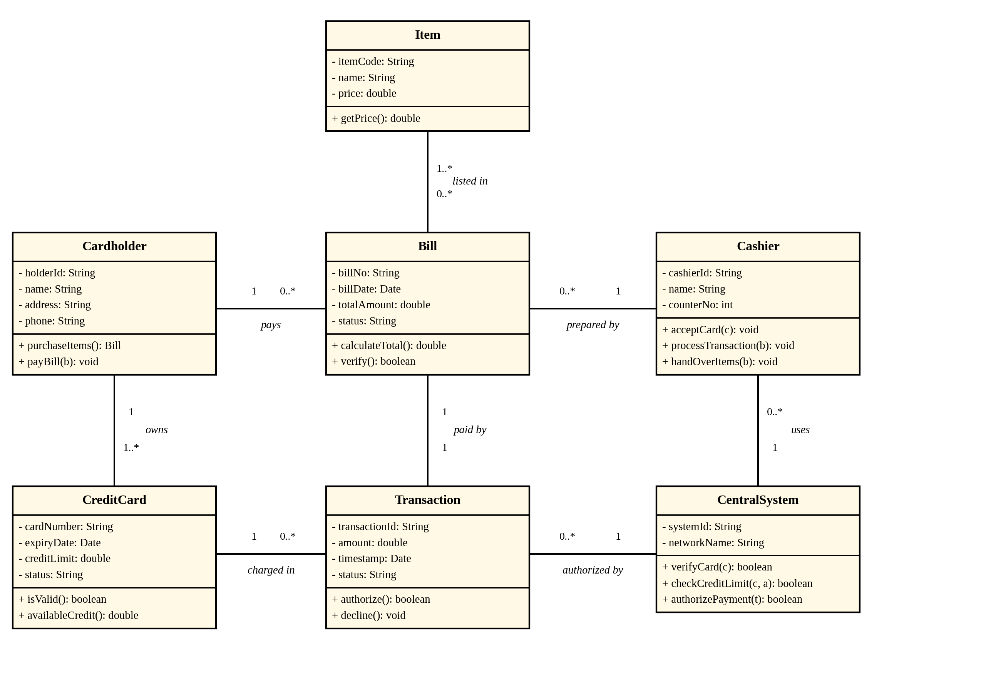
Figure 8: Class Diagram of the Credit Card Processing System

5.6 Results and Analysis
Traceability from the problem statement
Requirement in the Problem Statement | Realised By
The cardholder purchases items and pays the bill with a credit card. | UC1, UC2, UC3; associations Cardholder–CreditCard and Cardholder–Bill
The cashier accepts the card and proceeds using the central system. | UC7, UC9; association Cashier–CentralSystem
The bill is to be verified. | UC8 Verify Bill; Bill.verify()
The items are delivered based on the bill. | UC5 Receive Items; Cashier.handOverItems()

Validation of the models
Check | Result
All nouns in the problem statement are classes, attributes or rejected with a reason. | Satisfied
Every verb in the main flow appears as a use case or a method. | Satisfied
Include and extend arrows are drawn in the correct direction. | Satisfied
Every association has a name and multiplicity at both ends. | Satisfied

Observations
- Transaction is a separate class because one card can be charged many times and each attempt has its own result, so the history of attempts is kept.
- Authorization is a chain: Process Transaction includes Authorize Payment, which includes Check Credit Limit. This keeps the limit check inside the central system, away from the cashier.
- Decline Transaction is an extension, so declined payments never change the normal flow.
- Limitations: fraud detection, refunds and interest are not part of the problem statement and are not modelled.

6. Conclusion
Four systems were developed using UML. For each system the requirements were analysed with a noun–verb analysis, the actors and use cases were identified, a use case model was built with include and extend relationships, and a class model was built with attributes, methods, relationships and multiplicities. The table summarises the result.
Exp. | System | Actors | Use Cases | Classes
1 | Passport Management | 3 | 12 | 6
4 | Stock Maintenance | 3 | 11 | 6
5 | Online Course Reservation | 3 | 12 | 5
7 | Credit Card Processing | 3 | 12 | 7

In all four systems the central system turned out to be a class that is called by every main use case: it verifies, approves or authorizes. Separating it as its own actor and class made the responsibility of each part clear. This meets Course Outcome CO3: to analyse requirements with object-oriented techniques, identify classes, attributes and relationships, and develop use case models.

7. Alignment with the Assessment Rubric
Rubric Criterion | Weightage | Where it is Addressed
Understanding of Concepts | 25 | Requirement analysis, actors, use cases and class identification in every experiment (x.3 to x.5).
Experimental Design | 30 | The seven-step procedure in Section 1.4, followed in order in every experiment.
Use of Tools | 20 | UML 2.5.1 notation, noun–verb analysis and use case and class modelling (Section 1.3).
Analysis of Results | 15 | Traceability tables, validation checks and observations in Sections 2.6 to 5.6.
Documentation | 10 | Aim, problem statement, tables, one landscape diagram per model, and references.

References
Abbott, R. J. (1983). Program design by informal English descriptions. Communications of the ACM, 26(11), 882–894.
Booch, G., Rumbaugh, J., & Jacobson, I. (2005). The Unified Modeling Language user guide (2nd ed.). Addison-Wesley.
Cockburn, A. (2001). Writing effective use cases. Addison-Wesley.
Fowler, M. (2003). UML distilled: A brief guide to the standard object modeling language (3rd ed.). Addison-Wesley.
Jacobson, I., Christerson, M., Jonsson, P., & Övergaard, G. (1992). Object-oriented software engineering: A use case driven approach. Addison-Wesley.
Larman, C. (2004). Applying UML and patterns: An introduction to object-oriented analysis and design and iterative development (3rd ed.). Prentice Hall.
Object Management Group. (2017). OMG Unified Modeling Language (OMG UML), Version 2.5.1. https://www.omg.org/spec/UML/2.5.1

