Milestone 3
Nowrin Mustary
Faculty of Computing & Data Sciences, Boston University
Module C2: Data Science Capstone
Dr. Joshua Von Korff
Oct 18, 2025

Executive Summary
This project analyzes two datasets, the Austin Housing dataset and the Inside Airbnb dataset, to understand how property features, location, and behavior shape pricing. Together they capture both traditional housing and the fast-moving short-term rental market.
Using models such as K-Nearest Neighbors, Random Forests, Gradient Boosting, and clustering methods like K-Means, DBSCAN, and Hierarchical Clustering, the study compared predictive accuracy and market segmentation.
Ensemble models (Random Forest and Gradient Boosting) outperformed linear ones in both datasets, reaching R² values of about 0.57 for Austin and 0.72 for Airbnb. Airbnb’s richer data, host activity, reviews, and amenities made patterns easier to capture, while clustering revealed clear tiers of listings from budget to premium.
Overall, the analysis shows that machine learning can effectively model housing and rental behavior, but results depend on data quality and thoughtful tuning rather than any single algorithm.
Introduction and Problem Definition
Real estate has always relied on data. Buyers, sellers, and investors make decisions based on location, size, and historical sales trends. But the market has grown more complex in the past decade. The rise of short-term rentals has blurred the line between traditional housing and hospitality, while rapid urban growth has introduced new risks and opportunities. With large public datasets now available, it’s possible to use data science, not just intuition, to understand what truly drives property value and rental performance.
This project uses data-driven modeling to analyze how housing and rental markets behave. It focuses on two datasets that represent different sides of the market: the Austin Housing dataset and the Inside Airbnb dataset. Together, they combine structured property data and behavioral rental data, providing a balanced view of both long-term home sales and dynamic short-term listings.
A third dataset, the USA Real Estate dataset, was originally included but later removed due to its quality issues. Many entries had missing or unreliable values for key features like price and square footage. Because it combined records from vastly different markets, the results became too noisy for reliable modeling. In contrast, the Austin and Airbnb datasets offered cleaner, more localized data suitable for meaningful analysis.
The project’s goal is to identify patterns that can inform real-world decision-making. Investors want to spot undervalued properties. Homeowners and hosts want to know which features affect value or demand. Policymakers want to understand how short-term rentals shape affordability and neighborhood structure. These goals guided three main research questions:
- Prediction: Can housing and rental prices be accurately predicted using machine learning models, and which features matter most?
- Classification: Can host or listing performance be predicted using behavioral and property data?
- Clustering: Can unsupervised learning reveal market segments that traditional methods overlook?
Model success is measured both technically and practically. Technically, regression models use R² and RMSE for accuracy, classification models use precision, recall, and F1-score, and clustering models use silhouette scores and interpretability. Practically, success depends on whether the findings produce insights that real stakeholders, investors, buyers, and hosts can act on.
This work builds on previous analysis and extends it through advanced methods such as K-Nearest Neighbors, Gradient Boosting, Random Forests, and clustering algorithms like DBSCAN and Hierarchical Agglomerative Clustering. The study also addresses challenges common to real-world datasets, including overfitting, noise, and class imbalance.
More broadly, this project mirrors how the real estate industry is evolving. Companies increasingly use machine learning to build valuation tools and demand forecasts. By replicating a smaller version of that process, this analysis shows how data science can transform raw housing and rental data into insights that improve how people buy, sell, and invest.
Data Overview
This project used three datasets representing different dimensions of the housing market: the USA Real Estate, Austin Housing, and Inside Airbnb datasets. Each required a tailored approach to cleaning and analysis based on its quality, structure, and scope.
Austin Housing Dataset
The Austin dataset contained about 15,000 property listings, each with detailed attributes like price, square footage, year built, bedrooms, bathrooms, home type, and school rating. The data quality was high, with minimal missing values and reliable local coverage. Minor inconsistencies in year built and property type were corrected.
This dataset was chosen because it provides a focused view of a fast-growing metropolitan market where property values fluctuate due to economic and population growth. Its mix of numeric and categorical variables made it suitable for regression analysis.
Inside Airbnb Dataset
The Inside Airbnb dataset included thousands of listings with over 75 features describing both properties and hosts. Key variables included room type, location, number of reviews, average price, minimum nights, and host response rate. This dataset differed from the housing data in that it included behavioral and temporal factors, making it ideal for classification and clustering.
The data required more cleaning due to outliers and missing values. Columns like listing_id and host_name were dropped, missing values were imputed, and extreme nightly rates (over $2,000) were removed. Because entire home/apartment listings dominated over 90% of the sample, class imbalance was addressed through stratified sampling.

Data Quality and Ethical Considerations
All datasets were publicly available, but care was taken to protect any potentially identifying information. Predictive models can unintentionally reinforce existing inequalities, for instance, overvaluing certain neighborhoods or underestimating others, so results were interpreted cautiously. The combination of structured (Austin) and behavioral (Airbnb) data provided a balanced foundation for modeling housing and rental dynamics.
Data Cleaning, Preprocessing, and Exploratory Data Analysis (EDA)
The goal of preprocessing was to ensure data accuracy and comparability across datasets. Steps included removing invalid entries, imputing missing data, encoding categorical variables, scaling features, and detecting outliers. Each dataset required a slightly different treatment.
USA Real Estate Dataset
Data Cleaning and Preprocessing and EDA
Cleaning focused on reducing redundancy and addressing missing values. The street and brokered_by columns were dropped, and zip code fields were standardized. Histograms of log-scaled price and house size showed right-skewed but unimodal distributions. However, correlations between price and variables like bedrooms or square footage were weak, confirming the dataset’s heterogeneity.
Regional analysis showed strong urban bias, with states like Texas, New York, and Illinois dominating listings. Given these imbalances and the inconsistent relationships between key features, the dataset was removed from final modeling to prevent misleading interpretations.
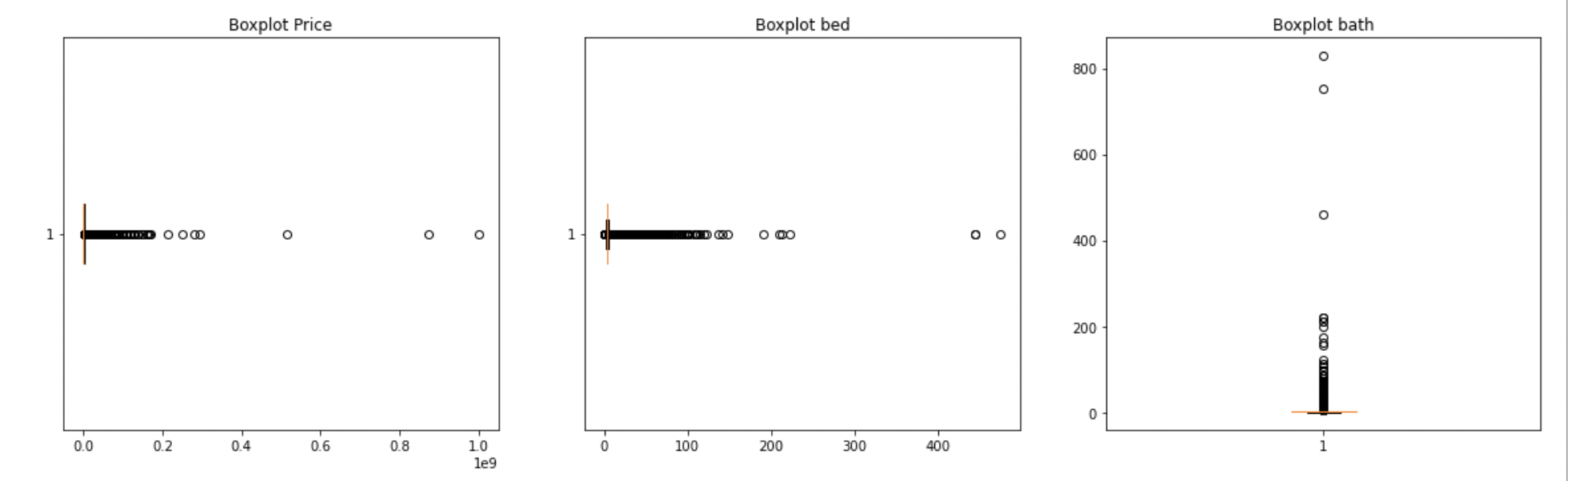
Figure 2. Boxplot of Bedroom Counts
Figure 3. Boxplot of Bathroom Counts
Figure 3. Boxplot of Property Prices

A bar plot of listings by state revealed clear regional imbalances. Major metropolitan areas like Houston, Chicago, and New York dominated the dataset, while smaller states had minimal representation.
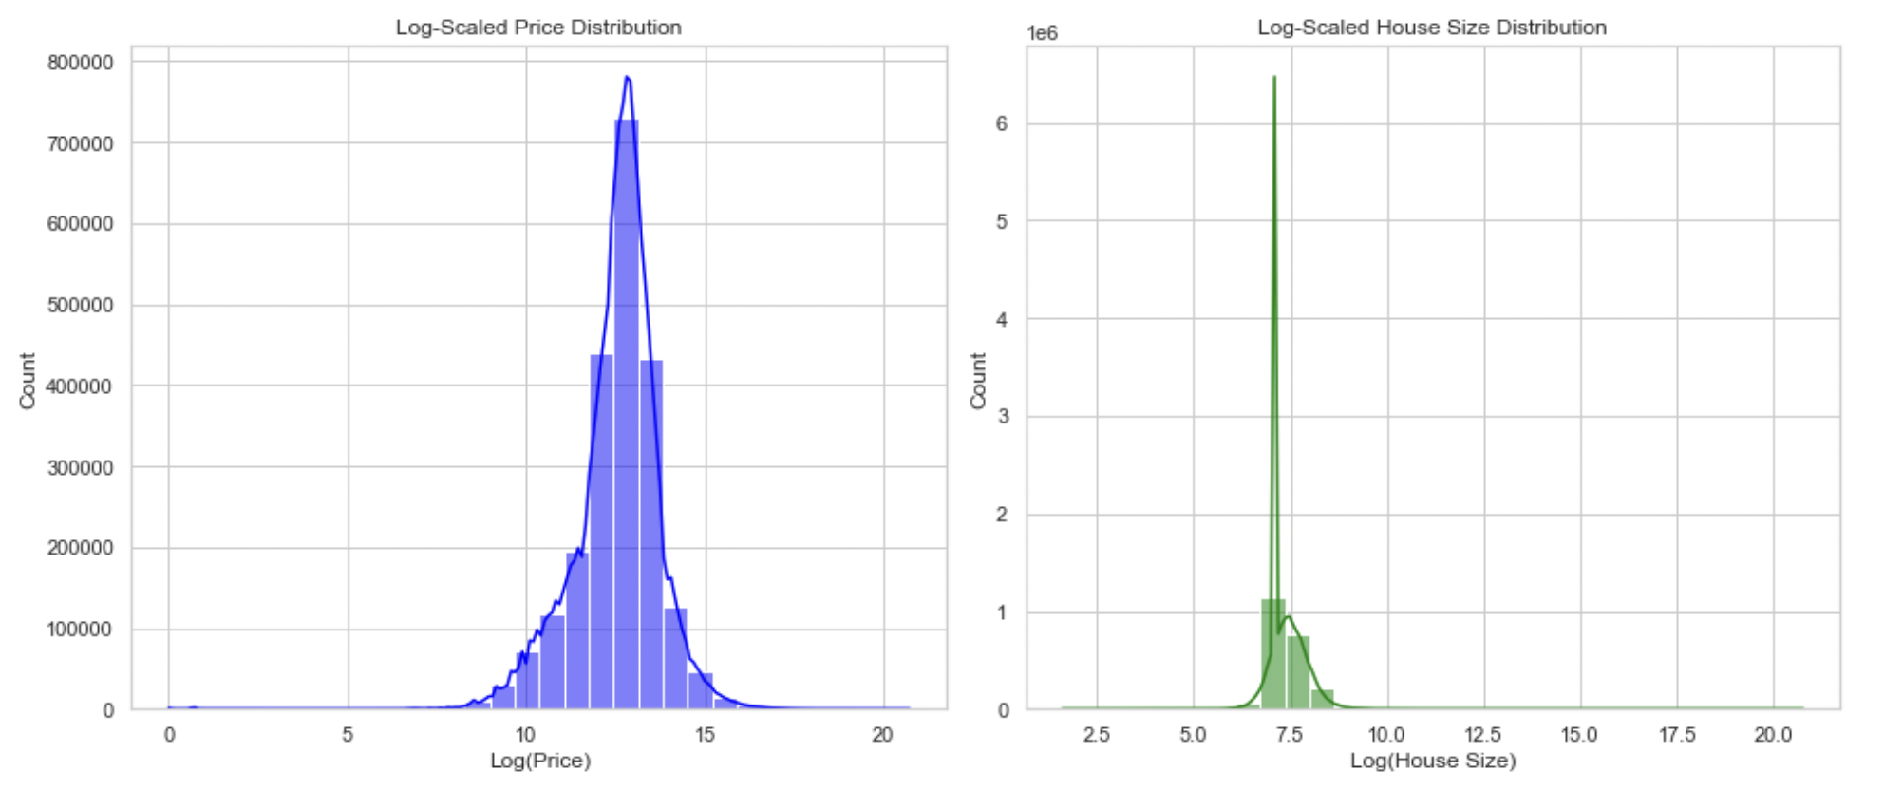
Figure 1
Log-Scaled Price Distribution for the USA Real Estate Dataset
Figure 2
Log-Scaled House Size Distribution for the USA Real Estate Dataset
Reason for Exclusion
While the USA dataset was initially valuable for context, its quality issues made it unsuitable for inclusion in the final analysis. The volume of missing data, inconsistent formatting, and cross-market variability would have produced misleading models. Cleaning the data to a usable standard would have required extensive imputation that could distort outcomes.
Ultimately, the decision was made to exclude this dataset and focus on the Austin and Airbnb datasets.
Austin Housing Dataset
Data Cleaning and Preprocessing and EDA
Outliers were detected using the IQR method. Genuine luxury properties were retained, while unrealistic price anomalies were removed. Continuous variables were standardized, and categorical variables were one-hot encoded.
EDA revealed that price, bathrooms, and square footage were right-skewed but became normally distributed after log transformation. Correlation and pair plots identified square footage, lot size, and school rating as strong price predictors. Neighborhood-level patterns showed higher property values clustered around top-rated school districts, supporting known market behaviors.
Univariate analysis showed that most numerical variables, including price, bathrooms, and square footage, were right-skewed. Log transformations improved their interpretability. Histograms highlighted meaningful patterns, such as peaks in “year_built” around the 1980s and early 2000s, reflecting construction booms. A KDE plot of property taxes showed a strong clustering around 2 percent, consistent with typical tax rates in the region.
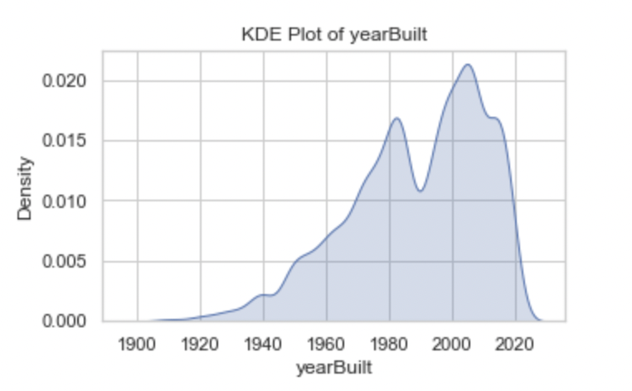
Bivariate analysis revealed more interpretable relationships compared to the USA dataset. For example, violin plots of price distributions across home types showed wide variation for vacant land and single-family homes, while condos and townhouses had narrower ranges. Scatterplots confirmed positive correlations between lot size and living area, while grouped histograms revealed that zip codes with more schools tended to have higher average property prices. This supports the widely held belief that school access is a key driver of housing demand.
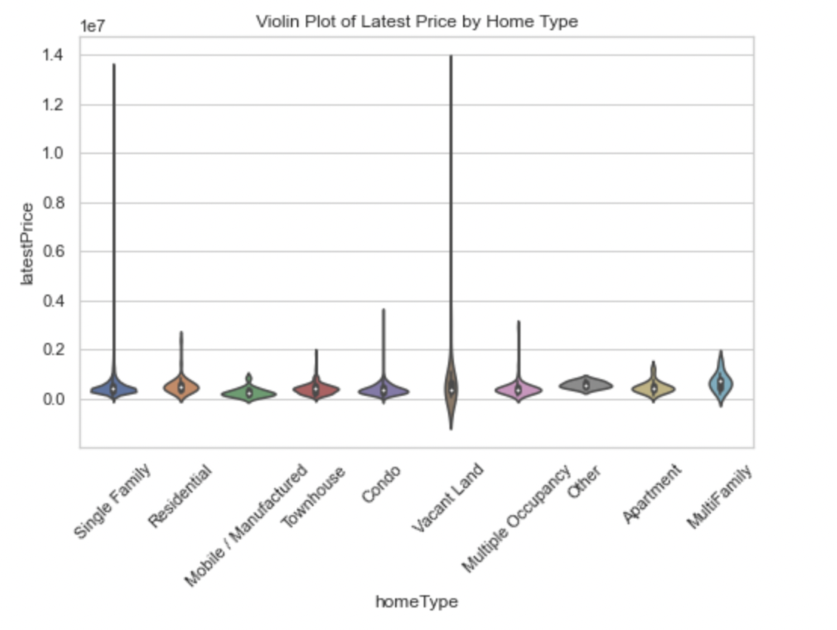
Inside Airbnb Dataset
Data Cleaning and Preprocessing and EDA
The Airbnb dataset required the most extensive cleaning. Median imputation was used for reviews per month, host response rate, and availability_365. Numerical variables were scaled using MinMax normalization, and room_type was one-hot encoded to prepare for modeling.
EDA revealed heavy price skew, driven by a small number of high-end listings. After log transformation, the distribution became more uniform. Entire home/apartment listings had the highest median prices, while private rooms and shared rooms were priced lower. Superhosts had higher average ratings and more bookings, confirming that reputation correlates with financial performance. Correlation heatmaps showed that review count, response rate, and availability were moderately associated with both price and booking likelihood.
Neighborhood-level analysis confirmed clear geographic price segmentation, with premium listings concentrated in central urban areas.
Univariate analysis showed that price distributions were highly skewed, with most properties falling in the affordable range but a long tail of luxury rentals.
Boxplots of price and minimum nights highlighted extreme outliers, such as properties priced at thousands of dollars per night or requiring year-long stays. These outliers were flagged and either capped or excluded.
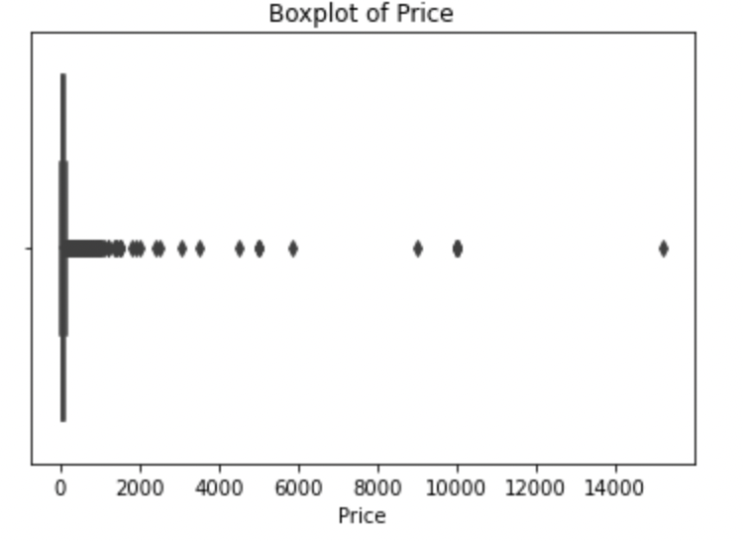
Bivariate analysis revealed that reviews per month increased over time, reflecting Airbnb’s rising popularity. Pair plots of price, reviews, and availability showed that while reviews and availability fluctuated, prices remained relatively stable across most listings.
A heatmap of correlations revealed stronger relationships than in the USA dataset, with meaningful ties between variables such as reviews, availability, and booking likelihood. Neighborhood-level analysis revealed that certain areas consistently had higher average prices, confirming location as the dominant driver of short-term rental performance. 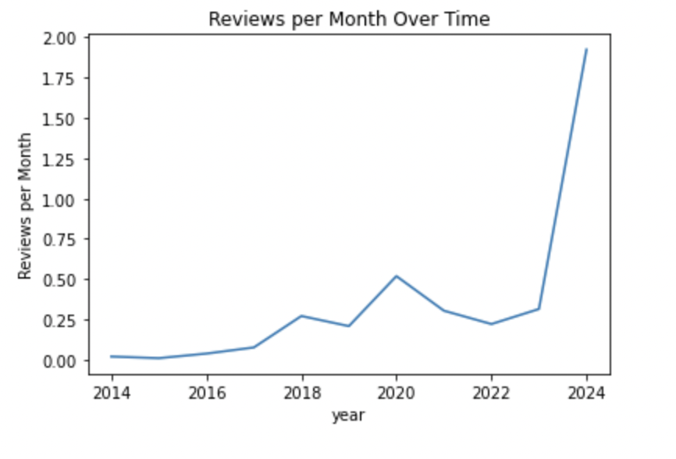
Key Findings from EDA
- USA Real Estate Dataset: Wide variability, weak correlations, and regional imbalance make it useful for macro-level context but less reliable for predictive accuracy.
- Austin Housing Dataset: Stronger correlations, interpretable patterns, and richer features make this dataset highly useful for regression modeling.
- Airbnb Dataset: Rich in categorical and behavioral features, but challenged by class imbalance and outliers. Offers strong potential for classification and clustering models.
Modeling and Analysis
The modeling phase aimed to predict housing prices, classify Airbnb listing performance, and uncover hidden market patterns through clustering. Both supervised and unsupervised learning methods were used, tailored to the Austin Housing and Inside Airbnb datasets. The USA Real Estate dataset was tested briefly but excluded due to quality and imbalance issues.
Supervised Learning
Austin Housing (Regression)
Several regression algorithms were tested to predict housing prices based on property and neighborhood attributes.
Model choices
- Linear Regression served as a baseline (R² ≈ 0.55) but failed to capture non-linear interactions.
- Ridge Regression stabilized results but offered little accuracy gain.
- KNN (k=8) captured local patterns (R² = 0.47) but struggled with scale.
- Random Forest improved substantially (R² ≈ 0.68), identifying square footage, year built, and school rating as top predictors.
- Gradient Boosting achieved the best results (R² ≈ 0.63) after tuning, balancing accuracy and generalization.
Training and Validation
Data was split 80/20 into training and test sets, with 5-fold cross-validation used during training to ensure generalization.
Hyperparameter Tuning
For ensemble models (Random Forest and Gradient Boosting), grid search was used to tune key parameters:
- Random Forest: number of estimators (100–500), max depth (3–10), min samples split (2–6)
- Gradient Boosting: learning rate (0.05–0.1), depth (3–5), estimators (200–400)
Regularization and parameter optimization improved R² by approximately 5–8% compared to defaults.
Evaluation Metrics
Model performance was measured using R² and Root Mean Squared Error (RMSE) to balance interpretability and predictive power. Random Forest slightly outperformed Gradient Boosting on accuracy, while the latter generalized better across unseen data.
Inside Airbnb (Regression and Classification)
Regression Task
Regression using Gradient Boosting (350 estimators, depth=4, LR=0.1) reached R² = 0.72, outperforming Austin due to richer behavioral features like host activity, reviews, and availability.
Classification Tasks
For classification, two binary tasks were modeled:
- Superhost prediction
- High-performing listings (above-median price)
- Logistic Regression: 77% accuracy.
- Random Forest: 82% accuracy, F1 = 0.81, top predictors were reviews, response rate, and review scores.
- SVM: Overfit the data, performing poorly on unseen samples.
Training and Validation
Stratified sampling-maintained balance across classes. Models were evaluated using precision, recall, F1-score, and overall accuracy. Cross-validation confirmed consistent model performance.
Hyperparameter Tuning
Grid search was used for both Logistic Regression (regularization strength) and Random Forest (n_estimators, depth, and min_samples_leaf). Gradient Boosting parameters mirrored the regression task and were optimized for classification accuracy.
Key Insights
Ensemble methods consistently outperformed simpler models, demonstrating their ability to capture complex, non-linear behavioral relationships. Simpler models, while interpretable, traded off performance.

Unsupervised Learning
Three clustering methods were tested: K-Means, DBSCAN, and Hierarchical Agglomerative Clustering (HAC).
- K-Means revealed limited separation in Austin (silhouette = 0.13), reflecting gradual market variation. Airbnb clustering was clearer (k=3, silhouette = 0.58), showing budget vs. premium listing tiers.
- DBSCAN performed best for Austin (eps=17, silhouette = 0.74), uncovering irregular geographic clusters and filtering price outliers effectively.
- HAC performed best for Airbnb (silhouette = 0.61), showing a natural three-tier hierarchy budget, mid-range, and luxury.
Model Evaluation
Cross-validation and hyperparameter tuning were applied throughout. Regularization controlled overfitting in Ridge and Boosting models. For Airbnb’s class imbalance, stratified sampling ensured balanced training. For clustering, silhouette scores guided optimal configurations.
Results and Key Insights
- Best Price Predictor: Gradient Boosting—R² ≈ 0.63 (Austin), R² ≈ 0.72 (Airbnb).
- Best Classifier: Random Forest, 82% accuracy for Superhost prediction.
- Best Clustering: DBSCAN for Austin (silhouette = 0.74) and HAC for Airbnb (0.61).
Three major themes emerged:
- Model choice depends on data type. Ensemble methods outperform when relationships are non-linear.
- Short-term rentals are more segmented. Airbnb data formed clear clusters; Austin’s was continuous.
- Behavioral factors drive rental success. Host activity, reviews, and response rate mattered more than property size.
Overall, Gradient Boosting and Random Forest proved the most versatile models, while clustering methods offered complementary insights. Together, they showed how machine learning can capture both structural and behavioral dynamics across housing and rental markets.
Conclusion and Recommendations
This project examined how housing and rental markets behave through data. By analyzing the Austin Housing and Inside Airbnb datasets, it tested multiple regression, classification, and clustering models to understand pricing patterns and performance drivers. Ensemble models consistently performed best.
For the Austin dataset, Gradient Boosting and Random Forest achieved the highest accuracy (R² = 0.63–0.68), capturing complex relationships between square footage, school rating, and year built.
For Airbnb, the inclusion of behavioral features host responsiveness, reviews, and availability boosted Gradient Boosting’s performance to R² = 0.72. Random Forest also performed best for classification, reaching 82% accuracy in predicting Superhost status, confirming that host engagement and reliability strongly influence success.
Unsupervised learning added another layer of insight. In Austin, DBSCAN produced the strongest clustering results (silhouette = 0.74), uncovering neighborhood-level pricing patterns. For Airbnb, Hierarchical Clustering achieved a silhouette score of 0.61, revealing natural groupings among budget, mid-range, and premium listings.
These findings show that model effectiveness depends on data type and structure. Traditional housing markets behave more continuously, while short-term rentals form distinct behavioral segments. Ensemble models excel when data includes both structural and behavioral variables, while clustering reveals patterns traditional analysis might overlook.
The decision to exclude the USA Real Estate dataset proved important, its inconsistent and incomplete data would have weakened the analysis. Focusing on localized, high-quality datasets produced more interpretable and actionable results.
Practically, the findings provide guidance for different stakeholders:
- Investors can use ensemble models to identify undervalued properties by factoring in community-level attributes.
- Homeowners and Agents can focus on features with the strongest price influence—school quality, lot size, and year built.
- Airbnb Hosts can improve performance by emphasizing communication, responsiveness, and guest experience.
- Policymakers can use clustering insights to monitor how short-term rentals affect housing supply and affordability.
While the study offers valuable insights, it has limits. Macroeconomic variables were absent, and the Airbnb data reflected a single snapshot in time. Future work could integrate time-series and spatial modeling or develop interactive dashboards for real-time prediction and visualization.
In sum, this project demonstrates how data science can turn raw housing and rental data into meaningful insights. Machine learning doesn’t just predict price, it reveals how structure, behavior, and geography combine to shape real-world markets.

References
Get the Data. (n.d.). Insideairbnb.com. Retrieved November 24, 2024, from
https://insideairbnb.com/get-the-data/
Pierce, E. (2021). Austin housing prices. Kaggle.com; Kaggle. https://www.kaggle.com/datasets/ericpierce/austinhousingprices/data
Shahriar Sakib, A. (2023). USA Real Estate Dataset. Www.kaggle.com. https://www.kaggle.com/datasets/ahmedshahriarsakib/usa-real-estate-dataset/data
GeeksforGeeks. (n.d.). Support vector machine (SVM) algorithm. GeeksforGeeks. https://www.geeksforgeeks.org/machine-learning/support-vector-machine-algorithm/
Damavis. (2020, July 9). Linear regression with Elastic Net: Implementations in Python. Damavis Blog. https://blog.damavis.com/en/linear-regression-with-elastic-net-implementations-in-python/
Fiveable. (n.d.). Polynomial regression & interaction terms. Fiveable. https://library.fiveable.me/linear-modeling-theory-and-applications/unit-6/polynomial-regression-interaction-terms/study-guide/MjYsQrAp2si8IaEA
NVIDIA. (2020, October 16). A comprehensive guide to interaction terms in linear regression. NVIDIA Developer Blog. https://developer.nvidia.com/blog/a-comprehensive-guide-to-interaction-terms-in-linear-regression

