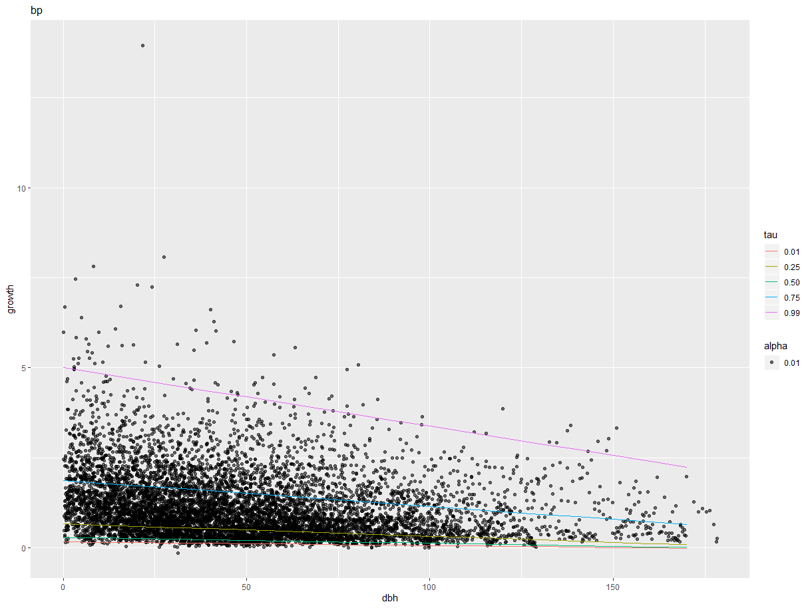

Call:

rq(formula = (data$growth) ~ (data$dbh), tau = taus)

Coefficients:

tau= 0.01 tau= 0.25 tau= 0.05 tau= 0.75

(Intercept) 0.171147020 0.669699962 0.290218270 1.87598090

data$dbh -0.001059603 -0.003418154 -0.001616815 -0.00722508

tau= 0.99

(Intercept) 5.00137092

data$dbh -0.01621522

Degrees of freedom: 7983 total; 7981 residual

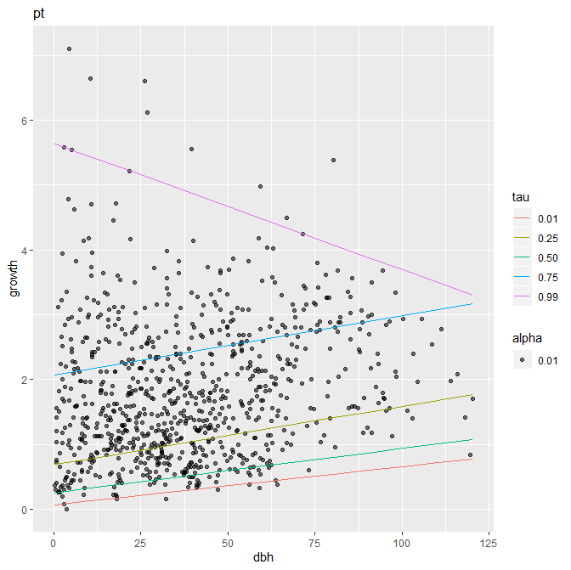

Call:

rq(formula = (data$growth) ~ (data$dbh), tau = taus)

Coefficients:

tau= 0.01 tau= 0.25 tau= 0.05 tau= 0.75

(Intercept) 0.062574909 0.685820505 0.25136705 2.062702703

data$dbh 0.005926902 0.009003776 0.00685155 0.009237085

tau= 0.99

(Intercept) 5.64250914

data$dbh -0.01948843

Degrees of freedom: 837 total; 835 residual

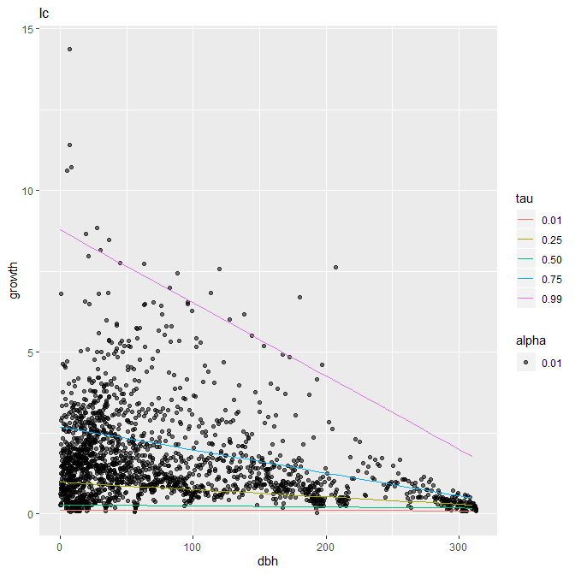

Call:

rq(formula = (data$growth) ~ (data$dbh), tau = taus)

Coefficients:

tau= 0.01 tau= 0.25 tau= 0.05

(Intercept) 1.209749e-01 0.977525600 0.2829190771

data$dbh -6.924249e-05 -0.002244354 -0.0003324689

tau= 0.75 tau= 0.99

(Intercept) 2.693238834 8.77752519

data$dbh -0.007132032 -0.02257154

Degrees of freedom: 1938 total; 1936 residual

|  |
| --- |
| Nenrin.csv |
| bunitenkaiki<-function(sp,motodata){  data<-subset(motodata,spp==sp)  taus <- c(.01,.25,.05, .75,.99)  buniten<-rq( (data$growth) ~ (data$dbh), tau=taus)  f<-coef(buniten)  kaiki001<-data.frame(dbh=seq(min(data$dbh),max(data$dbh),10),  growth=seq(min(data$dbh),max(data$dbh),10)*f[2,1]+f[1,1],  tau="0.01")  kaiki025<-data.frame(dbh=seq(min(data$dbh),max(data$dbh),10),  growth=seq(min(data$dbh),max(data$dbh),10)*f[2,2]+f[1,2],  tau="0.25")  kaiki050<-data.frame(dbh=seq(min(data$dbh),max(data$dbh),10),  growth=seq(min(data$dbh),max(data$dbh),10)*f[2,3]+f[1,3],  tau="0.50")  kaiki075<-data.frame(dbh=seq(min(data$dbh),max(data$dbh),10),  growth=seq(min(data$dbh),max(data$dbh),10)*f[2,4]+f[1,4],  tau="0.75")  kaiki099<-data.frame(dbh=seq(min(data$dbh),max(data$dbh),10),  growth=seq(min(data$dbh),max(data$dbh),10)*f[2,5]+f[1,5],  tau="0.99")  kaiki<-rbind(kaiki001,kaiki025,kaiki050,kaiki075,kaiki099)  g<-ggplot()+  ggtitle(sp)+  layer(  data=data,  mapping=aes(x=dbh,y=growth,alpha=0.01),  geom="point",  stat="identity",  position="identity"  )+  layer(  data=kaiki,  mapping=aes(x=dbh,y=growth,colour=tau),  geom="line",  stat="identity",  position="identity"  )  plot(g)  return(buniten)  } |