Happy Customers

**Background:**  
  
We are one of the fastest growing startups in the logistics and delivery domain. We work with several partners and make on-demand delivery to our customers. During the COVID-19 pandemic, we are facing several different challenges and everyday we are trying to address these challenges.  
  
We thrive on making our customers happy. As a growing startup, with a global expansion strategy we know that we need to make our customers happy and the only way to do that is to measure how happy each customer is. If we can predict what makes our customers happy or unhappy, we can then take necessary actions.  
  
Getting feedback from customers is not easy either, but we do our best to get constant feedback from our customers. This is a crucial function to improve our operations across all levels.  
  
We recently did a survey to a select customer cohort. You are presented with a subset of this data. We will be using the remaining data as a private test set.  
  
**Data Description:**  
  
Y = target attribute (Y) with values indicating 0 (unhappy) and 1 (happy) customers  
X1 = my order was delivered on time  
X2 = contents of my order was as I expected  
X3 = I ordered everything I wanted to order  
X4 = I paid a good price for my order  
X5 = I am satisfied with my courier  
X6 = the app makes ordering easy for me  
  
Attributes X1 to X6 indicate the responses for each question and have values from 1 to 5 where the smaller number indicates less and the higher number indicates more towards the answer.

**Goal(s):**  
  
Predict if a customer is happy or not based on the answers they give to questions asked.  
**Success Metrics:**  
  
Reach 73% accuracy score or above

**Bonus(es):**  
  
We are very interested in finding which questions/features are more important when predicting a customer’s happiness. Using a feature selection approach show us understand what is the minimal set of attributes/features that would preserve the most information about the problem while increasing predictability of the data we have. Is there any question that we can remove in our next survey?

**Data Analysis:**

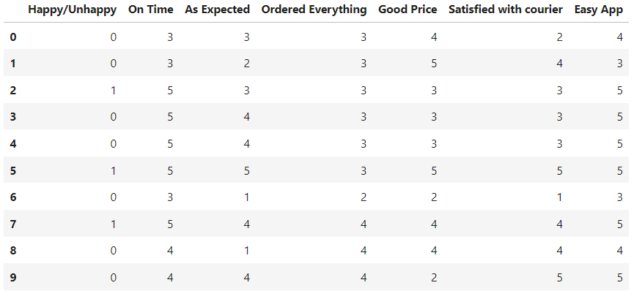

Original Data

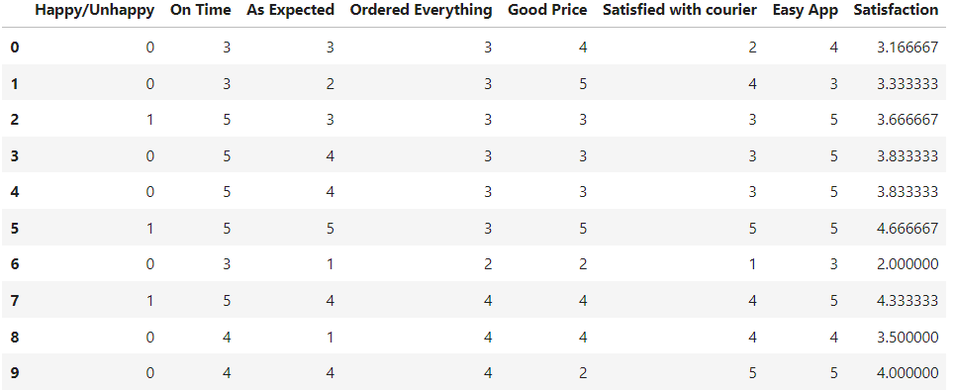

Data After Adding New Feature (Over All Satisfaction )

* **Statistics of the data set**

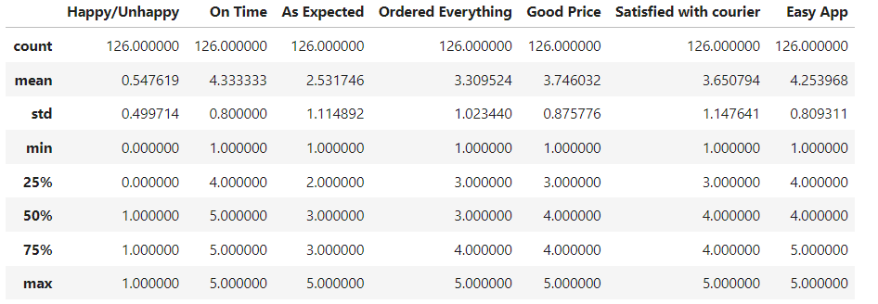

**Data Visualization:**

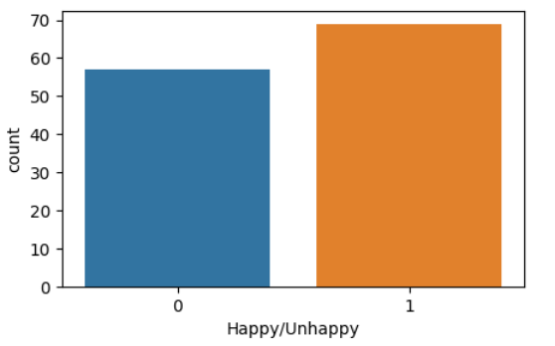

Figure Show the total number of happy and unhappy customers.

The dataset has more happy customer but the difference is not big to effect the trained model and have biased toward happy customers

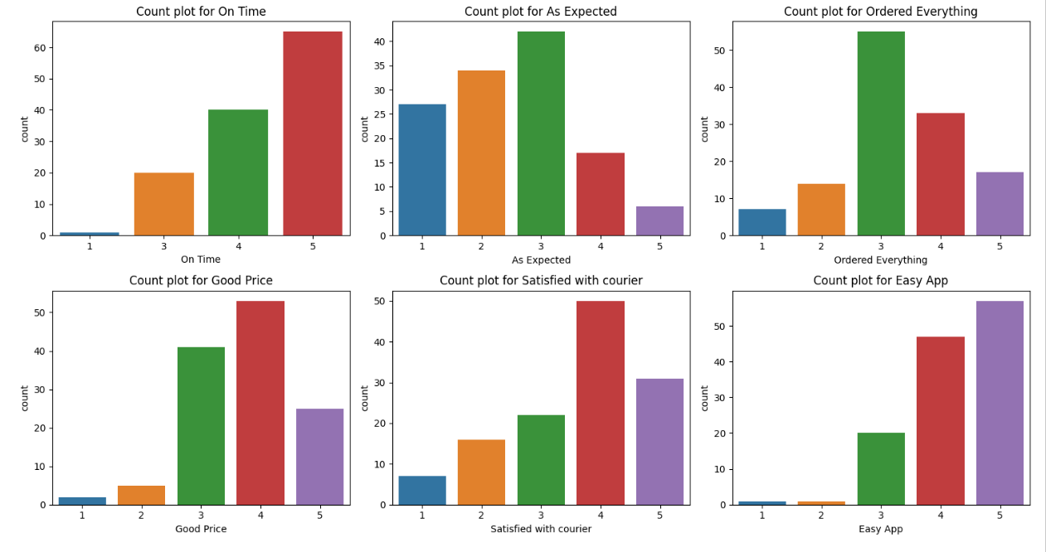

* Getting orders “On Time” and having an “Easy App” shows more satisfaction from customers.
* Getting orders “As Expected” , having a “Good Price”, being :Satisfied with courier”, and “Ordering Everything” shows that customer satisfaction has a different distribution and decline after the rating of ( 3 ) or ( 4 ) in the survey; thus more analysis/improvement is needed on these.

**Model & Coclusion:**

To start building the classification model, I choose 5 initial models to train using the default parameters, and the result was as follow:

* **Support vector machine (using linear kernel ):** Accuracy = 78.9% and F1 score = 0.8
* **Logistic Regression:** Accuracy = 57% and F1 score = 0.63
* **Descension Tree:** Accuracy = 63% and F1 score = 0.66
* **Random Forest:** Accuracy = 57.8% and F1 score = 0.63
* **K nearest neighbour :** Accuracy = 36.8% and F1 score = 0.45

To improve the models performance and tune the parameters of each model, grid search is implemented and the result as follow:

* **Support vector machine (using linear kernel ):** Accuracy = 78.9% and F1 score = 0.8
* **Logistic Regression:** Accuracy = 57% and F1 score = 0.63
* **Descension Tree:** Accuracy = 63% and F1 score = 0.66
* **Random Forest:** Accuracy = 52.6% and F1 score = 0.57
* **K nearest neighbour :** Accuracy = 47% and F1 score = 0.54

**Concluded that support vector machine produced the best result with an accuracy of 79% and an F1 score of 0.8 .**