**UNIVERSITY OF RWANDA**

College of Science and Technology



**African Center of Excellence in Internet of Things**

**(ACEIoT)**

**Masters in IoT-WiSeNet**



**MODULE: IOT6164 DESIGNING AND PROGRAMMING EMBEDDED DEVICES**

**GROUP PROJECT: SERVICE DELIVERY TABLET**

**Group 3 /members:**

1. Kannole Veronica Eugene 220012874
2. Halima Namudu 220012803
3. Marvin Muyonga Ogore 220014154
4. Ingabire Ariane 220014279

**Lecturer: Dr. Jimmy Nsenga.**

**System-level design**

**The Micro-controller Unit**

|  |  |  |  |  |  |  |  |  |  |
| --- | --- | --- | --- | --- | --- | --- | --- | --- | --- |
| Processor model | Power specifications | | | Clock Frequency | ROM | FLASH | RAM | UNIT COST($) | |
| Active current(μA) | Sleep current(μA) | Power  supply  range(V) | 1 item | 24 items |
| M263KIAAE  Arm® Cortex®-M23 core | 97 μA (LDO),  45 μA (DC) | 2μA in deep Power-down mode | 1.8V to 3.6 V | 64 MHz | 4Kb  (LDROM) | 512Kb | 96KB  (SRAM) | 5 | 100 |

Source: <https://direct.nuvoton.com/en/numaker-iot-m263a>. Has inbuilt Lora which eliminates need of buying a separate LoRa component.

Power and energy calculations:

* Microcontroller Power in active mode = Active current x max voltage

= 97 x 10-6 A x 3.6V

= 3.52x10-4 W

* Microcontroller Power in sleep mode =sleep current x minimum voltage

= 2x10-6 A x 1.8V

= 3.6 x10-6 W

Energy for active mode = power in active mode x time microcontroller is active in hrs

= 3.52x10-4 W x 8hrs

= 2.816 x 10-3 Wh

Energy for sleep mode = power in sleep mode x time microcontroller is sleep mode in hrs

=3.6 x10-6 Wh

Overall energy for the microcontroller = Energy for active mode + Energy for sleep mode

= 2.816 x 10-3 Wh + 3.6 x10-6 Wh

= 2.82 x10-3 Wh

**DISPLAY MODULE**

|  |  |  |  |  |  |  |
| --- | --- | --- | --- | --- | --- | --- |
| Product model | Display quality | | | Product specifications | | Unit cost ($) |
| Screen size | Dimension | Resolution | Active current(mA) per LED | Power supply range(V) |
| DM-TFT35-107 | 3.5” | 78.10x65.14 | 320x240 | 30 | 3.3 to 5 | 38.99 |

**Power and energy calculations**

* Touch screen Power calculated = active current x voltage supply

= 30mA x5V

= 0.15W

Energy for the touch screen = Touch screen Power calculated x time in hrs

=0.15 W x 8hrs

=1.2Wh

* The total energy for the system = energy for the touch screen + Energy for active mode of microcontroller

**= 2.82 x10-3 + 1.2**

**= 1.203Wh**

**SOLAR PANEL AND BATTERY**

|  |  |  |  |  |  |
| --- | --- | --- | --- | --- | --- |
| **Product model** | **Ampere** | **Voltage** | **Size** | **Price** | **Source** |
| 1. ST094 | 200mA | 5V | 100*70mm | 3.17 £ | https://www.bitsbox.co.uk/ |
| 1. USB Battery Pack | 2200mAH | 5V | 25mm x 91mm x 25mm / 1" x 3.6" x 1" | 14.95 $ | https://www.amazon.com/ |

Total current consumed by system = 30mA + (97x10-3) mA

= 30.097mA

The amount of time taken before battery needs recharging

= 2200mAH/30.097mA

= 73.097H

Active time of system in a day is 8hrs

So, 73.097/8 = 9.14 days before the battery is recharged again.

**System Block diagram**

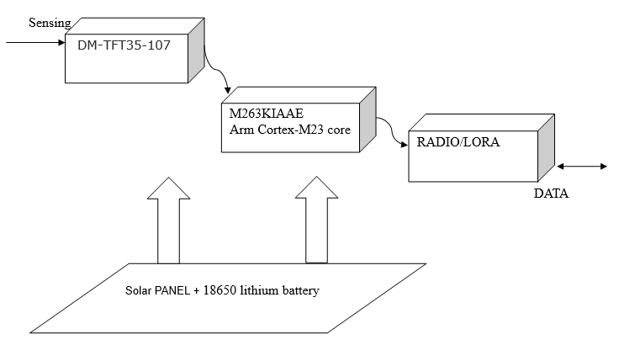

**Program Description Language**

**BEGIN|**myDuration

**IF** button2=1 **THEN**

**REPEAT**

j=j+1;

**PRINT** seconds passed is = j

**WAIT** 1 second

**UNTIL** Button is OFF

**ENDIF**

**IF** j>=5 **THEN**

Turn Red LED ON

Turn Blue LED OFF

i=i-1

**ELSE**

Turn Blue LED ON

Turn Red LED OFF

i=i+1

**ENDIF**

**END|**myDuration

**BEGIN|modeOne**

**CALL** blink

Display time on LCD

Wait 1.5 seconds

Display temperature on LCD

Wait 1.5 seconds

**DO FOREVER**

Display topic one on LCD

i=0

Wait 2 seconds

Display topic one on LCD

i=1

Wait 2 seconds

Display topic one on LCD

i=2

Wait 2 seconds

Display topic one on LCD

i=3

Wait 2 seconds

Display topic one on LCD

i=4

Wait 2 seconds

**ENDDO**

**END|modeOne**

**BEGIN|display**

k=0

**REPEAT**

Display topic on LCD

Wait 1 second

Display Summary on LCD

**CALL** myDuration

k=k+1

**UNTIL** k=5

**IF** k=5 **THEN**

Print k, and i

**ENDIF**

**END|display**

**BEGIN|**modeTwo

DO FOREVER

Print entered mode two

Wait 2 seconds

**CALL** topicSelection

ENDDO

**END|**modeTwo

**BEGIN|**topicSelection

**IF** i=0 **OR** i<0**THEN**

i=0

topic=topic_one

summary = summary_one

**CALL** display

**ELSE IF(i==1)**

topic=topic_two

summary = summary_two

**CALL** display

**ELSE IF(i==2)**

topic=topic_three

summary = summary_three

**CALL** display

**ELSE IF i=3 THEN**

topic=topic_four

summary = summary_four

**CALL** display

**ELSE IF** i==4 **THEN**

topic=topic_five

summary = summary_five

**CALL** display

**ELSE**

print nothing to display

**ENDIF**

**END|**topicSelection

**BEGIN|**main

**IF** interrupt **THEN**

**CALL** modeTwo

**ELSE**

**CALL** modeOne

**ENDIF**

**END|**main

**BEGIN**|blink

Turn ON white LED

wait 1 second

Turn OFF white LED

wait 1 second

**END|blink**

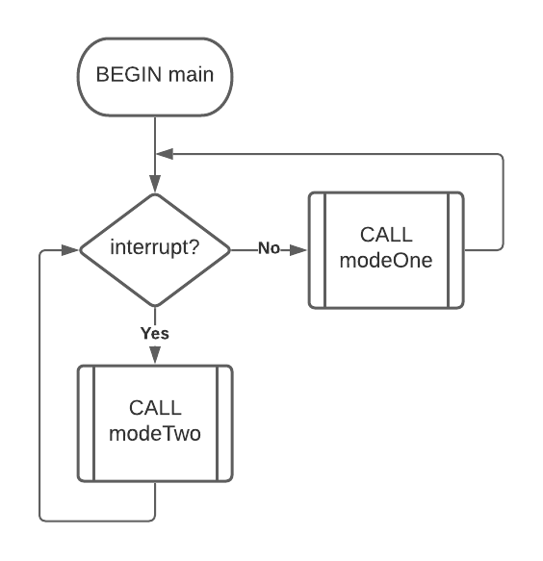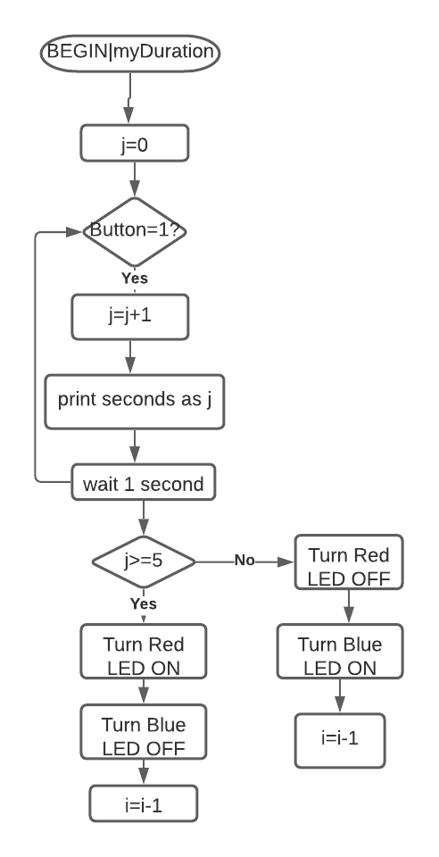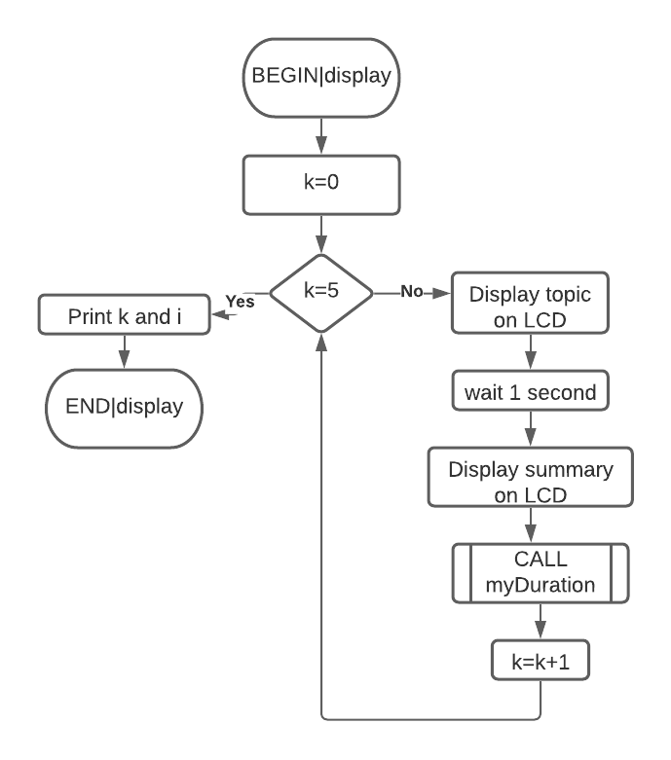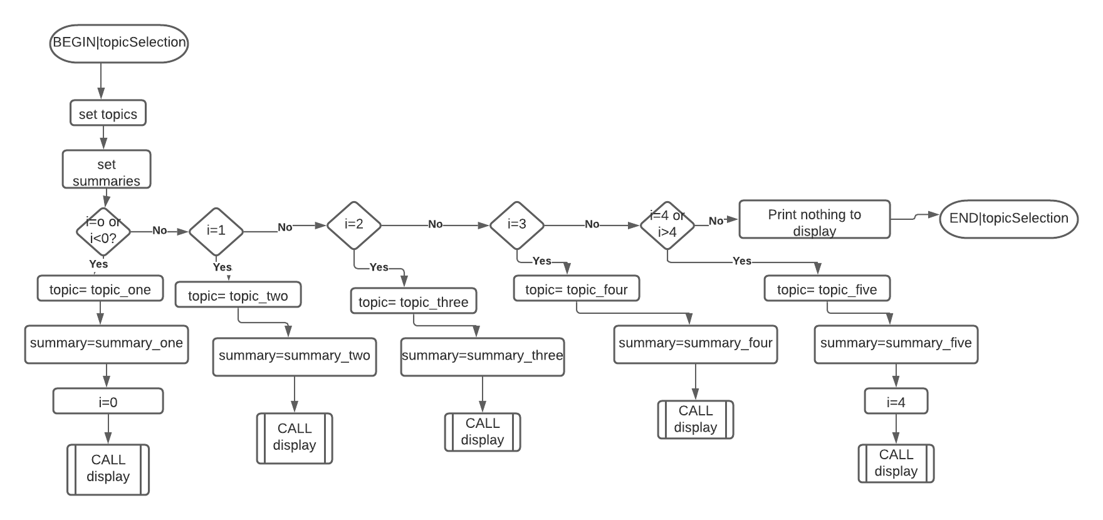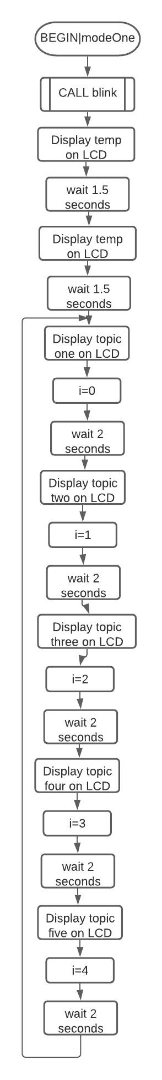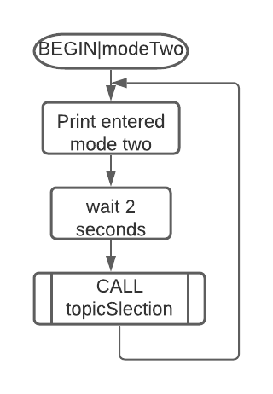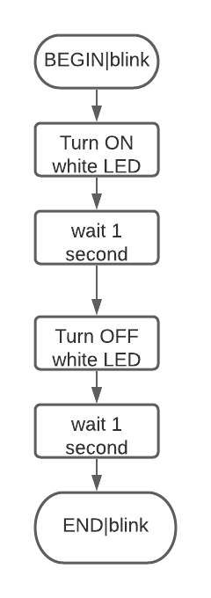

**Repository link to the code:**

https://os.mbed.com/users/ogore/code/rapidtouchscreenprototype//file/75bc6a58b8e3/main.cpp/

Kindly see comments at the start of the code to see why our group decided to go with option one of printing on the console instead of sending to LoRa.

**Business sectors which may be interested**

1. The Police department
2. The department of interior security and immigrations(The government)

**Why use our system**

1. The system is cost effective-Looking at the overall calculated cost of buying components, our system will be sold at a far cheaper price compared to existing tablets. The components picked are specifically picked with the intention of providing a pocket-friendlysystem that can be deployed on a large scale.
2. Power saving-with the calculated power consumed as shown in this document, it is fit to say that our solution beats the always-on power hungry tablets that are in the market. The use of LoRa is far less power hungry compared to traditional cellular networks that most tablets come with as their communication modules
3. Efficiency. The concept is forward thinking. It will eliminate the need to make long lines in pursuit of services that people are entitled to. With topics provided in our code, we can see that the system is well design to fit governmental services in an efficient fashion. Authorities that deal with issues related to civilian documents such as certificates of good conduct and such may find that the system could be shaped to suit their specific services.
4. IoT- with LoRa we have a system that can be monitored from anywhere and at anytime. Statistics can be analysed effectively by eliminating the need of a person to physucally be present to collect statistics.