|  |  |
| --- | --- |
| Internship Project Title | Employee Attrition and Performance Analysis |
| Name of the Company | TCS iON |
| Name of the Industry Mentor | Harish Kumar |
| Name of the Institute | IIT, Madras |

|  |  |  |  |  |  |  |
| --- | --- | --- | --- | --- | --- | --- |
| Start Date | End Date | | Total Effort (hrs.) | | Project Environment | Tools used |
| 23/01/2023 | 27/01/2023 | | 24 | | Windows 10, Chrome | Power Bi |
| Milestone # | 1 | Milestone: | | To understand and analyse factors that lead to employee attrition. | | |

**TABLE OF CONTENT**

* Acknowledgements
* Objective
* Introduction / Description of Internship
* Internship Activities
* Approach / Methodology
* Assumptions
* Exceptions / Exclusions
* Charts, Table, Diagrams
* Algorithms
* Challenges & Opportunities
* Risk Vs Reward
* Reflections on the Internship
* Recommendations
* Outcome / Conclusion
* Enhancement Scope
* Link to code and executable file
* Research questions and responses

**Acknowledgements:**

I’m thankful to TCS iON for this internship. I'd want to offer my heartfelt gratitude and appreciation to my industry mentor for his time and attention.

**Objective:**

This project's goal is to create analytics and reports using Data Science tools to provide detailed insights on HR Analytics, with a focus on employee attrition and performance.

**Introduction:**

Employee attrition is a major issue for Human Resources. In this day and age, it is critical to understand the elements that influence employee turnover and retention. Some of these elements may be evident, while others may be buried.

Employee performance measures how successfully or poorly an employee performs their assigned work obligations and how quickly they satisfy deadlines or criteria. Employee performance is critical to the success of any organisation. Every employee must contribute to the company's vision and objectives. More than 85% of employees are disengaged at work. As a result, organisations must find a means to assure employee engagement, which leads to staff productivity.

**Approach:**

1. Analyse dataset
2. Identify important features of the dataset
3. Design graphs and charts using Power BI
4. Design dynamic dashboard using Power BI

**Charts, Table, Diagrams:**

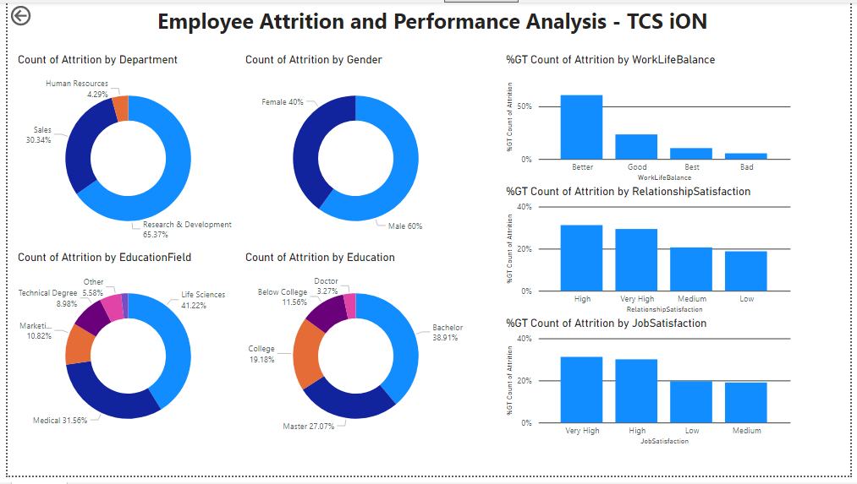

**Conclusions:**

1. The highest attrition rates were among those who studied in the fields of technical, marketing, and human resources.
2. While managers, directors, and employees in senior positions tended to stay with the firm, sales reps had an extremely high attrition rate.
3. Males experienced slightly higher attrition.
4. For workers who were working their third, fourth, or fifth job, the attrition rate was very low.
5. The likelihood of leaving the firm was higher for singles than for married or divorced workers.
6. Compared to the sales and HR divisions, the R&D department saw slightly less attrition.
7. Attrition rate for the employees that received no training was around 25%, compared to values that range from 10% to 15% for employees that did receive some training.
8. 'Very dissatisfied' employees have an attrition rate twice as high as that of the other cases.
9. When employees worked extra, we observed that they were more likely to quit.
10. Frequent travellers were more likely to abandon their jobs.
11. Performance rating had no impact on attrition rate.