|  |  |
| --- | --- |
| Internship Project Title | Employee Attrition and Performance Analysis |
| Name of the Company | TCS iON |
| Name of the Industry Mentor | Harish Kumar |
| Name of the Institute | IIT, Madras |

|  |  |  |  |  |
| --- | --- | --- | --- | --- |
| Start Date | End Date | Total Effort (hrs.) | Project Environment | Tools used |
| 23/01/2023 | 01/02/2023 | 45 | Win 10, Chrome | Power BI |

**Table of Contents:**

**1. Acknowledgements:** 2

**2. Objective:** 2

**3. Introduction:** 2

**4. Internship Activities:** 3

**5. Approach:** 3

**6. Assumptions:** 3

**7. Visualisations:** 4

**8. Algorithms:** 6

**9. Recommendations:** 6

**10. Conclusion:** 7

10.1 Employee Attrition: 7

10.2 Employee Performance: 7

**11. Enhancement Scope:** 8

**12. Link to Project Files:** 8

# **1. Acknowledgements:**

I’m thankful to TCS iON for this internship. I'd want to offer my heartfelt gratitude and appreciation to my industry mentor for his time and attention.

# **2. Objective:**

This project's goal is to create analytics and reports using Data Science tools to provide detailed insights on HR Analytics, with a focus on employee attrition and performance. We will use Power BI, as a data science tool, in this report.

In this report, we will explore and evaluate the elements that contribute to employee attrition. We will also evaluate the elements that influence employee performance and find ways to improve it.

# **3. Introduction:**

Employee attrition is a major issue for Human Resources. In this day and age, it is critical to understand the elements that influence employee turnover and retention. Some of these elements may be evident, while others may be buried. When one employee leaves, the firm suffers a large overall loss due to the time, money, and effort required in training new employees, work dependency, and other issues. Furthermore, attrition fosters distrust among current employees, which can be a serious challenge for organisational management.

Employee performance measures how successfully or poorly an employee performs their assigned work obligations and how quickly they satisfy deadlines or criteria. Employee performance is critical to the success of any organisation. Every employee must contribute to the company's vision and objectives. More than 85% of employees are disengaged at work. As a result, organisations must find a means to assure employee engagement, which leads to staff productivity.

# **4. Internship Activities:**

1. Collect/import data
2. Transform data
3. Modelling and calculations
4. Visualisation
5. Create dashboard
6. Sharing of report

# **5. Approach:**

# **6. Assumptions:**

We have to create analytics and reports based on employee attrition and performance, for the given dataset. We assume that the data provided is free from errors and its features are inter-related.

# **7. Visualisations:**

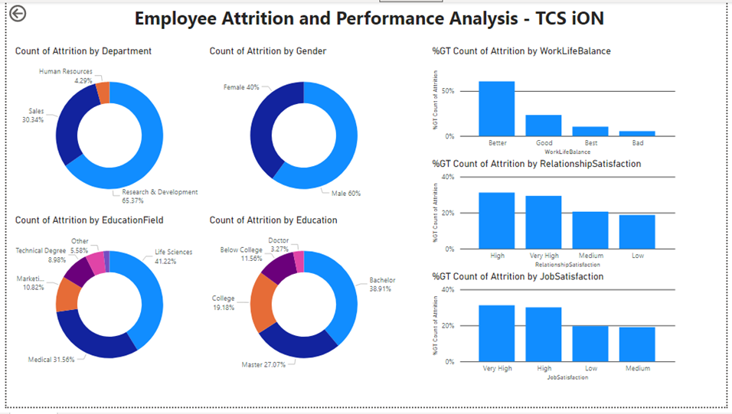

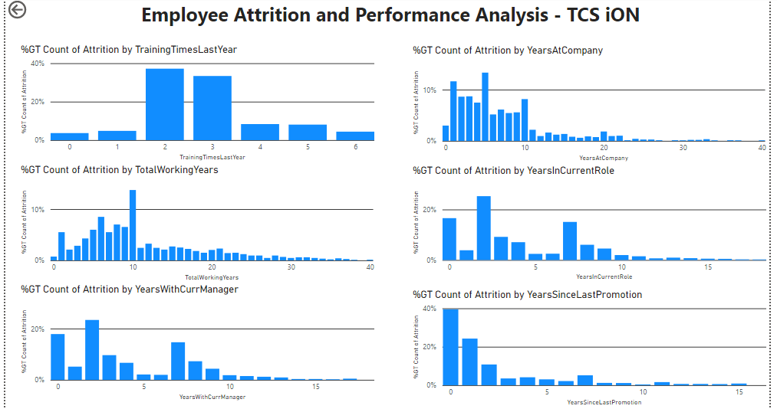

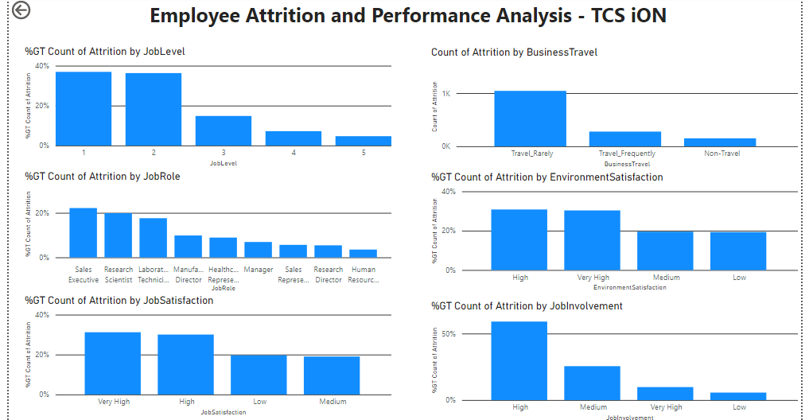

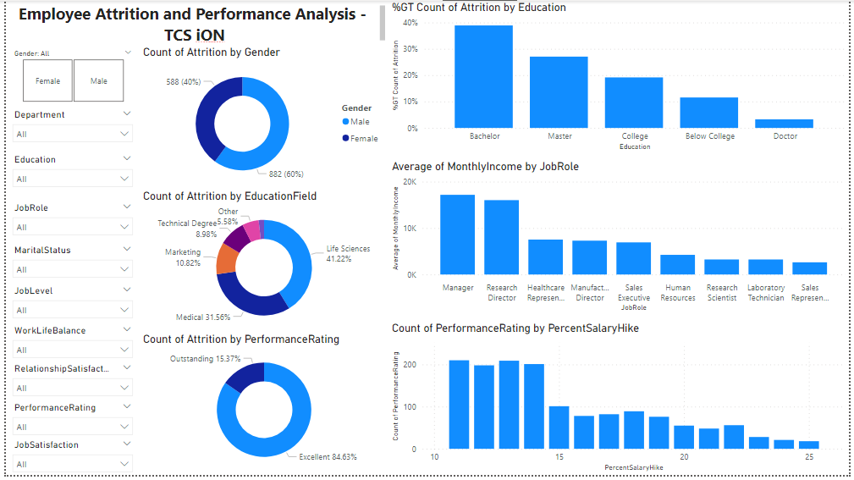

# **8. Algorithms:**

# **9. Recommendations:**

1. Employees tend to change jobs during the outset of their careers or in the early stages of their careers. Once they have settled with a family or found stability in their jobs, they tend to stay in the same organisation for a long time, only making vertical moves within the same organisation.
2. Employees are highly motivated by salary and stock options, and they are less likely to leave the firm. With higher salary and greater stock options, more employees are staying with their business.
3. Work-life balance is an excellent motivator for employees. Employees that have a good work-life balance, on the other hand, tend to switch in quest of greater prospects and a higher standard of living.
4. Departments where target meeting performance is critical (for example, sales) have a higher likelihood of leaving the firm than departments with a more administrative approach (For e.g., Human Resources)
5. Employees who are satisfied with their jobs and their surroundings are loyal to their employers, and this speaks volumes for any firm. Employees who are dissatisfied with their present project, on the other hand, leave the company significantly more frequently.

# **10. Conclusion:**

## 10.1 Employee Attrition:

1. **Education**: The highest attrition rates were among those who studied in the fields of technical, marketing, and human resources.
2. **Job Role**: While managers, directors, and employees in senior positions tended to stay with the firm, sales reps had an extremely high attrition rate.
3. **Gender**: Males experienced slightly higher attrition.
4. **Monthly Income:** Attrition rate is evidently high at very low-income levels.
5. **No. of Companies Worked**: For workers who were working their third, fourth, or fifth job, the attrition rate was very low.
6. **Marital Status**: The likelihood of leaving the firm was higher for singles than for married or divorced workers.
7. **Department**: Compared to the sales and HR divisions, the R&D department saw slightly less attrition.
8. **Training:** Attrition rate for the employees that received no training was around 25%, compared to values that range from 10% to 15% for employees that did receive some training.
9. **Stock Options:** Employees with very limited or no stock options have high attrition rates.
10. **Work Experience:** Employees with less work experience have higher attrition rates than people with more experience.
11. **Years in Current Role:** Employees are more prone to leave the organization in the starting years on their role.
12. **Percentage Salary Hike:** Employee attrition is higher where the salary hike is lower.
13. **Years with Current Manager:** Employee attrition is higher when years with current manager is less than 7 years.
14. **Job Satisfaction**: 'Very dissatisfied' employees have an attrition rate twice as high as that of the other cases.
15. **Environment Satisfaction**: The attrition rate decreases with increase in satisfaction levels.
16. **Over Time**: When employees worked extra, we observed that they were more likely to quit.
17. **Business Travel**: Frequent travellers were more likely to abandon their jobs.
18. **Performance rating**: Performance rating had no impact on attrition rate.

## 10.2 Employee Performance:

1. **Age**: Employee performance gradually increases with age and peaks at 36.
2. **Business Travel:** Business Travels have no effect on Performance.
3. **Education**: Looks like the level of education has not much to add to the Work Performance
4. **Department**: On an average Healthcare Representatives are the most and HR Employees are the least satisfied employees
5. **Distance from home**: Distance of an employee's home from office has no effect in his/her performance
6. **Percentage Salary Hike**: More the salary hike, better the performance.
7. All other features have little or no effect on employee performance.

# **11. Enhancement Scope:**

1. Data provided is very small. Bigger dataset is needed.
2. Correlation analysis can be performed for finding important features.
3. For further analysis, we can use machine learning models for predicting attrition.

# **12. Link to Project Files:**

GitHub Link: https://github.com/m-parth/Employee-Attrition-and-Performance-Analysis