**Word Count: 750**

Problem 1

|  |  |  |  |
| --- | --- | --- | --- |
| **Column name** | **Situation of the column** | **Cleaning action/steps** | **Justification/Explanation** |
| ALL COLUMNS | Mixed case values. | Convert to lowercase | More standardised. Improves duplicate detection |
| model | Marketing terminology | Remove instances from model | Not meaningful.  Doesn’t help identify laptops |
| Extra data from other columns | Extract into correct column | Enhances clarity of data |
| Rows contain brand | Remove brand from model | Data duplication |
| Missing values | Drop rows | Cannot identify laptop with absolute certainty without model. |
| brand | Impute brand based on model | Brand & model are intrinsically related – Less missing data |
| graphics | Values other than integrated, dedicated | Move other values into graphics_coprocessor column | graphics column = binary classification |
| ram | Unstandardised numeric values | Round & convert to consistent unit | Easier to compare & read |
| harddisk |
| cpu_speed | Convert to consistent unit. |
| brand | Unstandardised, Syntax Errors, Trailing & Leading whitespace | Pattern match (RegEx)  Map semantically identical values to common format  Strip whitespace | Reduces number of unique values.  Improves comparisons, duplicate detection. |
| model |
| color |
| OS |
| cpu |
| special_features |
| graphics_coprocessor |
| Wgraphics | Trailing & Leading whitespace | Strip whitespace |
| special_features | Identical but shuffled rows | Convert to set, then sort | Improves duplicate row detection |
| cpu | Unstructured, complex data | Extract into cpu_brand, cpu_series, cpu_model | Granular data easier to analyse |
| graphics | Extract into graphics_brand, graphics_details |
| Missing values | Backfill/Impute values from graphics_details | Less missing data |
| cpu | Empty | Drop columns | Data was extracted |
| grpahics_coprocessor |
| screen_size | Non-standard column names (no units) | screen_size_inches | Standardised, meaningful names are clearer (Sundaramurugan, 2022) |
| color | colour |
| harddisk | harddisk_gb |
| ram | ram_gb |
| cpu_speed | cpu_speed_ghz |
| price | price_usd |
| OS | os |
| brand | Type inconsistency | New type = **str** | Columns were Objects, containing various datatypes - Not consistent or accurate. |
| model |
| colour |
| cpu_series |
| cpu_model |
| os |
| special_features |
| graphics |
| graphics_brand |
| graphics_details |
| harddisk_gb | New type = **Int64** |
| ram_gb |
| screen_size_inches | New type = **float** |
| rating |
| price_usd |
| cpu_speed_ghz | Mostly empty | Drop column (Ngugi, 2022) | Over 88% missing (Figure-5) |
| rating | None | Not over 80% missing, and no valid reason (Ngugi, 2022) |
| special_features |
| colour |
| ALL COLUMNS | Duplicates | Drop duplicate rows | Duplicates skew data (Dhar, 2023) |
| brand | Too many groups  (Figure-6) | Less frequent become ‘OTHER’ | Less groups = better visualisation readability  (Figure-7) |
| colour |
| cpu_brand |
| os |
| graphics_brand |
| cpu_series | Bin using cpu_brand |
| harddisk_gb | Bin using ranges |
| ram_gb | None | Values too small |
| harddisk_gb | Outliers | None | Outlier values don’t imply erroneous/false values (Elgabry, 2019) |
| ram_gb |
| rating |
| price |
| screen_size_inches | Remove screen-sizes above 21inches.  (Figure-8) | Largest laptop screen-size is 21inches (Levin, 2022) |

Problem 2

Customer 1: Video Editor

* Large screen for multitasking
* Sufficient RAM and Storage
* Powerful CPU
* Dedicated GPU Preferred

Customer 2: Travel Photographer

* Lightweight
* Lots of storage
* Long battery life

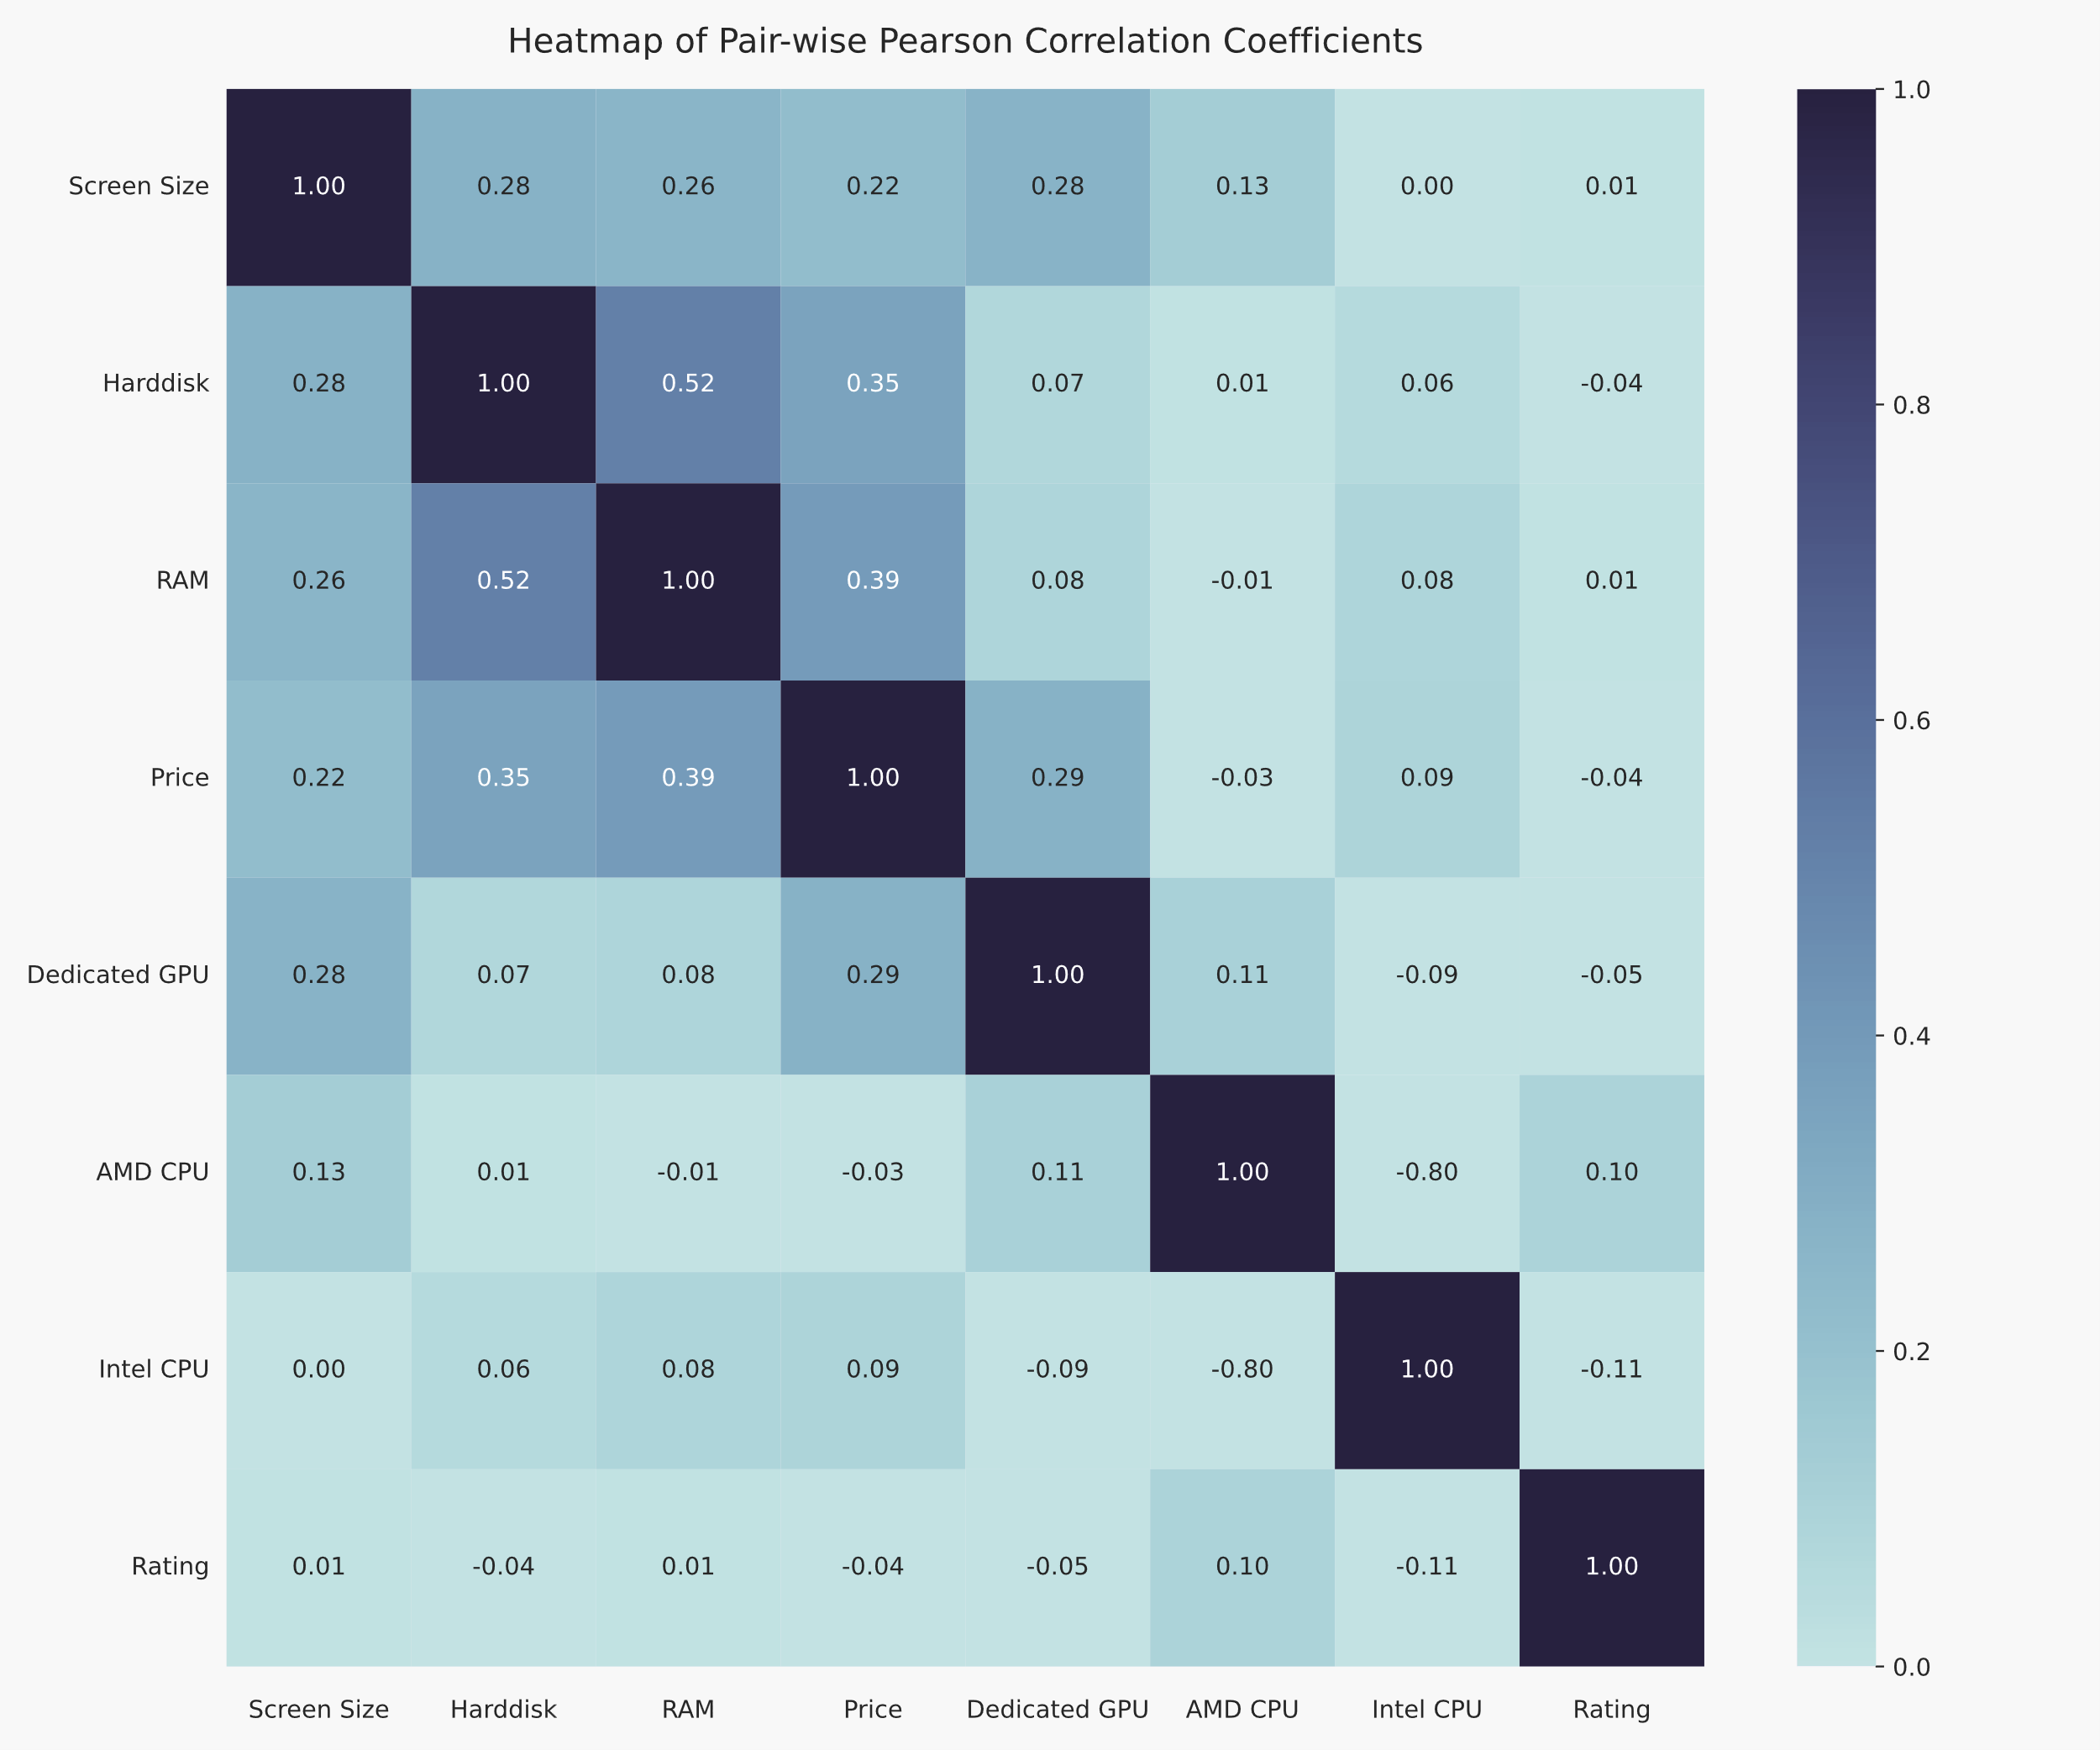

Figure-1: Pearson Correlation Coefficient Matrix

From *Figure-1*, it is clear there are many correlations within the data.

Most notably, RAM and Harddisk have a strong correlation (0.52), and both have a moderate correlation (0.39 and 0.35 respectively) with price. Unsurprisingly, screen size and dedicated GPU have a moderate correlation (0.22 and 0.29 respectively) with price.

Most interesting is the correlation between Dedicated GPU and screen size. This is likely because dedicated GPUs require more cooling and space in the laptop, and therefore have a bigger screen. For customer 2, this suggests they may need an integrated GPU as it would likely have a smaller screen, and hence weight less. This, together with the fact that integrated GPUs consume less power (HP, 2023), implies a bigger battery life.

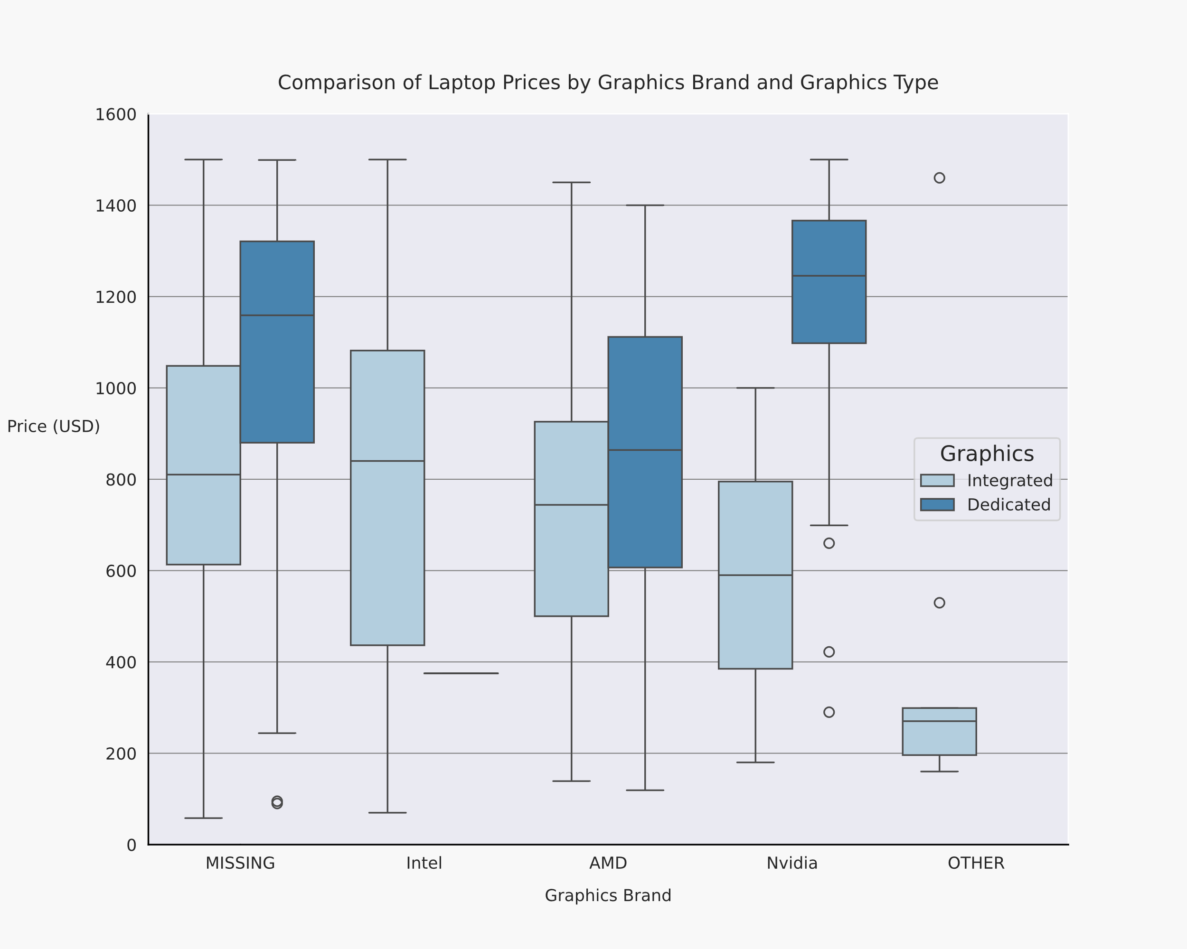

Figure-2: Laptop Prices grouped by Graphics Brand & Type

While not all brands make both dedicated and integrated, the general trend is that laptops with dedicated GPUs are more expensive than integrated. Additionally, Figure-2 shows that laptops with dedicated Nvidia GPUs are more expensive than laptops with dedicated AMD GPUs, and all other GPUs.

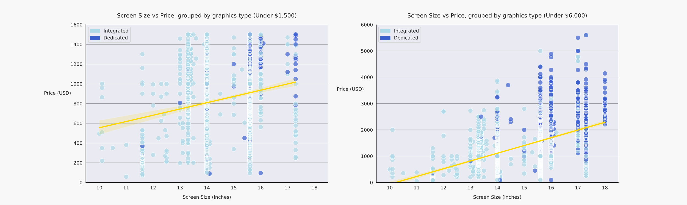

Figure-3: Screen Size vs Price grouped by graphics.

*Figure-3* also shows that dedicated GPUs tend to have larger screens. Within the budget, most dedicated GPUs occur above 15.6inches.

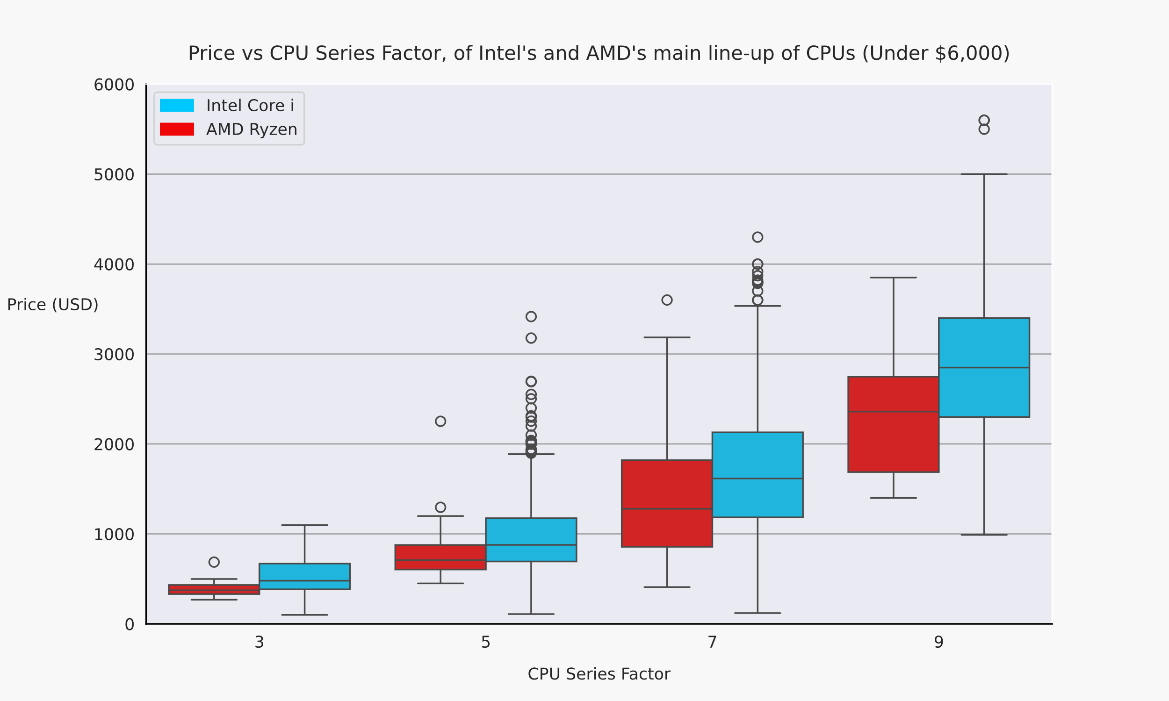

Figure-4: Price vs CPU Series Factor

If we assume CPU series across Intel and AMD are equivalent in performance, an immediate trend is visible, a higher series factor means a higher price. Additionally, at every series factor, the median price of Intel CPUs is higher than AMD CPUs – this matches with the *Figure-1* correlation.

AMD CPUs also have a weak correlation (0.10) with rating (Figure-1). This suggests AMD CPUs are cheaper and higher rated.

Using this analysis and other sources, the following criteria are chosen:

Customer 1:

* Large screen (>15inches) (Microsoft, 2023)
* >32GB RAM (Kingston Technology, 2021),
* >1TB Harddisk
* AMD CPU
* Dedicated GPU

Customer 2:

* > 2TB storage (Donadi, 2022)
* Integrated graphics
* > 16GB RAM (Crucial, 2023)
* Maximum Medium Screen (<15inches) (Microsoft, 2023)

# Figures

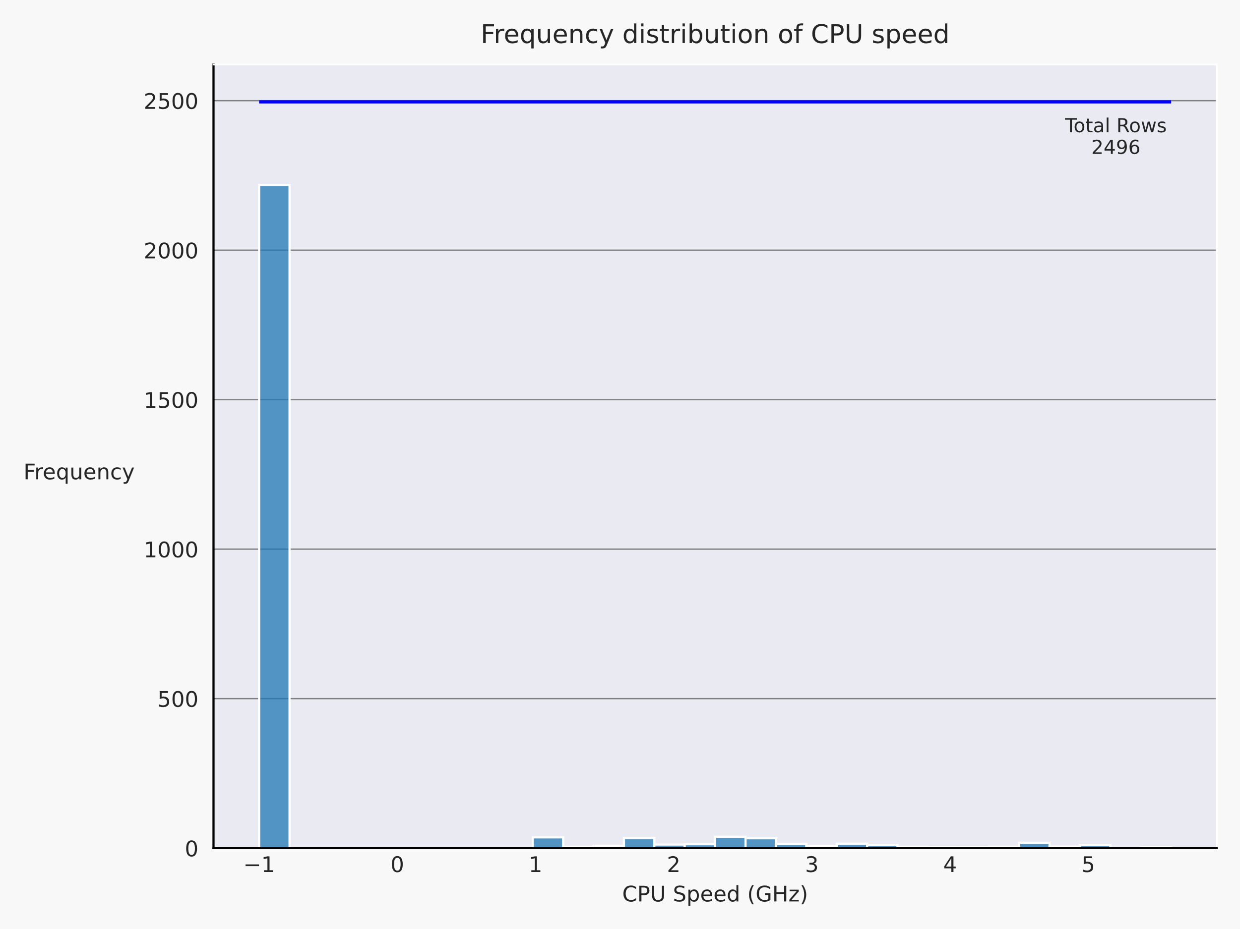

Figure-5: CPU Speed Distribution

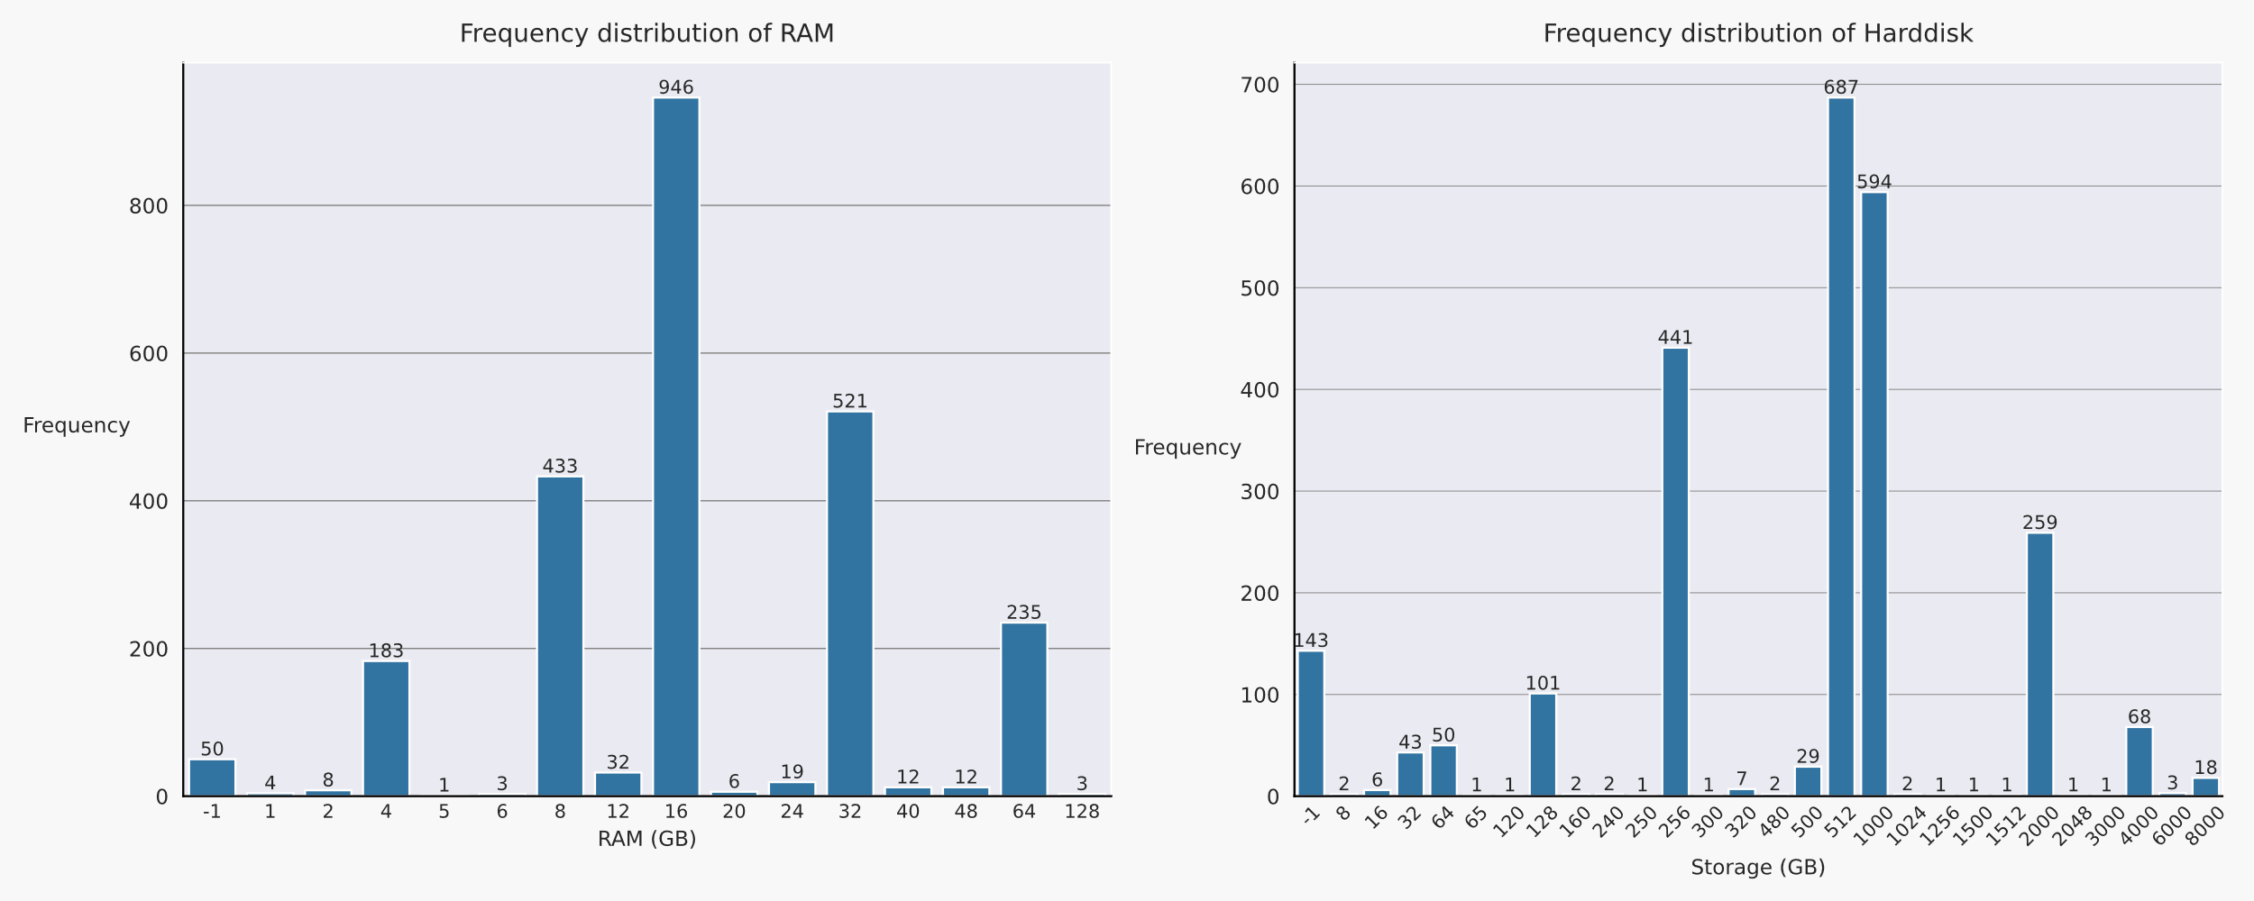

Figure-6: RAM and Harddisk Frequency Distributions

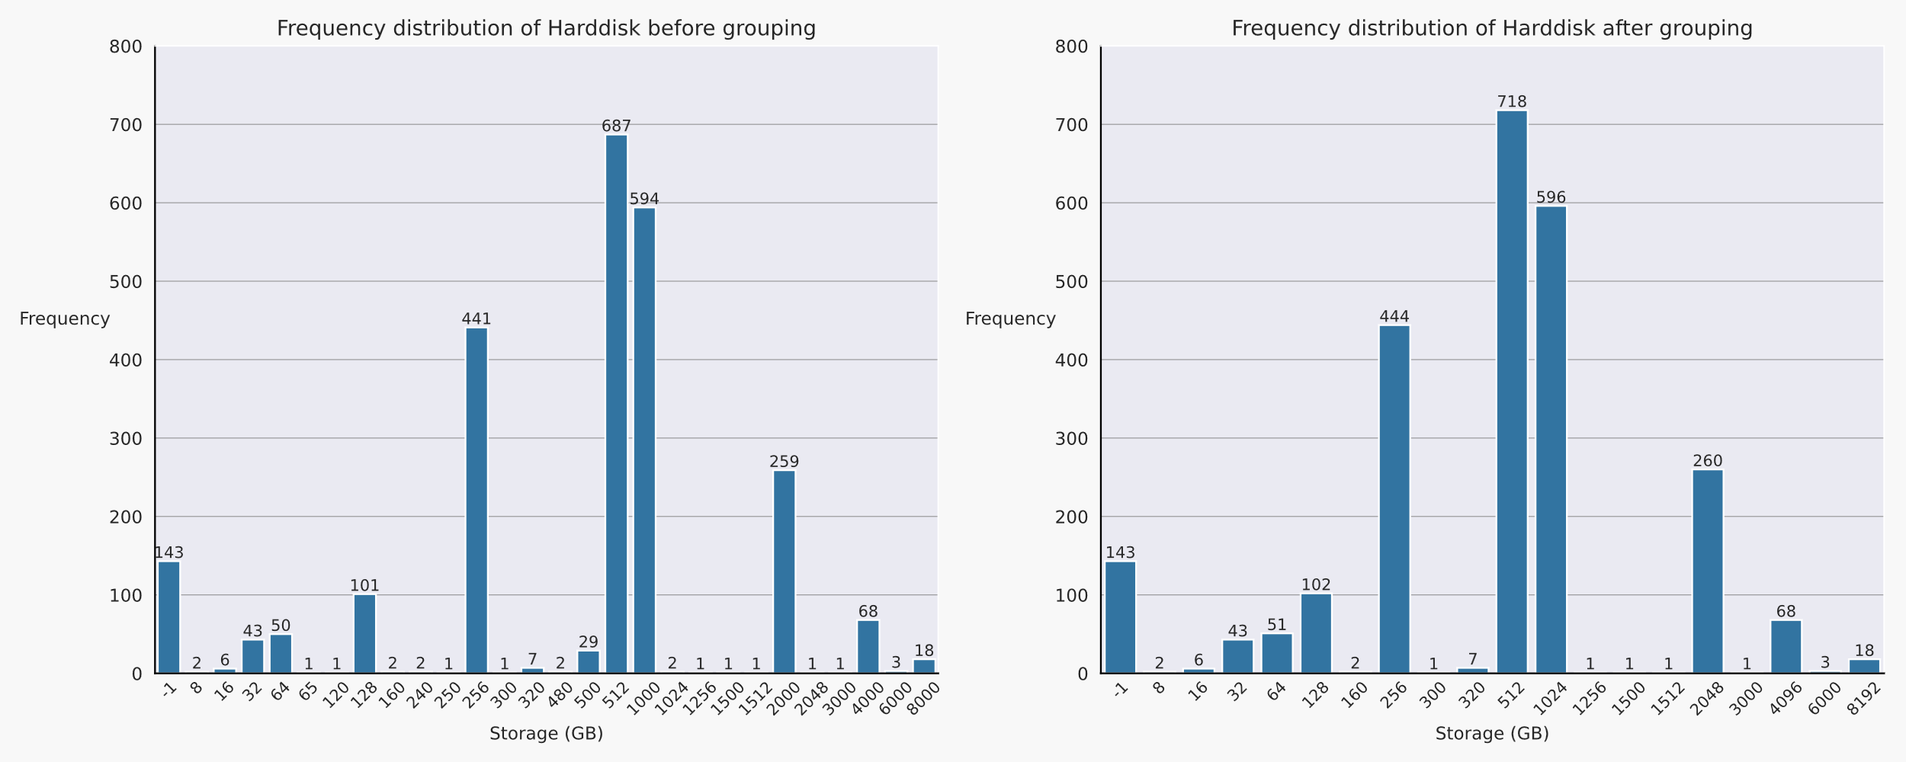

Figure-7: Effects of grouping Harddisk capacity

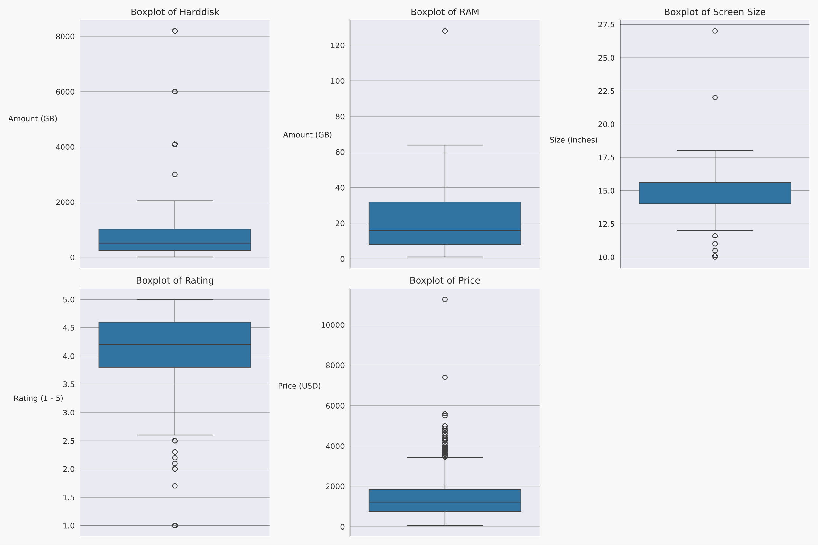

Figure-8: Boxplots of all numerical columns

# Bibliography

Crucial. (2023). *How Much RAM Do You Need For Your Computer Memory?* Retrieved from Crucial by Micron: https://uk.crucial.com/articles/about-memory/how-much-ram-does-my-computer-need

Dhar, A. (2023, October 6). *A Comprehensive Guide to Data Cleaning Techniques.* Retrieved from Medium: https://medium.com/@abhishiktadhar111/a-comprehensive-guide-to-data-cleaning-techniques-ebb2659c89a7

Donadi, C. (2022, July 18). *How Much Photo Storage Do You Need for Photography*. Retrieved from chrissydonadi: https://chrissydonadi.com/how-much-photo-storage-do-you-need-for-photography/

Elgabry, O. (2019, February 28). *The Ultimate Guide to Data Cleaning.* Retrieved from Medium: https://towardsdatascience.com/the-ultimate-guide-to-data-cleaning-3969843991d4

HP. (2023). *HP Tech Takes: Integrated vs Dedicated Graphics Cards; How to Choose the Best GPU*. (D. Horowitz, Editor) Retrieved from hp.com: https://www.hp.com/ca-en/shop/offer.aspx?p=integrated-vs-dedicated-graphics-cards

Kingston Technology. (2021, March). *How much memory do you need for video editing?* Retrieved from Kingston: https://www.kingston.com/unitedkingdom/en/blog/pc-performance/how-much-memory-needed-for-video-editing

Levin, N. (2022, November 23). *8 Largest Laptops By Screen Size.* Retrieved from Largest.org: https://largest.org/technology/laptops-by-screen-size/

Microsoft. (2023, May 30). *How to choose the best laptop screen size*. Retrieved from Microsoft: https://www.microsoft.com/en-us/surface/do-more-with-surface/how-to-choose-the-best-laptop-screen-size

Ngugi, J. (2022, May 21). *Handling Missing Values - Data Science.* Retrieved from Medium: https://medium.com/mlearning-ai/handling-missing-values-data-science-7b8e302264ee

Sundaramurugan, S. (2022, May 25). *Five Golden Rules for Cleaning Data in Power BI.* Retrieved from Medium: https://swaathi317.medium.com/five-golden-rules-for-cleaning-data-in-power-bi-a50ed37dda54