**Networks Assignment**

Michal Pluta

Word count: 611

# **Question 1**

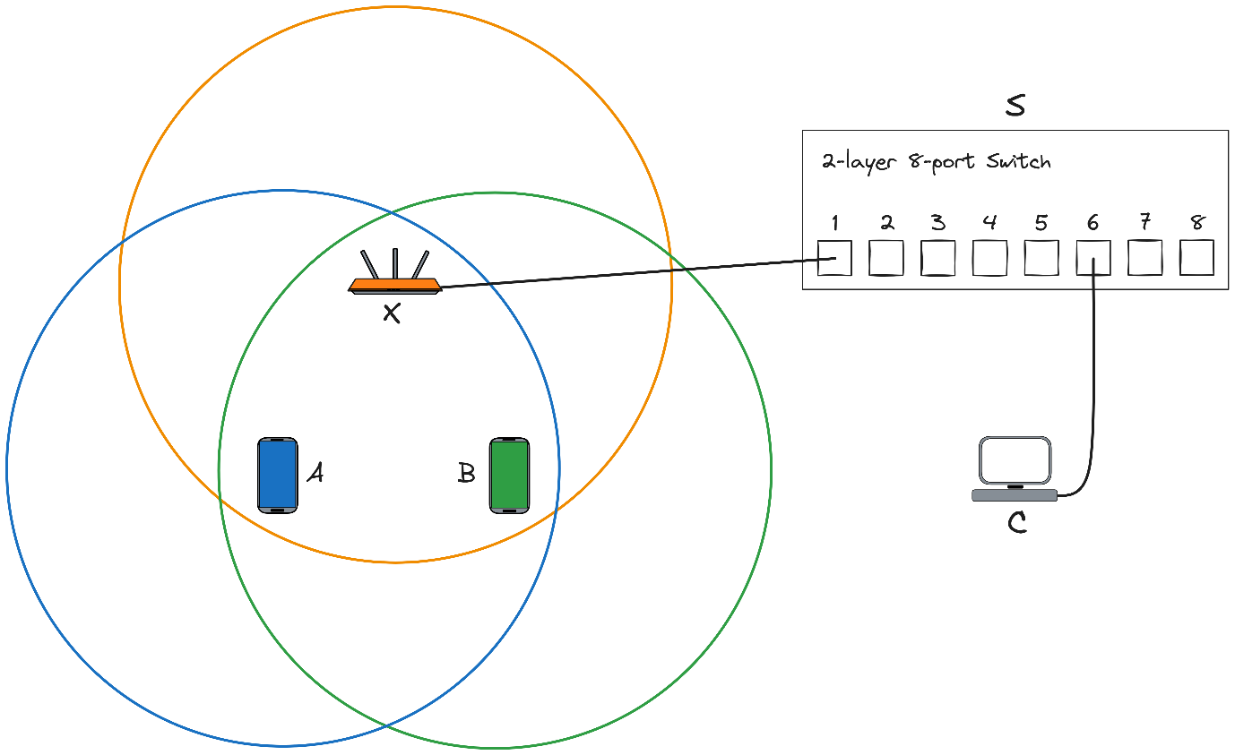

# **Question 2**

When device C sends the frame, the frame is first received by device S (the switch) through the wired connection. Since the switch has been cold-started, it does not have any entries in its switching table and so it broadcasts the frame to every connected device excluding device C. This means it forwards the frame to device X, the Wireless Access Point (WAP) and the WAP broadcasts the frame to all wireless devices, A and B.

Hence, all the devices (S, X, A, and B) receive the frame.

# **Question 3**

Above is a communication timeline for this specific scenario.

At t=0µs, C begins transmitting its frame for a duration of 50µs and finishes transmitting at 50 µs.

During this time, device A attempts DIFS 3 separate times at t=20µs, 30µs, 40µs, but finds the channel busy and backs off for 10µs each time. At t=50µs, device A attempts DIFS and successfully acquires the channel, beginning the transmission of its frame at **t=55µs**.

Similarly to device A, device B also attempts DIFS at t=40µs, but senses the channel is busy and backs off for 12µs. It reattempts DIFS at t=52µs, however since device A began its DIFS at t=50µs (2µs earlier), device A is the one that acquires the channel. Device B senses this in its DIFS at t=55µs, and immediately backs off for another 12µs.

While device A is sending its frame for a duration of 60µs, device B reattempts DIFS 4 separate times at t=67µs, 79µs, 91µs, 103µs, backing off for 12µs each time. At t=115µs, device A finishes sending its frame and coincidentally, device B initiates its DIFS. It successfully acquires the channel at **t=120µs** and starts sending its frame. It ends its transmission at t=200µs.

# **Question 4**

Initially, since the switch is cold started, its switching table contains no entries.

At t=0µs, device C begins transmitting their frame to some device connected to the WAP. The switch takes note of the source MAC address (CC-CC-CC-CC-CC-CC) and port (6) from which this frame came from. The switch cannot unicast this frame since its switching table doesn’t contain any devices connected to the WAP, and hence, it broadcasts this frame to all devices except device C. It does this by sending the frame to all the ports except port 6.

At t=55µs, device A begins transmitting their frame to device C. The frame is first sent wirelessly to the WAP and the WAP sends this frame to the switch across its wired connection. The switch takes note of the frame’s source MAC address (AA-AA-AA-AA-AA-AA) and the port (1) from which it came from. The port is 1 because the frame arrived indirectly from device A through the WAP and the WAP is connected to port 1. Since device C is already in the switching table, the switch can unicast the frame directly to device C by sending to port 6.

The switching table remains unchanged until t=120µs. The switching table at **t=60µs** is the rightmost table in the figure above.

# **Question 5**

If you connect a computer to port 2 of S, it will only receive the first frame (sent by device C).

This is because the switch was cold-started, and hence initially its switching table is empty. This means that when C is transmitting its frame, the switch is forced to broadcast the frame to all connected ports (in this case port 1 & 2).

After this first transmission, device C’s MAC address and connected port are stored in the switching table. This means for all subsequent transmissions (A → C and B → C), the switch can directly unicast the frames to C, therefore the computer connected to port 2 won’t receive these frames.