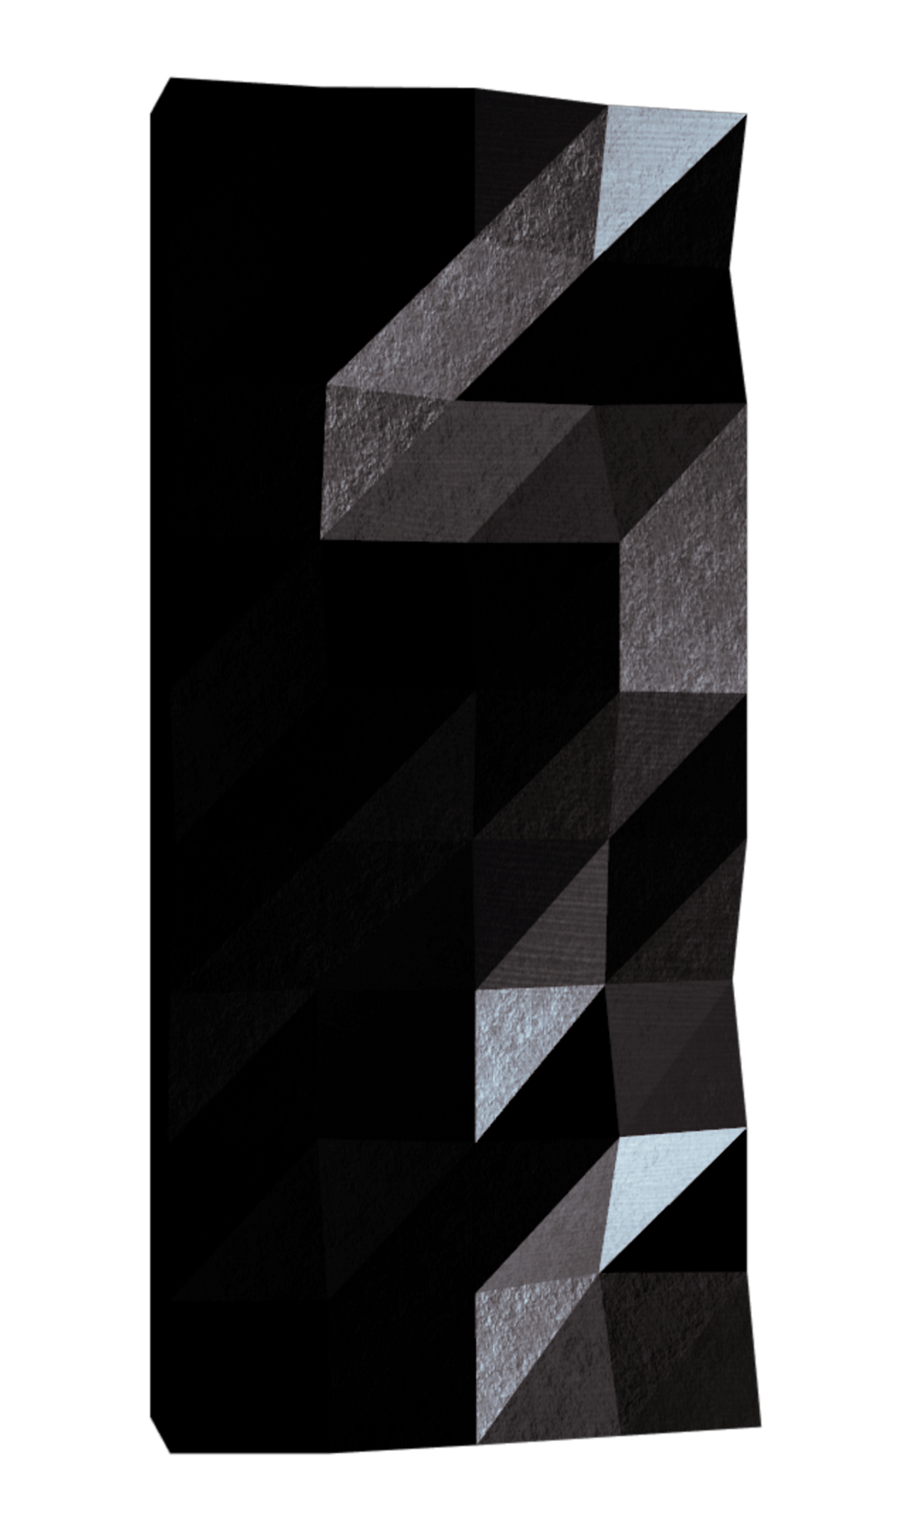
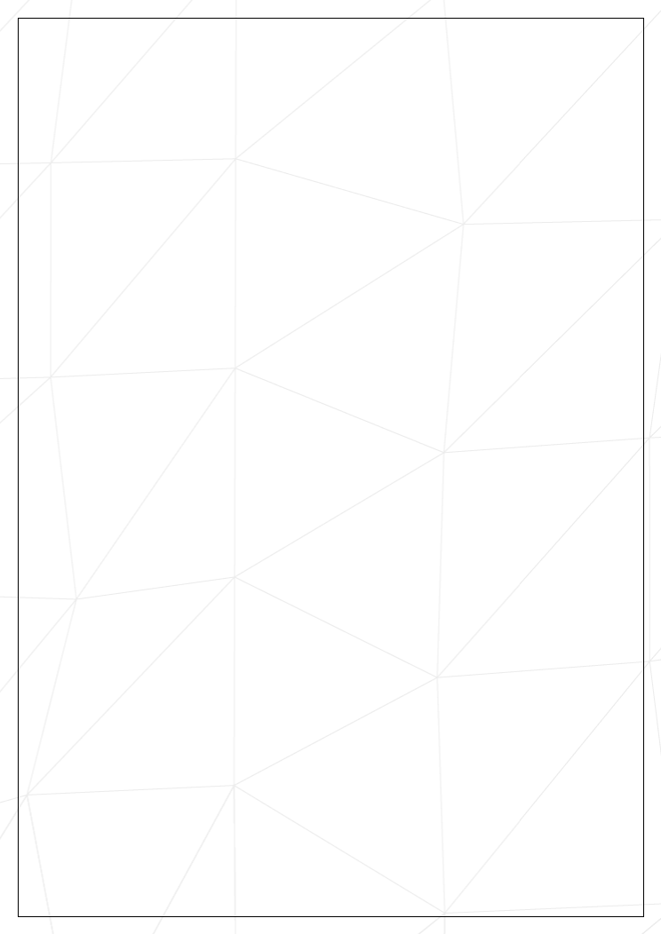
3
Version:
fractals.
This project is about creating graphically beautiful
Summary:
Computer Graphics Fractals
fract’ol
1
10
Submission and peer-evaluation
VII
9
Bonus part
VI
8
.
.
.
.
.
.
.
.
.
.
.
.
.
.
.
.
.
.
.
.
.
.
.
.
.
.
.
Graphic management
V.2
8
.
.
.
.
.
.
.
.
.
.
.
.
.
.
.
.
.
.
.
.
.
.
.
.
.
.
.
.
.
.
.
.
.
Rendering
V.1
7
Mandatory part
V
5
Common Instructions
IV
4
Objectives
III
3
Introduction
II
2
Foreword
I
Contents
2
turing.
and accordingly has no relation to hydraulic frac-
This project is not called fract’oil
was adjusted.
The fluid could be the water, a slurry or a technical fluid whose viscosity
micro porosity.
to increase the macro porosity and less the
under high pressure from a surface drilling,
It is performed by fracturing the rock by a mechanical "stress" using a fluid injected
accessible resources, or which have been exploited at exorbitant costs and slowly.
it made available formerly in-
guided the recent development of the operation of these:
who
mastery of the economic viability of this association for non-conventional deposits,
It is the gradual
newed by its association with horizontal drilling (developed from 1980).
is re-
deposits,
oil
developed for conventional
This relatively old technique (1947),
horizontal.
sloped or
wells,
shale gas) and from vertical
1 km or more than 4 km in the case of
This fracturing can be performed near the surface or at depth (over
and crack the rock.
low permeability by means of injection under high pressure of a fluid to micro-cracking
formations with
geological
The "hydraulic fracturing," is the targeted disruption of
Here’s what Wikipedia has to say on hydraulic fracturing:
Foreword
Chapter I
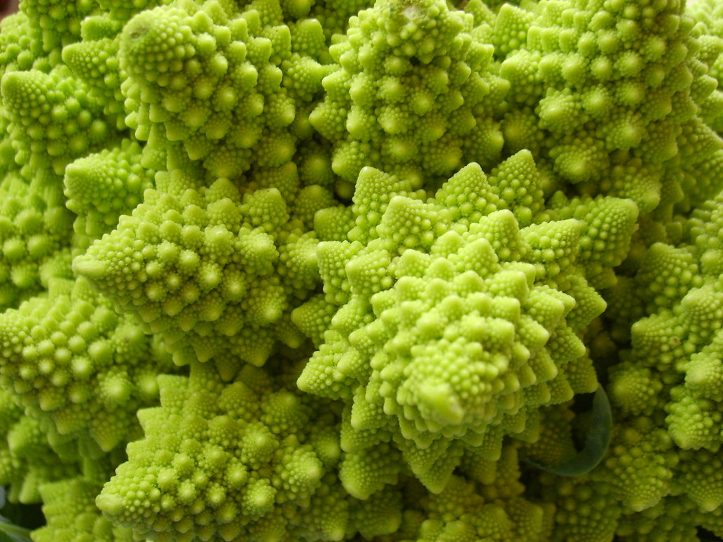
3
Now, it’s your turn to generate some magnificent fractals!
Various natural phenomena – like the romanesco cabbage – have some fractal features.
remains the same at every scale.
A fractal is an abstract mathematical object, like a curve or a surface, which pattern
it on the Latin word fractus which means "broken" or "fractured".
He based
was first used by mathematician Benoit Mandelbrot in 1974.
The term fractal
Introduction
Chapter II
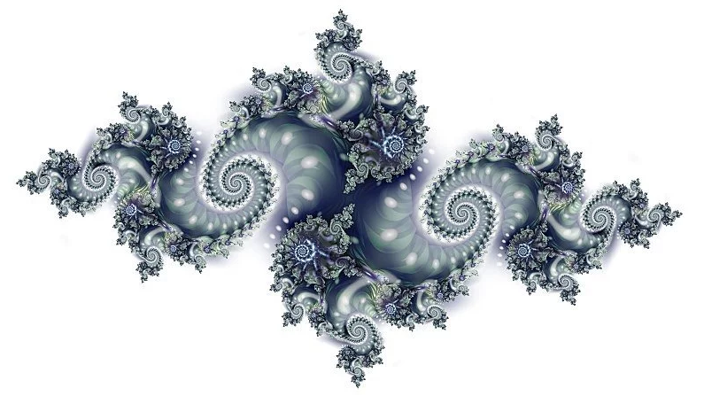
4
Don’t forget to watch the videos on e-learning!
optimization in computer graphics and practice event handling.
complex numbers, to take a peek at the concept of
or use the mathematical notion of
to discover
,
MiniLibX
be the opportunity for you to get familiar with the
This will
and deal with keyboard and mouse events.
developed internally and includes basic necessary tools to open a window, create images
This library was
!
MiniLibX
the
library:
graphical
You are going to use the school
It’s time for you to create a basic computer graphics project!
Objectives
Chapter III
5
If Deepthought is assigned to grade your work, it will be done
tory will be graded.
Only the work in the git reposi-
Submit your work to your assigned git repository.
•
and/or the tests of the peer you are evaluating.
you are free to use your tests
during defence,
Indeed,
during your defence.
useful
You will find those tests especially
to easily test your work and your peers’ work.
It will give you a chance
won’t have to be submitted and won’t be graded.
We encourage you to create test programs for your project even though this work
•
, then compile the project.
Makefile
must compile the library by using its
Makefile
Your project’s
folder with its associated Makefile.
libft
in a
Makefile
associated
you must copy its sources and its
,
libft
your project allows you to use your
If
•
is done separately.
Mandatory and bonus part evaluation
the subject does not specify anything else.
if
_bonus.{c/h}
Bonuses must be in a different file
the main part of the project.
which will add all the various headers, librairies or functions that are forbidden on
to your Makefile,
bonus
To turn in bonuses to your project, you must include a rule
•
.
re
and
fclean
,
clean
,
all
,
$(NAME)
must at least contain the rules
Makefile
Your
•
cc, and your Makefile must not relink.
, use
-Werror
and
-Wextra
,
-Wall
source files to the required output with the flags
compile your
which will
Makefile
you must submit a
the subject requires it,
If
•
will be tolerated.
No leaks
All heap allocated memory space must be properly freed when necessary.
•
during the evaluation.
0
considered non functional and will receive a
be
your project will
this happens,
If
etc) apart from undefined behaviors.
free,
Your functions should not quit unexpectedly (segmentation fault, bus error, double
•
is a norm error inside.
if there
0
files/functions, they are included in the norm check and you will receive a
you have bonus
If
Your project must be written in accordance with the Norm.
•
Your project must be written in C.
•
Common Instructions
Chapter IV
6
Deepthought’s grading, the evaluation will stop.
If an error happens in any section of your work during
after your peer-evaluations.
Computer Graphics Fractals
fract’ol
7
Global variables are forbidden.
•
relink.
It must not
compile your source files.
which will
Makefile
You have to turn in a
•
or installing it using its sources.
. Either the version available on the school machines,
MiniLibX
You must use the
•
Your project must comply with the following rules:
a fractal is.
First, you have to know what
exploration program.
This project is about creating a small fractal
Description
Yes
Libft authorized
YOU coded
ft_printf and any equivalent
•
All functions of the MiniLibX
•
man man 3 math)
library (-lm compiler option,
All functions of the math
•
strerror, exit
malloc, free, perror,
open, close, read, write,
•
External functs.
available
The type of fractal to display and any other option
Arguments
NAME, all, clean, fclean, re
Makefile
Makefile, *.h, *.c
Turn in files
fractol
Program name
Mandatory part
Chapter V
8
is mandatory.
MiniLibX
of the
images
The use of the
•
program in a clean way.
Clicking on the cross on the window’s frame must close the window and quit the
•
must close the window and quit the program in a clean way.
ESC
Pressing
•
dow, minimizing, and so forth).
The management of your window must remain smooth (changing to another win-
•
Your program has to display the image in a window.
•
Graphic management
V.2
better if you hack away on psychedelic effects.
It’s even
each fractal.
You must use at least a few colors to show the depth of
•
a list of available parameters and exits properly.
If no parameter is provided, or if the parameter is invalid, the program displays
◦
You can handle more parameters to use them as rendering options.
◦
displayed in a window.
A parameter is passed on the command line to define what type of fractal will be
•
the program.
You must be able to create different Julia sets by passing different parameters to
•
This is the very principle of fractals.
computer).
the
almost infinitely (within the limits of
zooms in and out,
The mouse wheel
•
Your program must offer the Julia set and the Mandelbrot set.
•
Rendering
V.1
Computer Graphics Fractals
fract’ol
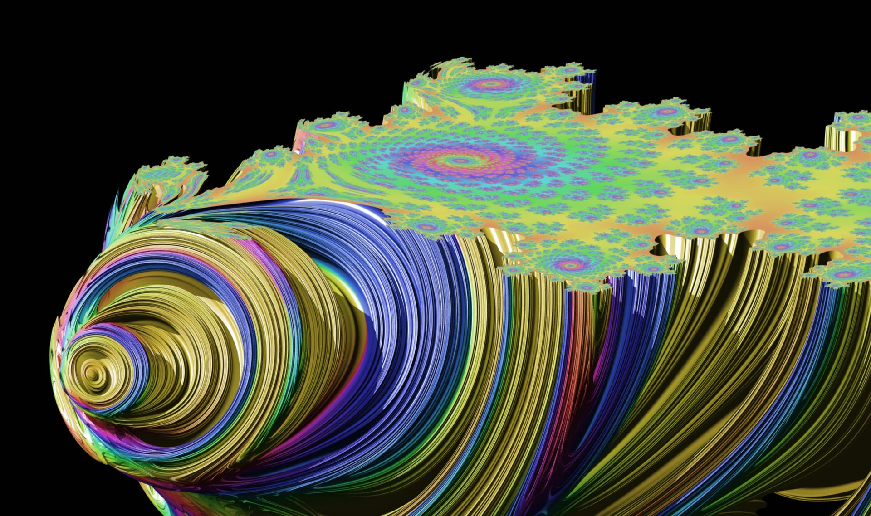
9
mandatory requirements, your bonus part will not be evaluated at all.
If you have not passed ALL the
and works without malfunctioning.
PERFECT. Perfect means the mandatory part has been integrally done
The bonus part will only be assessed if the mandatory part is
Make the color range shift.
•
moving the view by pressing the arrows keys.
In addition to the zoom:
•
The zoom follows the actual mouse position.
•
referenced online).
fractals are
(more than a hundred different types of
One more different fractal
•
You will get some extra points with the following features:
Don’t lose too much time on this assignment!
They are waiting for you!!
be much more interesting graphic projects later.
there will
However,
Usually, you would be encouraged to develop your own original extra features.
Bonus part
Chapter VI
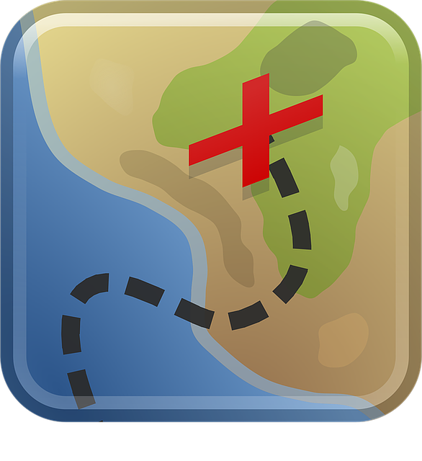
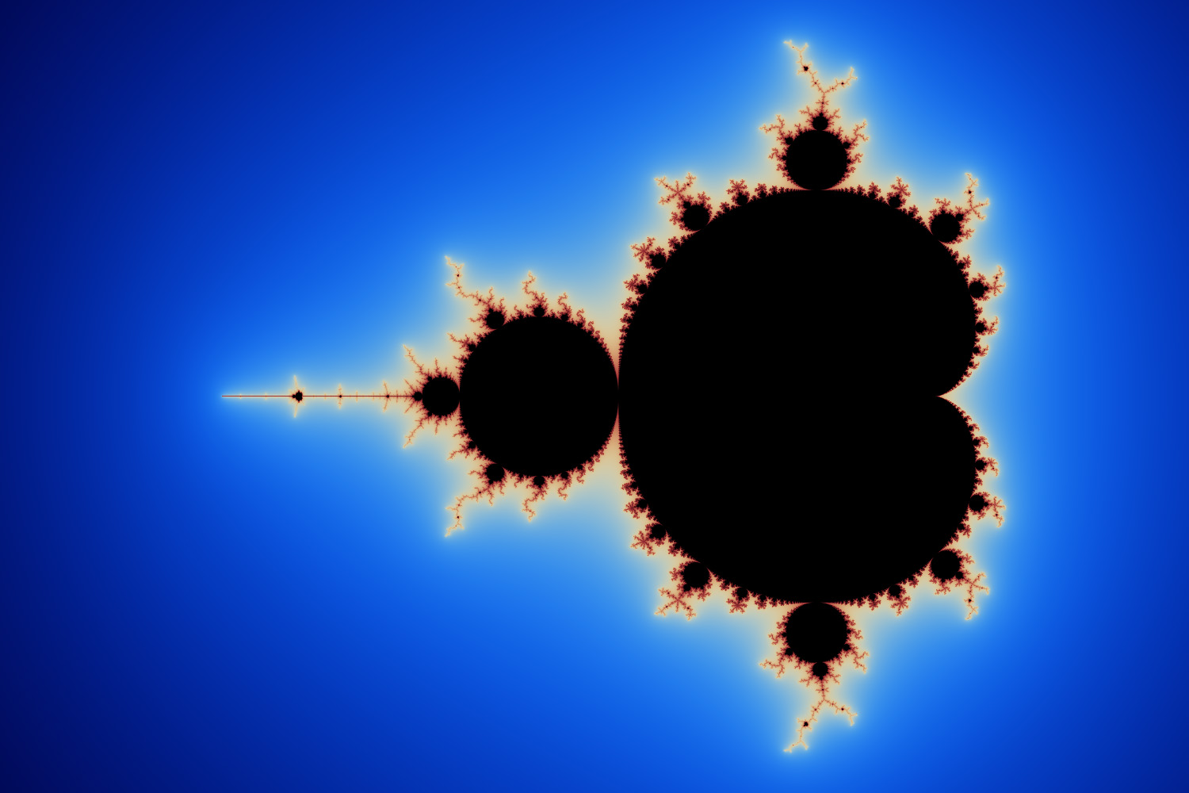
10
QS8mvM8V5xQQpLc6cDCFXDWTiFzZ2H9skYkiJ/DpQtnM/uZ0
file.bfe:VAD2sO2qgbqPEXROeASsmsgnY0o0sDMJev7zFHhw
you wish, as long as you turn in the mandatory files and comply with the requirements.
As these assignments are not verified by a program, feel free to organize your files as
your files to ensure they are correct.
Don’t hesitate to double check the names of
itory will be evaluated during the defense.
Only the work inside your repos-
repository as usual.
Git
Turn in your assignment in your
Submission and peer-evaluation
Chapter VII

