Part 3, progress report, DSI East Capstone

Marc White

My approach is to use as little cryptocurrency data as possible to tell the best story. Currently my challenge is saving all the data to a database, there is no historical social media information that I can find so I need to build my own database. There is no key or Oauth for the API and the limits are quite high. I am saving current coin prices (for the top 10 or so coins) along with their social media scores (aggregated from reddit, twitter, facebook, github, & crypto exchanges)

Second limits:

{"Message":"Total Rate limit second stats","CallsMade":{"Histo":0,"Price":0,"News":0},"CallsLeft":{"Histo":15,"Price":50,"News":15}}

Hour limits:

{"Message":"Total Rate limit hour stats","CallsMade":{"Histo":0,"Price":32,"News":0},"CallsLeft":{"Histo":6000,"Price":149968,"News":30000}}

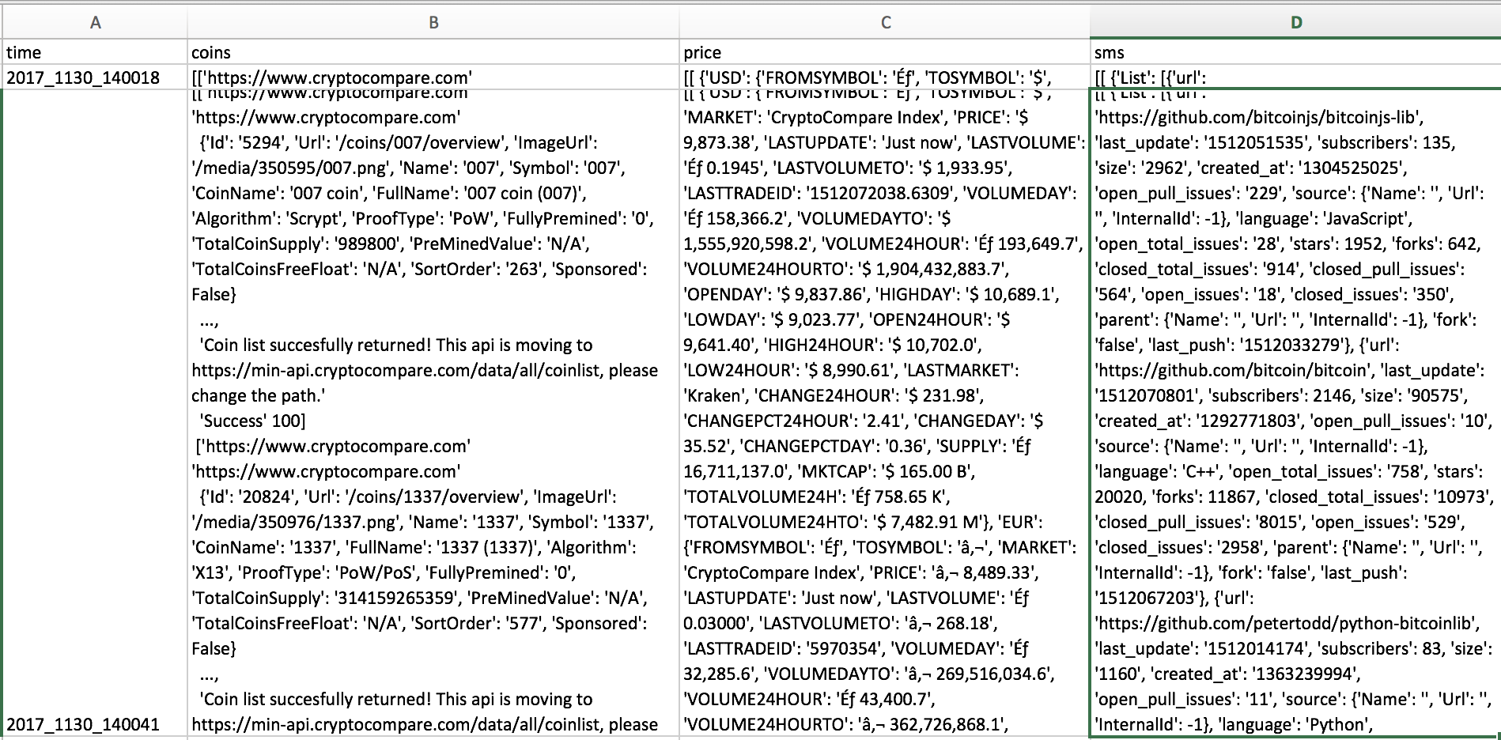

Initial results:

Results have been slow, yet I have already used multiple clustering methods to group coins, Bitcoin & BitcoinCash are always node 1. I will have the database up and being fed data this week. The script is complete, need to refresh my AWS knowledge.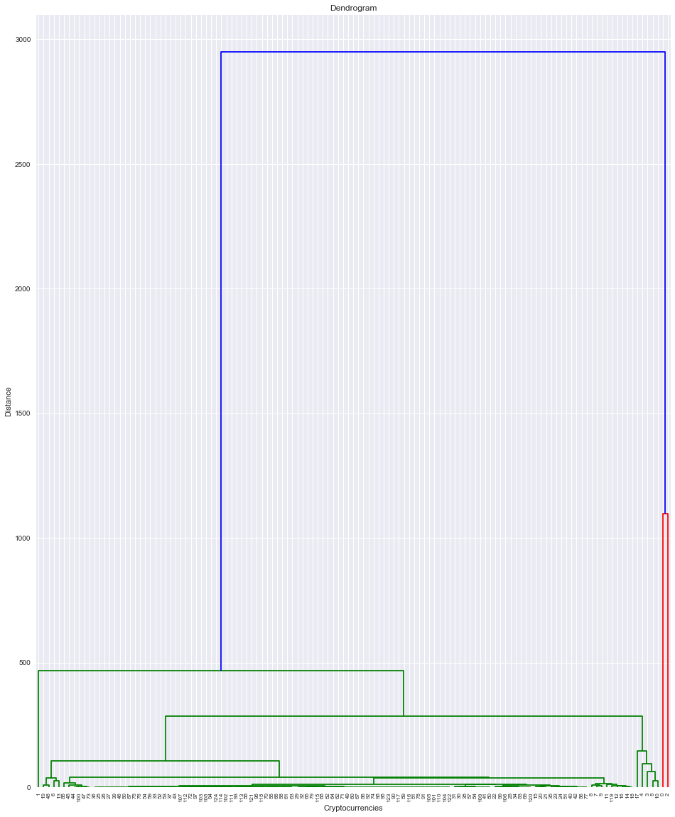

Statistical analysis:

This will be where I need to simplify the most. The current question is simply to compare social media metrics with prices. There is a single aggregate score available that adds and weights metrics from each different site. I may just use the one number.

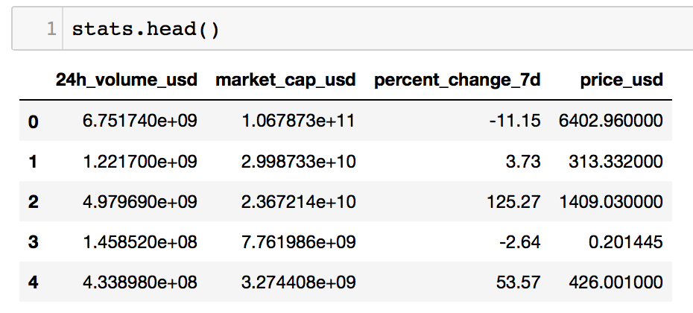

Setbacks or lessons learned so far:

Setbacks are simply the scope of knowledge/skills necessary to complete a project. There more tools you are familiar with the better.