CAS Applied Data Science, University of Bern, S. Haug
Assignment Work Instructions for Module 1
The assignment work for Module 1 is a Conceptual Design Report (CDR) for a Data Science project you would like to perform. Maybe you already know what will be your final CAS project, however, that doesn’t have to be? Please use or orient yourself according to the template below. Remove this page for the submission version. Key information for the report is the following.
Language: English (exceptionally German)
Deadline: To be defined in class
Expected effort and length: About 30 hours, minimum 5 pages. You may work in teams (max 3).
Further formal quality requirements:
- All references must be listed in corresponding Reference section at the end of the CDR and cited with numbers in text
- All tables and figures should have numbered legends with short explanations (tables above, figures below) and be referenced in text (Figure 1: blabla, Table 1: blablabla).
- Figures to be as self explanatory as possible, e.g. plots with at least axis labeling including units.

Mélisande Rappo
melisande.rappo@gmail.com

Data Science Project

Projections of the School-Age Population in Lausanne

Conceptual Design Report

5th of October 2025

Abstract

Understanding how the number of students will change in the city of Lausanne is important for planning schools. The School Services Department needs information about future school populations to organize classrooms, teachers, and school facilities. In this project, we try to predict the number of children in primary and secondary schools using data science methods. We use historical communal data, including births, population changes, migrations, and past school enrollments. First, the data are cleaned, checked, and combined to make one complete dataset. Then, we test different models, including linear regression and some simple machine learning methods, to estimate the number of students in each school level. We also study which variables have the most influence on school population trends. The models are evaluated using metrics like errors and explained variance, and results are shown in tables and charts. This report describes the data, methods, and analysis process. It also gives ideas for future work, for example, testing different scenarios if migration or birth rates change.

Table of Contents

Abstract 1
Table of Contents 2
1 Project Objectives 2
2 Methods 2
3 Data 3
4 Metadata 3
5 Data Quality 3
6 Data Flow 3
7 Data Model 3
8 Documentation 4
9 Risks 4
10 Preliminary Studies 4
11 Conclusions 4
Acknowledgements 4
Statement 4
Appendix X 5
References and Bibliography 5

1 Project Objectives

The main goal of this project is to estimate how many students will attend primary and secondary schools in Lausanne in the next years. This information is very important for the School Services Department to plan classrooms, assign teachers, and organize school buildings properly. We want to predict the number of students for each school cycle and for each year, using the past trends and current demographic data. We will use data about births, population movements, school enrollments, and urban development projects. First, we will clean and combine all this data to make one complete dataset. Then, we will test different models, like linear regression and simple machine learning methods, to forecast the student numbers. The project will produce numbers for each school level and also visualizations, such as plots showing the trends over time. We will also check which factors have the strongest effect on school population, for example migration, birth rates, or new housing projects. At the end, the goal is to give the School Services Department clear and usable forecasts, with charts and tables, to help them plan for teachers, classrooms, and school facilities in the future.

2 Methods

In this project, we will predict the number of students in Lausanne schools using data science methods. We will use Google Colab for cloud development, and also local Python installations on private machines with Visual Studio Code and Anaconda. This allows flexibility to test models and work with notebooks easily. Python will be the main programming language. For data work, we will use pandas and numpy. For charts and visualizations, we will use matplotlib and seaborn. For predictions, we will use scikit-learn to build models like linear regression and other simple machine learning methods. We may also use basic time-series models if we see seasonal patterns in school enrollments. The workflow will start with cleaning and combining data from different sources: historical school enrollments, population statistics, births, and urban development projects. We will also check which variables have the strongest effect on student numbers. Models will be evaluated using metrics like mean absolute error, RMSE, and R².Finally, results will be shown in tables and plots to make trends clear. Some methods may change during the project, but the goal is to provide clear and useful forecasts for the School Services Department.

3 Data
For this project, we will use several datasets. The main data sources are:
- Historical school enrollments from the city of Lausanne, including the number of students by school cycle and year.
- Population statistics and demographic data from the city of Lausanne, including birth records, migration, and population by age.
- Urban development projects data from the city of Lausanne, including information about new housing and school facilities.
4 graphes
Evolution population en âge scolaire (1-6, 7-8, 9-11, 7-11)

Mouvements (Arrivées, départs, naissances, décès)
Evolution du parc locatif
Projections population
Projections parc locatif
All data are stored securely and personal identifiers will not be used in the analysis. Only aggregated numbers will be processed. By exploring and visualizing the data first, we can better understand the trends and prepare it for modeling, ensuring the forecasts are reliable and interpretable.
Comment sont construites les données
Which data will be used (with references) 0.5-1.0 page
A couple of plots, maybe some histograms of the columns
A couple table row as an example maybe
Projections de poplluation de stat vd
Security issues etc (see data management plan, you may attach a SNSF data management plan for your data).

4 Metadata
What metadata is required for reproducing your analysis?
Where do you store the metadata, how can people access it?

5 Data Quality
What are the quality requirements you need in order to meet your project objectives (data size, data precision missing values, ….)?
Are they met? If not, do you expect a significant impact on your result?
Any measures to improve the data quality?

6 Data Flow
Explain with a figure and words how the data flow of your project will be, from the data source to the final plots and numbers.
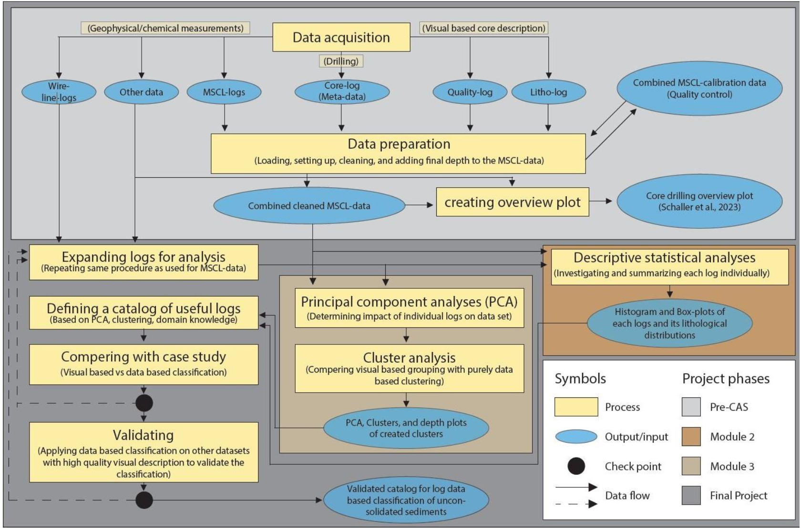
Figure X: A quite complex and detailed data flow diagram.

7 Data Model
Draw and explain your data model at the conceptual level, the logical level and the physical level. .
Conceptual
Logical (what columns/features will you use/need)
Physical (infrastructure needs)

8 Documentation
How will the project be documented?

9 Risks
What can go wrong?
When this and that goes wrong, what counter measures do you have?
What will be the impact on the quality of the aimed output, project time schedule, project cost ?

10 Preliminary Studies
Plots and numbers (from Module 2).

11 Conclusions
….

Acknowledgements
Acknowledge persons or institutions that helped you with the CDR here.

Statement
The following part is mandatory and must be signed by the author or authors.
„Ich erkläre hiermit, dass ich diese Arbeit selbstständig verfasst und keine anderen als die angegebenen Quellen benutzt habe. Alle Stellen, die wörtlich oder sinngemäss aus Quellen entnommen wurden, habe ich als solche gekennzeichnet. Mir ist bekannt, dass andernfalls die Arbeit als nicht erfüllt bewertet wird und dass die Universitätsleitung bzw. der Senat zum Entzug des aufgrund dieser Arbeit verliehenen Abschlusses bzw. Titels berechtigt ist. Für die Zwecke der Begutachtung und der Überprüfung der Einhaltung der Selbstständigkeitserklärung bzw. der Reglemente betreffend Plagiate erteile ich der Universität Bern das Recht, die dazu erforderlichen Personendaten zu bearbeiten und Nutzungshandlungen vorzunehmen, insbesondere die schriftliche Arbeit zu vervielfältigen und dauerhaft in einer Datenbank zu speichern sowie diese zur Überprüfung von Arbeiten Dritter zu verwenden oder hierzu zur Verfügung zu stellen.“
Date: Signature(s):

Appendix X
If you have something to attach to your report, do it here.

References and Bibliography
Please number any information source you used in the report with corresponding links here [1]:
[1] S. Haug et al., How to make a CDR, own brain, 2020 (put a weblink or DOI here)
[2]

