July 30th

1- TLDR
I closed the loop: trained actual students under each curriculum and measured test performance, which is the bar chart Eugene drew on the board. It took me three broken experiment designs to get one that says anything (notes below). Result is sharper than expected: whether the whole thing works comes down to one condition. If the solver estimates the hardest level's ceiling as exactly 0, the student ends at 0% on that level, 24 runs out of 24. If the estimate is anything above 0, the student ends between 94 and 100, 36 out of 36. Guided MCTS curriculum vs the exact oracle curriculum: 99.5 vs 100.

2- Why this experiment
- last week's result stops at the generator's distribution. A skeptic (or Eugene) can say: the distribution is off, fine, but maybe the student comes out ok anyway
- the board sketch from our meeting is exactly the missing plot: test performance under curriculum, method 1 vs method 2, next to max min E[J(pi) - J(pi*(c))]
- so: estimate the ceiling with each solver -> regret drives the curriculum -> train a student -> score it against the exact optimum. The only thing that changes between methods is where V* comes from.

3- Three designs that did NOT work first
- attempt 1: 9x9 mazes, 2000 episodes, 10% uniform floor on the generator. Every method ended at worst level 1.00, including the bad ones. Two problems at once: the budget was so generous that a lr-1 tabular student masters everything anyway, and the floor was doing the curriculum's job (10% of episodes go everywhere no matter what the generator thinks). Nothing to compare. (bottom line: a floor plus a fat budget can hide a completely broken regret signal, which is itself worth remembering)
- attempt 2: dropped the floor, tightened the budget, still almost everything at 1.00. Took me a while to find it: my code reset the generator to uniform whenever total regret hit zero. So the misled generators would master their believed levels, see zero regret, fall back to uniform, and accidentally train the starved levels for the remaining 90 rounds. A regret maximizer with zero gradient stays put. Fixed that (frozen generator on zero signal) and the starvation finally showed.
- attempt 3 problem: at 9x9 the levels are too easy for starvation to cost anything, the student stumbles into every goal by random walk. Moved to 13x13, goals at distance 2/5/8/11/14, and this time I measured first (calibrate.py): random walk reaches the distance-14 goal in 0.7 to 2.3% of episodes on the actual experiment mazes, and at B=16000 the guided solver has every ceiling within 0.12 while PPO and vanilla UCT report the distance-14 ceiling as literally 0. That is the regime to test in.
- then one more scare after the first full run: I noticed I was reading guided MCTS out by its internal value but vanilla MCTS by a greedy rollout. Two different estimands, so the comparison was skewed. Checked whether vanilla's total failure was an artifact of my readout choice. It partly was -> added a sixth method, the same vanilla search read out by its root value, and re-ran the whole grid with fresh seeds. Caught before the meeting.

4- Setup that survived
- 13x13 random mazes, level = goal at distance 2/5/8/11/14, 4 mazes x 3 seeds
- six sources for V*: exact oracle (value iteration), guided MCTS, PPO-style REINFORCE, vanilla UCT with greedy-rollout readout, vanilla UCT with root-value readout, and uniform (no curriculum)
- everything else shared: tabular Q-learning student (lr 1, deterministic env, eps 0.2), p proportional to clipped regret, generator frozen on zero total regret, 1800 episodes
- the student's own value is computed exactly by policy evaluation, so the ceiling estimate is the only estimated quantity in the loop

5- Results
ceiling source | worst level | mean
exact oracle | 100.0 (12/12 at 100) | 100.0
guided MCTS | 99.5 (11/12) | 99.9
vanilla MCTS, root readout | 90.7 (9/12) | 98.1
uniform | 83.3 (10/12) | 96.7
PPO (REINFORCE) | 8.3 (1/12) | 76.7
vanilla MCTS, greedy readout | 0.0 (0/12) | 61.7
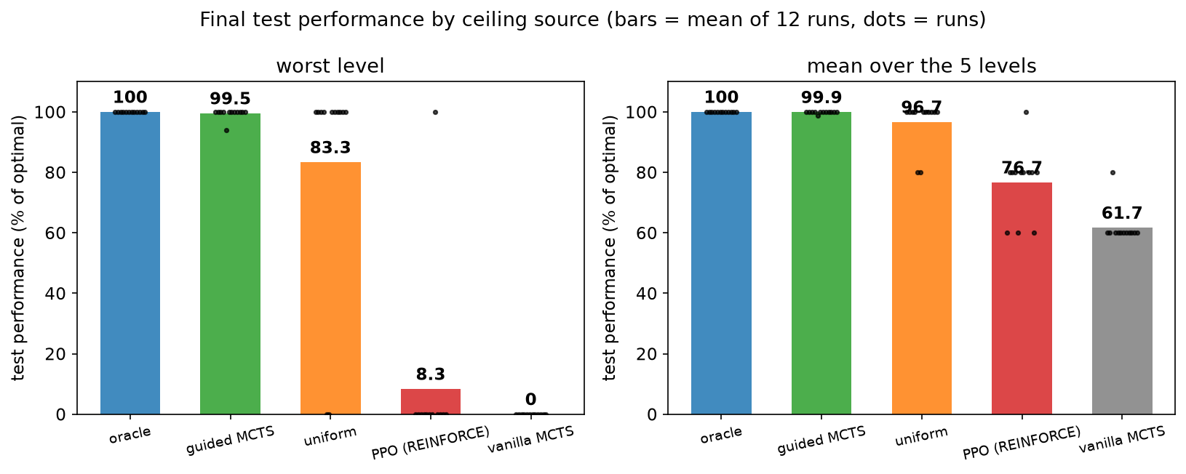
fig_test_performance.png
- the split is on one condition. I pooled the 60 non-uniform runs (five V* sources x 12) and split them by "did the solver report the distance-14 ceiling as exactly 0". Zero: 24/24 runs end at 0 on that level. Nonzero: 36/36 end at 94 to 100, nothing in between.
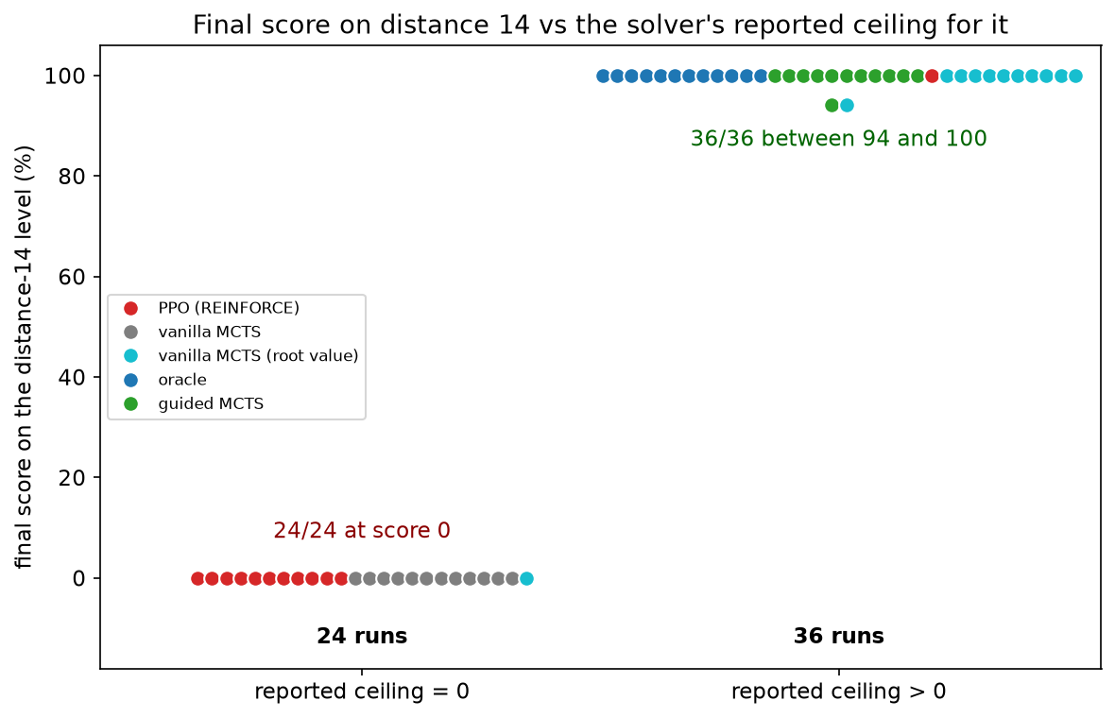
fig_knife_edge.png
- mechanically obvious once you see it: reported ceiling 0 -> clipped regret 0 -> sampling probability 0, at every round, and the frozen generator never comes back. The failure is silent, no crash, and it is worse than not having a curriculum at all (uniform saves 10 of 12).
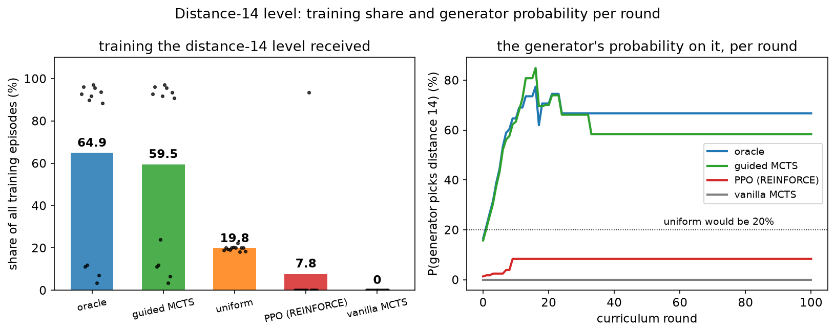
fig_hardest_level.png
- the readout ablation. Same vanilla search, greedy rollout says 0.000 -> total failure; root value says about 0.003, which is off from the true 0.673 by two orders of magnitude, and it recovers to 90.7. Because once the easy levels are mastered their regret clips away and whatever tiny regret is left dominates the distribution. Support first, accuracy second.
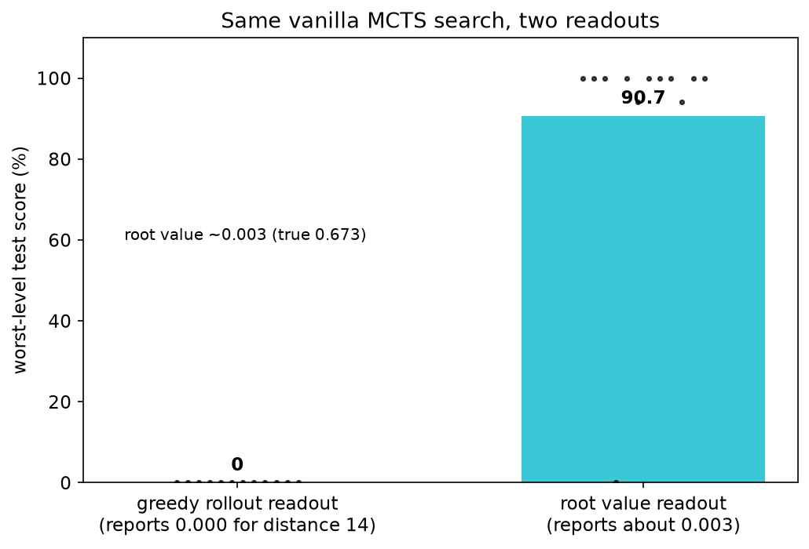
fig_readout.png
- PPO is the same story from the other side: 11 of its 12 runs report 0 for distance 14 and fail; the one run that happened to report 0.63 recovered fully. The same split inside one method.
- speed, the smaller claim: informed curricula cross 80% around 23k env steps, uniform needs 38k and 2 of its 12 runs never master distance 14 at all.
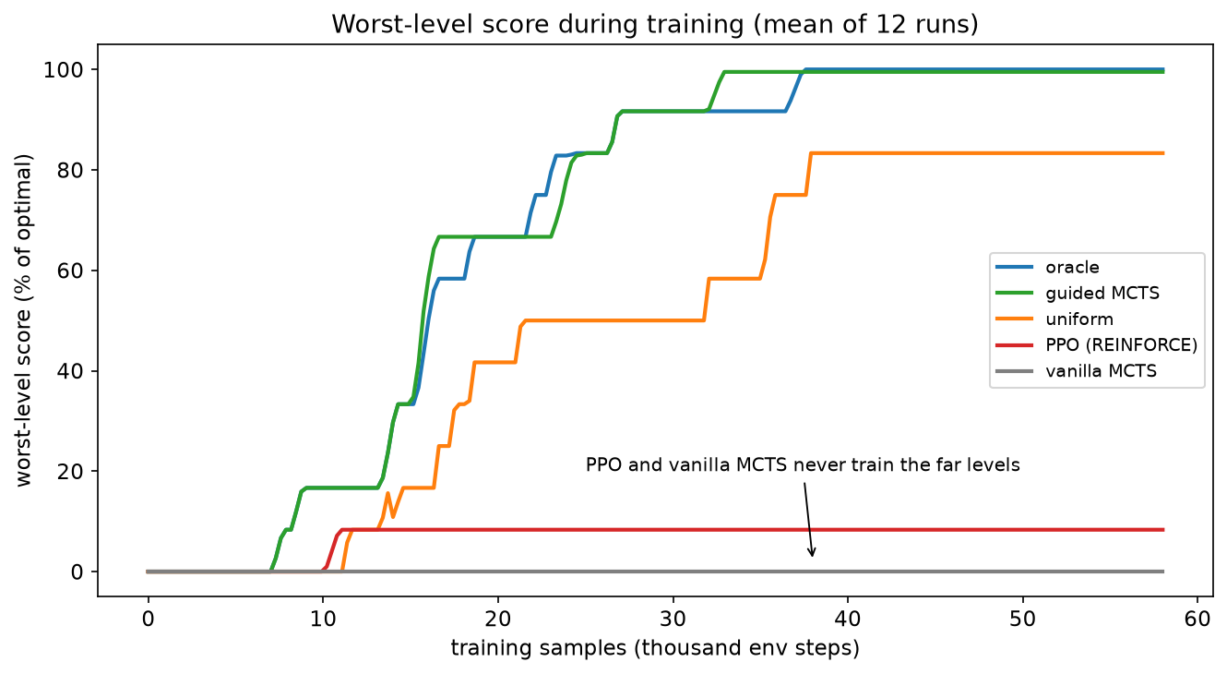
fig_learning_curves.png

6- The 94.1 run
Guided's single sub-100 run bugged me until the number clicked: 0.97^2 = 0.941. The student found a path two steps longer than optimal, the estimated ceiling on that maze was slightly low (0.633 vs 0.673), the student's detour value beat the false ceiling, so regret clipped to 0 and training stopped with the detour frozen in. That is the exact cost of an underestimate: the curriculum stops at the first policy that beats the false ceiling. The oracle never stops early. The tabular student hides most of this cost because it masters a level almost in one jump; with a value network the cap should bind much harder. That is my concrete prediction for the jaxued version and I want to test it.

7- Numbers that did not survive
- "informed curricula are 2x more sample-efficient than uniform": does not hold on the env-step axis, it is 1.6x at the 80% crossing and part of that gap is uniform's two failed runs dragging its mean.
- a correlation plot of ceiling error vs outcome (corr -0.91): the root readout has the largest error of all solvers and recovers anyway, so error magnitude is the wrong axis. Dropped it.
- "the floor does not matter": re-ran everything with a forced 10% floor. Greedy-readout methods still fail 23 of 24. Stray episodes do not master a 1%-success level; only a nonzero estimate brings it back on the curriculum.

8- For the paper
- panel one (last week): the solver decides whether the generator finds the right curriculum, and at what compute
- panel two (this week): what the student ends up able to do is set by the curriculum, and the estimate has to keep every learnable level in play; accuracy is second order
- the thesis now runs end to end with an exact oracle at both ends: regret estimate -> curriculum -> final agent

Next
- jaxued Maze + PAIRED, value network instead of the tabular value, test the false-ceiling prediction from section 6
- then partners instead of goals, back in Overcooked, where the inner best-response is the part the solver owns

End of July 30th

