Nama : Muhammad Rizqi

NIM : 21/478592/TK/52739

**Bukti Pengerjaan Responsi Junior Project**

1. **ERD Database**

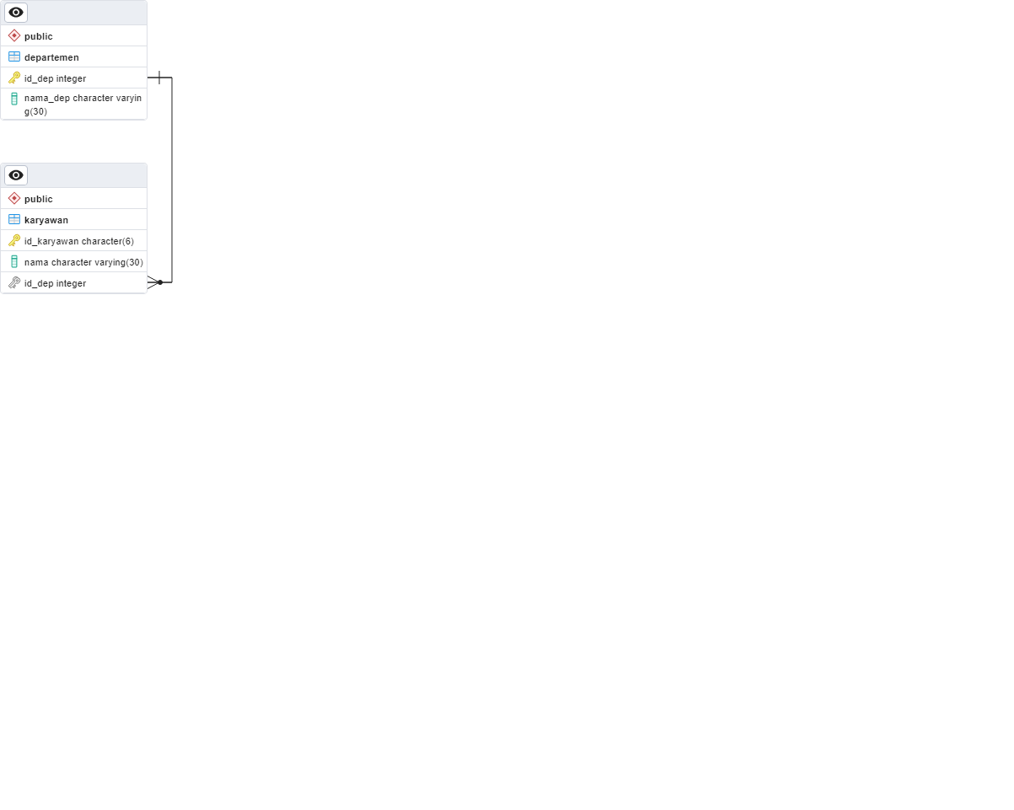

1. **Tampilan Aplikasi**
   1. **Read**

* 1. **Insert**

* 1. **Update**

* 1. **Delete**