Part 1 Figure Illustration:
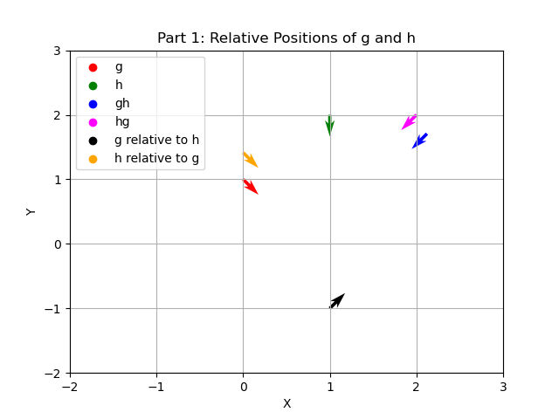

Part 2 Figure Illustration:
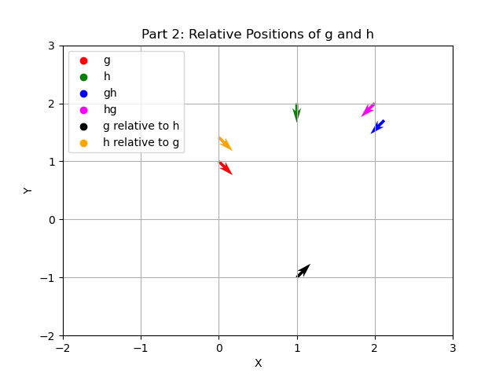

Part 3 Figure Illustration – The relative positions are overlaid:
