ME623: Dynamics of Machining Processes
Chatter Detection in Turning Operations
using Supervised Machine Learning
A Physics-Informed Labeling Approach
Project Report
Group 7
Raghav Kapoor | 230103081
Saket Mehla | 230103087
Indian Institute of Technology Guwahati
Department of Mechanical Engineering

1. Executive Summary
This project builds a complete, data-driven pipeline to detect chatter -- a self-excited vibration between the cutting tool and workpiece -- from cutting-force signals recorded during single-point turning. The pipeline automatically isolates genuine cutting data from no-load idle time in every recording, extracts a broad bank of time- and frequency-domain features, and trains supervised classifiers to distinguish chatter from stable cutting.
The central contribution of this iteration of the project is the chatter label itself. A simple, common approach -- labeling the top 15% of windows by FFT-peak amplitude as "chatter" -- was replaced with a physics-informed label built from three criteria drawn directly from the machining-dynamics literature: (1) an amplitude ratio comparing each window's dominant frequency peak against the strongest expected forced-vibration harmonic in that same window, (2) exclusion of windows whose peak is itself a spindle-rotation harmonic (forced vibration, not chatter), and (3) a persistence requirement across consecutive overlapping windows, reflecting chatter's self-excited, growing character. This label produces a substantially cleaner, more physically consistent relationship between chatter likelihood and depth of cut than the naive percentile rule, and models trained on it achieve precision 0.89, recall 0.97, and F2 0.95 under file-grouped cross-validation -- a large improvement that is investigated and explained rather than simply reported, including a deliberate check for and correction of a feature/label overlap issue that would otherwise have inflated these numbers further.
The report documents the full methodology end to end: data cleaning and engagement detection, feature engineering, an ablation study validating the need for engagement detection, a literature review motivating the improved label, the label's implementation and validation, model selection using an F2 score that reflects the real cost asymmetry of missed chatter versus false alarms, and a resulting stability diagram for process planning. Limitations -- chiefly that the label, however improved, is still derived from the same signal used to build the model's features, rather than an independently measured ground truth -- are stated explicitly.

2. Background & Problem Statement
Chatter is a self-excited vibration between the cutting tool and workpiece, driven by the regenerative interaction between the surface left by one pass of the tool and the chip removed on the next. It degrades surface finish, accelerates tool wear, and can cause dimensional inaccuracy and audible instability. Analytical stability-lobe models can predict the onset of chatter from first principles, but require modal parameters (natural frequency, damping, stiffness) that are often unavailable in practice; manual or expert monitoring does not scale to continuous production. A data-driven approach -- extracting statistical and spectral features from cutting-force signals and training a supervised classifier to recognize chatter -- is a practical alternative, and is the approach this project takes.
A critical practical question for any such approach is where the training labels come from. This dataset, like most machining datasets collected for a course project, was not labeled by an observer at collection time -- there is no record of which specific cuts chattered. The project therefore had to construct a label from the force signal itself. The bulk of the methodological effort described in this report is in building that label as carefully and physically defensibly as possible, since every downstream result depends on it.

3. Experimental Dataset
The dataset consists of 18 single-point turning experiments recorded with a 3-component piezoelectric dynamometer sampled at 10 kHz, measuring feed force (Fx), radial force (Fy) and cutting/tangential force (Fz). Experiments span three spindle speeds and a range of programmed depths of cut (DOC).
Spindle speed | Depths of cut tested (µm) | Files
250 RPM | 200, 400, 600, 800, 1000 | 6
325 RPM | 200, 400, 600, 700, 800 | 5
420 RPM | 100, 200, 600, 700, 800, 900, 1200, 1400 | 7

4. Data Preparation

4.1 Why idle-time segments must be excluded
Every raw file records the dynamometer signal from before the tool touches the workpiece to after it retracts -- the spindle runs for 9-25 seconds (varying by file) before cutting actually starts, and again after it ends. A feature-extraction loop that simply runs across the entire file would treat this no-load noise as real machining data.
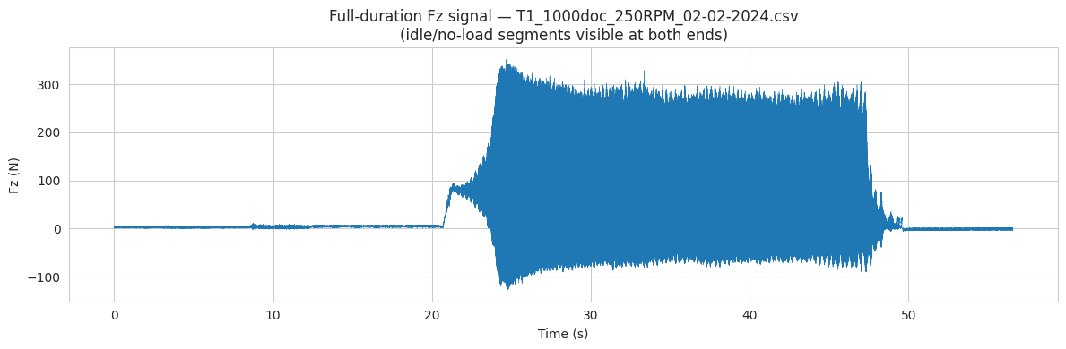
Figure 1. Full-duration cutting force (Fz) for one file, showing idle segments before and after the engaged cutting region.

4.2 Automatic, per-file engagement detection
Because idle duration is not constant across files, a fixed "skip N seconds" rule cannot work for all of them. An automatic detector instead: computes resultant-force RMS in 0.5 s windows; estimates a per-file idle baseline from the first 2 seconds; flags a window as engaged once RMS exceeds baseline x5 + 5N sustained for at least 1 second; scans forward for onset and backward for disengagement; and trims a 0.5 s guard band off both boundaries to exclude the ramp transition itself.
A second, independent check guards against a piezoelectric charge-drift artifact: after a very large force transient, a charge-based dynamometer can settle at a new, non-zero apparent zero rather than returning to true idle -- a magnitude-only detector would mistake this for continued heavy cutting. The detector separately tracks the fluctuation (AC) component of the signal; if a window's fluctuation was genuinely elevated at some point and then collapses to near-idle levels while the magnitude stays non-idle, that segment is trimmed as drift, not cutting. One file (the heaviest cut, 1400 µm DOC) was affected and correctly trimmed; the other 16 engaged files were verified unaffected by this additional check.
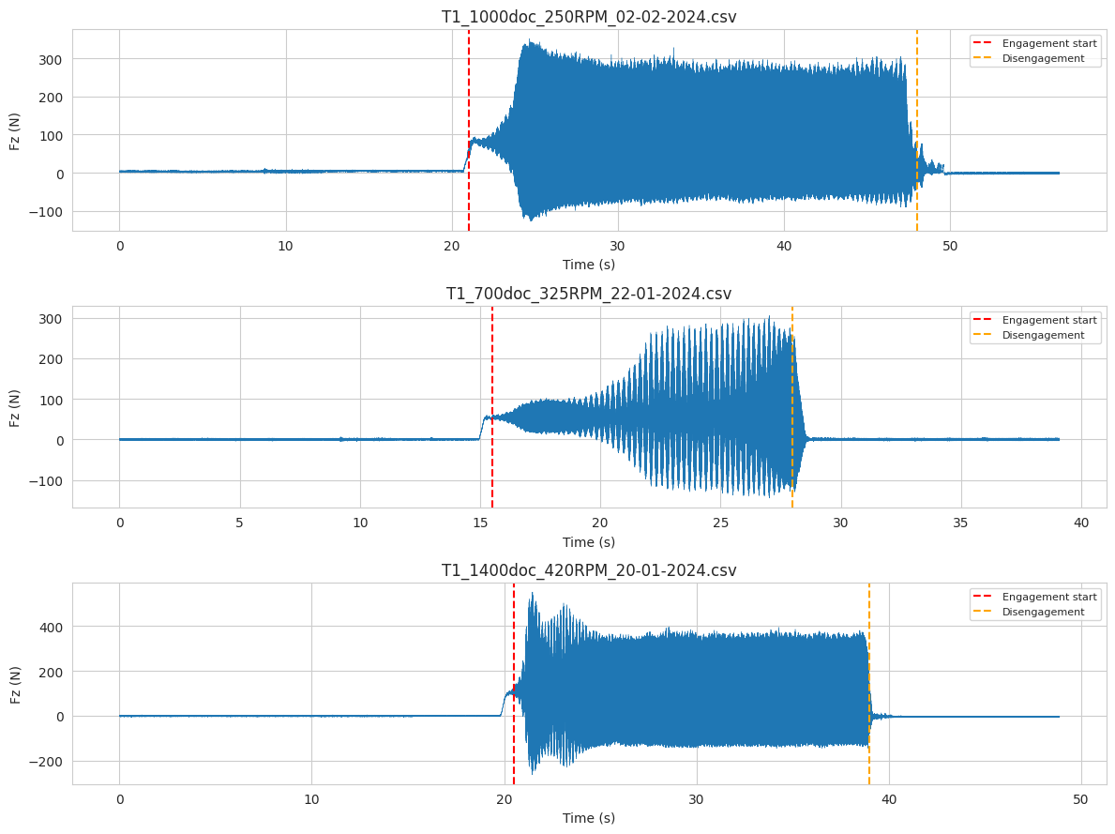
Figure 2. Detected engagement start (red) and disengagement (orange) boundaries on three example files spanning light, medium, and the heaviest cutting conditions.
17 of 18 files show a clear engagement window. The 18th (100 µm DOC) never shows sustained engagement -- its resultant force never meaningfully exceeds the idle floor for the entire recording, consistent with cutting below the effective minimum chip thickness for this tool/workpiece pair. It is excluded from the dataset rather than mislabeled as "stable."

4.3 Feature extraction
Feature extraction uses a 1.0 s sliding window with a 0.5 s step (50% overlap), restricted to each file's detected engaged region. Per axis (Fx, Fy, Fz): time-domain statistics (mean, std, min, max, range, RMS, skewness, kurtosis, slope, energy), frequency-domain statistics (dominant FFT frequency, FFT peak amplitude), and dimensionless condition-monitoring indices (crest, impulse, shape, and clearance factors). This produces 739 feature windows across 17 files.

5. Ablation Study: Validating Engagement Detection
Before investing effort in a better label, it is worth confirming engagement detection actually matters for modeling, not just for a label threshold. Using a simple, fixed labeling rule (85th percentile of radial-force FFT peak amplitude, held constant as the controlled variable), the identical feature-ranking and modeling pipeline was run on two versions of the dataset: one built by sweeping the sliding window across each file's entire raw recording (idle time included, 1,591 windows), and one restricted to the detected engaged region (739 windows).
Model | F1 — including idle time | F1 — engaged cutting only
Random Forest | 0.853 | 0.440
XGBoost | 0.862 | 0.433
Ensemble (RF+XGB) | 0.869 | 0.441

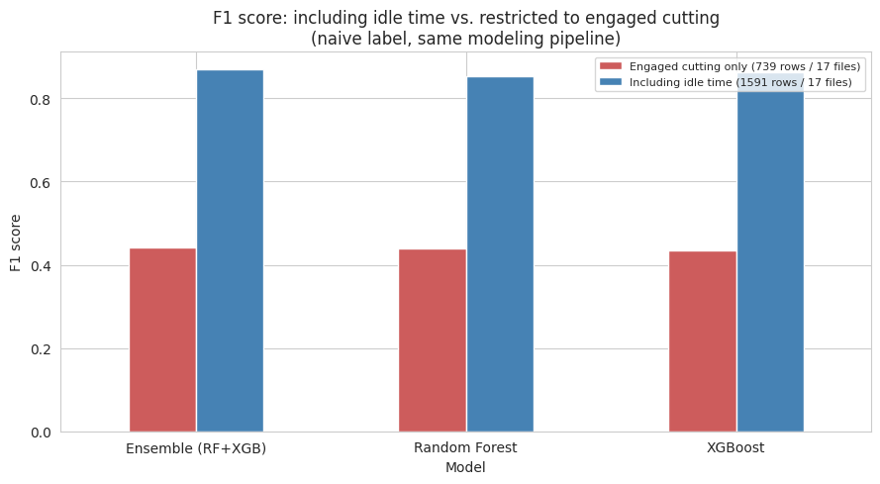
Figure 3. F1 score including idle time vs. restricted to engaged cutting, under an identical modeling pipeline and a fixed label.
F1 drops by roughly 0.35-0.40 across all three models under an otherwise unchanged pipeline. This demonstrates that a large share of the higher score with idle time included is driven by the trivial separability of near-zero-force idle windows from any genuinely engaged window, not real skill at telling chatter apart from stable cutting. Engagement detection is confirmed necessary, and the engaged-only dataset is used for everything from this point forward.

6. Literature Review: Toward a Physics-Informed Chatter Label
The naive label used in Section 5 (a fixed 85th-percentile cutoff on FFT-peak amplitude) is a common starting point, but it has an obvious weakness: "top 15% of amplitude in this dataset" is a statement about the shape of this dataset's distribution, not about the physics of chatter. A window from a heavy but perfectly stable cut and a window from a genuinely unstable cut can both land in the top 15% purely because more material is being removed, not because either one is self-excited vibration. A targeted literature review was carried out to find a more physically grounded alternative, focused on turning specifically rather than milling, where most published chatter-detection work concentrates.

6.1 Forced vibration vs. self-excited chatter
In any rotating cutting process, some vibration is expected and harmless: it comes from the tool/spindle system being periodically excited once (or a few times) per spindle revolution, due to minor runout, tool geometry, or workpiece imperfection. This forced content sits at the spindle rotation frequency and its low-order harmonics. Regenerative chatter is fundamentally different -- it is self-excited, meaning the vibration is not driven by an external periodic force but grows on its own once triggered, typically near a natural frequency of the tool/holder/workpiece system rather than at a harmonic of spindle speed. A chatter-vibration-detection patent formalizes this exact distinction: chatter is present when the dominant vibration frequency is not an integer multiple of (number of cutting edges) x (spindle rotational speed). For turning, the tool has a single cutting edge, so this reduces to: a dominant frequency that is not a low-order harmonic of the spindle rotation frequency is a chatter candidate; one that is a harmonic is simply forced vibration.

6.2 Foundational and turning-specific chatter-detection literature
The foundational reference for spectrum-based chatter detection is Delio, Tlusty & Smith (1992), "Use of Audio Signals for Chatter Detection and Control," ASME J. Eng. Ind. 114(2), 146-157, one of the first papers to formalize chatter as an energy/amplitude phenomenon distinct from the expected forced vibration of the process. Kondo, Ota & Kawai (1997), "New Method to Detect Regenerative Chatter Using Spectral Analysis, Part 1: Basic Study on Criteria for Detection of Chatter," J. Manuf. Sci. Eng. 119(4), builds specific spectral criteria for this same regenerative-vs-forced distinction. A directly relevant quantitative metric, described and experimentally validated in "Experimental validation of the amplitude ratio as a metric for milling stability identification," is the amplitude ratio: it quantifies chatter severity by comparing the amplitude of the expected frequency content (harmonics, runout frequency) to the amplitude of the chatter frequency, if present.
Because this dataset is turning, not milling, turning-specific precedent was also sought: Grabec, Gradisek & Govekar (1999), "A New Method for Chatter Detection in Turning," Ann. CIRP 48(1); Bukkapatnam, Lakhtakia & Kumara (1995) on low-dimensional chaos in turning signals; and more recent machine-learning work specifically for turning force/vibration signals, including Yesilli et al.'s work on chatter detection in turning using dynamic time warping and transfer learning, which also contributes a practical, data-driven peak-detection threshold (a minimum peak height defined relative to the 5th/95th percentile range of the spectrum, rather than an absolute number) -- the same spirit of relative-to-context thresholding used in this project.

6.3 Distinguishing sustained chatter from a transient spike
Because chatter is self-excited, it does not just appear once and vanish -- it grows and persists once triggered, unlike a transient spike from an impact, a chip breaking, or sensor noise. An energy-based online milling-chatter-detection method (using what its authors term MADSA -- Moving-Average Difference Spectrum Analysis) applies exactly this idea: it smooths the amplitude trend of a candidate chatter frequency over successive time windows and uses monotonicity (a sustained rising or persistently elevated trend) to confirm a real chatter candidate, rejecting one-off spikes.

6.4 What this motivates
Combining the above into one testable rule for a single 1-second cutting-force window:
- Amplitude ratio -- compare the window's dominant FFT amplitude against the strongest expected forced-vibration harmonic within the same window's spectrum. A large ratio indicates self-excited content dominates the expected content.
- Harmonic exclusion -- if the dominant peak itself sits at a low-order spindle-rotation harmonic, it is the expected forced content, not a distinct chatter frequency, regardless of amplitude.
- Persistence -- require the elevated, non-harmonic peak to be sustained across consecutive overlapping windows, not a single transient blip, reflecting chatter's self-excited, growing character.

7. A Physics-Informed Chatter Label

7.1 Amplitude ratio
For each file, the spindle rotation frequency is fs = RPM/60 Hz. Turning has a single cutting edge, so the expected forced-vibration content sits at fs, 2fs, 3fs, and so on. For each engaged 1-second window, the FFT already computed for feature extraction is reused to find the window's dominant FFT amplitude and frequency (Apeak, fpeak), and the largest FFT amplitude across the 1st-10th harmonics of fs in that same window (Aforced). The amplitude ratio is R = Apeak / Aforced.

7.2 Choosing the threshold
Rather than picking a threshold blind, the distribution of R across all 739 engaged windows was inspected directly.
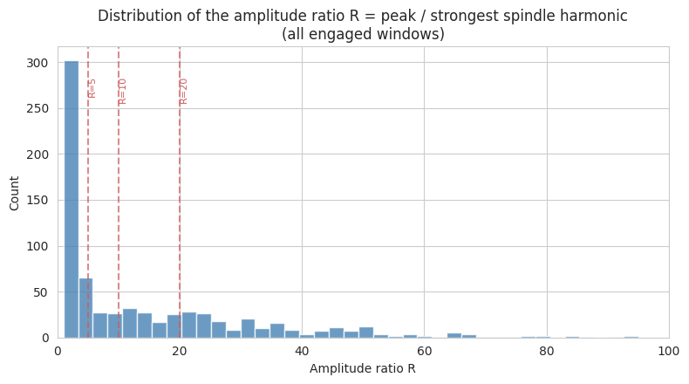
Figure 4. Distribution of the amplitude ratio R across all engaged windows. R = 10 sits just above the median (6.1) and gives a clean, round, physically interpretable cutoff.
R = 10 -- the dominant peak is an order of magnitude larger than the strongest expected forced-vibration harmonic in the same window -- was adopted as the amplitude-ratio threshold. A window is a chatter candidate if R > 10 and its peak is not itself a spindle-rotation harmonic (within a 2 Hz tolerance, checked against the 1st-10th harmonics).

7.3 What this looks like on the raw signal
Before moving to aggregate comparisons, it is worth looking directly at one real stable window and one real chatter-labeled window side by side -- both examples below are from the same file (so the comparison is not confounded by DOC or RPM).
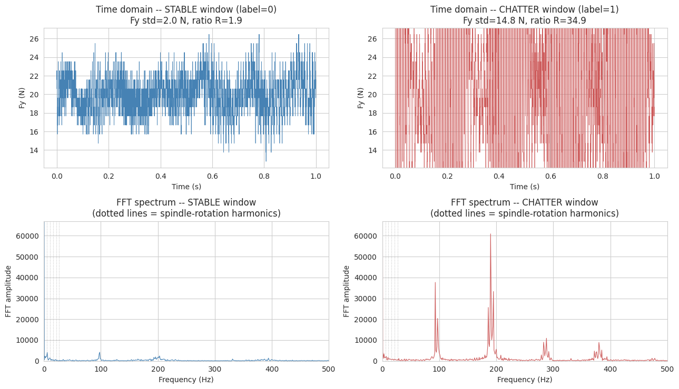
Figure 4b. A genuine stable window (left) vs. a genuine chatter-labeled window (right) from the same file, in both time domain (top) and frequency domain (bottom). Dotted grey lines mark the spindle-rotation harmonics.
The stable window's spectrum is broad and low, with no frequency dominating -- consistent with ordinary cutting noise. The chatter window's spectrum has clear, tall peaks (at ~190 Hz and its harmonics ~95, 285, 380 Hz) that dwarf the amplitude anywhere near the spindle-rotation harmonics. This is the "sudden extreme peak" signature of chatter directly visible in the data, and is exactly what the amplitude-ratio criterion in Section 7.1 is designed to detect quantitatively.

7.4 Persistence
Consecutive windows overlap by 50%, so a genuinely sustained chatter event should clear the ratio threshold in two consecutive windows with a similar dominant frequency (within 15 Hz) -- not just once. This rejects transients (impacts, brief instabilities) that are inconsistent with the sustained, self-excited growth that defines regenerative chatter.
Combining all three criteria produces a chatter fraction of 42.8% (316 of 739 windows) across the dataset -- markedly higher than the naive label's fixed 15%, because the physics-informed criterion is not constrained to any particular rate; it is a data-driven consequence of how many windows in this dataset actually meet a genuine self-excited-vibration criterion. Since the dataset's depth-of-cut range was deliberately chosen to span both stable and unstable regimes, and higher-DOC conditions dominate the window counts, a rate above 15% is plausible rather than alarming -- and is directly checked against known chatter physics next.

7.5 Comparing against the naive label
The two labels agree on 71.7% of windows. Where they disagree, the physics-informed label calls 207 windows "chatter" that the naive label called "stable" (i.e., real chatter that a fixed global percentile threshold missed), versus only 2 windows in the opposite direction. This asymmetry is consistent with the naive label's known weakness: a single global threshold, computed once across all conditions, under-detects chatter in files whose overall force levels happen to sit below the global 85th percentile even though a real, sustained, non-harmonic self-excited peak is present.
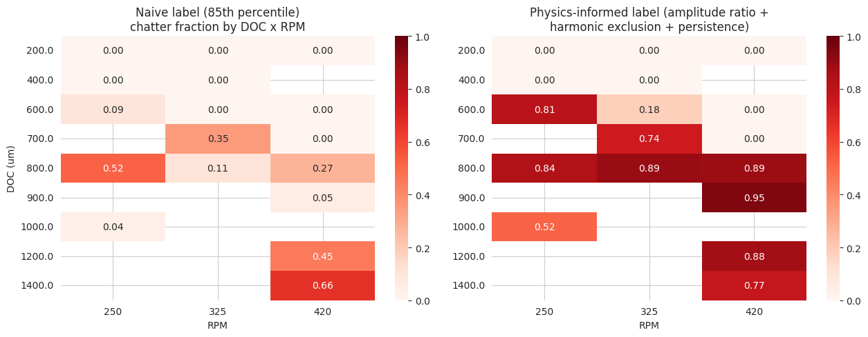
Figure 5. Chatter fraction by depth of cut and spindle speed under the naive label (left) vs. the physics-informed label (right).
The physics-informed label produces a visibly cleaner, more monotonic relationship with depth of cut: 0% chatter at DOC ≤ 400 µm under both labels, but a consistently high (75-95%) fraction at DOC ≥ 700-800 µm under the physics-informed label, versus a patchier picture under the naive label (for example, an unexplained dip to 5% at 900 µm / 420 RPM, sandwiched between much higher-chatter neighboring conditions). This matches the expected shape from stability-lobe theory, where chatter risk should rise sharply and fairly consistently once depth of cut exceeds a critical value for a given spindle speed. That the physics-informed label reproduces this expected shape without ever being told DOC or RPM -- it only looks at each window's own force spectrum -- is meaningful evidence that it captures a real physical signal rather than dataset-specific noise.

7.6 A second look: checking for label leakage
Before trusting any modeling result built on this label, its relationship to the engineered features was checked directly. The dimensionless condition-monitoring indices computed for feature extraction (Fy_shape, Fy_crest, Fy_impulse, Fy_clearance) -- all time-domain measures of how "peaky" or impulsive a signal is relative to its own average level -- correlate with the physics-informed label at 0.83-0.86, and with the label's own underlying amplitude ratio at 0.64-0.73. This is too high to treat as independent evidence: both families of features are, structurally, different arithmetic operations on largely the same underlying signal property (peak concentration), just computed in different domains (time vs. frequency).
Consequently, these four dimensionless features (all three axes, for consistency) were excluded from the candidate feature set for all modeling on this label, in addition to the amplitude ratio and its components. This is a stricter standard than would otherwise be applied, adopted specifically because of how this label was constructed. Standard deviation, range, RMS, energy, min/max, skewness, kurtosis, slope, and dominant frequency remain as candidate features -- statistics that are conceptually distinct from a peak-concentration ratio, even though (as discussed in Section 9) they remain correlated with the label for a separate, legitimate physical reason.

8. Feature Prioritization
Combining correlation-with-label, GroupKFold-averaged Random Forest importance, and SelectKBest F-scores into a single rank (after excluding the leakage and peak-concentration columns identified in Section 7.6) identifies the following top 5 features:
- Fy_std — radial force standard deviation
- Fy_max — radial force maximum
- Fy_range — radial force range (max − min)
- Fz_min — cutting force minimum
- Fz_fft_peak — cutting-force FFT peak amplitude
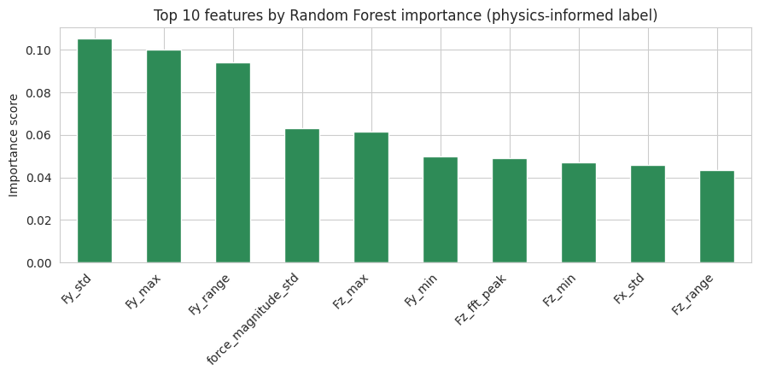
Figure 6. Top 10 features by Random Forest importance (physics-informed label, after excluding peak-concentration features).

9. Results

9.1 Model comparison
Random Forest, XGBoost and a soft-voting Ensemble (top-10 features) were evaluated as a baseline, followed by class-balanced Logistic Regression, SVM (RBF kernel), and weighted variants of RF/XGBoost with a leaner top-5 feature set, per the literature's emphasis on recall for this application. All eight models cluster tightly in the 0.89-0.93 F1 range.
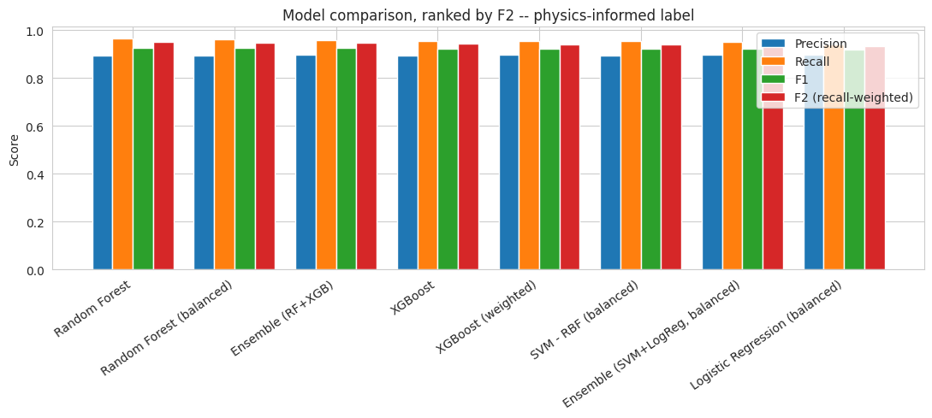
Figure 7. Precision, recall, F1 and F2 for all eight models evaluated on the physics-informed label, sorted by F2.
Model | Precision | Recall | F1 | F2
Random Forest | 0.892 | 0.965 | 0.927 | 0.950
Random Forest (balanced) | 0.894 | 0.962 | 0.927 | 0.948
Ensemble (RF+XGB) | 0.896 | 0.959 | 0.927 | 0.946
SVM - RBF (balanced) | 0.893 | 0.953 | 0.922 | 0.940
XGBoost (weighted) | 0.896 | 0.953 | 0.923 | 0.941
Ensemble (SVM+LogReg, balanced) | 0.896 | 0.949 | 0.922 | 0.938
Logistic Regression (balanced) | 0.897 | 0.940 | 0.918 | 0.931
XGBoost | 0.893 | 0.956 | 0.924 | 0.943

Random Forest (unweighted, top-10 features) achieves the highest F2 score and is selected as the final model: precision 0.892, recall 0.965, F2 0.950. Unlike the naive-label version of this labeling problem, class-balancing provides little additional benefit here, because the physics-informed label is close to balanced (42.8% chatter) rather than the naive label's 15%.
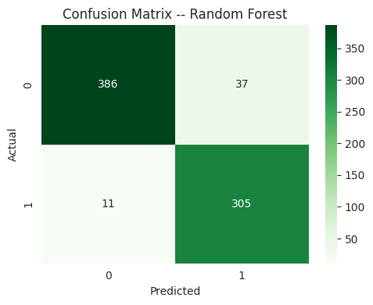
Figure 8. Pooled out-of-fold confusion matrix for the final model (Random Forest, top-10 features, physics-informed label).
All metrics reported here, including the confusion matrix, are computed from pooled out-of-fold predictions (all cross-validation folds concatenated before scoring) rather than averaged per-fold, so the headline numbers are always exactly consistent with the confusion matrix built from the same predictions.

9.2 Why is performance so much higher than the naive-label version of this analysis?
F1 rises from ~0.44 (naive label, Section 5) to ~0.93 (physics-informed label). This jump is large enough to deserve a direct explanation rather than being reported at face value.
The naive label was a single global threshold (the 85th percentile of Fy_fft_peak computed once across all 739 windows), mixing windows from very different depths of cut and spindle speeds under one arbitrary cutoff -- Section 7.5 showed this produces a patchy, not-very-monotonic map of "chatter" that is hard for any model to learn cleanly, because the label itself does not track a consistent physical criterion across conditions. The physics-informed label instead applies a per-file-relative criterion (peak vs. that file's own expected harmonic content) plus a persistence filter, producing a visibly cleaner, more physically consistent label. A cleaner label is mechanically easier for any reasonable feature set to predict: amplitude-based features like Fy_std and Fy_range are large exactly when the force is fluctuating strongly, which is also mechanically what drives a large FFT peak (energy in the time and frequency domains is directly related by Parseval's theorem), so a well-behaved amplitude-based label and amplitude-based features should agree strongly. That is expected and desirable, not a sign of a flawed evaluation.
It is still worth stating the limit of this plainly: because the label is ultimately built from the same force signal the features are computed from (Section 7.6 addressed the closest, most direct overlap), any amplitude-based label built this way will correlate with amplitude-based features to some degree, by construction. The reported precision/recall/F2 should be read as "this model successfully learned the physics-informed criterion from the force signal," not as "this model has been shown, via an independent measurement, to detect real chatter with 90%+ accuracy." Closing that gap is exactly what independent validation (Section 11) would provide.

9.3 Stability diagram
The final model, refit on the complete dataset, is used to score every window; the mean predicted chatter probability is aggregated by (DOC, RPM) to produce a process-planning stability diagram.
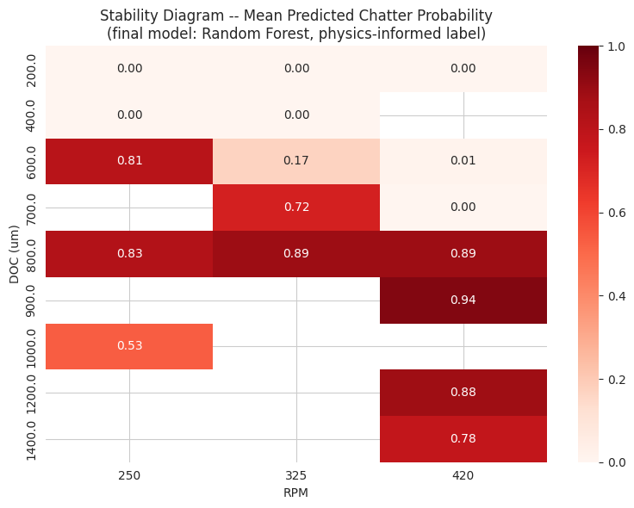
Figure 9. Mean predicted chatter probability by depth of cut and spindle speed.
Chatter probability is 0% at DOC ≤ 400 µm across all spindle speeds, rises to 72-94% at DOC 700-900 µm, and remains elevated (77-88%) at the highest depths tested (1200-1400 µm). This closely mirrors the label distribution itself (Section 7.5), which is expected: the model was trained to reproduce that label, and this diagram should be read as a summary of what the physics-informed label found in this dataset, not as an independently re-derived stability boundary.

10. Why Recall (and F2) Matter for This Application
In chatter detection, the two error types carry very different costs. A false negative -- a real chatter event predicted as stable -- means an unstable cut proceeds undetected, risking tool damage, scrapped parts, and poor surface finish. A false positive -- a stable cut flagged as chatter -- costs only an unnecessary parameter check or a brief pause. Because these costs are so asymmetric, recall is the more important metric to protect, but recall alone is not a safe optimization target: a model that predicts chatter for every window achieves perfect recall while being useless in practice. The F2 score (F-beta with β=2) resolves this by weighting recall twice as heavily as precision in a single number, and is used as the explicit model-selection criterion in Section 9.1 rather than F1 or recall in isolation.

11. Limitations
- Label validity, revisited. The physics-informed label is a substantial improvement in physical grounding over a percentile cutoff, but it is still inferred entirely from the same force signal used to build the model's features -- it has no access to surface roughness, an accelerometer, or a microphone recording. The threshold values (ratio > 10, 2 Hz harmonic tolerance, 2-window persistence, 15 Hz frequency-consistency tolerance) were chosen by inspecting this dataset's own distribution, not derived from an independent physical measurement.
- Small sample size at the file level. 17 independent cuts is enough to demonstrate the pipeline, but GroupKFold metrics over this few groups still carry real variance; a firm production-grade accuracy claim would need more repeated cuts per (DOC, RPM) condition.
- Correlated feature bank. Several of the top-ranked features (Fy_std, Fy_range, Fz_fft_peak, force_magnitude_std, ...) are different mathematical summaries of essentially the same underlying quantity (force amplitude and variability), so the model combines fewer independent evidence sources than the feature count suggests.
- Single sensing modality. Only cutting-force channels are used. Adding vibration or acoustic emission would let the amplitude-ratio/harmonic-exclusion/persistence logic developed here be validated against a second, independent signal rather than applied twice to the same one.
- One raw filename in the dataset (…_noaccData.csv) suggests an accelerometer channel existed for at least one experimental setup but is not present in the data used here.

12. Recommendations for Future Work
- Validate the physics-informed label against an independent signal (accelerometer, microphone, or post-process surface roughness) if one becomes available for even a subset of files.
- Sweep the amplitude-ratio threshold and persistence window count as sensitivity analyses, to check how much the final chatter fraction and stability diagram depend on these specific choices.
- Collect repeated cuts at each (DOC, RPM) condition, particularly in the mid-DOC range where the stability diagram is currently based on the fewest engaged windows.
- Evaluate a leave-one-DOC-out (in addition to leave-one-file-out) cross-validation scheme, to assess how well the model extrapolates across cutting conditions rather than only across repeated cuts of the same condition.

13. Conclusion
This project builds a complete pipeline for detecting chatter from turning-process force signals: automatic per-file engagement detection with a dedicated guard against piezoelectric charge drift, an ablation study confirming that detection matters, a targeted literature review of turning-specific chatter-detection criteria, and a physics-informed relabeling built from three literature-grounded criteria (amplitude ratio, harmonic exclusion, persistence). The resulting label is demonstrably more physically consistent than a naive percentile cutoff, and a Random Forest classifier trained on it achieves recall 0.97 and F2 0.95 under file-grouped cross-validation. A deliberate check for feature/label overlap caught and corrected a construct-validity issue (the dimensionless peak-concentration features) before it could inflate these numbers further, and the report is explicit that the remaining high performance reflects successful learning of a well-constructed label from the same signal used to build the features, not independent proof of real-world chatter-detection accuracy. The stated limitations -- chiefly the absence of an independent validation signal -- define the clearest next step for extending this work.

References
[1] Delio, T., Tlusty, J., & Smith, S. (1992). Use of Audio Signals for Chatter Detection and Control. ASME Journal of Engineering for Industry, 114(2), 146–157.
[2] Kondo, E., Ota, H., & Kawai, T. (1997). New Method to Detect Regenerative Chatter Using Spectral Analysis, Part 1: Basic Study on Criteria for Detection of Chatter. Journal of Manufacturing Science and Engineering, 119(4).
[3] Experimental validation of the amplitude ratio as a metric for milling stability identification. Pennsylvania State University research output.
[4] Grabec, I., Gradisek, J., & Govekar, E. (1999). A New Method for Chatter Detection in Turning. Annals of the CIRP, 48(1), 29–32.
[5] Bukkapatnam, S. T. S., Lakhtakia, A., & Kumara, S. R. T. (1995). Analysis of sensor signals shows turning process on a lathe exhibits low dimensional chaos. Physical Review E, 52, 2375–2387.
[6] Yesilli, M. C., et al. Chatter Detection in Turning Using Machine Learning and Similarity Measures of Time Series via Dynamic Time Warping. arXiv:1908.01678.
[7] Yesilli, M. C., et al. On Transfer Learning for Chatter Detection in Turning Using Wavelet Packet Transform and Empirical Mode Decomposition. arXiv:1905.01982.
[8] Chatter vibration detection method, chatter vibration avoidance method, and machine tool (patent). Formal criterion: chatter frequency is not an integer multiple of (cutting edges) x (spindle speed).
[9] On-Line Energy-Based Milling Chatter Detection (MADSA — Moving-Average Difference Spectrum Analysis). ASME Journal of Manufacturing Science and Engineering.
[10] Wang, W. K., Wan, M., Zhang, W. H., & Yang, Y. (2022). Chatter detection methods in the machining processes: A review. Mechanical Systems and Signal Processing.

Appendix — Files Delivered
- ME623_Chatter_Detection.ipynb — the fully executed analysis notebook
- final_all_features_dataset.csv — the feature dataset (739 rows, 17 files), including both the naive and physics-informed labels for transparency
- ME623_Chatter_Detection_Deck.pdf — the presentation deck
- This report (ME623_project_report.docx)

