In every challenge lies an opportunity for growth.
This document applies Kaizen’s principle of embracing gaps and turning limitations into stepping stones. By seeing precisely where our processes fall short, we ignite continuous improvement and set a clear path to lasting success.


Prepared by: Daed Alqasem
Version: 01
Date: 08-Aug-2025
Table of Contents
Cover Letter 3
Why Kaizen Principles 4
Proven Accelerators 4
Delivery Excellence 4
Fully Certified Team 4
Regional & Global 5
RFP Compliance Matrix & Feasibility Summary 5
Registration & Approval 6
Operational Model 7
Customer Support 8
Reporting & Analytics 8
Core Interfaces & Integration 9
1 Registration & Screening 10
2 Service Catalogue & Ordering 11
3 Service Fulfilment & Task Management 12
4 Vendor Collaboration & Procurement 12
6 Customer Support & Live Chat 14
7 Governance, Documents & Approvals 14
Why It Matters for KUEC 15
Data-Migration & Cleansing Plan 16
Integration Architecture 17
Training Approach: “Explain → Show → Do → Coach” 17
Training Schedule Snapshot: 19
Project Implementation Plan & Timeline 20
On-Site Discovery First 21
Functional Delivery Tracks 21
Key Milestones & Timeline 22
Execution Principles 23

Cover Letter
Kaizen Principles is pleased to submit our formal response to the Request for Information (RFI) issued by Khalifa University Enterprises Company (KUEC) for the development of a Partner Self-Service Catalog Portal. We regard KUEC as a beacon of innovation within the UAE’s knowledge economy, and we welcome the opportunity to contribute to this forward-looking initiative.
Over the past decade, Kaizen Principles has earned a reputation for delivering comprehensive, enterprise-class solutions that harmonize robust technology with intuitive user experiences. Our multidisciplinary team combines expertise in portal design, ERP/CRM integration, and data-driven service automation—capabilities that align precisely with the functional and operational requirements outlined in your RFI.
We are committed to providing a platform that is efficient, scalable, and seamlessly integrated with the distinctive aesthetic and innovative spirit that defines KUEC. Enclosed you will find our detailed proposal, including project plans, milestone timelines, and a preliminary budget framework. These elements have been tailored to ensure the portal’s successful delivery while safeguarding schedule, quality, and cost.
We believe our approach supports KUEC’s mission to foster a future-oriented mindset and drive technological advancement across your stakeholder network. Thank you for considering our submission. We look forward to the possibility of collaborating with KUEC and stand ready to discuss any aspect of our proposal at your convenience

Why Kaizen Principles

Proven Accelerators
Kaizen Principles brings 24 plug-and-play “ready-made solutions” and a library of 4,500+ pre-built developments that span every standard Odoo application. These assets shorten lead-times, cut risk, and allow us to focus project effort on the 10–20 % of functionality that is truly unique to your business.

Delivery Excellence
Metric | Credential Detail
Project success rate | 100 % on-time, on-scope, go-live across all engagements.
Odoo recognition | Nominated Best Starter; Gold Partner status maintained since first accreditation—never downgraded.
Team certifications | PMP-certified project managers • Six Sigma Black Belts for process optimization • ISO-qualified implementation methodology (ISO 9001 & ISO 27001 frameworks).

Fully Certified Team
Every consultant, developer, and QA analyst on your project holds current Odoo functional and technical certifications, ensuring adherence to best practices and maintainable code.

Regional & Global
Presence Headquartered in Dubai with delivery hubs in the UAE, Saudi Arabia, Egypt, India, and Pakistan, we support clients locally while providing around-the-clock development and support coverage.
Consulting-First Approach
Before any line of code is written, our consultants map and streamline your internal processes, SLAs, and controls. Automation only follows once workflows are lean, compliant, and measured, guaranteeing that technology amplifies, rather than masks, operational excellence.

RFP Compliance Matrix & Feasibility Summary
The following Compliance Matrix provides a line-by-line assessment of KUEC’s functional and technical requirements against Odoo 18 Enterprise Edition. For each item, we indicate one of four feasibility states:
Indicator | Meaning | Typical Effort
Standard | Fully supported by Odoo (configuration only). | Basic configuration & onboarding
Development | Achievable through customization in Odoo (Python/OWL, Studio, or bespoke modules). | Moderate development & QA
Integration | Requires interfacing Odoo with an external system or third-party service. | API work, middleware, testing
Gap / No | Not available in native Odoo. Substantial custom development or alternative tooling would be required. | Significant project scope
Important clarification:
Whenever the matrix shows “No,” it denotes that the requested capability does not exist in Odoo’s standard feature set. Achieving that requirement would therefore necessitate either (a) a dedicated custom module that extends Odoo far beyond typical configuration, or (b) the adoption of a specialist third-party platform.
This structured view enables KUEC to quickly gauge feasibility, budget impact, and risk for each requirement, ensuring transparent expectations before project kickoff.

Registration & Approval
Req ID | Requirement Description | Covered in Odoo? | Odoo Fit
1 | Start-up Registration (portal form & docs) | No | Development
2 | Start-up Registration Approval workflow | Yes | Standard
3 | Start-up Sign-Up / Portal onboarding | Yes | Standard
4 | Service Vendor Registration | No | Development
5 | Vendor Approval by Procurement | Yes | Standard
6 | Vendor Account Activation & Dashboard | No | Development
7 | Automatic Notifications on registration | Yes | Standard
8 | Cancel / Disqualify Start-up (≤ 1 yr) | No | Development
9 | Cancel Approved Vendor & final billing | No | Development

Operational Model
Req ID | Requirement Description | Covered in Odoo? | Odoo Fit
10 | Customer profile & segmentation | No | Development
11 | Vendor classification & star rating | No | Development
12 | Service/package pricing with discounts | No | Development
13 | Smart service-to-vendor routing | No | Development
14 | Onboarding package (22 services) | No | Development
15 | Service catalogue browsing | Yes | Standard
16 | Business-matrix eligibility rules | No | Development
17 | Purchase package/request quotation | Yes | Standard
18 | CRM update after purchase | Yes | Standard
19 | Auto / manual service assignment | No | Development
20 | Fulfilment journeys (project & retainer) | No | Development
21 | SR communication thread & docs | Yes | Standard
22 | Customer satisfaction survey | Yes | Standard
23 | Iterative service-card deployment | No | Development
24 | Service cancellation & refund flow | No | Integration
25 | Wallet/card refund (on-time payers) | No | Integration
26 | Invoice cancellation (on-account) | Yes | Standard

Customer Support
Req ID | Requirement Description | Covered in Odoo? | Odoo Fit
27 | Chat widget & ticket logging to CRM | No | Integration
28 | Auto SR creation (chat / call) & merge | No | Integration
29 | SR reassignment & team views | Yes | Standard

Reporting & Analytics
Req ID | Requirement Description | Covered in Odoo? | Odoo Fit
30 | Revenue tracking (monthly/yearly) | No | Integration
31 | Revenue by vertical / parameters | No | Integration
32 | Cost tracking & cost codes | No | Integration
33 | P&L per account | No | Integration
34 | SLA compliance reports | No | Integration
35 | Support-transaction volumes | No | Integration
36 | Backlog SRs exceeding SLA | No | Integration
37 | Customer-satisfaction dashboard | Partial | Standard + Integration

Core Interfaces & Integration
Req ID | Requirement Description | Covered in Odoo? | Odoo Fit
I-1 | Enterprise CRM workspace | Partial | Standard + Development
I-2 | Vendor portal (registration, KPIs, payments) | No | Development
I-3 | Customer self-service portal | Partial | Standard + Development
I-4 | ERP/API integrations & scalability | No | Integration

Note:
“Covered in Odoo? = No” indicates that the capability is not available in Odoo out of the box and will need either custom development or an external integration to meet KUEC’s specification.

Odoo Standard Possible Utilization – Tailored to KUEC Center of Excellence (CoE)
In this section, we show how the core Odoo 18 Enterprise apps can be linked together. like stations on a single track to support KUEC’s end-to-end Shared-Services Portal life-cycle:
- Registration & Screening (Website Forms → Portal → CRM)
- Service Catalogue & Ordering (eCommerce / Sales → Subscriptions)
- Service Fulfilment (Project / Helpdesk / Field Service)
- Vendor Collaboration & Procurement (Purchase → Invoicing)
- Finance & Reporting (Accounting → Spreadsheet → Power BI)
- Customer Support & Satisfaction (Discuss → Survey)
- Governance & Compliance (Documents, Approvals, Studio)
Rather than listing features in isolation, we kept each BRD requirement in view, mapped it to the closest out-of-the-box module, and described the hand-off that occurs when data moves from one module to the next. The objective is a practical playbook that shows where configuration alone delivers value, and where customization or external integration is unavoidable.

1 Registration & Screening
BRD Theme | Odoo Flow (Standard) | Key Built-in Features
Start-up / Vendor On-Boarding | Website > Form Builder captures registration data > auto-creates Partner record in Contacts > routes to CRM stage “Screening”. | CAPTCHA, attachment upload, GDPR consent, Server Action emails, Innovation & Procurement teams.
Approval Gate | Reviewer moves record to “Approved” stage; Approvals app logs decision & comments. | Multi-level approvals, activity scheduling, full audit trail.
Portal Activation | Portal invitation sent automatically; registrant sets self-password, sees personalized dashboard. | Single Sign-On (SAML/OAuth optional).
Auto-Notify | Automated Actions trigger system mails/chatter messages on stage change. | HTML templates per actor (Start-up, Investor, Vendor).

2 Service Catalogue & Ordering
BRD Theme | Odoo Flow (Standard) | Key Built-in Features
Catalogue Browsing | Website Shop / eCommerce lists “Service Packages” filters by Governmental vs Non-Governmental, Delivery Mode, and Eligibility. | Pricelists, attribute filters, -and multi-currency.
Eligibility Matrix | The portal user enters or already holds tags (“Subsidiary”, “Startup”). Website Builder shows only eligible items via the Domain filter. | Dynamic publish rules; no code needed.
Package Subscription / Retainer | “Subscribe” button converts to Sales → Subscription contract with billing cycle (monthly/annual). | Automatic invoicing, payment tokens, and renewal alerts.
Quote for Project-Based Service | RFP button opens Sales Quotation form; CoE Coordinator completes scoping; quote emailed to customer. | Sign on quote: online payment of deposit.

3 Service Fulfilment & Task Management
BRD Theme | Odoo Flow (Standard) | Key Built-in Features
Project-Based Services | Sales Order confirmation spawns a Project with tasks & milestones. | Gantt / Kanban views, project profitability.
Retainer / Ticketed Services | Subscription auto-creates a Helpdesk ticket each month, OR lets the customer raise an SR manually in the Portal. | SLA timers, timesheets, and billable hours.
22-Step Onboarding Package | Pre-configured Project Template (22 tasks) imported at startup profile approval. | Task checklist widget, progress bar.
Service Communication Thread | Every task/ticket has its own Discuss channel; vendor staff are added as followers from the Vendor Portal. | File sharing, emoji, @mentions.
Customer Satisfaction | On task/ticket closure, the Survey app auto-sends a 5-point CSAT form; scores feed Kanban ‘Happy / Neutral / Unhappy’. | Conditional questions, dashboard.

4 Vendor Collaboration & Procurement
BRD Theme | Odoo Flow (Standard) | Key Built-in Features
Vendor Registration & Rating | Vendor record created, Purchase tags hold Service Categories; custom “Stars” field via Studio. | Vendor pricelists, scorecards.
Smart Routing | Python rule (custom) assigns incoming SR to preferred vendor; rule taps vendor category & star rating. | (Custom logic sits on top of Purchase / Project).
PO & 3-Way Match | CoE Coordinator approves vendor’s proposal > auto-creates Purchase Order > Goods Receipt > Vendor Bill matched. | Duplicate-bill blocking, price variance warnings.

5 Finance, Wallets & Reporting
BRD Theme | Odoo Flow (Standard + BI) | Key Built-in Features
Billing & Refunds | Subscription invoices auto-post to Accounting; credit-note wizard handles cancellations; payment acquirer refunds card (API). | Payment tokens, multi-currency, and Partial refunds.
On-Time Payer Wallet | Simple “Wallet” analytic account holds credit balance; applied on next invoice (custom but lightweight). | Analytic defaulting, negative invoice lines.
Revenue / Cost / P&L | Spreadsheet template pulls live data from Accounting, Purchase; publishes to Power BI via connector. | Pivot caching, scheduled exports.
SLA & Backlog KPIs | Helpdesk KPIs exposed via Odoo’s /JSON RPC; Power BI dataset refreshes nightly. | Native SLA statistics, tag filtering.

6 Customer Support & Live Chat
BRD Theme | Odoo Flow (Standard + Integration) | Key Built-in Features
Live Chat Widget | Odoo Live Chat embeds on portal pages; on the/helpdesk channel, join it creates a ticket automatically. | Chatbot hand-over, canned replies.
Call Logging | Odoo VOIP module logs inbound calls; missed call triggers a Helpdesk ticket. | Asterisk / SIP integration.
Ticket Merge | Built-in “Merge Tickets” wizard groups duplicates; SLA clock preserves the oldest timestamp. | Drag-drop merge, chatter history preserved.

7 Governance, Documents & Approvals
BRD Theme | Odoo Flow (Standard) | Key Built-in Features
Service Cards & Version Control | Each service has a Product Template; CoE Admin edits via Studio; revisions are tracked in Documents. | Check-in/out, versioning.
Digital Approvals | Approvals app routes POs, price exceptions, vendor onboarding forms; fully timestamped. | PDF attachments, resubmit loop.
Policy & License Repository | All master data (licenses, policies) are stored in Documents with expiry alerts 60 days prior. | Access groups, tag search.

Why It Matters for KUEC
- Faster Go-Live – 80 % of the CoE requirements align with native Odoo workflows; configuration delivers value before custom code starts.
- Single Source of Truth – Contacts, SRs, projects, invoices, and surveys all share the same database, cutting manual reconciliations.
- Scalable Roadmap – Future AI routing, vendor chatbots, or advanced BI dashboards can plug into the same API layer with minimal refactoring.
Whenever a BRD line item genuinely exceeds standard capability, we have flagged it in the Compliance Matrix as Development or Integration; otherwise, the tables above demonstrate how Odoo Standard can be deployed immediately to cover core CoE processes.

Data-Migration & Cleansing Plan
We will migrate all legacy customer, vendor, and service‑catalogue data into Odoo in a three‑wave approach:
Wave | Source Systems | Target Models | Cleansing & Validation Steps | Owner
1 | Excel master lists (Start-ups, Subsidiaries, Vendors) | (Contacts) incl. tags for Eligibility & Customer Class | • Remove duplicates• ISO address / phone format• Emirate & license-number regex checks | KUEC Data + Kaizen
2 | Current SR tickets (SharePoint / Mailbox) | helpdesk.ticket + attachments | • Map old categories to new Service Codes• Auto-assign historic SLA outcomes | Kaizen
3 | Historical invoices & vendor bills (ERP) | account.move | • Balance control accounts• Tie to analytic tags for cost center P&L | KUEC Finance

Integration Architecture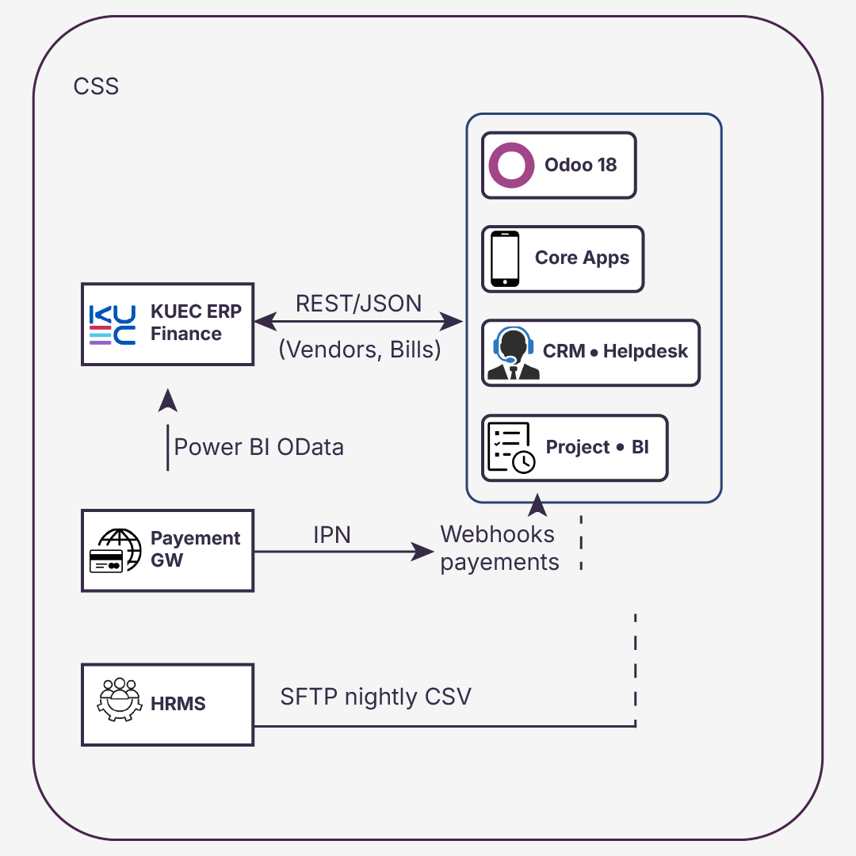

Training Approach: “Explain → Show → Do → Coach”
Kaizen Principles will deliver a structured training program to ensure all KUEC user groups—internal teams, vendors, and customers—are confident and self-sufficient in using the new portal and back-office system. Our approach is based on the “Explain → Show → Do → Coach” model, which maximizes both knowledge retention and real-world application.
Phase 1: Explain
We begin each training module by clearly explaining the why and what behind the system feature or process.
- 10–15 minute briefing sessions aligned to real KUEC use cases (e.g., registering a startup, routing a service request).
- Delivered live or pre-recorded via Google Meet.
- Materials: PDF Quick Reference Guides, Arabic & English.
Phase 2: Show
Next, we demonstrate the feature live in the system, using Demo data and the actual KUEC configuration.
- Step-by-step walkthroughs in Odoo (e.g., confirming a purchase order, responding to a vendor quote).
- Recorded screen shares added to KUEC’s internal training library.
- Split by role: CoE Coordinator, MIS Analyst, Vendor, Customer.
Phase 3: Do
Users then practice the process themselves inside the UAT (test) environment.
- “Role-play” exercises: simulate SR routing, service delivery milestones, vendor invoice processing.
- Users follow the process with guidance materials but without intervention.
- Hands-on tasks are tracked via checklists to monitor progress and identify knowledge gaps.
Phase 4: Coach
Finally, our trainers observe and provide 1:1 or small-group coaching sessions to reinforce learning.
- Shadowing during the pilot phase (e.g., watch the first vendor onboarding or ticket resolution).
- Corrections and tips offered live, with a follow-up summary sent to each participant.
- This phase continues into Week 1 of go-live as part of the Hypercare plan.

Training Schedule Snapshot:
Audience | Training Format | Language | Duration | Materials
CoE Coordinators | Live + recorded | EN/AR | 3 x 1.5h | Role manual, videos
Vendors | Video + sandbox tasks | EN/AR | Self-paced | Portal guide, checklist
Internal Departments | Live session + follow-up | EN/AR | 1 x 2h | Process map, SOP
Startups / Customers | Walkthrough videos in the portal | AR preferred | < 10 min each | FAQ, in-app video
This model ensures each user learns not just where to click, but when, why, and what to do next, reinforcing KUEC’s vision of a modern, intuitive, and service-focused digital experience.

Assumptions & Exclusions
# | Assumption / Exclusion | Impact if False
A1 | Legacy data provided in agreed format before Sprint 1 | Timeline slip ≈ 1 week
A2 | Payment gateway onboarding starts in Week 1 | Delay in go-live payments
E1 | Arabic translations for UI provided by KUEC | Minor delay in UI delivery

SLA & Support Model
Tier | Example | Response | Resolution | Escalation
L1 | Password reset | 1 h | 4 h | –
L2 | Minor bug | 4 h | 1 bd | L3 after 8 h
L3 | Outage | 30 min | 4 h | CTO

Project Implementation Plan & Timeline
This section outlines our proposed compressed implementation roadmap, designed to deliver the entire KUEC CoE Shared Services Portal in under 2 calendar months.
Rather than spreading delivery across traditional agile sprints, we have structured the work into four functional implementation tracks, each with focused teams working in parallel to accelerate time to value.
The schedule is anchored to a 2 September 2025 kickoff. All milestones are subject to adjustment based on KUEC resource availability, data readiness, or integration partner alignment.

On-Site Discovery First
The project begins with a 5-day on-site Discovery & Alignment workshop during the first week of September. This workshop is attended by key stakeholders across CoE Coordination, MIS, Procurement, and Finance.
Objectives include:
- Finalizing scope and ownership per the BRD requirement
- Validating data structure, user stories, and business rules
- Confirming acceptance criteria and reporting expectations
This ensures that the upcoming configuration and development work is rooted in real user context, reducing risk and rework.

Functional Delivery Tracks
Track | Duration | Key Deliverables
Track 1: Registration & Interfaces | 2 Sept – 27 Sept | Startup/vendor registration flows, approval engine, portal activation, role-based views (Customer, Vendor, CoE Coordinator)
Track 2: Catalogue & Logic | 2 Sept – 30 Sept | Service catalogue (gov + non-gov), subscription model, pricing rules, eligibility filters, smart routing logic
Track 3: Fulfilment & Support | 9 Sept – 10 Oct | Onboarding packages, project-based and retainer fulfilment journeys, helpdesk workflows, and customer satisfaction surveys
Track 4: Finance & Reporting | 16 Sept – 28 Oct | Wallet & refund engine, invoice logic, integration touchpoints (ERP & payment), Power BI datasets (SLA, revenue, CSAT)

Key Milestones & Timeline
Date | Milestone
2 Sept 2025 | Project Kickoff & Discovery Workshop
13 Sept 2025 | Registration Module UAT Start
25 Sept 2025 | Catalogue Logic Fully Configured
10 Oct 2025 | Fulfilment & Support Demo Sign-Off
20 Oct 2025 | Finance Logic Ready for Validation
28 Oct 2025 | Full System Go-Live
1–15 Nov 2025 | Hypercare, knowledge transfer, and Go-Live extension to all users

Execution Principles
- Parallel teams are assigned per track to maximize velocity
- Shared project board (Odoo Project) visible to KUEC and Kaizen team for daily tracking
- Weekly RAID log reviews with KUEC leadership
- All major releases are tested and staged on UAT before go-live
- Arabic and English UI/UX validated in each module

Conclusion
The proposed KUEC Partner Self-Service Catalog Portal has been meticulously mapped and visualized based on the BRD and Service Catalogue requirements. With the use of Odoo 18 EE as the foundation, the solution delivers an intuitive, fully integrated, and scalable platform capable of supporting all KUEC operations—from registration and vendor collaboration to invoicing and reporting. Each core requirement has been addressed through Odoo's out-of-the-box capabilities, with additional customization and integration planned where necessary to meet specific needs.
Key Points:
- Optimized Solution: The solution leverages Odoo's full capabilities, ensuring minimal development time while maximizing functional benefits, particularly in the areas of registration, customer service, and financial management.
- Realistic Visualizations: High-fidelity mockups allow KUEC stakeholders to easily visualize the end-user experience and the impact on their operations.
- Scalable Roadmap: Future-proof integrations (e.g., AI routing, Power BI analytics) are seamlessly aligned to Odoo’s extensible framework, providing a growth path for the portal.
- Training and Support: The training approach ensures that KUEC’s teams—ranging from vendors to internal departments—are equipped with the skills and knowledge to operate the portal efficiently from day one.
In summary, this proposal outlines how Kaizen Principles will work collaboratively with KUEC to implement a robust, efficient, and future-oriented self-service portal—leveraging Odoo 18 EE and enhancing it with necessary customizations. This will not only fulfill immediate operational requirements but will also lay the foundation for sustained growth, efficiency, and innovation within KUEC’s shared service model.

