< Introduction >

The program consists of 48 run days. Each run day takes from 13 to 30 minutes.
Each run day is made up of 1 or more activities - these varies between running and walking.
The idea is that you start by running day 1 on a monday, day 2 on the following wednesday and day 3 on the saturday here after. You should preferable complete 3 run days per week for a total of 16 weeks. Also, you must try to run days 1, 4, 7, ... on the same weekday. The same goes for days 2, 5, 8, ... and day 3, 6, 9, ...
See the following table for inspiration:
 | Monday | Wedne | Saturday
Week 1 | 1 | 2 | 3
Week 2 | 4 | 5 | 6
Week 3 | 7 | 8 | 9
Week 4 | 10 | 11 | 12
Week 5 | 13 | 14 | 15
Week 6 | 16 | 17 | 18
Week 7 | 19 | 20 | 21
Week 8 | 22 | 23 | 24
Week 9 | 25 | 26 | 27
Week 10 | 28 | 29 | 30
Week 11 | 31 | 32 | 33
Week 12 | 34 | 35 | 36
Week 13 | 37 | 38 | 39
Week 14 | 40 | 41 | 42
Week 15 | 43 | 44 | 45
Week 16 | 46 | 47 | 48

The 5km program tracks your progress giving your an idea about which run days you need to complete.
When you want to go for a run you simply start the 5km application on your mobile phone and follow the instructions.

< Installation >
Install the 5km application using the OVI store.
A list of supported Nokia mobile phones can be found at the following location: http://www.skumr.com/5km/index.php. Touch mobiles are supported if they have a soft keyboard when executing J2ME programs. F.ex. the Nokia 5530 (Symbian) divides the screen in half - the upper half being the program and the lower half is navigation and A - D buttons.

< Walkthrough >

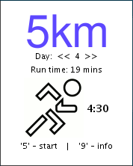
When the 5km application is launched the main screen is shown. On the main screen you can start todays run, find help and see the activities of the day:

- 0 or B - select first non-completed day
- 1 or D - toggle status of the day
- 5, fire or A - to start the selected run
- 9 or C - show help
- 4 or left - show previous day
- 6 or right - show next day
- 2 or up - show previous activity
- 8 or down - show next activity

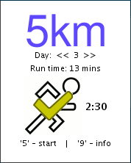
If the day is marked with a yellow checkmark it means that this day is already completed. You can ofcourse run that day again but, really, you should move on.

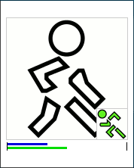
When running the current activity is shown with a large icon - this is what you need to do now. The next activity is shown as a small icon in the lower right corner. The blue line shows your progress in the current activity and the green line shows the overall progress. When you need to change activity (from run to walk or vice versa) your mobile phone will play a sound and vibrate (if supported). At any point of time you can press:

- 0, up or B - to pause the application
- 5, fire or A - to exit the current day (this will not mark the day as completed)

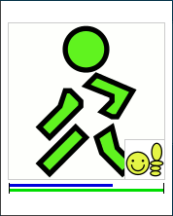
When half the time of the days activity has been reached the icons will change color to green. This indicates that you need to run towards home.

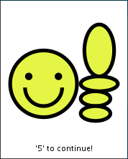
When done with the days run you are greeted with the yellow happy face. The run will be marked as completed. Please do some stretching before hitting the shower. Get some rest before running the next day ...

< Activities >



This activity means that you must run in a steady pace. The speed must be so that you could have a conversation with a partner without losing your breath. A green man indicates it's time to run towards home.



This activity means that you must walk in a more up-beat tempo than what you normally would do. Do not run, though. Walk fast and keep up the pulse. A green man indicates it's time to walk towards home.


Running is over. Give yourself some credit, do some stretching and then hit the shower.

