Session 02, Applied Analytics
----

conda env update --file environment.yml

Section 1: Setting Up Environment For Collaborative Code Development

Command Line & Python Virtual Development Environment
We will use the command line (also known as the command line shell/prompt/console) to run our Python code and interact with the version control tool Git and software sharing platform GitHub. We will also use command line tools conda to set up a Python virtual development environment and isolate our software project from other Python projects we may work on.

Integrated Development Environment (IDE)
An IDE integrates a number of tools that we need to develop a software project that goes beyond a single script - including a smart code editor, a code compiler/interpreter, a debugger, etc.
We will use VS Code with Anaconda

Git & GitHub
Git is a free and open source distributed version control system designed to save every change made to a (software) project, allowing others to collaborate and contribute. In this course, we use Git to version control our code in conjunction with GitHub for code backup and sharing. GitHub is one of the leading integrated products and social platforms for modern software development, monitoring and management - it will help us with version control, issue management, code review, code testing/Continuous Integration, and collaborative development. An important concept in collaborative development is version control workflows (i.e. how to effectively use version control on a project with others).

Python Coding Style
Most programming languages will have associated standards and conventions for how the source code should be formatted and styled. Although this sounds pedantic, it is important for maintaining the consistency and readability of code across a project. Therefore, one should be aware of these guidelines and adhere to whatever the project you are working on has specified. In Python, we will be looking at a convention called PEP8.

Downloading Our Software Project
To start working on the project, you will first create a fork of the software project repository from GitHub within your own GitHub account and then obtain a local copy of that project (from your GitHub) on your machine.
- Log into your GitHub account.
- Go to the software project repository in GitHub.
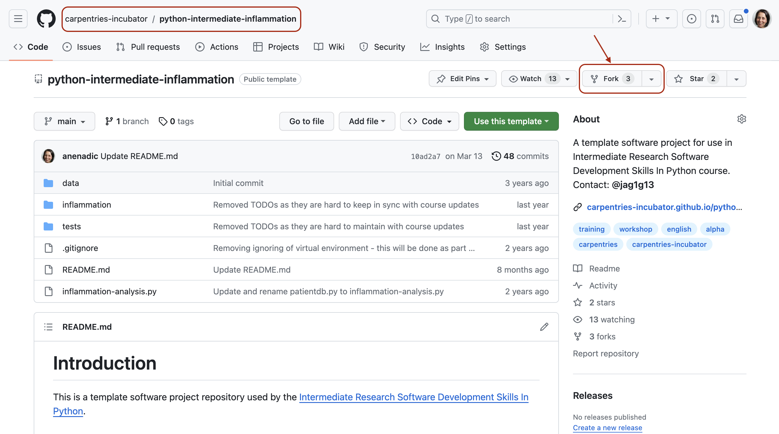
- Click the Fork button towards the top right of the repository’s GitHub page to create a fork of the repository under your GitHub account. Remember, you will need to be signed into GitHub for the Fork button to work.
Note: each participant is creating their own fork of the project to work on.
Note 2: we are creating a fork of the software project repository (instead of copying it from its template) because we want to preserve the history of all commits (with template copying you only get a snapshot of a repository at a given point in time).
- Make sure to select your personal account and set the name of the project to python-intermediate-inflammation (you can call it anything you like, but it may be easier for future group exercises if everyone uses the same name). Ensure that you uncheck the Copy the main branch only option. This guarantees you get all the branches from this repository needed for later exercises.
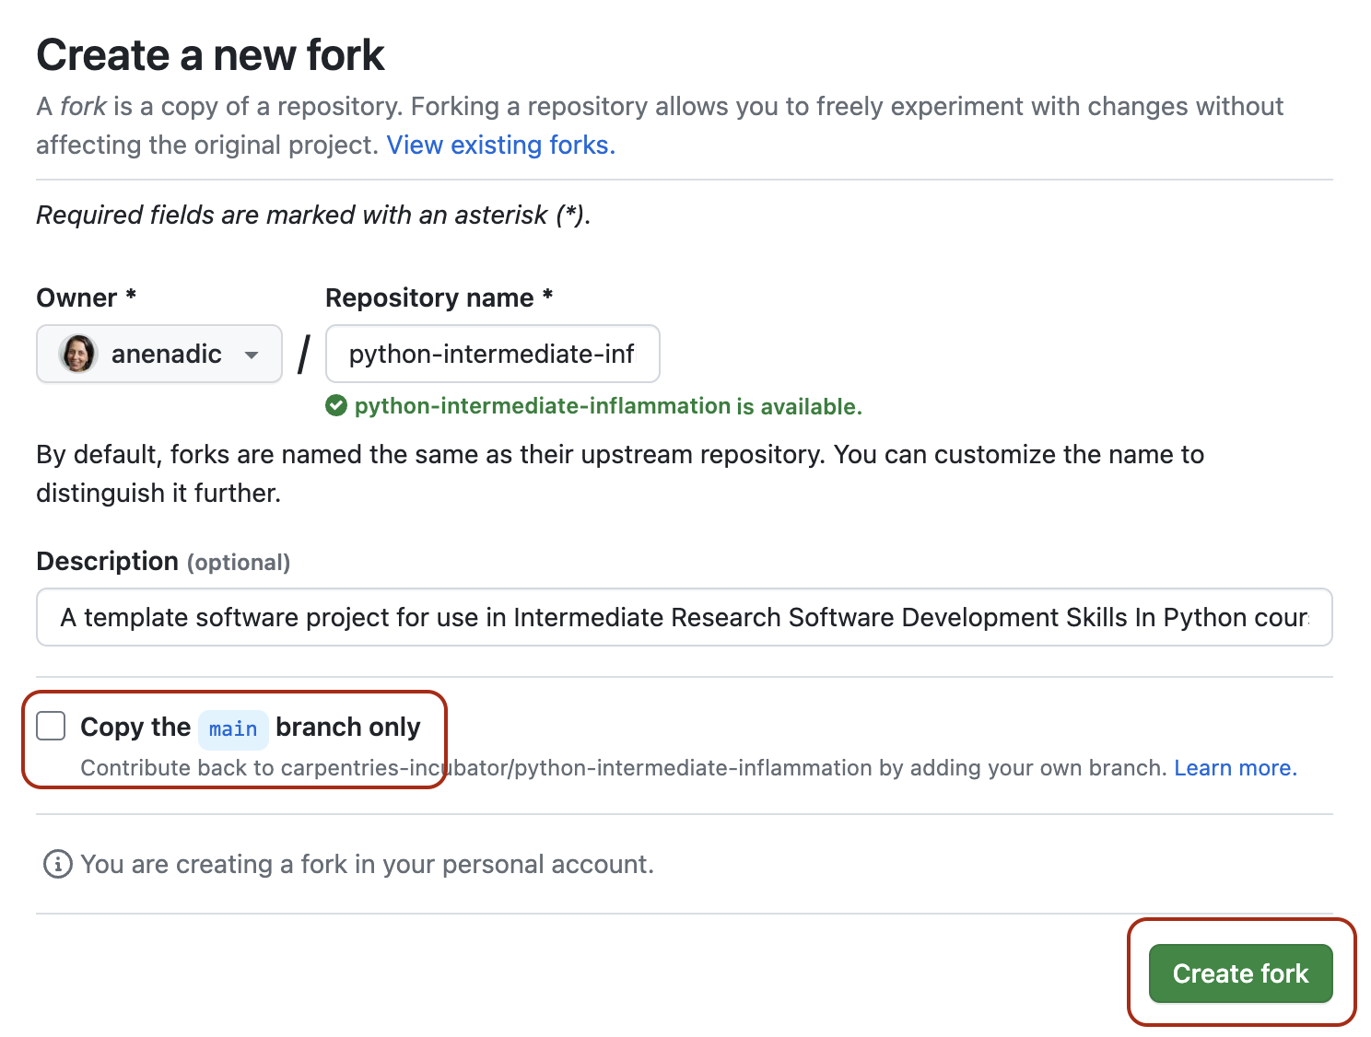
- Click the Create fork button and wait for GitHub to create the forked copy of the repository under your account.
- Locate the forked repository under your own GitHub account. GitHub should redirect you there automatically after creating the fork. If this does not happen, click your user icon in the top right corner and select Your Repositories from the drop-down menu, then locate your newly created fork.

Virtual Environments
So what exactly are virtual environments, and why use them?
A Python virtual environment helps us create an isolated working copy of a software project that uses a specific version of Python interpreter together with specific versions of a number of external libraries installed into that virtual environment. Python virtual environments are implemented as directories with a particular structure within software projects, containing links to specified dependencies allowing isolation from other software projects on your machine that may require different versions of Python or external libraries.

A Specific Python or Package Version is Only Ever Installed Once
Note that you will not have a separate Python or package installations for each of your projects - they will only ever be installed once on your system but will be referenced from different virtual environments.

Managing Python Virtual Environments
There are several commonly used command line tools for managing Python virtual environments:
- venv, available by default from the standard Python distribution from Python 3.3+
- virtualenv, needs to be installed separately but supports both Python 2.7+ and Python 3.3+versions
- pipenv, created to fix certain shortcomings of virtualenv
- conda, package and environment management system (also included as part of the Anaconda Python distribution often used by the scientific community)
- poetry, a modern Python packaging tool which handles virtual environments automatically
While there are pros and cons for using each of the above, all will do the job of managing Python virtual environments for you and it may be a matter of personal preference which one you go for. In this course, we will use venv to create and manage our virtual environment (which is the preferred way for Python 3.3+). The upside is that venv virtual environments created from the command line are also recognised and picked up automatically by PyCharm IDE, as we will see in the next episode.

Managing External Packages
Part of managing your (virtual) working environment involves installing, updating and removing external packages on your system. The Python package manager tool pip is most commonly used for this - it interacts and obtains the packages from the central repository called Python Package Index (PyPI). pip can now be used with all Python distributions (including Anaconda).

A Note on Anaconda and conda
Anaconda is an open source Python distribution commonly used for scientific programming - it conveniently installs Python, package and environment management conda, and a number of commonly used scientific computing packages so you do not have to obtain them separately. conda is an independent command line tool (available separately from the Anaconda distribution too) with dual functionality: (1) it is a package manager that helps you find Python packages from remote package repositories and install them on your system, and (2) it is also a virtual environment manager. So, you can use conda for both tasks instead of using venv and pip.

Many Tools for the Job
venv and pip are considered the de facto standards for virtual environment and package management for Python 3. However, the advantages of using Anaconda and conda are that you get (most of the) packages needed for scientific code development included with the distribution. If you are only collaborating with others who are also using Anaconda, you may find that conda satisfies all your needs. It is good, however, to be aware of all these tools, and use them accordingly. As you become more familiar with them you will realise that equivalent tools work in a similar way even though the command syntax may be different (and that there are equivalent tools for other programming languages too to which your knowledge can be ported).

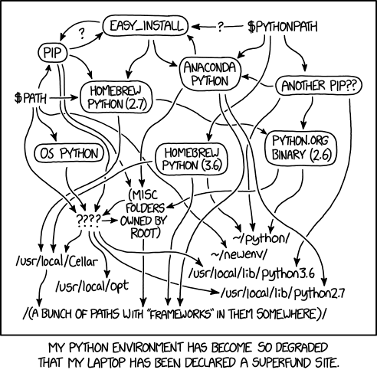

Creating Virtual Environments Using conda

conda create –name pimaIndianData python=3.11
conda activate ...
conda deactivate

python3 -m pip freeze > requirements.txt
cat requirements.txt

Look around in data with bash:
- less
- wc -» infer no of rows

Create python env: (-m stands for module)
- python3 -m venv .
- . venv/bin/activate //source would also work
- which python // verify that python interpreter comes from venv
- Good idea to keep all venvs in one dir, such as ~/venv

Install packages:
- python3 -m pip install numpy // use python3 -m to control which pip will be used: the version inside your env
- python3 -m pip show numpy | less
- python3 -m pip list
- python3 -m pip freeze // no pip for instance --» exportable
- python3 -m pip freeze > requirements.txt
- python3 -m pip install -r requirements.txt // all is already installed

- python -m pip install pytest

Git Refresher
Git is a version control system for tracking changes in computer files and coordinating work on those files among multiple people.
Git has several important characteristics:
- support for non-linear development allowing you and your colleagues to work on different parts of a project concurrently,
- support for distributed development allowing for multiple people to be working on the same project (even the same file) at the same time,
- every change recorded by Git remains part of the project history and can be retrieved at a later date, so even if you make a mistake you can revert to a point before it.
The diagram below shows a typical software development lifecycle with Git (starting from making changes locally) and the commonly used commands to interact with different parts of the Git infrastructure, such as:
- working directory - a local directory (including any subdirectories) where your project files live and where you are currently working. It is also known as the “untracked” area of Git. Any changes to files will be marked by Git in the working directory. If you make changes to the working directory and do not explicitly tell Git to save them - you will likely lose those changes. Using git add filename command, you tell Git to start tracking changes to file filename within your working directory.
- staging area (index) - once you tell Git to start tracking changes to files (with git add filename command), Git saves those changes in the staging area on your local machine. Each subsequent change to the same file needs to be followed by another git add filename command to tell Git to update it in the staging area. To see what is in your working directory and staging area at any moment (i.e. what changes is Git tracking), run the command git status.
- local repository - stored within the .git directory of your project locally, this is where Git wraps together all your changes from the staging area and puts them using the git commit command. Each commit is a new, permanent snapshot (checkpoint, record) of your project in time, which you can share or revert to.
- remote repository - this is a version of your project that is hosted somewhere on the Internet (e.g., on GitHub, GitLab or somewhere else). While your project is nicely version-controlled in your local repository, and you have snapshots of its versions from the past, if your machine crashes - you still may lose all your work. Furthermore, you cannot share or collaborate on this local work with others easily. Working with a remote repository involves pushing your local changes remotely (using git push) and pulling other people’s changes from a remote repository to your local copy (using git fetch or git pull) to keep the two in sync in order to collaborate (with a bonus that your work also gets backed up to another machine). Note that a common best practice when collaborating with others on a shared repository is to always do a git pull before a git push, to ensure you have any latest changes before you push your own.
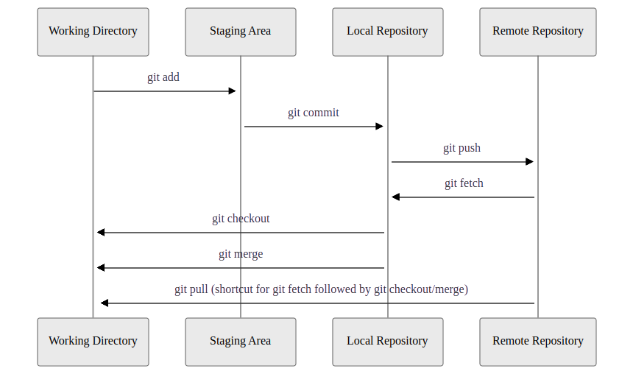
Software development lifecycle with Git

Checking-in Changes to Our Project
Let’s check-in the changes we have done to our project so far. The first thing to do upon navigating into our software project’s directory root is to check the current status of our local working directory and repository.
$ git status
...

$ git add .gitignore requirements.txt
Now we can commit them to the local repository with:
$ git commit -m "Initial commit of requirements.txt. Ignoring virtual env. folder."
Remember to use meaningful messages for your commits.
Now we’ve ensured our repository is synchronised with the remote one, we can now push our changes:
$ git push origin main
In the above command, origin is an alias for the remote repository you used when cloning the project locally (it is called that by convention and set up automatically by Git when you run git clone remote_url command to replicate a remote repository locally); main is the name of our main (and currently only) development branch.

GitHub Authentication/Authorisation Error
If, at this point (i.e. the first time you try to write to a remote repository on GitHub), you get a warning/error that HTTPS access is deprecated, or a personal access token is required, then you have cloned the repository using HTTPS and not SSH. You should revisit the instructions on setting up your GitHub for SSH and key pair authentication and can fix this from the command line by changing the remote repository’s HTTPS URL to its SSH equivalent:
$ git remote set-url origin git@github.com:<YOUR_GITHUB_USERNAME>/python-intermediate-inflammation.git

Git Remotes
Note that systems like Git allow us to synchronise work between any two or more copies of the same repository - the ones that are not located on your machine are “Git remotes” for you. In practice, though, it is easiest to agree with your collaborators to use one copy as a central hub (such as GitHub or GitLab), where everyone pushes their changes to. This also avoid risks associated with keeping the “central copy” on someone’s laptop. You can have more than one remote configured for your local repository, each of which generally is either read-only or read/write for you. Collaborating with others involves managing these remote repositories and pushing and pulling information to and from them when you need to share work.
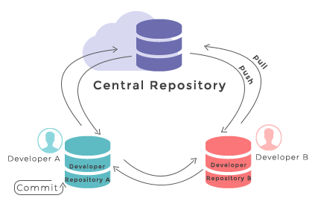
Git - distributed version control system
From W3Docs (freely available)

Git Branches
When we do git status, Git also tells us that we are currently on the main branch of the project. A branch is one version of your project (the files in your repository) that can contain its own set of commits. To see what other branches are available, do:
$ git branch
* main
At the moment, there’s only one branch (main) and hence only one version of the code available. When you create a Git repository for the first time, by default you only get one version (i.e. branch) - main. Let’s have a look at why having different branches might be useful.
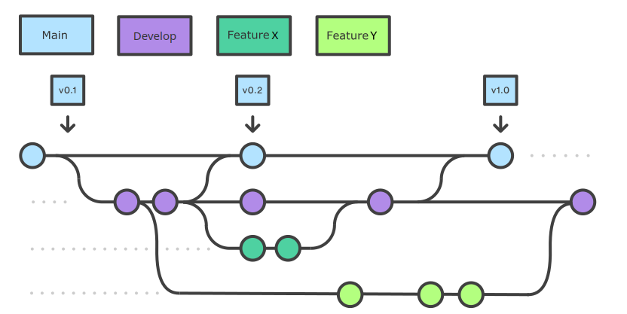
Git feature branches
Adapted from Git Tutorial by sillevl (Creative Commons Attribution 4.0 International License)

Creating Branches
Let’s create a develop branch to work on:
$ git branch develop
This command does not give any output, but if we run git branch again, without giving it a new branch name, we can see the list of branches we have - including the new one we have just made.
$ git branch
develop
* main
The * indicates the currently active branch. So how do we switch to our new branch? We use the git switch command with the name of the branch:
$ git switch develop
Switched to branch 'develop'

Create and Switch to Branch Shortcut
A shortcut to create a new branch and immediately switch to it:
$ git switch -c develop

Updating Branches
If we start updating and committing files now, the commits will happen on the develop branch and will not affect the version of the code in main. We add and commit things to develop branch in the same way as we do to main.
Let’s make a small modification to inflammation/models.py in PyCharm, and, say, change the spelling of “2d” to “2D” in docstrings for functions daily_mean(), daily_max() and daily_min() to see updating branches in action.
If we do:
$ git status
On branch develop
Changes not staged for commit:
(use "git add <file>..." to update what will be committed)
(use "git restore <file>..." to discard changes in working directory)

modified: inflammation/models.py

no changes added to commit (use "git add" and/or "git commit -a")
Git is telling us that we are on branch develop and which tracked files have been modified in our working directory.
We can now add and commit the changes in the usual way.
$ git add inflammation/models.py
$ git commit -m "Spelling fix"

Currently Active Branch
Remember, add and commit commands always act on the currently active branch. You have to be careful and aware of which branch you are working with at any given moment. git status can help with that, and you will find yourself invoking it very often.

Pushing New Branch Remotely
We push the contents of the develop branch to GitHub in the same way as we pushed the main branch. However, as we have just created this branch locally, it still does not exist in our remote repository. You can check that in GitHub by listing all branches.
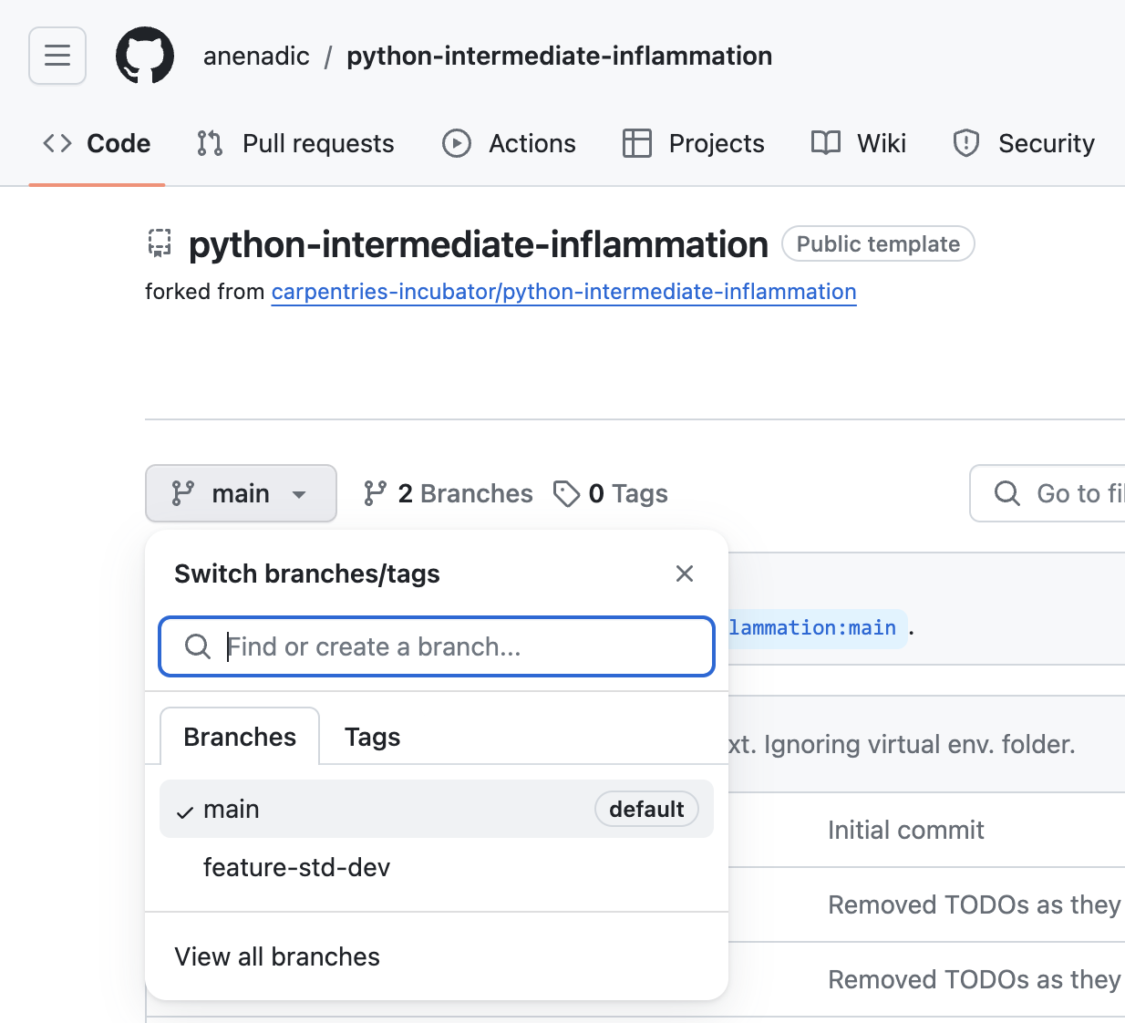
To push a new local branch remotely for the first time, you could use the -u flag and the name of the branch you are creating and pushing to:
$ git push -u origin develop
Let’s confirm that the new branch develop now exist remotely on GitHub too. From the Code tab in your repository in GitHub, click the branch dropdown menu (currently showing the default branch main). You should see your develop branch in the list too.
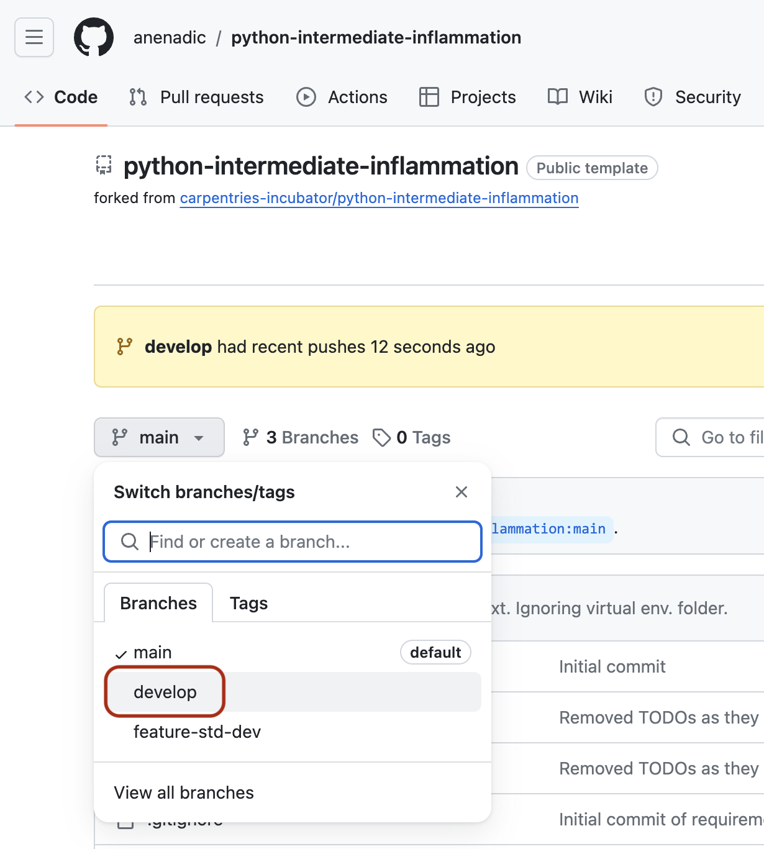
You may also have noticed GitHub’s notification about the latest push to your develop branch just on top of the repository files and branches drop-down menu.
Now the others can check out the develop branch too and continue to develop code on it.
After the initial push of the new branch, each next time we push to it in the usual manner (i.e. without the -u switch):
$ git push origin develop

What is the Relationship Between Originating and New Branches?
It’s natural to think that new branches have a parent/child relationship with their originating branch, but in actual Git terms, branches themselves do not have parents but single commits do. Any commit can have zero parents (a root, or initial, commit), one parent (a regular commit), or multiple parents (a merge commit), and using this structure, we can build a ‘view’ of branches from a set of commits and their relationships.

Merging Into Main Branch
Once you have tested your changes on the develop branch, you will want to merge them onto the main branch. To do so, make sure you have committed all your changes on the develop branch and then switch to main:
$ git switch main
Switched to branch 'main'
Your branch is up to date with 'origin/main'.
To merge the develop branch on top of main do:
$ git merge develop
Updating 05e1ffb..be60389
Fast-forward
inflammation/models.py | 6 +++---
1 files changed, 3 insertions(+), 3 deletions(-)
If there are no conflicts, Git will merge the branches without complaining and replay all commits from develop on top of the last commit from main. If there are merge conflicts (e.g. a team collaborator modified the same portion of the same file you are working on and checked in their changes before you), the particular files with conflicts will be marked and you will need to resolve those conflicts and commit the changes before attempting to merge again. Since we have no conflicts, we can now push the main branch to the remote repository:
$ git push origin main

Keeping Main Branch Stable
Good software development practice is to keep the main branch stable while you and the team develop and test new functionalities on feature branches (which can be done in parallel and independently by different team members). The next step is to merge feature branches onto the develop branch, where more testing can occur to verify that the new features work well with the rest of the code (and not just in isolation). We talk more about different types of code testing in one of the following episodes.

- which python // verify that python interpreter comes from venv
- python3 -m pip freeze > requirements.txt
- python3 -m pip install -r requirements.txt // all is already installed

---

Use Git:

- git diff // check differences to repo
- git add // or git restore
- Use the .gitignore to add the virtual env: venv
- git status // check what has been changes: “modified .gitignore”
- git commit .gitignore -m "chore: ignore virtual env” //use semantic standards: “chore, fix, feature()
- git add requirements.txt
- git commit -m "chore: add requirement"
- git push

// Initialise and upload to Github:
git init -b main
gh repo create
//you want to create a remote (git remote add main https://github.com/m-schulte-althoff/AlboConservative.git)

- Master/Slave outdated wording -» main
- git branch
- git branch –remote //see the remote branches
- git branch develop // create branch develop
- git switch develop
- git branch // confirm that you are on the develop branch
- git add . && git commit -m "model fix"
- git diff main //see changes with regard to remote repo
- git push --» copy paste: git push --set-upstream origin develop
- git merge develop

Style-Tipps
- git switch -c style-fixes // create new branch and switch to it
- git commit -a -m "model fix"
- pydoc3 inflammation/models.py //create documentation
- Check docs within python:
  - ipython3 --» import inflammation.models --» inflammation.models.daily_max?
- python3 -m pip install pylint
- python3 -m pip freeze > requirements.txt
- git status
- git commit -a -m "install linter"
- pylint inflammation // see some issue that your code might have!
  - Same in VS Code in the tab “Problems” WHEN Pylint as addon installed
- Add different chunks:
  - git commit -m “chore: require linter” requirements.txt
  - git commit -a -m “style: make linter happy”

---

Python Code Style Conventions

https://softwaresaved.github.io/az-intermediate-software-skills-course/15-coding-conventions/index.html

Indentation
Python is a kind of language that uses indentation as a way of grouping statements that belong to a particular block of code.

Maximum Line Length
All lines should be up to 80 characters long; for lines containing comments or docstrings (to be covered later) the line length limit should be 73 - see this discussion for reasoning behind these numbers. Some teams strongly prefer a longer line length, and seemed to have settled on the length of 100. Long lines of code can be broken over multiple lines by wrapping expressions in delimiters, as mentioned above (preferred method), or using a backslash (\) at the end of the line to indicate line continuation (slightly less preferred method).

Should a Line Break Before or After a Binary Operator?
Lines should break before binary operators so that the operators do not get scattered across different columns on the screen.

Function, Variable, Class, Module, Package Naming
- Function and variable names should be lowercase, with words separated by underscores as necessary to improve readability.
- Class names should normally use the CapitalisedWords convention.
- Modules should have short, all-lowercase names. Underscores can be used in the module name if it improves readability.
- Packages should also have short, all-lowercase names, although the use of underscores is discouraged.

The Good, the Bad, and the Ugly Comments
As a side reading, check out the ‘Putting comments in code: the good, the bad, and the ugly’ blogpost. Remember - a comment should answer the ‘why’ question”. Occasionally the “what” question. The “how” question should be answered by the code itself.

... software correct at scale --- testing...

Model view controller &&
Python vs. Jupyter Notebook

Verifying Code Style Using Linters
https://scientificcomputingcharite.github.io/2024-06-24-python-intermediate-development/16-verifying-code-style-linters/index.html

pylint inflammation
You should see an output similar to the following:
************* Module inflammation.models
inflammation/models.py:13:23: C0303: Trailing whitespace (trailing-whitespace)
inflammation/models.py:34:0: C0305: Trailing newlines (trailing-newlines)
************* Module inflammation.views
inflammation/views.py:4:0: W0611: Unused numpy imported as np (unused-import)

------------------------------------------------------------------
Your code has been rated at 8.50/10 (previous run: 8.50/10, +0.00)
Your own outputs of the above commands may vary depending on how you have implemented and fixed the code in previous exercises and the coding style you have used.
The five digit codes, such as C0303, are unique identifiers for warnings, with the first character indicating the type of warning. There are five different types of warnings that Pylint looks for, and you can get a summary of them by doing:
$ pylint --long-help
Near the end you’ll see:
Output:
Using the default text output, the message format is :
MESSAGE_TYPE: LINE_NUM:[OBJECT:] MESSAGE
There are 5 kind of message types :
* (C) convention, for programming standard violation
* (R) refactor, for bad code smell
* (W) warning, for python specific problems
* (E) error, for probable bugs in the code
* (F) fatal, if an error occurred which prevented pylint from doing
further processing.
So for an example of a Pylint Python-specific warning, see the “W0611: Unused numpy imported as np (unused-import)” warning.
It is important to note that while tools such as Pylint are great at giving you a starting point to consider how to improve your code, they won’t find everything that may be wrong with it.

How Does Pylint Calculate the Score?
The Python formula used is (with the variables representing numbers of each type of infraction and statement indicating the total number of statements):
10.0 - ((float(5 * error + warning + refactor + convention) / statement) * 10)

