Forecasting Town Traffic Five Seconds Ahead
A separate model already turns the pictures from 141 fixed traffic cameras into one top down view of a whole town, showing where every vehicle is. This work takes that view and asks the next question: given the last five seconds of it, what do the next five seconds look like? Crash warning, congestion detection and violation detection all sit on top of an answer to that, so the forecast is what gets built and measured here.
What follows runs in order: how the data was made, what the model is, how it was trained, and what it scores.
1. Generating the data
Real roads cannot supply what this needs. Training requires the exact position of every vehicle at every instant, and it requires crashes often enough to learn from. Both are free in a simulator, so the data is generated in CARLA, an open driving simulator, using its built in town called Town05.
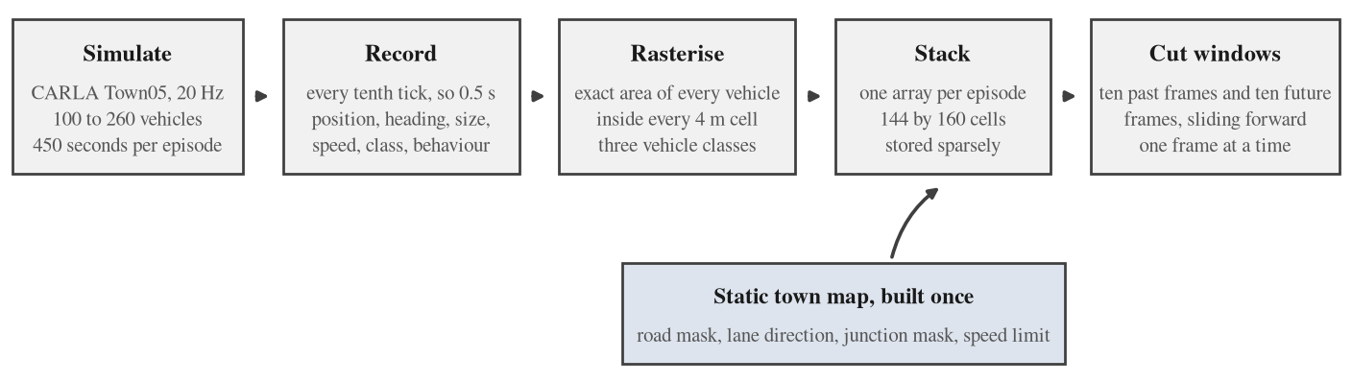
Figure 1. From simulator to training example. The town map is built once and reused by every episode.
One episode
An episode is a single run of the simulator. Each one places between 100 and 260 vehicles at random spawn points and lets them drive for 450 seconds. Physics runs at 20 steps per second and the world is saved every tenth step, so one saved frame every 0.5 seconds. For every vehicle the record holds its position, heading, length and width, speed, class and behaviour tag, along with every collision the simulator reports. Episode number maps to configuration through a seeded generator, so any episode can be regenerated exactly. Half the episodes are ordinary traffic and half contain bad drivers.
What nominal traffic means
Nominal does not mean identical. Every vehicle is driven by CARLA's Traffic Manager, and each one draws its own settings, so the traffic has natural spread rather than moving as a block:
- speed: drawn per vehicle between 5 percent above the posted limit for its lane and 20 percent below it
- following distance: drawn per vehicle between 2.0 and 4.5 metres
- traffic lights and road signs: always obeyed
- collision avoidance: fully on
Traffic like this still produces about one contact per simulated minute, almost all of it slow bumping in queues. That is the clean baseline the bad drivers are measured against.
Adding bad drivers
On the other half of the episodes a fraction between 6 and 14 percent of the vehicles is drawn at random without replacement and reassigned to one of four profiles in rotation, so the four kinds appear in roughly equal numbers. Every profile works by changing the rules a driver follows rather than by making the driver blind, with one deliberate exception. A vehicle that cannot see other vehicles simply drives through them: an early calibration measured 126 collisions per simulated minute that way, which is carnage rather than traffic.
Profile | The idea | Exact settings
Speeding | Well over the limit with almost no gap, which is the classic rear end setup when the vehicle ahead stops for a light. | speed 50 to 90 percent above the lane limit; following distance 0.3 to 1.2 m; ignores stop and yield signs 90 percent of the time; obeys traffic lights; avoidance on
Red light runner | Enters junctions against the signal. Avoidance stays on, so a crash happens only when the cross traffic is genuinely unavoidable. | ignores every traffic light and every sign; speed 20 to 50 percent above the limit; following distance 1.0 to 2.5 m; avoidance on
Erratic, the impaired driver | Weaves between lanes, judges gaps badly and is slow to notice other traffic. The only profile given partial blindness, because that is the behaviour being modelled rather than a side effect. | random lane change 40 to 90 percent to the left and 40 to 90 percent to the right; ignores other vehicles 10 to 35 percent of the time; ignores lights 5 to 25 percent of the time; speed from 50 percent above the limit to 30 percent below it; following distance 0.2 to 1.5 m
Tailgater | Sits on the bumper of the vehicle ahead. | following distance 0 m; speed 10 to 35 percent above the limit; obeys lights; avoidance on
Table 1. Every bad driver is a change of rules, not a change of physics.
With this mix, an episode carrying bad drivers produces roughly one meaningful collision per simulated minute.
Turning vehicles into a picture
The town is covered with square cells 4 metres across, 144 rows by 160 columns, which spans 576 by 640 metres and contains all of Town05. A cell does not store yes or no. It stores the fraction of its own area covered by vehicle bodies, a number from 0 to 1. Each vehicle rectangle is intersected with each cell exactly, by clipping polygons, so the value is a measured area rather than an estimate.
This is the most consequential choice in the whole dataset. Four metres is coarse next to a car, but because the stored value is an area fraction, a car straddling a boundary splits itself between the two cells in proportion. Its position inside the cell survives, and so does its motion from one frame to the next.
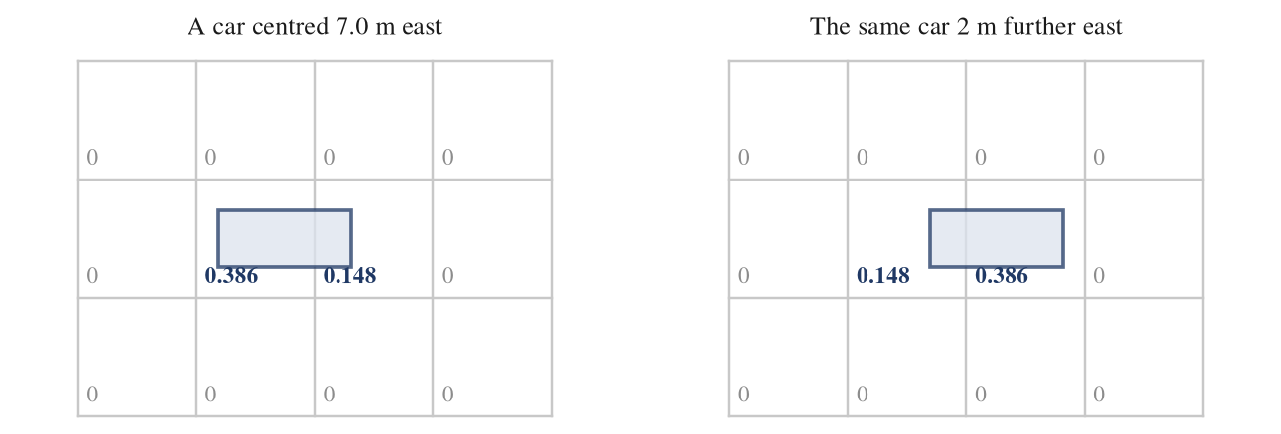
Figure 2. The same car, two metres apart. Each cell is 4 metres across and holds the fraction of its area under a vehicle, so a shift far smaller than one cell still changes the numbers.
Three occupancy channels are kept, because the three groups move differently:
- cars
- large vehicles: trucks, vans and buses
- two wheelers: motorcycles and bicycles
Two more channels hold the speed of whatever is in the cell, east and north, in metres per second. These are targets only. The camera model that will feed this system produces occupancy and not speed, so handing the network true speeds as an input would flatter every number it later produces.
The map the town sits on
Six further channels describe the town itself. They never change and are attached to every frame. The last two columns below are the actual six numbers stored for one open road cell and one cell inside a junction.
Channel | Meaning | Open road | Junction
road | 1 where a vehicle can be | 1.000 | 1.000
lane direction, north | sine of the lane heading | -1.000 | -1.000
lane direction, east | cosine of the lane heading | -0.012 | 0.022
lane agreement | 1 where every lane in the cell points the same way | 1.000 | 0.123
junction | 1 inside an intersection | 0.000 | 1.000
speed limit | posted limit in metres per second | 8.333 | 8.333
Table 2. The six map channels, with a real sample of each.
Lane agreement is what separates the two samples. On a straight road every lane crossing the cell points the same way and the value is 1; inside a junction the lanes cross and it collapses to 0.123. About a quarter of the grid touches road at all, and telling the model where a vehicle can physically be saves it from spending capacity rediscovering the town.
Traffic light state is recorded but never given to the model. The task is to predict traffic from traffic. Handing over the signal phase would let the model learn that cars stop on red without learning that cars decelerate, and the camera model could not supply it anyway.
Training examples and the split
A training example is a window of twenty consecutive frames: ten past frames the model sees, and ten future frames it has to produce. At 0.5 seconds a frame that is five seconds of history and five seconds of forecast. Windows slide forward one frame at a time, so neighbouring windows overlap heavily. That overlap is why the train and validation split is made by episode and never by window: 53 of the 355 episodes are held out whole, and no frame from a training episode can appear in validation.
Quantity | Value
Episodes | 355, of which 302 are used for training and 53 held out
Frames | 318,180 at 0.5 s, which is 44 hours of traffic
Vehicles on screen | 176 per frame on average
Grid | 144 by 160 cells of 4 m, so 576 by 640 metres
Channels per frame | 3 vehicle classes, 2 speed channels, 6 map channels
Training windows | 264,742
Validation windows | 9,381, taken every fifth frame so they are not near duplicates of each other
Occupancy | 2.0 percent of cells hold a vehicle at any moment
Window labels | nominal 44 percent, incident traffic 28 percent, collision 16 percent, low speed contact 12 percent
Table 3. The dataset at a glance.
The window labels are for reporting only and never reach the model. A window counts as a collision if a crash at 3 metres per second or more happens inside its ten future frames, as low speed contact if a slower contact happens, as incident traffic if bad drivers are present but nothing is hit, and as nominal otherwise.
2. The model
Where the design comes from
Two papers settled the shape of it.
OpenSTL (arXiv 2306.11249) benchmarks 24 spatio temporal prediction models on a common footing. On TaxiBJ, a city traffic grid and the closest public relative of this problem, the best model without recurrence matches the best recurrent one while using about one twenty sixth of the computation. Their reading is that recurrence pays off on fast changing data and wastes effort on slow changing data. Town traffic at two frames per second is slow changing.
Earthformer (arXiv 2207.05833) compares seven ways of factorising attention across space and time under identical conditions. Attention applied along one axis at a time, plus a small set of global vectors, wins on every measure while being among the cheapest of the seven. Attending over the whole space and time block at once is the worst.
So the model is an encoder and a decoder built from axial attention blocks with global vectors, and it produces all ten future frames in one pass instead of one frame at a time, which removes any chance of error compounding down the horizon.
What we changed
- Soft targets. Earthformer predicts real valued weather fields. Here the target is an area fraction bounded between 0 and 1, which is what makes the loss in section 3 well posed.
- A convolutional stem and head instead of patch embedding. A 16 metre token cannot say which 4 metre cell a car is in, so the stem keeps full resolution features and hands the last observed frame's features straight across to the head.
- Start from persistence. The head adds its output to the last observed frame rather than drawing the future from nothing. At step one the model is exactly “nothing moves”, so every parameter it spends goes on the change.
- A second output for speed, and a loss term that ties the two outputs together.
- Map conditioning. Weather data has no road network. Town traffic does, and the road network is most of the prior.
The architecture
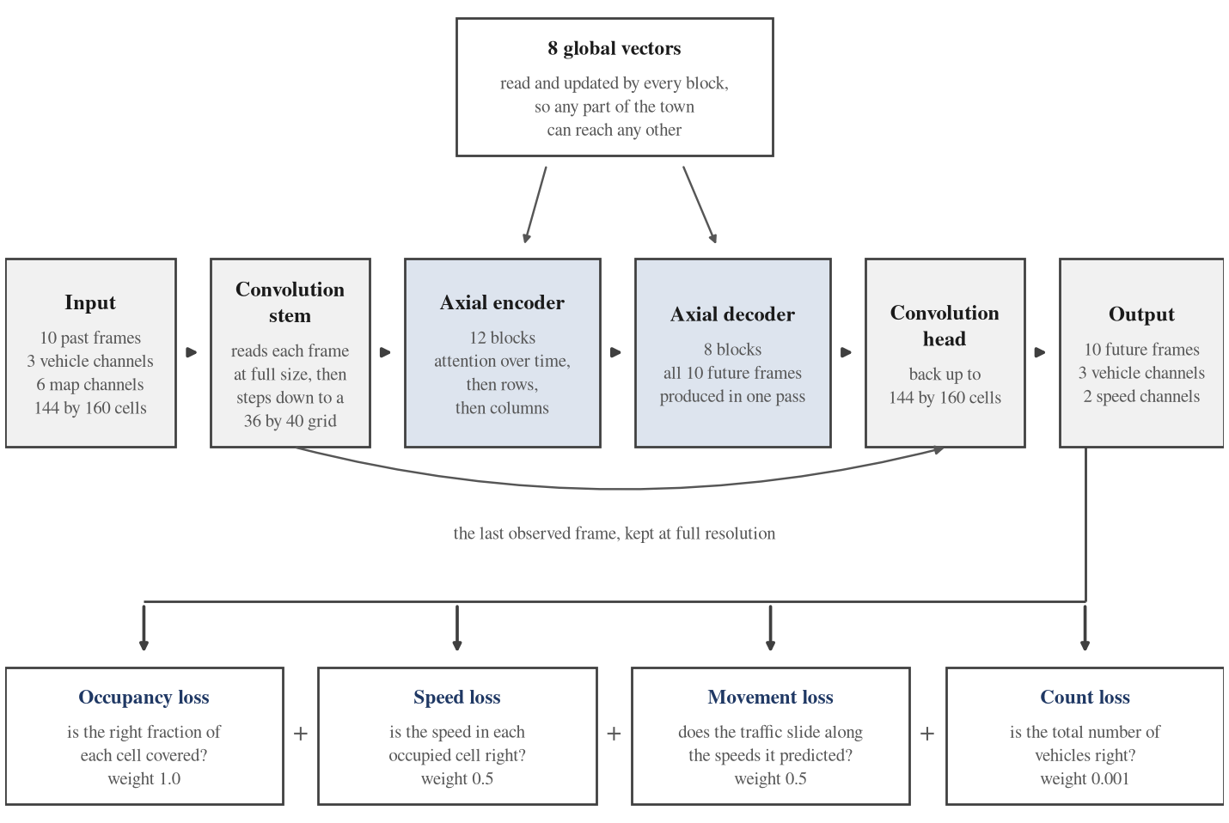
Figure 3. One training step. The upper row is the network, the lower row is the objective it is scored against.
The stem turns each 144 by 160 frame into a 36 by 40 grid of tokens of width 640, so the encoder is working on 14,400 tokens across the ten input frames. Attending over all of them at once would be 207 million pairs in every layer. Attending along one axis at a time means each token reaches 86 others instead of 14,400, and the eight global vectors put back the long range links the factorisation gives up.
Part | Parameters
Convolution stem | 2.0 M
Axial encoder, 12 blocks | 236.3 M
Axial decoder, 8 blocks | 197.0 M
Convolution head | 3.3 M
Position and global embeddings | 0.9 M
Total | 439.5 M
Table 4. Where the capacity sits.
3. Training
Batches
A batch is 8 windows on each of two H100 GPUs, so 16 windows per step, drawn at random from the training episodes. Mirroring is the only augmentation: with probability one half the whole batch is mirrored east to west, and independently with probability one half north to south. The map and the validity mask are mirrored with it and the sign of the matching speed channel is flipped, so the world stays consistent. It is applied to the whole batch at once because the map is shared across the batch, and mirroring one window's traffic without its map would put cars on the wrong side of the road.
What goes in and what comes out
Each of the ten input frames carries nine channels: three occupancy channels and the six map channels. A single cell of a single input frame is therefore nine numbers. For a cell holding most of one car on an open road they are:
cars | large | two wheelers | road | lane north | lane east | lane agreement | junction | speed limit
0.386 | 0.000 | 0.000 | 1.000 | -1.000 | -0.012 | 1.000 | 0.000 | 0.417
Table 5. One cell of one input frame. The posted limit is divided by 20 before it is fed in, so 8.333 metres per second arrives as 0.417 and sits in the same range as everything else.
The whole input is ten of those frames stacked, so 10 by 9 by 144 by 160 numbers. The output is 10 by 3 by 144 by 160 occupancy values and 10 by 2 by 144 by 160 speed values: for every future frame, the fraction of each cell covered by each of the three vehicle groups, and how fast whatever is in that cell is going.
The loss and why each part is there
The objective has four parts, shown along the bottom of Figure 3.
Occupancy loss. Cell by cell cross entropy between the predicted fraction and the true fraction, counting cells at or beside a vehicle ten times a cell of open ground. The target is a fraction, so the loss has to reach its lowest point exactly at the true fraction. Cross entropy does. The two obvious alternatives do not:
- Dice and intersection over union: for a cell that is half covered, soft Dice is lowest when the prediction is 1.0, so they push every partly covered cell to full and inflate the vehicle count (arXiv 2303.16296).
- Focal loss: not a proper scoring rule for any positive focusing parameter, and its bias runs toward under confidence (arXiv 2011.09172), which here means quietly losing vehicles.
The usual worry about cross entropy is that 98 percent of cells are empty and will drown the rest. That is true at the very first step, where the network says one half everywhere and 23,000 empty cells outvote 460 occupied ones, and it is fixed where it happens: the output bias starts at the measured occupancy rate (arXiv 1708.02002), instead of the loss being bent around the problem.
Speed loss. Absolute error between the predicted and true speed, on occupied cells only. An empty cell has no speed to be right about.
Movement loss. Take the occupancy that was actually observed, slide it along the speeds the model predicted, and require the result to match the next frame. This is the term that carries the physics: traffic has to move from where it was, it cannot appear in one place and evaporate from another (arXiv 2203.03312).
Count loss. The total predicted vehicle area in each frame, for each class, has to match the truth. Counting cells near vehicles ten times higher is useful, but it stops the objective being strictly proper, so the total will drift. This term measures that drift in the one quantity that is physically meaningful, the number of vehicles, and pulls it back (arXiv 2009.13077).
The four are combined with weights 1.0, 0.5, 0.5 and 0.001. The count weight looks tiny and is not: the first three are averages over roughly 1.7 million weighted cells, while the count is a sum over the same cells, so its natural gradient at any one cell is about a thousand times larger. Matching the two at an occupied cell is what puts the weight near 0.001.
Settings
Setting | Value
Optimiser | AdamW, betas 0.9 and 0.95, weight decay 0.05 on weight matrices only
Learning rate | 2e-4, with 1,000 warm up steps and then a cosine decay to 5 percent
Precision | bfloat16 mixed, with activation checkpointing on every block
Batch | 8 windows per GPU on 2 GPUs, so 16 per step
Length | 27,297 steps of a 32,000 step budget, which is 1.65 passes over the training set and 35 hours of wall clock
Table 6. Training settings.
4. Results
Everything below is measured on the 53 held out episodes, 9,381 windows, none of which were seen during training.
How it is scored
The headline number is soft intersection over union. For every valid cell of every future frame, add up the smaller of the predicted and the true coverage, add up the larger, and divide one by the other. A perfect forecast scores 1.0. It is computed on the fractions directly with no thresholding, and the cells outside the town boundary, which are 29 percent of the grid and always empty, are excluded so that blank ground cannot flatter the score.
The three baselines
- Repeat the last frame. Copy the present into the future. It sounds trivial, but about half the town is stopped at any moment because of the signals, so it is right about half the time.
- Constant speed, true speeds given. Slide every vehicle along its real velocity, held fixed across the horizon. The model never sees those velocities, so this baseline is handed information the model does not have. It answers how far pure extrapolation gets you even with perfect knowledge of current motion.
- Constant speed, speeds estimated. The same thing, but the velocities are estimated from the last two grids with off the shelf optical flow. This is the version that could actually be deployed.
All three use the same mass conserving warp as the training objective, so a difference in score is a difference in prediction and not in resampling.
 | Over the five seconds | At five seconds
Our model | 0.806 | 0.692
Constant speed, true speeds given | 0.517 | 0.404
Repeat the last frame | 0.465 | 0.408
Constant speed, speeds estimated | 0.400 | 0.276
Table 7. Agreement with what actually happened, higher is better.
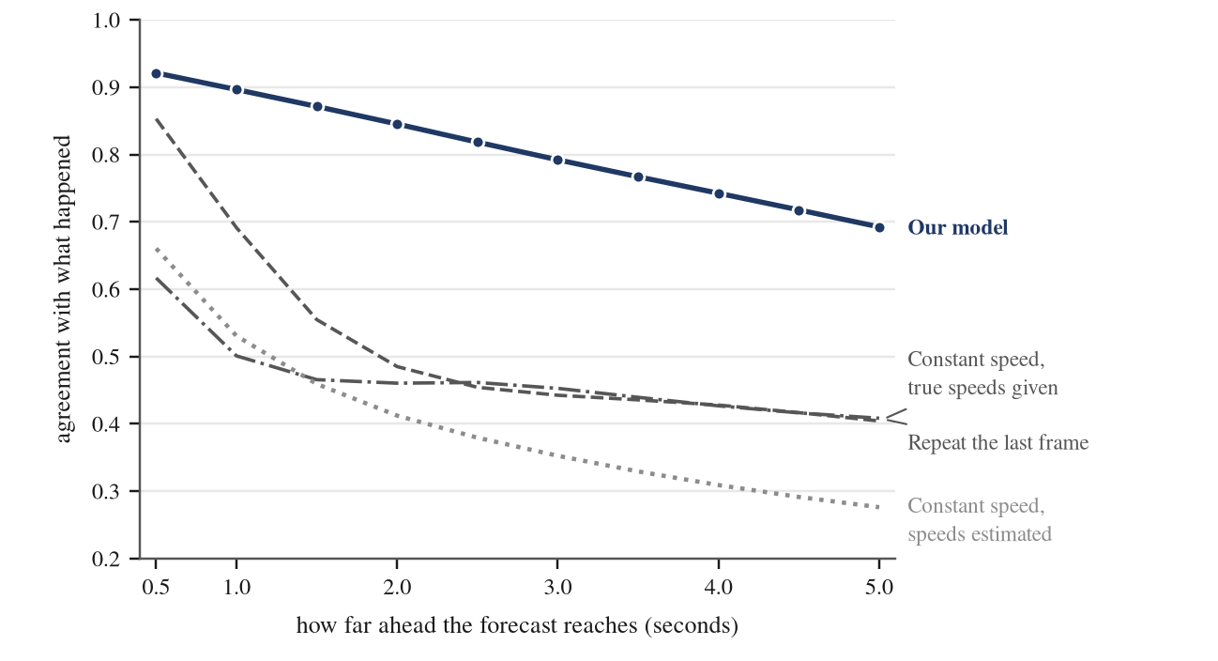
Figure 4. The gap widens with the horizon, which is where a forecast is worth having.
At half a second there is little to win: copying the present already scores 0.617 and the extrapolation given true speeds scores 0.853. By two seconds that extrapolation has fallen to 0.485 because constant velocity cannot turn a corner, stop at a light or join the back of a queue, while the model is still at 0.845. The skill the model has and the baselines do not is telling the vehicle that will sit still for five seconds apart from the one that will travel thirty six metres, and that cannot be read off a single frame.
The score is not bought by hedging
There is a known failure in this literature where a model wins overlap scores by predicting less area than really exists, and so is never wrong in an expensive way. The check is the ratio of predicted total vehicle area to true total vehicle area, which should be 1. Ours runs from 1.003 half a second out to 1.041 at five seconds, and the predicted vehicle count stays within 2.2 percent of the truth. The forecast is very slightly generous rather than timid, which is the right side to err on.
Where it holds up
Window type | Agreement
Nominal traffic | 0.814
Incident traffic, bad drivers present | 0.802
Low speed contact | 0.801
A crash happens in the forecast window | 0.798
Table 8. Accuracy by kind of window.
The hardest windows, the ones that contain an actual crash, cost about 1.6 points against ordinary traffic. Accuracy bends where it matters rather than breaking.
What the forecast looks like
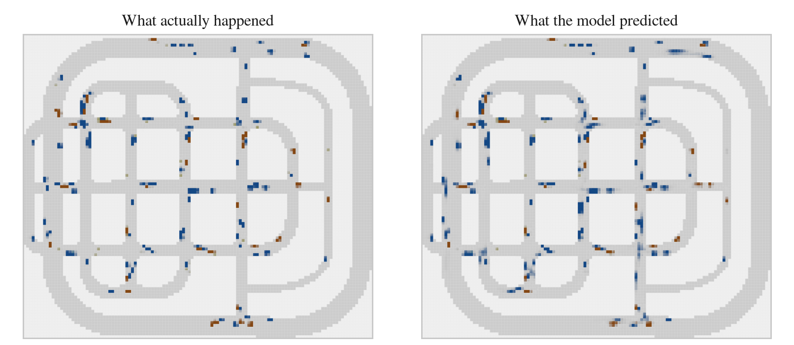
Figure 5. Five seconds ahead on a held out episode. Dark blue is cars, rust is trucks and buses, olive is two wheelers, and grey is the drivable road.
The queues at the junctions are in the right places and roughly the right lengths, worked out from the behaviour of the traffic itself since the model is never told the signal phase. Vehicles stay on the road. Where the forecast is fainter than the truth it is genuinely uncertain, usually about whether a queue has started moving yet, and the total mass still matches.
5. What comes next
- Finish the run. The numbers above come from 1.65 passes over the training data and the curve has not flattened.
- Crash anticipation. Read the forecast at the cell where a collision is about to happen and compare it against a matched control site, by lead time. That turns the forecast into a measured number of seconds of warning, which is the number a deployment would actually be judged on.
- A second town. Everything so far is Town05, so some of the score is certainly memorised layout. Measuring how much means training on one town and testing on another.
- Camera input end to end. Drive the forecaster from the camera model's grid rather than the simulator's. The forecaster was built to take exactly that format and was never given anything the camera model cannot produce, so the swap should be mechanical; what the input noise costs is the open question.
- Longer horizon and finer cells. Five seconds at 4 metres is the first version. Both are preprocessing constants rather than architecture, and the raw vehicle states are kept, so either can be revised for the cost of one pass over the data.

