/**
* Texas Holdem Pro
* © 2012-2013 Ken Wu All rights reserved.
*/
This is a Texas Holdem game that I wrote a year ago for fun. The user can play against the number computer players (3 to 7) simultaneously. The computer players are programmed with its simple artificial intelligence (i.e. A.I.) system to make a move against us.
To run the program, download the TexasHoldemPro-v{$version}.jar file and issue this command :
java -cp TexasHoldemPro-v1.0.jar kw.texasholdem.RunMain
**Note: in order to protect the copyright, I have taken out all the *.java source files inside the kw. texasholdem.ai and kw.texasholdem.tool packages. Any serious inquirer can contact me for the whole source code.

Screen shot 1: The opening screen. Users can input their name and choose number of players on the table.

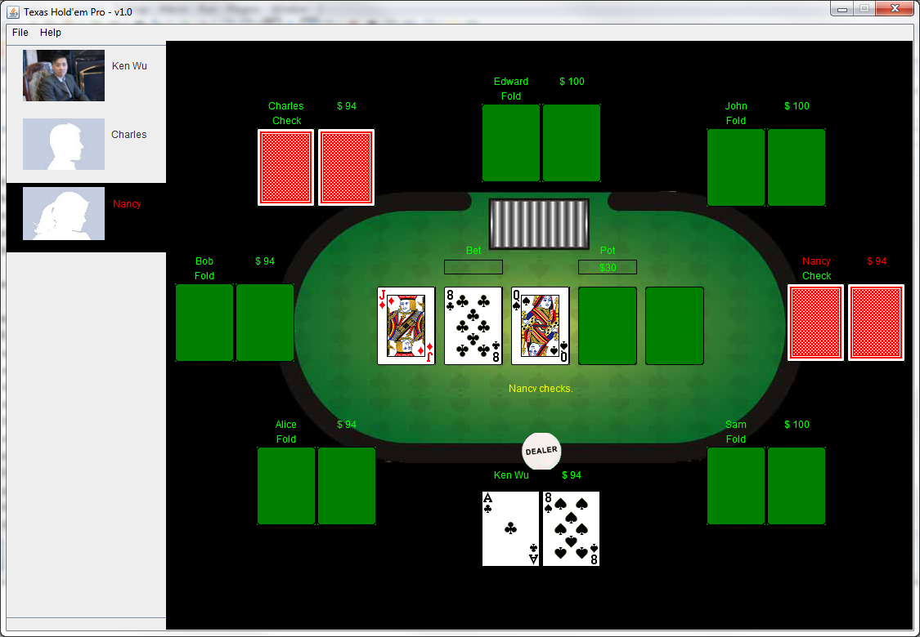
Screen shot 2: The game development – there are only three active players left.


Screen shot 3: At any point, users can exit the game and they will be prompted whether they want to save the game in order to continue it next time.

