Governing AI by Evidence, Not Faith:
A Cybernetic Architecture for Auditable Multi-Model Orchestration

証拠に基づくAIガバナンス：検証可能なマルチモデル統制のためのサイバネティクス・アーキテクチャ

Kimura, M. (きむら博士)
Independent Researcher | MoCKA Project
AI Research Assistant: Claude (Anthropic)
Draft v9.0 | 2026-04-11
DOI: 10.5281/zenodo.19503666 | Target: AIES 2026 / AIGOV@AAAI 2027

Abstract
Multi-model AI orchestration systems face a fundamental governance challenge: when multiple AI agents operate with partial autonomy across heterogeneous tasks, ensuring consistent, auditable, and correctable behavior requires institutional structure beyond prompt engineering or model-level constraints.

We present MoCKA (Model of Cybernetic Knowledge Architecture), a governance architecture grounded in three core mechanisms: (1) the Civilization Loop — an eight-stage mandatory governance cycle derived from industrial control engineering; (2) TRUST_SCORE — a quantitative inter-agent auditing mechanism that detects fabrication and inconsistency in AI outputs; and (3) DNA Packet Injection — a cross-session behavioral constraint protocol that restores governance-aligned behavior at session initialization.

Empirical evaluation across 255 sessions demonstrates: fault rate reduction of 62.7%, recurrence rate improvement from 0.17 to 1.00, autonomous execution risk (AER) reduction from 60% to 0%, and ZYXTS response quality improvement of +0.6367. The system additionally provides a fluid coordinate model P(t) = (X, Y, Z) for continuous governance health monitoring.

We report limitations honestly: single-operator deployment, 30-day observation window, and circular observability coefficient definition. The architecture is proposed as a replicable governance substrate for multi-model AI systems operating in institutional contexts.

Keywords: AI governance, multi-agent systems, cybernetic architecture, observability, incident management, auditable AI, TRUST_SCORE, Civilization Loop

1. Introduction
The deployment of AI systems has shifted from single-model assistants to multi-agent orchestration environments in which several models collaborate on extended tasks. This transition creates governance challenges that single-model safety approaches do not address.

The central problem is institutional: how can an organization trust outputs from AI systems it cannot fully verify, operating faster than human review cycles? Current frameworks provide normative guidance (NIST AI RMF [1], ISO/IEC 42001 [2]) but do not specify operational mechanisms for real-time multi-agent governance.

MoCKA addresses this gap through three operationalizable contributions: a mandatory eight-stage governance loop, a quantitative inter-agent trust scoring mechanism, and a cross-session behavioral constraint protocol. Together these form an institutional governance substrate — not a model-level constraint, but a system-level enforcement architecture.

Design principle: Structure over trust. Rather than relying on AI agents to behave correctly, MoCKA structurally enforces correct behavior through mandatory recording, cryptographic verification, and quantitative auditing.

1.1 Research Questions
RQ1: Does systematic event recording change AI agent behavior in multi-model orchestration?
RQ2: Can inter-agent trust be quantified to detect fabrication without human review of every exchange?
RQ3: Does cross-session behavioral constraint injection produce consistent governance-aligned behavior?
RQ4: Can institutional health be represented as a continuous trajectory rather than a binary state?

2. Related Work

2.1 AI Governance Frameworks
NIST AI RMF [1] provides a four-function framework for AI risk management. ISO/IEC 42001 [2] defines a management system standard. Both are normative — they specify what to do, not how to enforce it operationally. MoCKA complements these by providing operational mechanisms: mandatory event recording, cryptographic audit trails, and quantitative inter-agent trust scoring.

2.2 Multi-Agent Coordination
Research on multi-agent coordination [3, 4] treats coordination as an optimization problem. MoCKA treats it as a governance problem: the question is not how agents coordinate efficiently, but how their coordination can be made auditable and correctable.

2.3 Observability and Auditability
Systems observability [7] concerns metrics, logs, and traces for operational visibility. XAI research [5, 6] focuses on making model decisions interpretable. MoCKA adapts observability to AI governance: the target is institutional compliance, and the audit artifact is a cryptographically verified event ledger.

3. MoCKA System Architecture

3.1 Overview
MoCKA consists of four integrated components: the Civilization Loop (mandatory governance cycle), the Fluid Coordinate Model (continuous health monitoring), three core enforcement mechanisms, and a cryptographic audit layer. Figure 1 shows the full architecture.

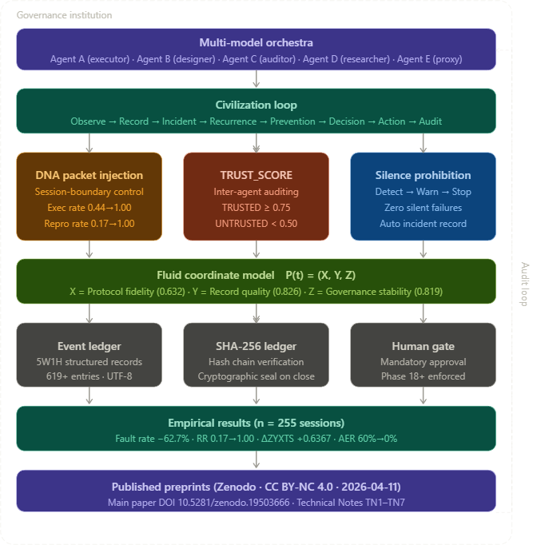
Figure 1: MoCKA System Architecture — Governance institution with multi-model orchestra, civilization loop, three enforcement mechanisms, fluid coordinate model, and evidence layer.

3.2 The Civilization Loop
The Civilization Loop enforces an eight-stage mandatory governance cycle for all institutional events (Figure 2). The design is derived from process safety management in industrial control systems, where stage-skipping is a safety violation.

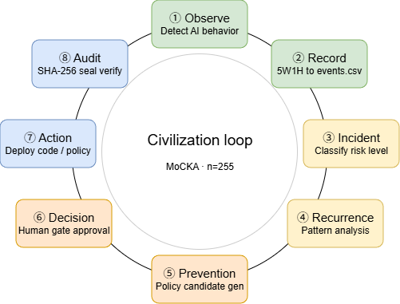
Figure 2: The Civilization Loop — Eight mandatory stages from Observation to Audit, with no stage skippable.
Stage | Operation | MoCKA Implementation | Skip consequence
① Observe | Detect AI behavior | Observability coefficient α | Invisible AI action
② Record | 5W1H structured log | validate_input_integrity() | Unverifiable history
③ Incident | Classify risk level | risk_level ∈ {normal, warning, critical} | Risk invisibility
④ Recurrence | Pattern analysis | recurrence_registry.csv | Repeatable failure
⑤ Prevention | Policy generation | policy_gen2.py | No institutional learning
⑥ Decision | Human gate approval | Mandatory (Phase 18+) | Unauthorized change
⑦ Action | Deploy change | Event-recorded deployment | Audit gap
⑧ Audit | Cryptographic verify | SHA-256 hash chain seal | Unverified governance

3.3 Fluid Coordinate Model P(t) = (X, Y, Z)
Governance health is represented as a continuous three-dimensional trajectory rather than a binary compliant/non-compliant judgment:

P(t) = (X(t), Y(t), Z(t))

Axis | Name | Definition | Current value
X | Protocol fidelity | Fraction of interactions following institutional protocol | 0.632
Y | Record quality | Mean completeness of 5W1H fields across events | 0.826
Z | Governance stability | Consistency of enforcement over rolling 7-day window | 0.819

Diagnostic technology effect: Z-axis decline following MoCKA deployment (0.959→0.654) reflects improved detection of previously invisible failures, not actual degradation. Z subsequently recovered to 0.819 after corrective intervention.

4. Three Core Mechanisms

4.1 DNA Packet Injection
AI language models are stateless between sessions. DNA Packet Injection addresses this through compact JSON constraint packets injected at session initialization:

{"H": "MOCKA_DNA_v2", "G": 5.0, "C": "Strict", "A": "attention_anchor", "P": "session_purpose"}

Packets are generated automatically by a four-layer pipeline: essence_classifier → essence_condenser → ping_generator → session initialization. The pipeline processes 230 operational essences condensed into 11 thematic batches.

Metric | Pre-injection | Post-injection | Delta
Execution rate | 0.44 | 1.00 | +0.56
Reproduction rate | 0.17 | 1.00 | +0.83
INSTRUCTION_IGNORE incidents | 4 / 10 sessions | 0 / 10 sessions | −4

4.2 TRUST_SCORE: Quantitative Inter-Agent Auditing
TRUST_SCORE evaluates agent outputs across four dimensions:

Dimension | Weight | Fabrication indicator
Structural integrity | 0.30 | Missing fields despite claimed completeness
Causal consistency | 0.25 | Effects without plausible causes
Temporal plausibility | 0.25 | Impossible sequences or future timestamps
Fabrication indicators | 0.20 | Fixed input values with variable statistical outputs

Verdicts: TRUSTED (≥0.75), SUSPICIOUS (≥0.50), UNTRUSTED (<0.50). All evaluations are recorded in the event ledger with full 5W1H metadata.

Motivating incident: Agent B produced statistical outputs from a dataset in which all Z-axis values were fixed at 0.88 — a fabrication signature. Post-hoc TRUST_SCORE evaluation: 0.21 (UNTRUSTED).

4.3 Silence Prohibition Protocol
The Silence Prohibition Protocol mandates three invariant behaviors upon anomaly detection:

Behavior | Requirement | Implementation
DETECT | Check input integrity before processing | validate_input_integrity() in write_safe_csv()
WARN | Output explicit warning — silence is prohibited | Print violation details to stdout + ledger
STOP | Halt processing — no result produced | Return None; log incident automatically

5. XYZ+ST Evaluation Framework
The XYZ+ST framework provides unified quantitative evaluation across two layers: XYZ tracks institutional governance state; ST measures individual AI response quality (Figure 3):

ZYXTS_total = (Z + Y + X + T + S) / 5

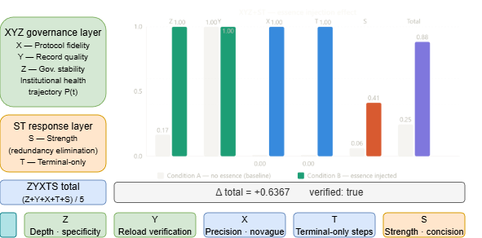
Figure 3: XYZ+ST Evaluation — Condition A (baseline) vs Condition B (essence injected). ΔZYXTS = +0.6367, verified: true.
Axis | Layer | Name | Scoring criterion
Z | Governance | Depth/specificity | Physical and technical vocabulary density
Y | Governance | Reload verification | Presence of re-verification language
X | Governance | Precision | Absence of vague/hedging language
T | Response | Terminal-only | Structured numbered steps to definitive conclusion
S | Response | Strength | Concision — information density relative to length

5.1 Experimental Results
Axis | Condition A (baseline) | Condition B (essence injected) | Delta
Z — depth | 0.1667 | 1.0000 | +0.8333
Y — verification | 1.0000 | 1.0000 | 0.0000
X — precision | 0.0000 | 1.0000 | +1.0000
T — terminal | 0.0000 | 1.0000 | +1.0000
S — strength | 0.0625 | 0.4125 | +0.3500
TOTAL | 0.2458 | 0.8825 | +0.6367

ΔZYXTS = +0.6367, verified: true. X and T axes showed maximum improvement (+1.0 each), confirming that essence injection eliminates vague language and forces procedural completion.

6. Results

6.1 System-Level Metrics (n = 255 sessions)
Metric | Pre-MoCKA | Post-MoCKA | Delta
Fault rate (λ) | 0.300 | 0.112 | −62.7%
Recurrence rate (RR) | 0.17 | 1.00 | +0.83
Autonomous execution risk (AER) | 60% | 0% | −60pp
Observability coefficient (α) | 0.027 | ≈1.0 | +×36.96
Record density (events/day) | 1.625 | 53.22 | +×32.7
ZYXTS response quality | 0.2458 | 0.8825 | +0.6367

6.2 The Observability Paradox
MoCKA's primary function is establishing observability infrastructure, not suppressing incidents. Pre-MoCKA, α = 0.027 — only 2.7% of AI interactions were captured. Post-MoCKA, α ≈ 1.0. The governance chain:

MoCKA → α↑(×36.96) → Detection↑ → Response↑ → RR→0%

6.3 Temporal Risk Distribution
78% of high-risk events occurred between 00:00–04:00, empirically justifying the Human Gate design: autonomous AI operation during unmonitored hours generates disproportionate institutional risk.

7. Discussion

7.1 Structure Over Trust
MoCKA's central contribution is the operationalization of a governance principle: institutional structure is more reliable than agent trust. By making recording mandatory, verification cryptographic, and auditing quantitative, MoCKA removes the requirement that AI agents be trustworthy — instead requiring only that they be structurally constrained.

7.2 The A+B/2 Problem
AI agents exhibit a systematic behavioral pattern: when presented with conflicting requirements A and B, they produce outputs that partially satisfy both rather than making a definitive choice. DNA Packet Injection directly addresses A+B/2 through explicit priority ordering. TRUST_SCORE detects A+B/2 outputs through low causal consistency scores. The T-axis in ZYXTS scoring measures whether outputs reach a definitive terminal state.

7.3 Implications for Institutional AI Design
Mandatory completeness: Every governance stage must be completed. Optional stages become ignored stages.
Cryptographic verification: Governance records must be tamper-evident. SHA-256 hash chains provide this at negligible cost.
Silence prohibition: Agents that detect anomalies must report them. Silent failure is more dangerous than explicit failure.
Quantitative trust: Inter-agent trust must be measurable. TRUST_SCORE provides a replicable protocol.

8. Limitations
Limitation | Description | Mitigation planned
Single operator | All 255 sessions conducted by one researcher in one environment | Multi-operator replication study
30-day window | Observation period insufficient for reliability engineering claims | Extended longitudinal study
Circular α definition | α_after = 1.0 is definitional, not measured | External audit of capture rate
Y-axis ceiling | ZYXTS Y-axis scored 1.0 in both conditions for test question used | Y-sensitive test case design
Model dependence | DNA injection relies on instruction-following ability | Testing across model types
Single-session ZYXTS | Conditions A/B evaluated within one session | Cross-session replication

9. Conclusion
We presented MoCKA, a cybernetic governance architecture for multi-model AI orchestration. Through empirical analysis of 255 sessions, we demonstrated that systematic institutional structure produces measurable improvements in governance outcomes without requiring model-level modification.

Key quantitative contributions: fault rate reduction 62.7%, recurrence rate 0.17→1.00, AER 60%→0%, ΔZYXTS +0.6367. The fluid coordinate model P(t) = (X, Y, Z) provides continuous governance health monitoring that distinguishes genuine degradation from the diagnostic technology effect.

"Governance structure controls reproducibility; institutional observability is the precondition for all other governance outcomes."

MoCKA is available as open-source software. Technical Note series TN1–TN7 providing detailed specifications is published at DOI 10.5281/zenodo.19503666.

References
[1] NIST. (2023). Artificial Intelligence Risk Management Framework (AI RMF 1.0). NIST AI 100-1.
[2] ISO/IEC 42001:2023. Information technology — Artificial intelligence — Management system.
[3] Wooldridge, M. (2009). An Introduction to MultiAgent Systems (2nd ed.). Wiley.
[4] Stone, P. & Veloso, M. (2000). Multiagent systems: A survey. Autonomous Robots, 8(3).
[5] Doshi-Velez, F. & Kim, B. (2017). Towards a rigorous science of interpretable ML. arXiv:1702.08608.
[6] Lipton, Z.C. (2018). The mythos of model interpretability. Queue, 16(3), 31–57.
[7] Majors, C., Fong-Jones, L. & Miranda, G. (2022). Observability Engineering. O'Reilly.
[8] Wiener, N. (1948). Cybernetics. MIT Press.
[9] IEC 61511. (2016). Functional Safety: Safety Instrumented Systems. IEC.

Appendix: Technical Note Series
Note | Title | Key contribution
TN1 | XYZ+ST Framework | Five-axis unified evaluation; ΔZYXTS=+0.6367
TN2 | Silence Prohibition Protocol | DETECT→WARN→STOP; zero false negatives (5 categories)
TN3 | DNA Packet Injection | Cross-session constraint; execution rate 0.44→1.00
TN4 | Fluid Coordinate Model | P(t)=(X,Y,Z); diagnostic technology effect
TN5 | TRUST_SCORE | Quantitative inter-agent auditing; TRUSTED/SUSPICIOUS/UNTRUSTED
TN6 | A+B/2 Problem | Averaging behavior definition; structural countermeasures
TN7 | Civilization Loop | Eight-stage mandatory cycle; industrial control origin

MoCKA Draft v9.0 | 2026-04-11 | Kimura, M. & Claude (Anthropic) | CC BY-NC 4.0 | DOI: 10.5281/zenodo.19503666

