Step 1: Under the “Services” menu, click on the “IAM” link, located within the “Security, Identity, & Comp” section

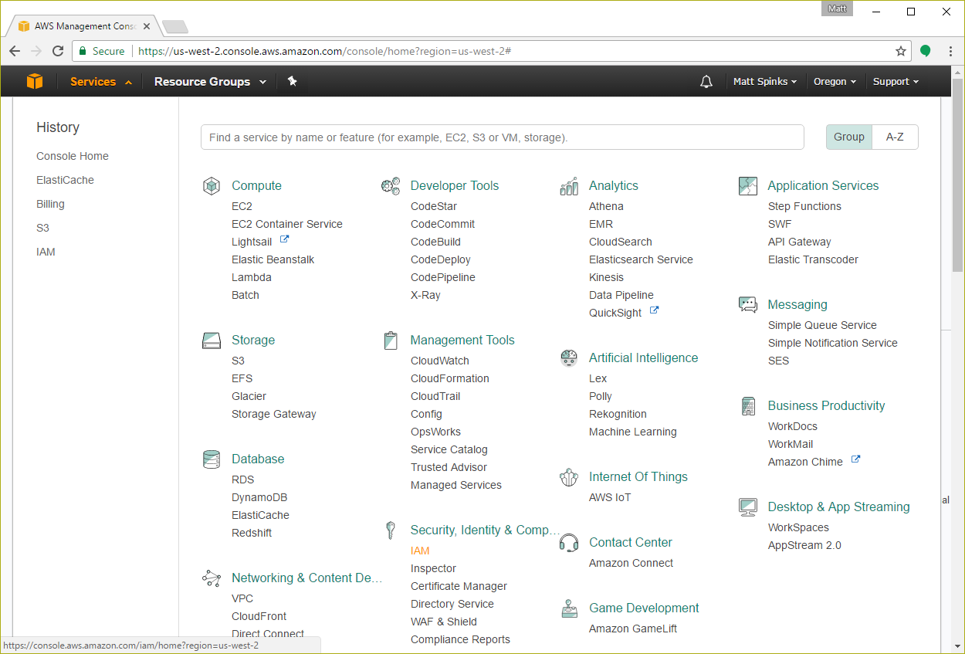

Step 2: This will take you into the IAM dashboard. Once here, click the “Users” link

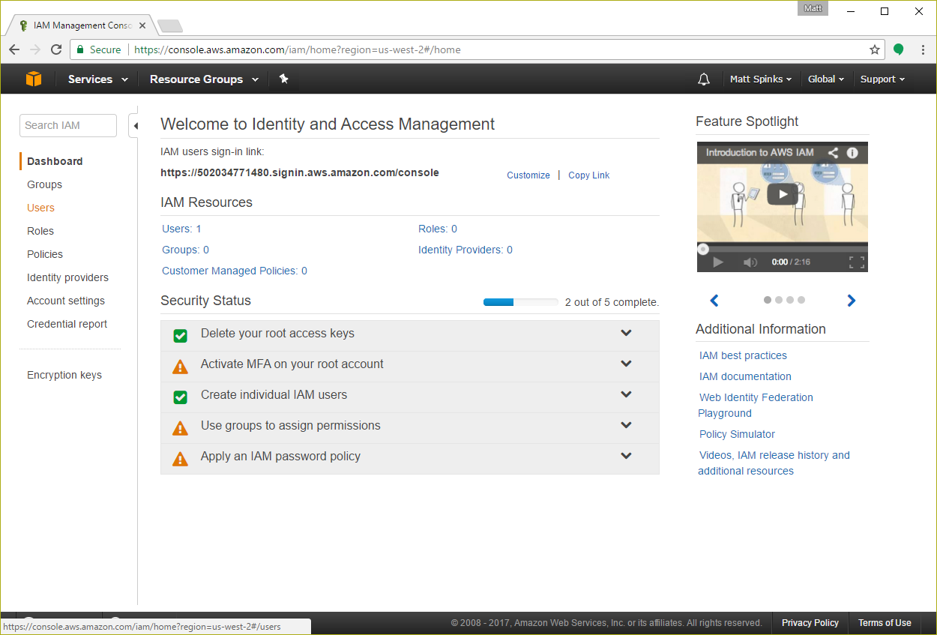

Step 3: In the “Users” screen, click the “Add User” button

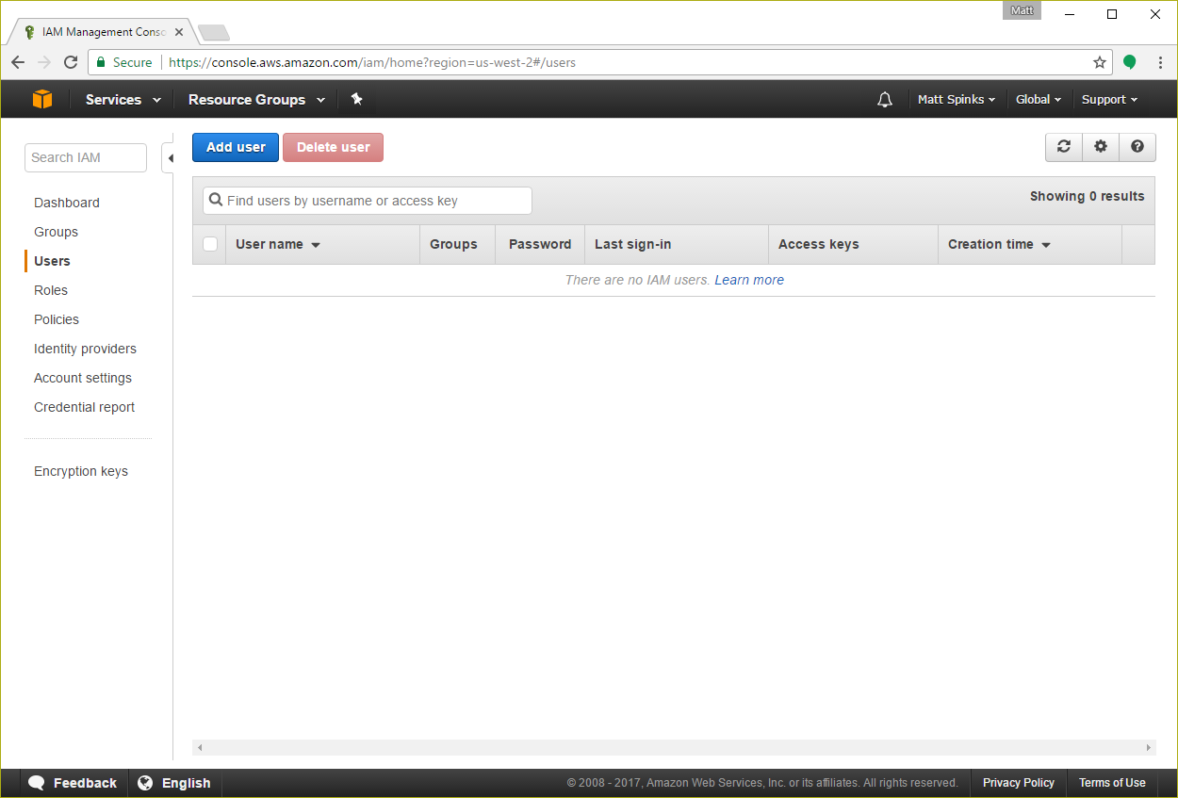

Step 4: In the “Add” screen, enter a name for this IAM user account. Something like “RingClone” will do. Also, in the “Access type” section, click the box to enable “Programmatic Access”. Click “Next”.

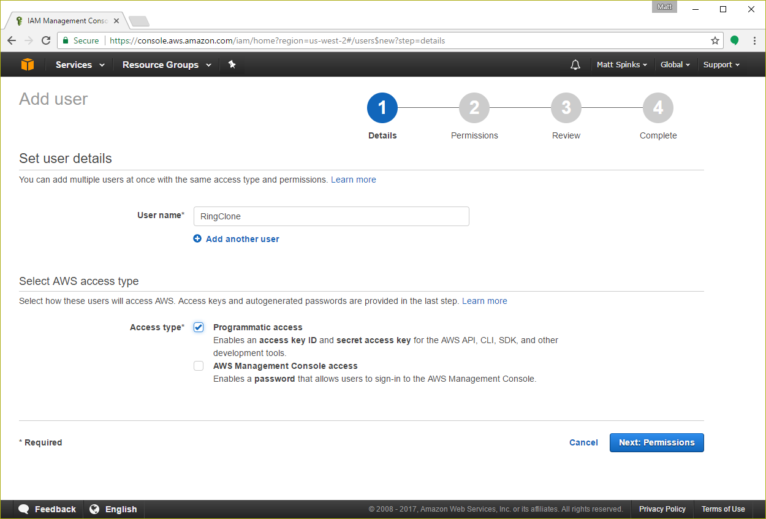

Step 5: On the permissions screen, click on the icon labeled “Attach existing policies directly”

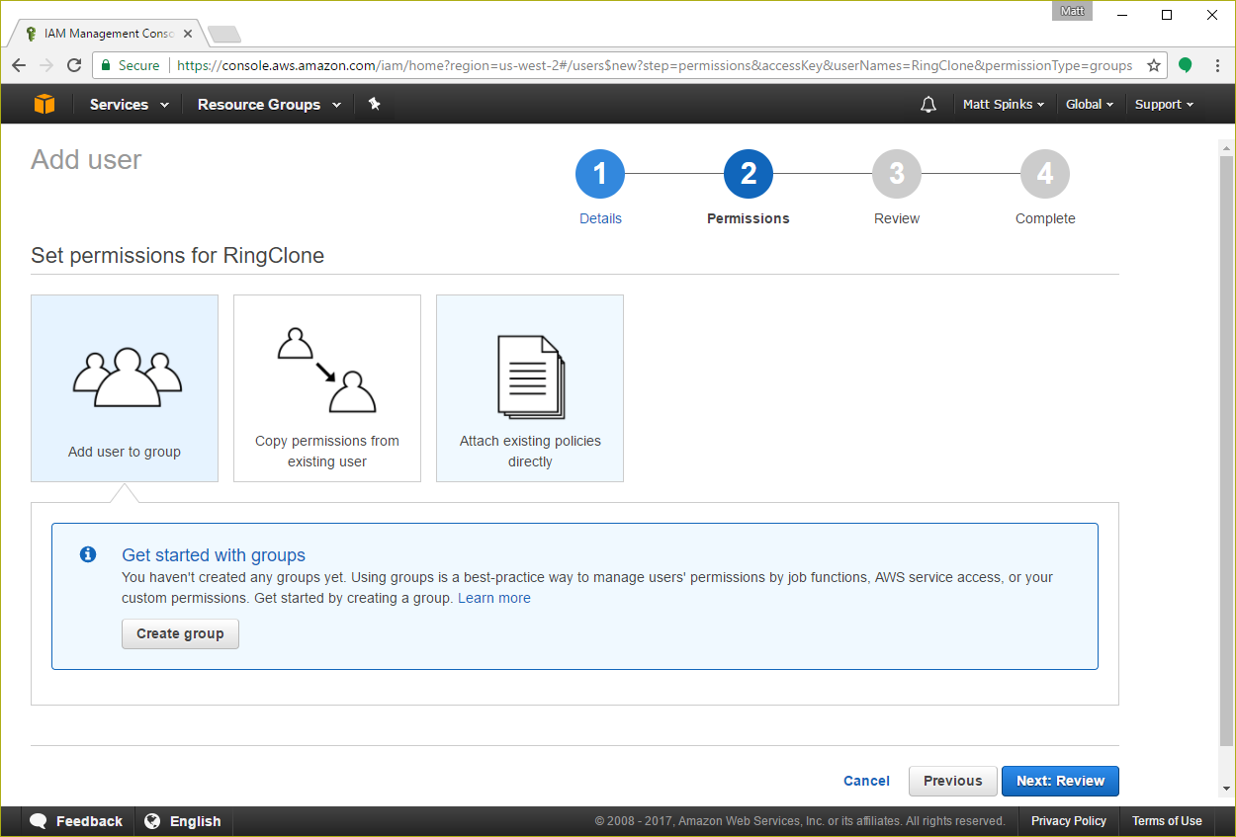

Step 6: In the Policy type “search” box, enter the text “S3”. Then, check the item in the list labeled “AmazonS3FullAccess” (click the “Next” button)

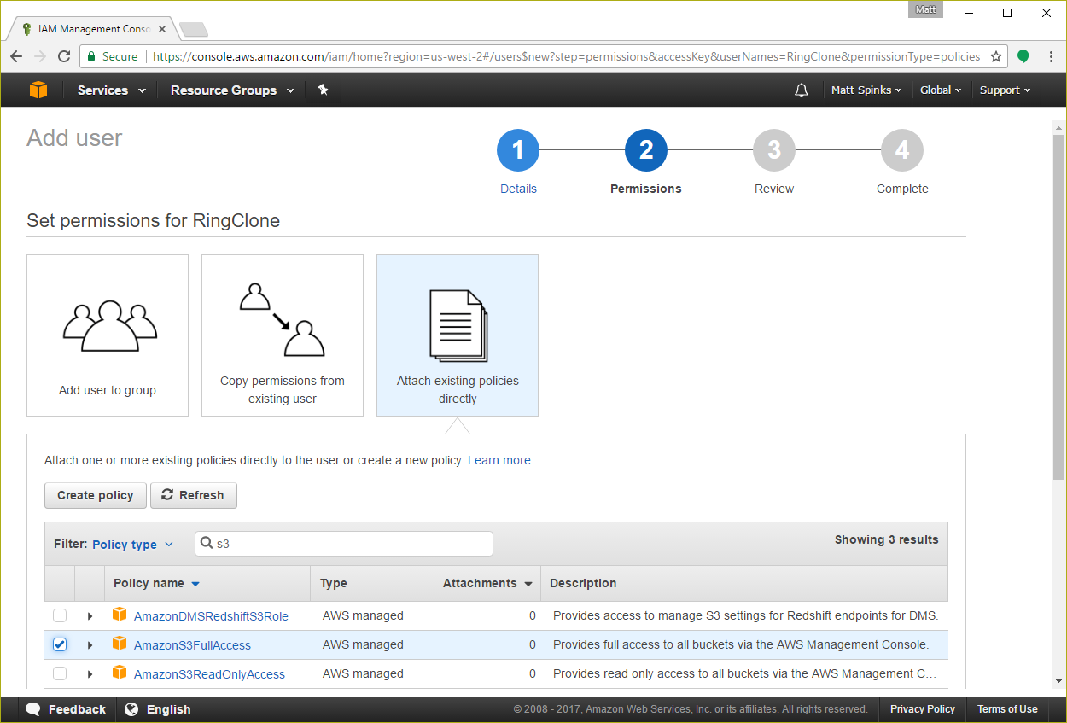

Step 7: Review your settings and click “Create User”

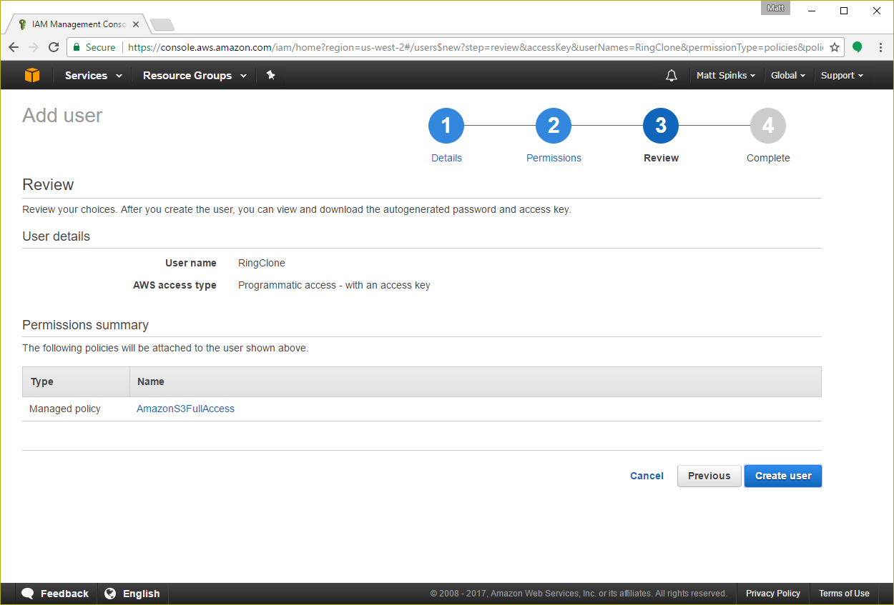

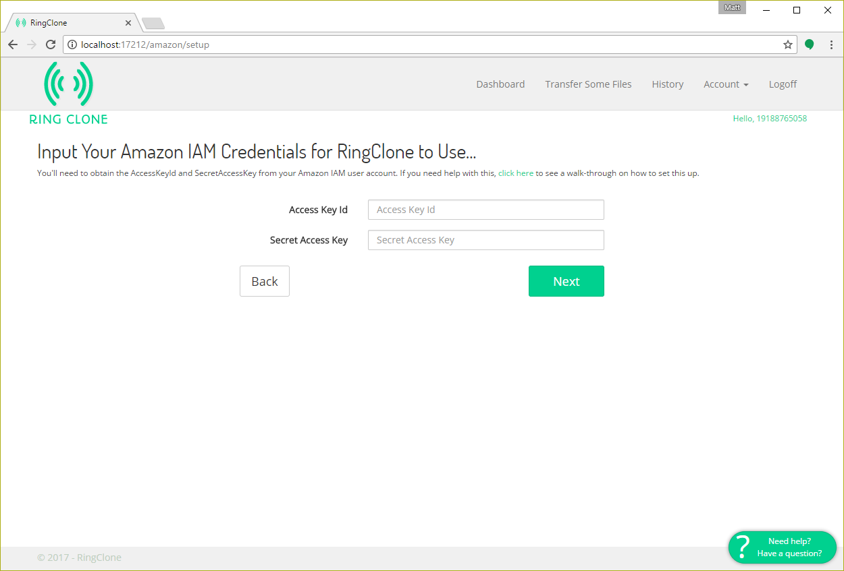

Copy and paste the Access Key ID to the “Access Key Id” field in the RingClone portal

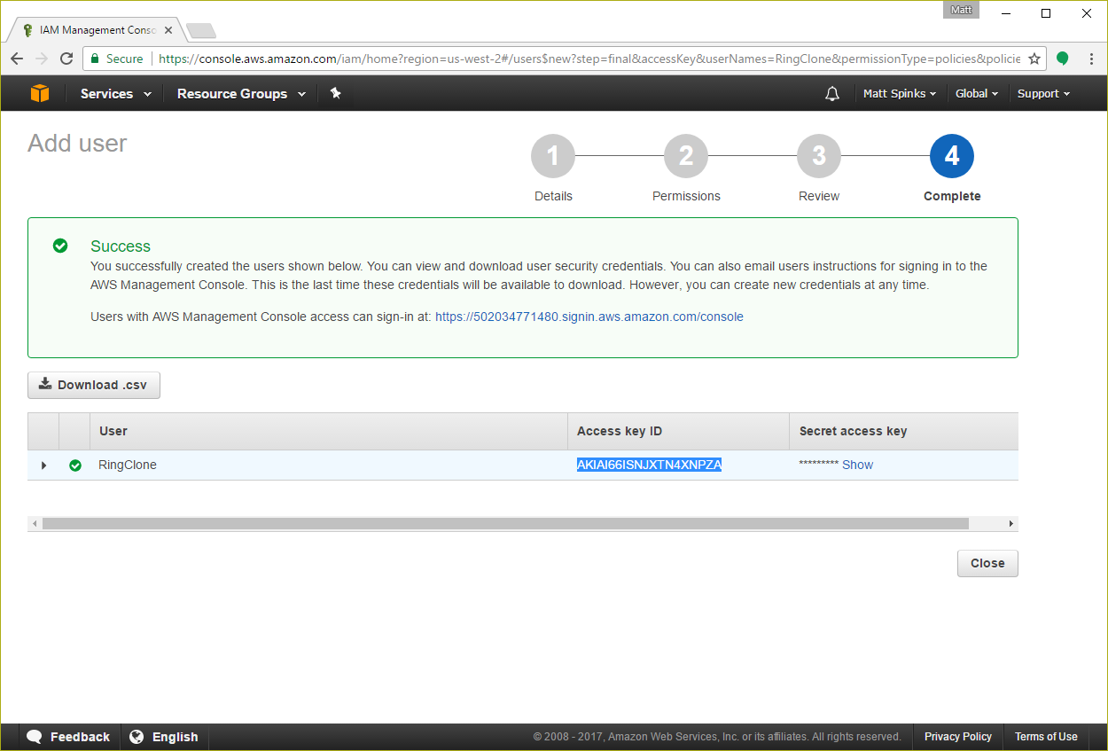

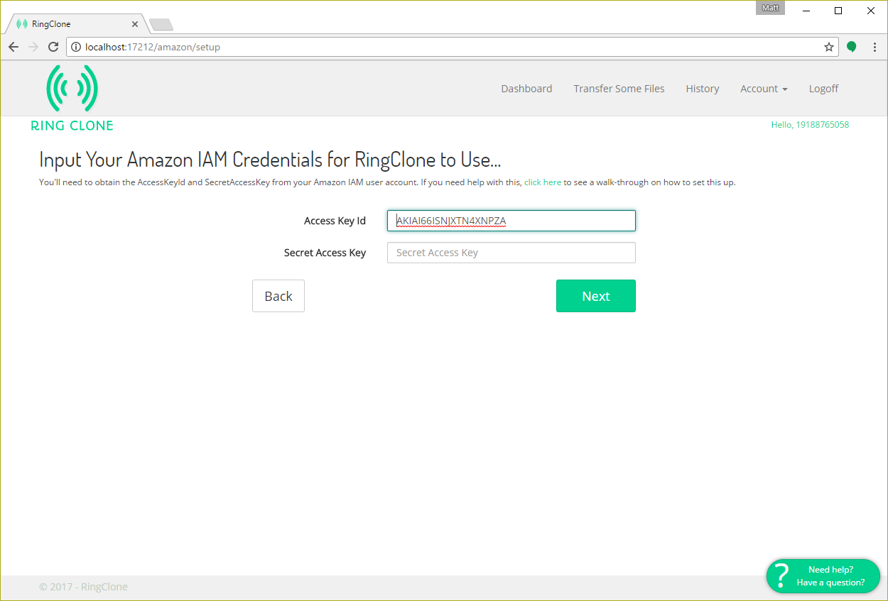

In the Amazon screen, under the “Secret access key”, click “Show”, and copy the secret access key value

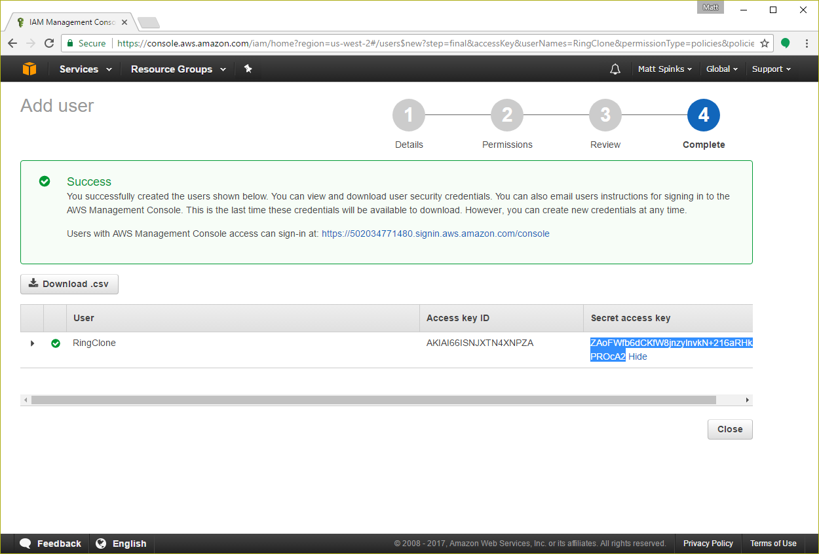

Switch to the RingClone portal and paste the value into the “Secret Access Key” field. 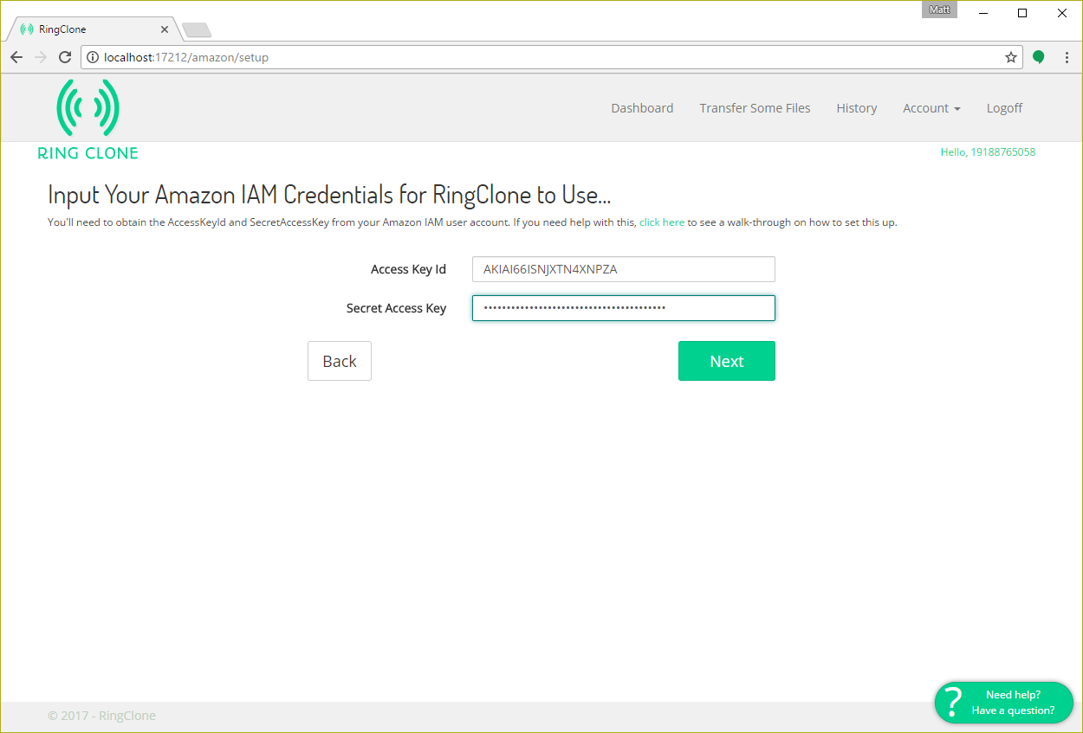

In the RingClone portal, click “Next”. At this point the RingClone system will attempt to validate the “Access Key Id” and “Secret Access Key”

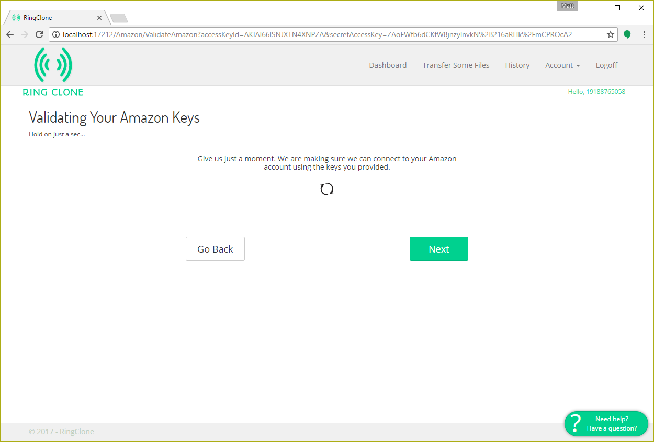

After the validation completes, click on the “Next” button

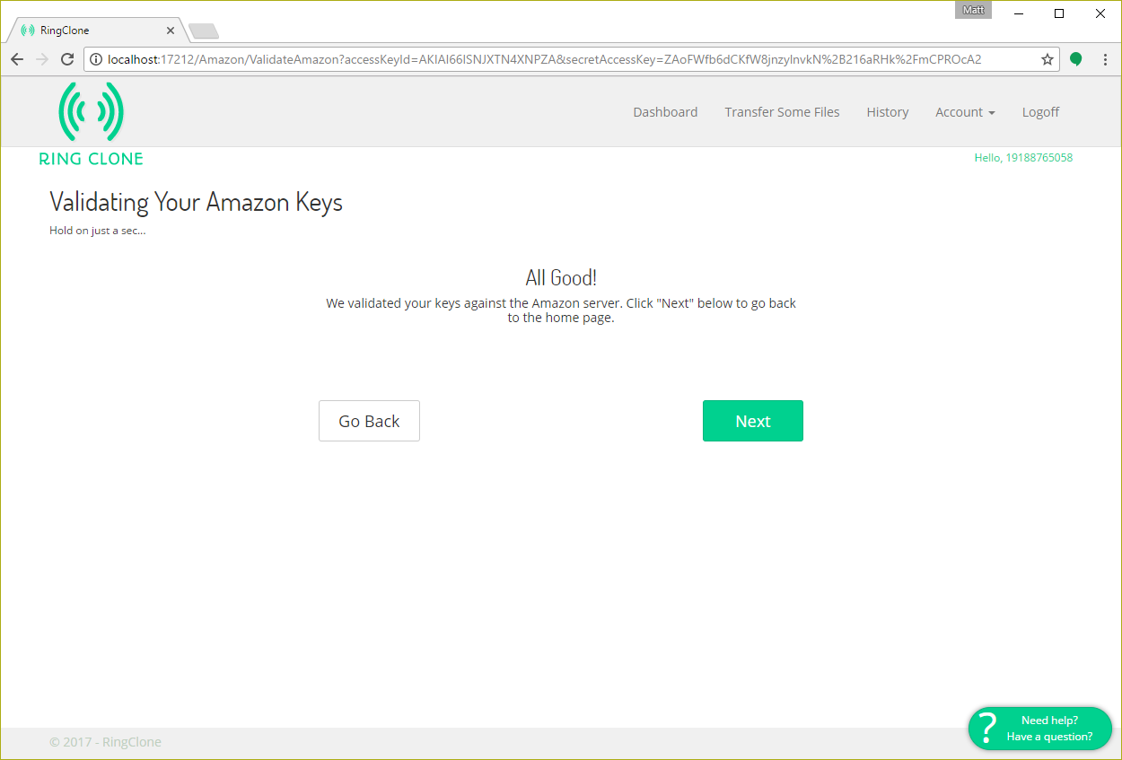

The Amazon setup process is complete.