WEEK – 5

TASK 1
(LeetCode – Maximum Subarray)
AIM:
To find the maximum sum of a contiguous subarray from a given integer array using Kadane’s Algorithm.

ALGORITHM:
- Start.
- Read the integer array nums.
- Initialize currentSum and maxSum with the first element.
- Traverse the array from index 1 to n-1.
- For each element:
a. Update currentSum = max(nums[i], currentSum + nums[i]).
b. Update maxSum = max(maxSum, currentSum).
- Return maxSum.
- Stop.

PROGRAM:
class Solution {
public int maxSubArray(int[] nums) {
int currentSum = nums[0];
int maxSum = nums[0];
for (int i = 1; i < nums.length; i++) {
currentSum = Math.max(nums[i], currentSum + nums[i]);
maxSum = Math.max(maxSum, currentSum);
}
return maxSum;
}
}

OUTPUT:
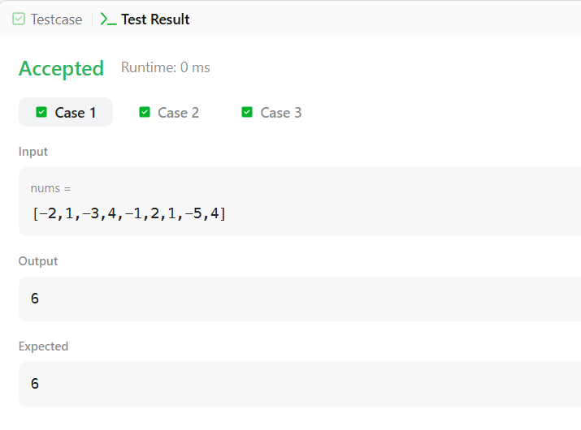

RESULT:
The program successfully calculates the maximum sum of a contiguous subarray using Kadane’s Algorithm.

TASK 2
(HackerRank – Subarray Division)
AIM:
To determine the number of contiguous segments of length m whose sum equals d.

ALGORITHM:
- Start.
- Read list s, integer d and m.
- If m > size of list, return 0.
- Compute sum of first m elements.
- If sum equals d, increment count.
- Slide the window through the list:
a. Subtract element leaving window.
b. Add new element entering window.
c. If sum equals d, increment count.
- Return count.
- Stop.

PROGRAM:
import java.io.*;
import java.math.*;
import java.security.*;
import java.text.*;
import java.util.*;
import java.util.concurrent.*;
import java.util.function.*;
import java.util.regex.*;
import java.util.stream.*;
import static java.util.stream.Collectors.joining;
import static java.util.stream.Collectors.toList;

class Result {

/*
* Complete the 'birthday' function below.
*
* The function is expected to return an INTEGER.
* The function accepts following parameters:
* 1. INTEGER_ARRAY s
* 2. INTEGER d
* 3. INTEGER m
*/

public static int birthday(List<Integer> s, int d, int m) {

int count = 0;
int sum = 0;

// If segment length is larger than list size
if (m > s.size()) {
return 0;
}

// Calculate sum of first window of size m
for (int i = 0; i < m; i++) {
sum += s.get(i);
}

if (sum == d) {
count++;
}

// Slide the window
for (int i = m; i < s.size(); i++) {
sum -= s.get(i - m); // remove element leaving window
sum += s.get(i); // add new element

if (sum == d) {
count++;
}
}

return count;
}

}

public class Solution {
public static void main(String[] args) throws IOException {
BufferedReader bufferedReader = new BufferedReader(new InputStreamReader(System.in));
BufferedWriter bufferedWriter = new BufferedWriter(new FileWriter(System.getenv("OUTPUT_PATH")));

int n = Integer.parseInt(bufferedReader.readLine().trim());

List<Integer> s = Stream.of(bufferedReader.readLine().replaceAll("\\s+$", "").split(" "))
.map(Integer::parseInt)
.collect(toList());

String[] firstMultipleInput = bufferedReader.readLine().replaceAll("\\s+$", "").split(" ");

int d = Integer.parseInt(firstMultipleInput[0]);

int m = Integer.parseInt(firstMultipleInput[1]);

int result = Result.birthday(s, d, m);

bufferedWriter.write(String.valueOf(result));
bufferedWriter.newLine();

bufferedReader.close();
bufferedWriter.close();
}
}

OUTPUT:
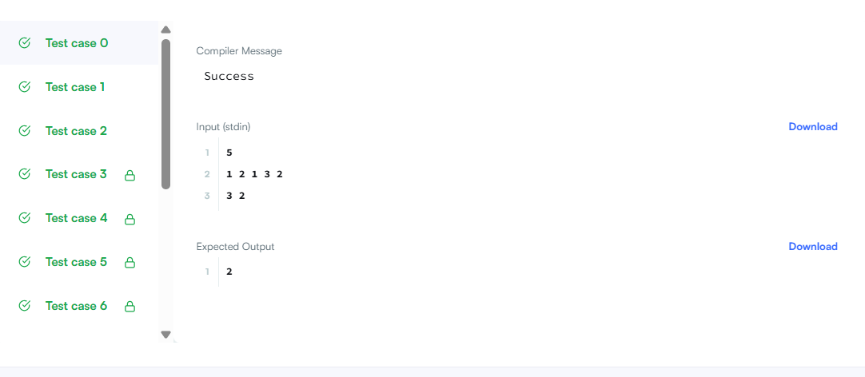

RESULT:
The program successfully counts the number of valid contiguous segments using the Sliding Window technique.

TASK 3
(HackerRank – The Maximum Subarray)
AIM:
To find both the maximum contiguous subarray sum and maximum non-contiguous subsequence sum.

ALGORITHM:
- Start.
- Read the array arr.
- Use Kadane’s Algorithm to find maximum contiguous sum.
- For subsequence sum:
a. Add all positive elements.
b. If no positive elements exist, select the maximum element.
- Return both sums.
- Stop.

PROGRAM:
import java.io.*;
import java.math.*;
import java.security.*;
import java.text.*;
import java.util.*;
import java.util.concurrent.*;
import java.util.function.*;
import java.util.regex.*;
import java.util.stream.*;
import static java.util.stream.Collectors.joining;
import static java.util.stream.Collectors.toList;

class Result {

/*
* Complete the 'maxSubarray' function below.
*
* The function is expected to return an INTEGER_ARRAY.
* The function accepts INTEGER_ARRAY arr as parameter.
*/

public static List<Integer> maxSubarray(List<Integer> arr) {

// --------- Maximum Subarray (Kadane) ----------
int maxEndingHere = arr.get(0);
int maxSoFar = arr.get(0);

for (int i = 1; i < arr.size(); i++) {
int num = arr.get(i);
maxEndingHere = Math.max(num, maxEndingHere + num);
maxSoFar = Math.max(maxSoFar, maxEndingHere);
}

// --------- Maximum Subsequence ----------
int maxSubsequenceSum = 0;
int maxElement = arr.get(0);
boolean hasPositive = false;

for (int num : arr) {
if (num > 0) {
maxSubsequenceSum += num;
hasPositive = true;
}
maxElement = Math.max(maxElement, num);
}

if (!hasPositive) {
maxSubsequenceSum = maxElement;
}

return Arrays.asList(maxSoFar, maxSubsequenceSum);
}

}

public class Solution {
public static void main(String[] args) throws IOException {
BufferedReader bufferedReader = new BufferedReader(new InputStreamReader(System.in));
BufferedWriter bufferedWriter = new BufferedWriter(new FileWriter(System.getenv("OUTPUT_PATH")));

int t = Integer.parseInt(bufferedReader.readLine().trim());

IntStream.range(0, t).forEach(tItr -> {
try {
int n = Integer.parseInt(bufferedReader.readLine().trim());

List<Integer> arr = Stream.of(bufferedReader.readLine().replaceAll("\\s+$", "").split(" "))
.map(Integer::parseInt)
.collect(toList());

List<Integer> result = Result.maxSubarray(arr);

bufferedWriter.write(
result.stream()
.map(Object::toString)
.collect(joining(" "))
+ "\n"
);
} catch (IOException ex) {
throw new RuntimeException(ex);
}
});

bufferedReader.close();
bufferedWriter.close();
}
}

OUTPUT:
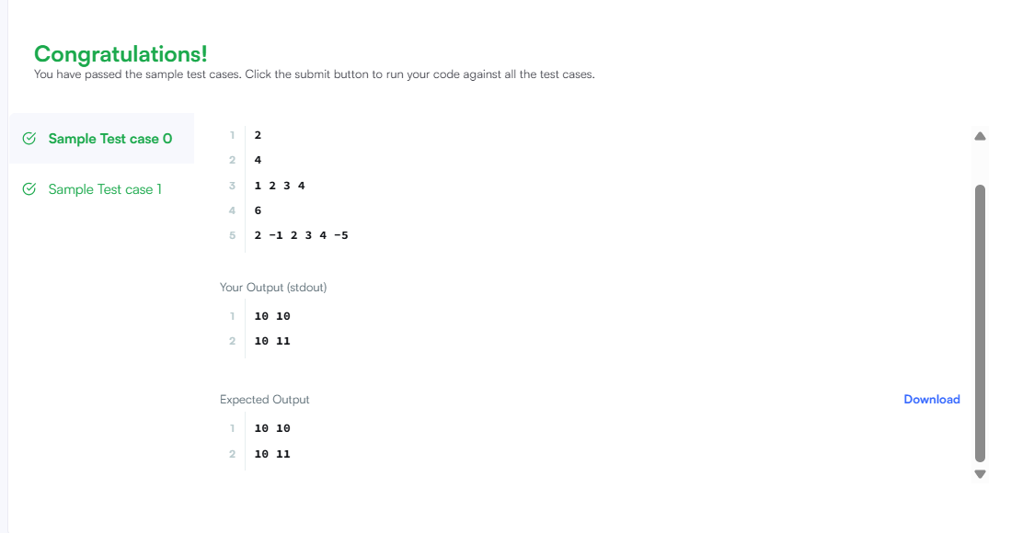

RESULT:The program successfully computes both the maximum contiguous and non-contiguous sums.

TASK 4
(LeetCode – Maximum Sum Circular Subarray)
AIM:
To find the maximum subarray sum in a circular integer array.

ALGORITHM:
- Start.
- Compute maximum subarray using Kadane’s Algorithm.
- Compute minimum subarray using modified Kadane’s Algorithm.
- Calculate total sum of array.
- If all elements are negative, return maximum subarray.
- Otherwise, return maximum of:
a. Normal maximum subarray
b. Total sum minus minimum subarray
- Stop.

PROGRAM:
class Solution {
public int maxSubarraySumCircular(int[] nums) {
int totalSum = 0;
int maxSum = nums[0], currentMax = 0;
int minSum = nums[0], currentMin = 0;
for (int num : nums) {
currentMax = Math.max(num, currentMax + num);
maxSum = Math.max(maxSum, currentMax);
currentMin = Math.min(num, currentMin + num);
minSum = Math.min(minSum, currentMin);
totalSum += num;
}
if (maxSum < 0) return maxSum;
return Math.max(maxSum, totalSum - minSum);
}
}

OUTPUT:
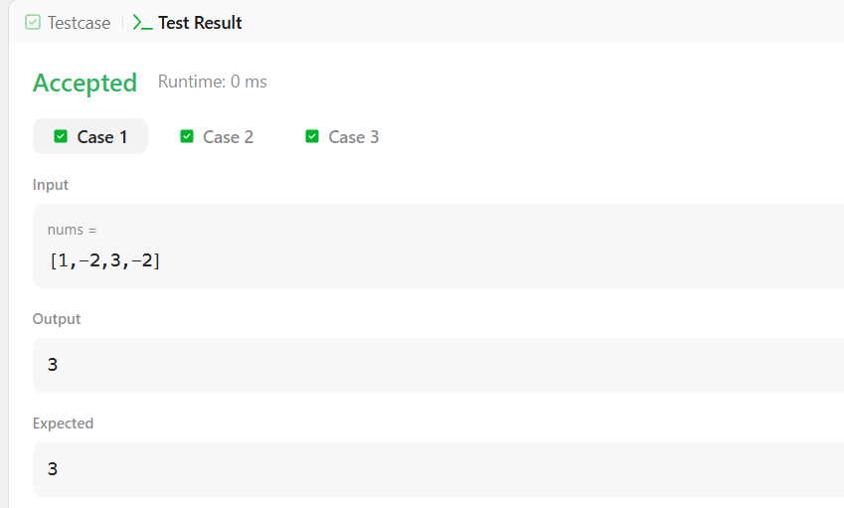

RESULT:
The program successfully determines the maximum circular subarray sum using Kadane’s Algorithm and its variation.
TASK 5
(LeetCode – String to Integer (atoi))
AIM:
To convert a given string into a 32-bit signed integer according to specified rules and handle overflow conditions correctly.

ALGORITHM:
- Start.
- Read the string s.
- Skip leading whitespace characters.
- Check for optional sign (‘+’ or ‘-’).
- Initialize result = 0.
- Traverse the string while characters are digits:
a. Convert character to digit.
b. Check for overflow before multiplying.
c. Update result = result × 10 + digit.
- If overflow occurs, return Integer.MAX_VALUE or Integer.MIN_VALUE.
- Return result × sign.
- Stop.

PROGRAM:
class Solution {
public int myAtoi(String s) {
int n = s.length();
int i = 0;
// Skip leading spaces
while (i < n && s.charAt(i) == ' ') {
i++;
}
if (i == n) {
return 0;
}
// Handle sign
int sign = 1;
if (s.charAt(i) == '+' || s.charAt(i) == '-') {
sign = (s.charAt(i) == '-') ? -1 : 1;
i++;
}
int result = 0;
// Process digits
while (i < n && Character.isDigit(s.charAt(i))) {
int digit = s.charAt(i) - '0';
// Overflow check
if (result > Integer.MAX_VALUE / 10 ||
(result == Integer.MAX_VALUE / 10 && digit > 7)) {
return sign == 1 ? Integer.MAX_VALUE : Integer.MIN_VALUE;
}
result = result * 10 + digit;
i++;
}
return result * sign;
}
}

OUTPUT:
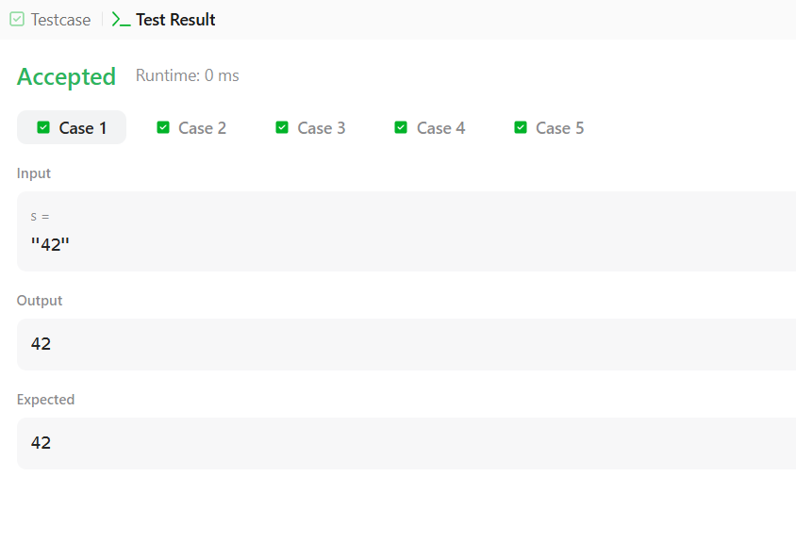

RESULT:
The program successfully converts a string into a 32-bit signed integer while handling whitespace, sign detection, invalid characters, and overflow cases.

TASK 6
(HackerRank – Alternating Characters)
AIM:
To determine the minimum number of deletions required so that no two adjacent characters in the string are the same.

ALGORITHM:
- Start.
- Read the string s.
- Initialize deletions = 0.
- Traverse the string from index 1 to n-1.
- If current character equals previous character, increment deletions.
- Return deletions.
- Stop.

PROGRAM:
import java.io.*;
import java.math.*;
import java.security.*;
import java.text.*;
import java.util.*;
import java.util.concurrent.*;
import java.util.function.*;
import java.util.regex.*;
import java.util.stream.*;
import static java.util.stream.Collectors.joining;
import static java.util.stream.Collectors.toList;

class Result {

/*
* Complete the 'alternatingCharacters' function below.
*
* The function is expected to return an INTEGER.
* The function accepts STRING s as parameter.
*/

// Write your code here
public static int alternatingCharacters(String s) {
int deletions = 0;

for (int i = 1; i < s.length(); i++) {
if (s.charAt(i) == s.charAt(i - 1)) {
deletions++;
}
}

return deletions;
}

}

public class Solution {
public static void main(String[] args) throws IOException {
BufferedReader bufferedReader = new BufferedReader(new InputStreamReader(System.in));
BufferedWriter bufferedWriter = new BufferedWriter(new FileWriter(System.getenv("OUTPUT_PATH")));

int q = Integer.parseInt(bufferedReader.readLine().trim());

IntStream.range(0, q).forEach(qItr -> {
try {
String s = bufferedReader.readLine();

int result = Result.alternatingCharacters(s);

bufferedWriter.write(String.valueOf(result));
bufferedWriter.newLine();
} catch (IOException ex) {
throw new RuntimeException(ex);
}
});

bufferedReader.close();
bufferedWriter.close();
}
}

OUTPUT:
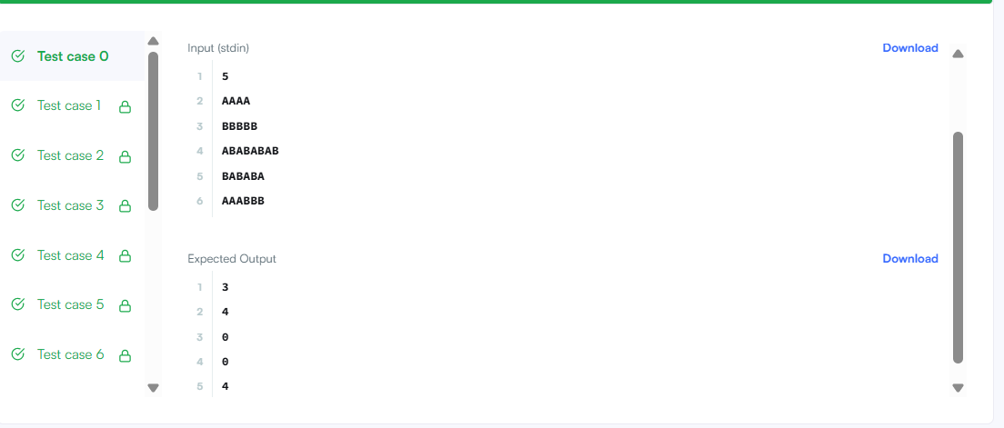

RESULT:
The program successfully calculates the minimum number of deletions required to make the string alternating.

