Program 1: Check Whether Two Halves of a String Are Alike
Task No: 1
Aim
To determine whether the two halves of a given string contain an equal number of vowels.
Algorithm
- Create a set containing all uppercase and lowercase vowels.
- Find the length of the string and divide it into two halves.
- Count vowels in the first half of the string.
- Count vowels in the second half of the string.
- Compare both counts.
- If equal, return true; otherwise, return false.
Program
import java.util.Set;
import java.util.HashSet;

class Solution {
public boolean halvesAreAlike(String s) {
Set<Character> vowels = new HashSet<>();
for (char c : "aeiouAEIOU".toCharArray()) {
vowels.add(c);
}

int n = s.length();
int mid = n / 2;
int countA = 0;
int countB = 0;

for (int i = 0; i < mid; i++) {
if (vowels.contains(s.charAt(i))) {
countA++;
}
if (vowels.contains(s.charAt(i + mid))) {
countB++;
}
}

return countA == countB;
}
}

Output:
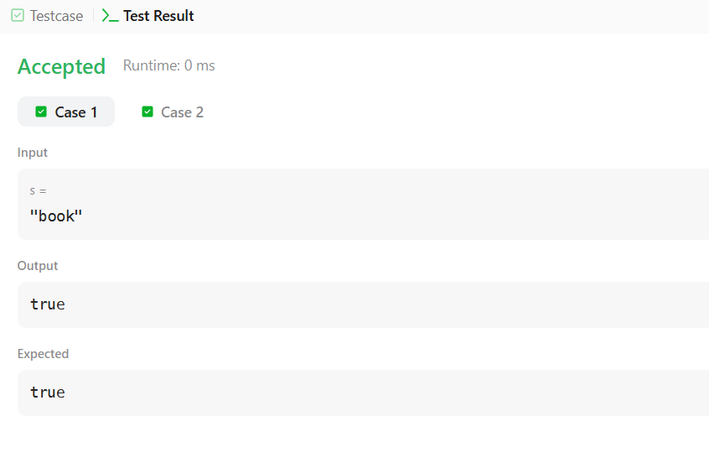
Result
The program successfully checks whether both halves of the string contain the same number of vowels.

Program 2: Check Whether a String Is a Lapindrome
Task No: 2
Aim
To check whether a given string is a Lapindrome (both halves have the same character frequency).
Algorithm
- Read the number of test cases.
- For each string:
  - Count character frequencies in the first half.
  - Subtract frequencies of characters in the second half.
- Ignore the middle character if the string length is odd.
- If all frequency values are zero, print YES; otherwise, print NO.
Program
import java.util.*;
import java.lang.*;
import java.io.*;

class Codechef {
public static void main (String[] args) throws java.lang.Exception {
Scanner sc = new Scanner(System.in);
int T = sc.nextInt();

while (T-- > 0) {
String s = sc.next();
System.out.println(isLapindrome(s) ? "YES" : "NO");
}
sc.close();
}

private static boolean isLapindrome(String s) {
int n = s.length();
int[] freq = new int[26];

for (int i = 0; i < n / 2; i++) {
freq[s.charAt(i) - 'a']++;
}

int start = (n % 2 == 0) ? n / 2 : n / 2 + 1;
for (int i = start; i < n; i++) {
freq[s.charAt(i) - 'a']--;
}

for (int count : freq) {
if (count != 0) {
return false;
}
}
return true;
}
}

Output:
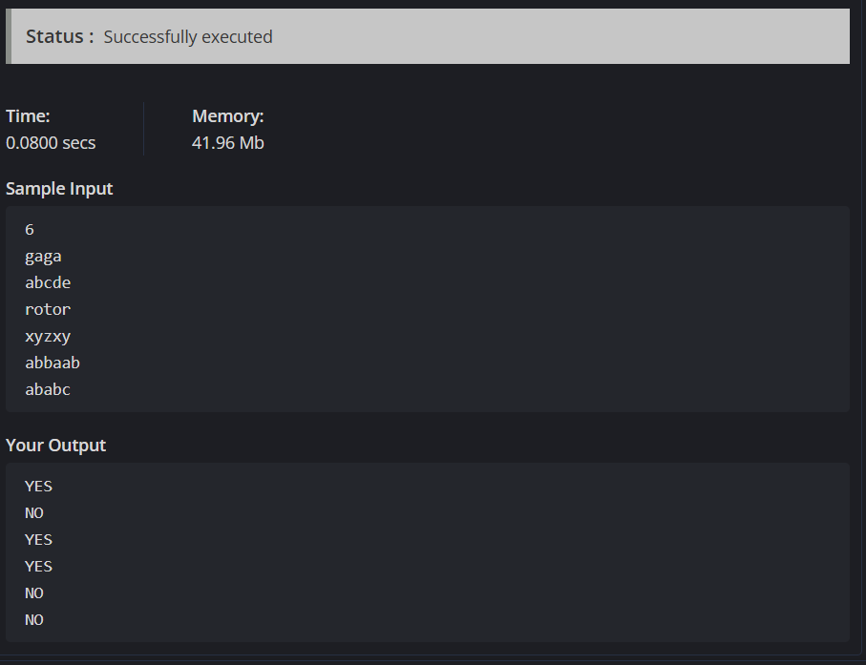
Result
The program correctly identifies whether a string is a Lapindrome.

Program 3: Compare Triplets
Task No: 3
Aim
To compare two triplets and calculate scores for Alice and Bob based on their values.
Algorithm
- Initialize scores for Alice and Bob as zero.
- Compare corresponding elements of both triplets.
- Increment Alice’s score if her value is greater.
- Increment Bob’s score if his value is greater.
- Store and return both scores as a list.
Program
import java.io.*;
import java.util.*;
import java.util.stream.*;

class Result {
public static List<Integer> compareTriplets(List<Integer> a, List<Integer> b) {
int alice = 0;
int bob = 0;

for (int i = 0; i < 3; i++) {
if (a.get(i) > b.get(i)) {
alice++;
} else if (a.get(i) < b.get(i)) {
bob++;
}
}

List<Integer> result = new ArrayList<>();
result.add(alice);
result.add(bob);
return result;
}
}

public class Solution {
public static void main(String[] args) throws IOException {
BufferedReader bufferedReader = new BufferedReader(new InputStreamReader(System.in));

List<Integer> a = Stream.of(bufferedReader.readLine().split(" "))
.map(Integer::parseInt)
.collect(Collectors.toList());

List<Integer> b = Stream.of(bufferedReader.readLine().split(" "))
.map(Integer::parseInt)
.collect(Collectors.toList());

List<Integer> result = Result.compareTriplets(a, b);
System.out.println(result.get(0) + " " + result.get(1));
}
}
Output:

Result
The program outputs the correct comparison scores for Alice and Bob.

Program 4: Check for Duplicate Elements in an Array
Task No: 4
Aim
To determine whether an integer array contains any duplicate elements.
Algorithm
- Create an empty hash set.
- Traverse the array elements.
- Add each element to the set.
- If insertion fails, a duplicate exists.
- Return true if duplicate found, else false.
Program
import java.util.HashSet;
import java.util.Set;

class Solution {
public boolean containsDuplicate(int[] nums) {
Set<Integer> seen = new HashSet<>();

for (int num : nums) {
if (!seen.add(num)) {
return true;
}
}
return false;
}
}
Output:
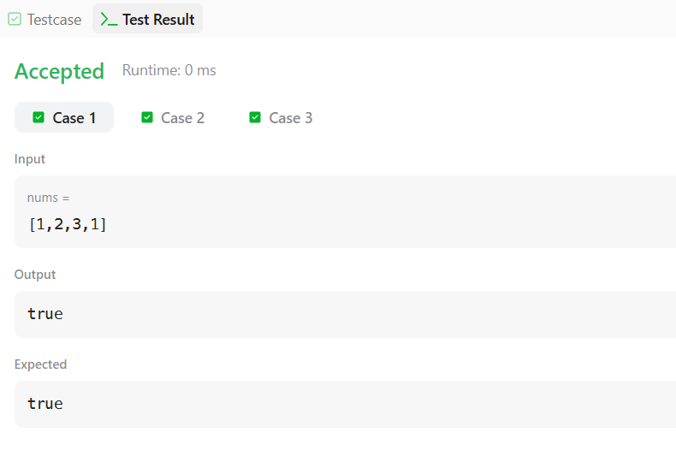

Result:
The program successfully detects whether duplicate values are present in the array.

