A PEOPLE’S HISTORY OF THE MODERN MIDDLE EAST
HIST/MENA 277B, Spring 2022

Syllabus is subject to change!

Dr. Laura Frances Goffman
lauragoffman@arizona.edu

Mr. Muhammet Topal
muhammettopal29@email.arizona.edu

Tuesday and Thursday, 11-12:15
Office Hours (ZOOM): Tuesdays, 3:30-4:30 or by appointment

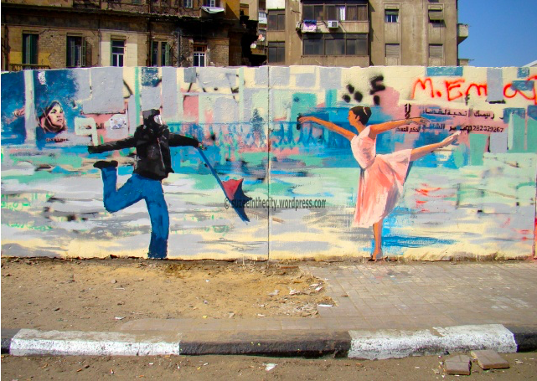
Street art in Cairo depicting a protestor and a dancer, 2012. From Suzeinthecity

Course Description
This course approaches the history of the modern Middle East through a Humanist perspective. We consider the Ottoman Empire, the Arab lands, and Iran from 1453 to the present through the interconnected spheres of political, economic, and social history. We will identify major historical periods, figures, geographical features, and movements that have shaped the region and assess the effects of colonialism and imperialism. Lectures, readings, writing, and discussions develop case studies to emphasize the interplay between individual lives, structural diversity and inequality, and historical contingency. Through guided primary source analysis and close readings of a range of texts, students will develop the tools to consider different temporal and spatial scales. Finally, students will consider their own positionality as historical actors in relation to the people of the modern Middle East.

Course Objectives
Students who come to class regularly, participate actively in discussions, and complete all readings and written assignments, will be able to:
- Describe how historians conduct research, analyze evidence, and reach conclusions.
- Analyze issues of class, religion, gender, and race in historical documents, modern film, and documentaries through writing and discussion.
- Interpret texts produced by people in the Middle East considering author, audience, genre, and context, and utilize those texts to support a historical argument.
- Explore specific case studies that highlight how various populations and individuals in the Middle East have interacted with regional trends in popular politics, class struggle, religious movements, and economic exploitation.
- Reflect on their positionality as producers, consumers, and subjects of historical knowledge.
- Activate the theoretical concepts of historical contingency and spatial and temporal scales through research, writing, and self-reflection.

History is not simply the study of the past, but a specific way of thinking, discussing, and writing about the past. History, like all disciplines, pursues particular ways of formulating questions, identifying relevant evidence and contexts, analyzing and interpreting evidence, connecting facts and sources with each other, drawing conclusions, and constructing answers. This course seeks to help students think historically and to understand the process of historical reasoning and analysis by improving the ability to analyze historical documents, to synthesize large amounts of data, and to evaluate contemporary media coverage of the region.

Equipment and software requirements: For this class you will need daily access to the following hardware: laptop; regular access to reliable internet signal; ability to download and run the following software: web browser. You are expected to have your assigned readings available to refer to during class. You are also expected to bring a pen/pencil and paper to class for brief writing assignments.

Learning Outcomes
As a required course for the MENAS major, this course provides a foundational understanding of the major historical developments of the modern Middle East. For the non-MENAS major, this course satisfies the UA General Education learning outcomes for Tier Two courses in the Humanities by ensuring that students who complete this course are able to:

- “Relate arguments and ideas from … historical documents to the circumstances under which they were written; read primary documents and be able to place them in their historical context; identify disparate ideas from the evidence of these documents;” and
- “Describe how the development of philosophical and religious thought has influenced human civilization.”

In addition, this course introduces, practices, and assesses the four General Education Program Outcomes, including: thinking critically, communicating effectively, using information effectively, and understanding and valuing differences.

Required Texts
We are using two required textbooks for this class:
Betty Anderson, A History of the Modern Middle East: Rulers, Rebels, and Rogues
Akram Fouad Khater, Sources in the History of the Modern Middle East, 2nd Edition

NOTE:

The ANDERSON textbook is available as a library ebook: http://ezproxy.library.arizona.edu/login?url=http://www.degruyter.com/isbn/9780804798754
This ebook is also linked through D2L Brightspace course site in Library Tools.

The KHATER textbook is being delivered digitally via D2L through the Inclusive Access program. Please access the material through D2L on the first day of class to make sure that there are no issues with delivery. The access is free through the add/drop date. After that, all enrolled students who have not opted-out of the program or dropped the course will have the discounted price applied to their Bursar account. The cost of the required digital content for Inclusive Access will appear on your Bursar Account as "Inclusive Access Digital Books."

Please refer to the Inclusive Access FAQs at https://shop.arizona.edu/textbooks/Inclusive.asp for additional information.

Quizzes
Weekly Quizzes: Most weeks you are required to complete a short multiple-choice quiz on D2L by 5 p.m. on Friday. The questions will derive from your textbook readings.

Every 24 hours that a quiz is late will result in one question being marked off.

Other Quizzes: Other quiz assignments will be built into course content and will count towards your final quiz grade.

Attendance
Attendance is 10% of your grade. The first three absences are free, no questions asked. After that you will lose 10% of your attendance grade for each absence unless you provide documentation of an excused absence.

Writing Requirement
*Further guidelines will be provided in class*
Developing clear, logical, and effective writing skills is necessary for your academic success and for your professional advancement, regardless of what field you enter. As a result, you will practice and develop your writing skills through a range of assignments and activities that are integrated into this course.

Final Examination
The final exam (take home) will be held during our scheduled final exam period.

Grading Scale:
Your overall grade for this course will be based on the following:
- Quizzes 15%
- “The First Pearl” (primary source and analysis)* 10%
- “The Second Pearl” (primary sources from your life) 5%
- “The Third Pearl” (writing yourself into history)* 10%
- West Beirut Film Response 5%
- Once Upon a Time in Iraq Film Response 5%
- Midterm 20%
- Final Exam 20%
- Attendance 10%

*HONORS SECTION will have additional research and writing on these assignments. Details will be provided in class.
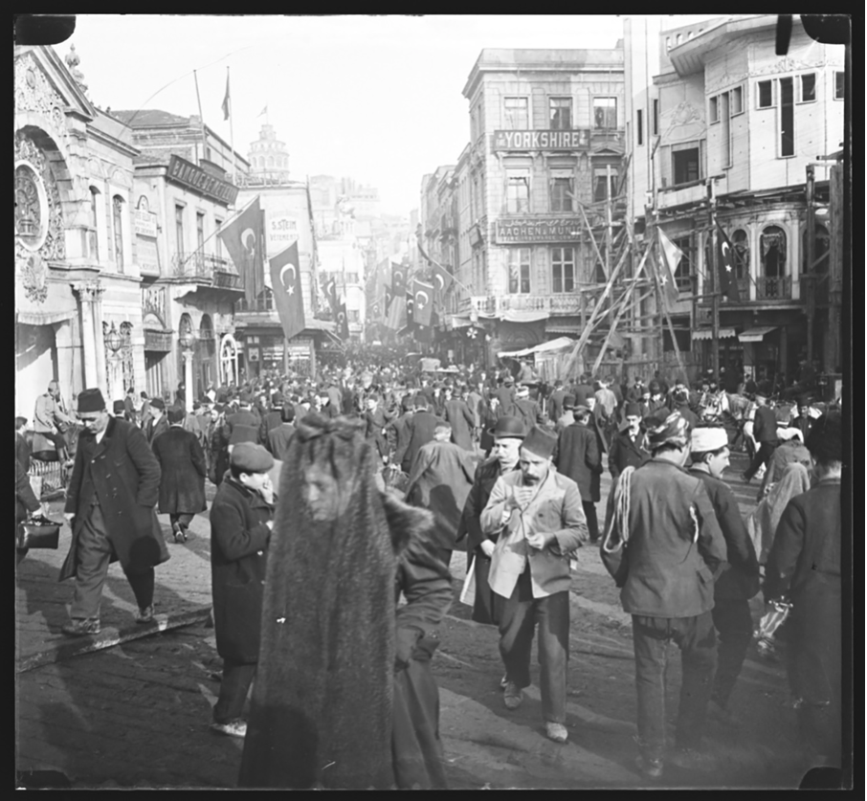
Busy street in Istanbul, circa 1890.
From the Pierre de Gigord Collection of Photographs of the Ottoman Empire and the Republic of Turkey, 1850-1958

Schedule of Classes and Assignments:
Week 1: Introduction
Thursday, January 13: Discussion and Lecture, What and where is the Middle East? What is a
“People’s History”?

Week 2: Islam and the Prophet’s Successors; Archives Workshop
Tuesday, January 18: Lecture, Islam and the Prophet’s Successors
Anderson, Preface and Prologue, xv-10

Thursday, January 20: Workshop, Primary Sources, Secondary Sources, and Online Archives
Khater, 1-6, How to Read a Primary Source
“How to Read a Secondary Source”: https://clas.uiowa.edu/history/teaching-and-writing-center/guides/source-identification/secondary-source

Week 3: The Ottoman and Safavid Empires through the 18th Century
Tuesday, January 25: Lecture, The Ottoman and Safavid Empires
Anderson, "Birth of Empires: The Ottoman and Safavid Empires through the 18th
Century," 11-58

Thursday, January 27: Discussion, Blindness in the Ottoman Arab World
Sara Scalenghe, Disability in the Ottoman Arab World, Chapter 2: “Blindness,” 52-87.

Week 4: Reform and Rebellion in the 19th Century
Tuesday, February 1: Lecture, 19th-Century State, Economy, and European Colonialism
Anderson, "Reform and Rebellion: The Ottoman Empire, Egypt, and Qajar Iran in
the 19th Century," 59-105

Thursday, February 3: Discussion, 19th-Century Political Reforms
Khater, 11-14, The Hatt-I-Serif Decree initiates the Tanzimat, or Reform, Period in
the Ottoman Empire, November 3, 1839
Khater, 14-16, An Ottoman Government Decree Defines the Official Notion
of the “Modern” Citizen, June 19, 1870

Week 5: 19th-Century Transformations, Part 1
Tuesday, February 8: Lecture, 19th-Century Social Transformations
Anderson, "Social Transformations: Workers and Nationalists in Egypt, Mount
Lebanon, and the Ottoman Empire in the 19th Century," STOP READING at "Nationalism in the Middle East" 107-135

Thursday, February 10: Discussion, 19th-Century Lives
Khater, 47-56, A Coal Miner’s Life During the Late Ottoman Empire
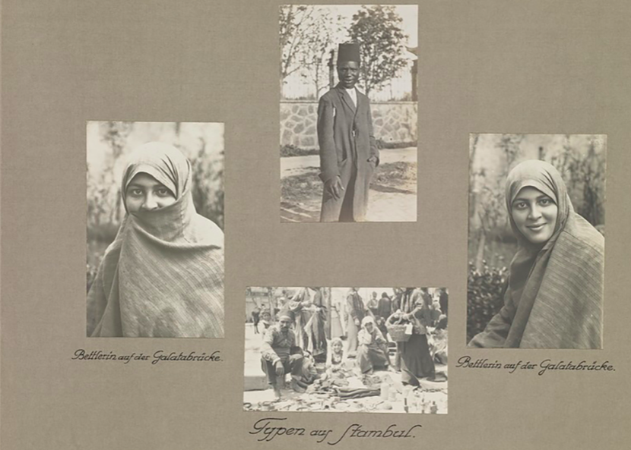
Photos of Ottomans. From the Pierre de Gigord Collection of Photographs of the
Ottoman Empire and the Republic of Turkey, 1850-1958
Week 6: 19th-Century Transformations, Part II
Tuesday, February 15: Lecture, Imperialism and Nationalism in the Persian Gulf and
Egypt
Anderson, "Social Transformations: Workers and Nationalists in Egypt, Mount
Lebanon, and the Ottoman Empire in the 19th Century," FROM "Nationalism in the Middle East" to end of chapter, 135-153

Thursday, February 17: Discussion,
Nels Johnson, 80-88, Ahmad: A Kuwaiti Pearl Diver
Khater, 61-65, Qasim Amin Argues for the Emancipation of Women in
Egypt, 1900

Week 7: Constitutional Revolutions and their Discontents
Tuesday, February 22: Lecture, The Young Turk Revolution and the Armenian Genocide
Anderson, "The Great War: Qajar Iran and the Ottoman Empire from Revolution to
World War I," STOP READING at "CUP Triumverate," 155-179

Thursday, February 24: Discussion, The Armenian Genocide
Khater, 144-150, Henry Morgenthau Recounts Aspects of Nationalist-Driven Ethnic
Cleansing of Armenians in Turkey, 1915

Week 8: The Great War and Political Consequences
Tuesday, March 1: Watch, World War One Through Arab Eyes Episode 3: “The New
Middle East”: https://www.aljazeera.com/program/featured-documentaries/2014/12/3/world-war-one-through-arab-eyes
Anderson, "The Great War: Qajar Iran and the Ottoman Empire from Revolution to
World War I," FROM "CUP Triumverate" to end of chapter, 179-198

Thursday, March 3: Discussion, The Great War and Political Consequences
Khater, 104-107, The Husayn-McMahon Correspondence, 1915-1916
Khater, 107-112, The Balfour Declaration, 1917

Friday, March 4, 5pm: “The First Pearl” Due on D2L: Primary Source and Analysis

March 7-11: SPRING BREAK

Week 9: State Formation, Colonial Control, and Gendered Citizenship
Tuesday, March 15: Lecture, State Formation and Colonial Control (Turkey, Iran, Syria,
Lebanon, Iraq, Transjordan, Saudi Arabia 1920s-1930s)
Anderson, "State Formation and Colonial Control," 199-239

Thursday, March 17: Discussion, State Formation and Colonial Control
Khater, 169-177, Women and the Vote in Syria, 1920

Week 10: Midterm and Palestine
Tuesday, March 22: MIDTERM

Thursday, March 24: NO CLASS: I am away at a conference

Week 11: Palestine
Tuesday, March 29: Lecture, Mandate Palestine and 1948
Anderson, "Rebels and Rogues: Egypt, Iraq, Transjordan, Palestine, and Israel in the
Interwar Years," 241-289

Thursday, March 31: Discussion, 1948
Listen, Shay Hazkani, Ottoman History Podcast:
https://www.ottomanhistorypodcast.com/2021/11/hazkani.html
Read, Adam Raz, “Murder by the Army,” Haaretz 10 December 2021
Shay Hazkani, Dear Palestine: A Social History of the 1948 War, Chapter 4: “The
Violence of Victory and the Violence of Defeat,” 140-175.

Week 12: Nasser and Arab Nationalism
Tuesday, April 5: Lecture, The rise of Arab nationalist politics and the impact of oil
Anderson, "Military Coups: Politics and Violence: Iran, Turkey, and the Arab States, 1952-1980," 291-323
Khaled Fahmy, “Gamal Abdel Nasser,” in Global Middle East: Into the Twenty-First Century, 103-116.

Thursday, April 7: WRITING DAY: NO CLASS

Friday, April 8, 5 pm: “The Second Pearl” Due on D2L: Primary sources from your life

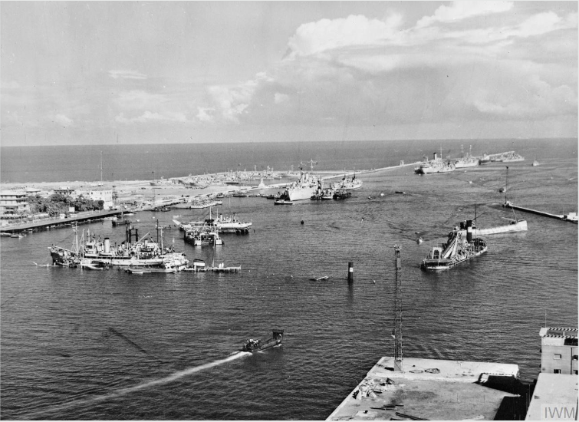
General view of the Suez Canal at Port Said showing a number of the blockships sunk by the Egyptians to prevent use of the canal
and Royal Navy salvage vessels preparing to clear these obstructions. From Imperial War Museum.
Week 13: Cold War Contestations in the Middle East
Tuesday, April 12: Watch: West Beirut https://www.youtube.com/watch?v=dCkQ7qC0C6I
Anderson, "Cold War Battles: The Suez Crisis, Arab-Israeli Conflicts, and the
Lebanese Civil War," 325-359

Thursday, April 14: Discussion, Lebanese Civil War
West Beirut
“Walid Jumblatt,” Playboy, 1984
Sami Hermez, War is Coming: Between Past and Future Violence in Lebanon, Chapter 6:
“Active Forgetting and the Memory of War in Everyday Life,” 141-157.
West Beirut Review Due

Week 14: Rulers for Life (1970s-80s)
Tuesday, April 19: Lecture, Consolidation of Power, Single Party Rule, Iranian Revolution
Anderson, "Rulers for Life: State Construction, Consolidation, and Collapse," 361-401

Thursday, April 21: Discussion, Living Authoritarianism
Khater, 229-232, Ayatollah Ruhollah Khomeini Denounces Rule of the Shah, 1971
Zakaria Tamer, “Tigers on the Tenth Day”

Week 15: Authoritarianism and Upheaval
Tuesday, April 26: Watch: Once Upon a Time in Iraq
https://www.pbs.org/wgbh/frontline/film/once-upon-a-time-in-iraq/
Anderson, "Upheaval: Islamism, Invasion, and Rebellion from the 1990s into the
21st Century," 403-445

Thursday, April 28: [Last Class Meeting] Discussion: Once Upon a Time in Iraq; Popular protests, Civil Wars, Foreign Interventions, Climate Change
Anderson, Epilogue, “Revolution, Reaction, and Civil War,” 447-455
Dan Rabinowitz, The Power of Deserts: Climate Change, The Middle East, and the Promise of
a Post-Oil Era, Chapter 3: “Climate of Insecurity,” 58-76
Once Upon a Time in Iraq Review Due

Week 16: The Middle East Since the Arab Uprisings
Tuesday, May 3: WRITING DAY: NO CLASS

Wednesday, May 4, 5pm: “The Third Pearl” Due on D2L: Writing yourself into history

Final Exam (Take Home): University Assigned Exam Period, falls between May 6-May 12

NO LATE EXAMS WILL BE ACCEPTED unless students experience an excused emergency.

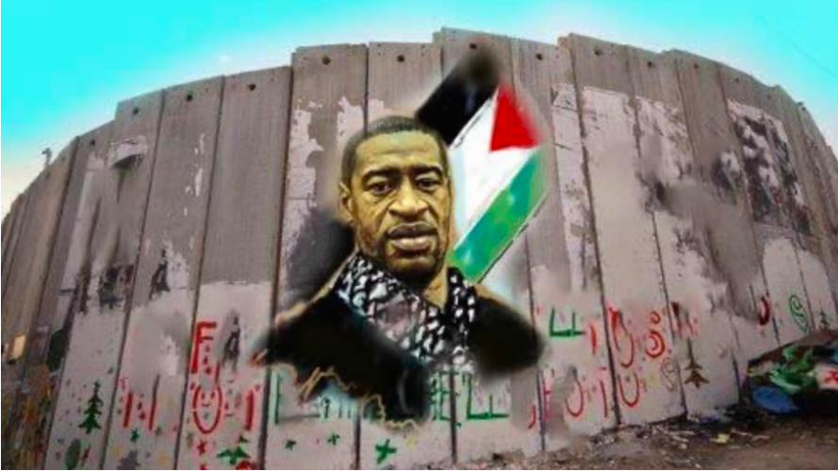
A mural of George Floyd painted on the Israel-West Bank separating wall, by Palestinian Artist Walid Ayoub.
From Al-Monitor/Twitter.

ADDITIONAL POLICIES
Absence and Class Participation Policy
Participating in the course and attending lectures and other course events are vital to the learning process. Much of the material on the exams is based on the lectures and discussions in class. As such, attendance is 10% of your final grade.

At the same time, I understand that this is a challenging time and there may be many surprises along the way. If you anticipate being absent, are unexpectedly absent, or are unable to participate in class activities, please contact me as soon as possible.

- Classroom attendance:
- If you feel sick, or may have been in contact with someone who is infectious, stay home. Except for seeking medical care, avoid contact with others and do not travel.
- Notify your instructor(s) if you will be missing a course meeting or an assignment deadline.
- Non-attendance for any reason does not guarantee an automatic extension of due date or rescheduling of examinations/assessments.
    - Please communicate and coordinate any request directly with your instructor.
  - If you must miss the equivalent of more than one week of class, you should contact the Dean of Students Office DOS-deanofstudents@email.arizona.edu to share documentation about the challenges you are facing.
- Voluntary, free, and convenient COVID-19 testing is available for students on Main Campus.
- COVID-19 vaccine is available for all students at Campus Health.
- Visit the UArizona COVID-19 page for regular updates.

- Academic advising: If you have questions about your academic progress this semester, please reach out to your academic advisor (https://advising.arizona.edu/advisors/major). Contact the Advising Resource Center (https://advising.arizona.edu/) for all general advising questions and referral assistance. Call 520-626-8667 or email to advising@.arizona.edu

- Life challenges: If you are experiencing unexpected barriers to your success in your courses, please note the Dean of Students Office is a central support resource for all students and may be helpful. The Dean of Students Office can be reached at (520) 621-2057 or DOS-deanofstudents@email.arizona.edu.

- Physical and mental-health challenges: If you are facing physical or mental health challenges this semester, please note that Campus Health provides quality medical and mental health care. For medical appointments, call (520) 621-9202. For After Hours care, call (520) 570-7898. For the Counseling & Psych Services (CAPS) 24/7 hotline, call (520) 621-3334.

Accessibility and Accommodations: At the University of Arizona, we strive to make learning experiences as accessible as possible. If you anticipate or experience barriers based on disability or pregnancy, please contact the Disability Resource Center (520-621-3268, https://drc.arizona.edu) to establish reasonable accommodations.

The UA’s policy concerning Class Attendance, Participation, and Administrative Drops is available at: http://catalog.arizona.edu/policy/class-attendance-participation-and-administrative-drop.

The UA policy regarding absences for any sincerely held religious belief, observance or practice will be accommodated where reasonable: http://policy.arizona.edu/human-resources/religious-accommodation-policy.

Absences pre-approved by the UA Dean of Students (or Dean Designee) will be honored. See: https://deanofstudents.arizona.edu/absences.

Course Communications
The best way to reach me is via email (lauragoffman@arizona.edu). I will communicate any announcements to you via the email function on D2L. You may want to link your D2L to your university email account.

Makeup Policy for Students Who Register Late
Students who register after the first class may make up missed assignments by the end of the third week of classes.

Requests for incomplete (I) or withdrawal (W) must be made in accordance with University policies, which are available at http://catalog.arizona.edu/policy/grades-and-grading-system#incomplete and http://catalog.arizona.edu/policy/grades-and-grading system#Withdrawal respectively.

Classroom Behavior Policy
To foster a positive learning environment, students and instructors have a shared responsibility. We want a safe, welcoming, and inclusive environment where all of us feel comfortable with each other and where we can challenge ourselves to succeed. To that end, our focus is on the tasks at hand and not on extraneous activities (e.g., texting, web surfing, chatting).

Threatening Behavior Policy: The UA Threatening Behavior by Students Policy prohibits threats of physical harm to any member of the University community, including to oneself. See http://policy.arizona.edu/education-and-student-affairs/threatening-behavior-students.

Dispute of Grade Policy:
If you wish to dispute your grade on a test or assignment, you may do so within one week of receiving your grade.

Code of Academic Integrity
Students are encouraged to share intellectual views and discuss freely the principles and applications of course materials. However, graded work/exercises must be the product of independent effort unless otherwise instructed. Students are expected to adhere to the UA Code of Academic Integrity as described in the UA General Catalog.

Selling class notes and/or other course materials to other students or to a third party for resale is not permitted. Violations to this and other course rules are subject to the Code of Academic Integrity and may result in course sanctions. Additionally, students who use D2L or UA e-mail to sell or buy these copyrighted materials are subject to Code of Conduct Violations for misuse of student e-mail addresses. This conduct may also constitute copyright infringement.

Note on plagiarism: Plagiarism is a very serious offence. Be sure to cite properly other people’s ideas in your writings. If any part of a paper is plagiarized, you will receive a zero for the assignment. No exceptions. Students are required to upload all papers to D2L.

UA Nondiscrimination and Anti-harassment Policy:
The University is committed to creating and maintaining an environment free of discrimination; see http://policy.arizona.edu/human-resources/nondiscrimination-and-anti-harassment-policy.

Our classroom is a place where everyone is encouraged to express well-formed opinions and their reasons for those opinions. We also want to create a tolerant and open environment where such opinions can be expressed without resorting to bullying or discrimination of others.
Additional Resources:
UA Academic policies and procedures are available at http://catalog.arizona.edu/policies.
Student Assistance and Advocacy information is available at: http://deanofstudents.arizona.edu/student-assistance/students/student-assistance.

Confidentiality of Student Records: http://www.registrar.arizona.edu/personal-information/family-educational-rights-and-privacy-act-1974-ferpa?topic=ferpa.

Subject to Change Statement: Information contained in the course syllabus, other than the grade and absence policy, may be subject to change with advance notice, as deemed appropriate by the instructor.

