Technical Report Analysis - Frequency Correlations

Marta Topor

09/03/2021

# Comparison of high and low frequecy noise in raw data

The first part of analysis assesses the noise in the data before any preprocessing was applied. This information can be used to assess the quality of recorded data. We can especially pay attention to low frequency noise which may lead to drifts in the data and 50Hz noise which is an important indication of noise especially for Mobita where impedence could not be tested.

## **0.1-2Hz**

**Descriptive statistics, Wilcoxon test and plot:**

* Median for EasyCap
* Median for Mobita
* Wilcoxon test result
* Pirate Plot, the box indicates the IQR and median

## [1] 0.03458169

## [1] 1.308575

##   
## Wilcoxon signed rank exact test  
##   
## data: E_chans_low_log$mean_E and M_chans_low_log$mean_M  
## V = 11, p-value = 0.1055  
## alternative hypothesis: true location shift is not equal to 0

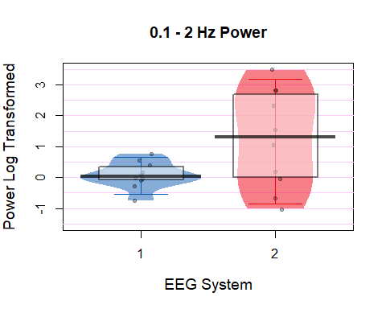

**Bonferroni Corrected Wilcoxon Results:**  
(p value times by 4 as there are 4 tests altogether looking at frequencies in the range of 0.1-2Hz and 49-51Hz)

V = 7, p = 0.422

## **49-51Hz**

**Descriptive statistics, Wilcoxon test and plot:**

* Median for EasyCap
* Median for Mobita
* Wilcoxon test result
* Piate Plot with IQR and median

## [1] -4.760796

## [1] -5.63999

##   
## Wilcoxon signed rank exact test  
##   
## data: E_chans_high_log$mean_E and M_chans_high_log$mean_M  
## V = 30, p-value = 0.8457  
## alternative hypothesis: true location shift is not equal to 0

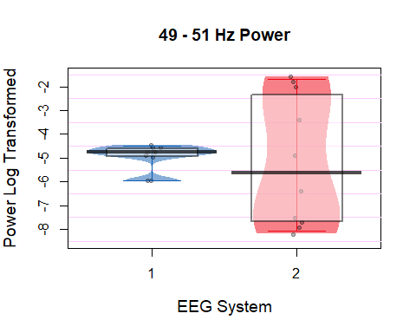 **Bonferroni Corrected Wilcoxon Results:**  
(p value times by 4 as there are 4 tests altogether looking at frequencies in the range of 0.1-2Hz and 49-51Hz)

V = 30, p = 1.0

**Raw Freq Plot Log-Transformed 0-60Hz**

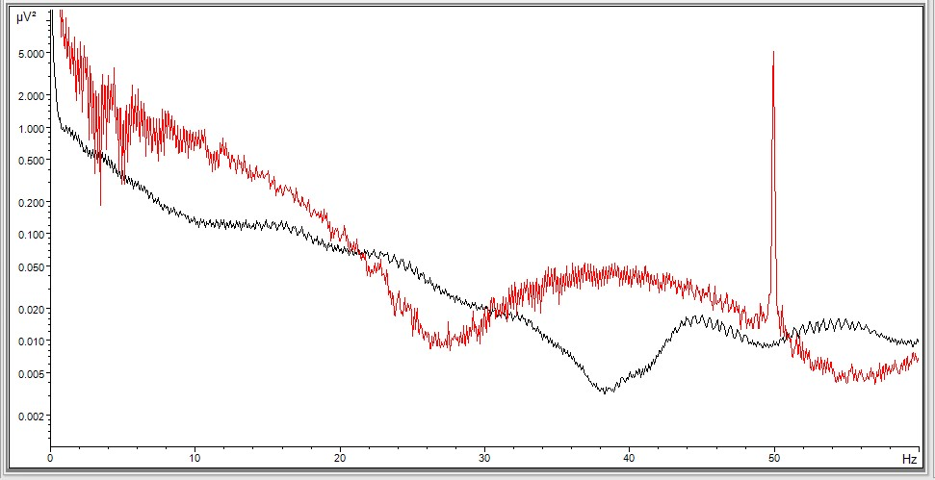

Raw_Freq

# Comparison of noise during and after pre-processing

In this part data will be analysed to compare artefacts which were removed during pre-processing. Then noise metrics SNR and RMS will be compared between the two systems. Lastly, 0.1-2Hz and 49-51Hz power will be compared between the systems again.

## **Rejected ICA components**

Firstly, it will be calculated whether there is a significant difference between the number of trials rejected for each system.

* Median for Easy Cap
* Median for Mobita
* Wilcoxon test results

## [1] 2.5

## [1] 2.5

##   
## Wilcoxon signed rank test with continuity correction  
##   
## data: df_preproc$E_Rej_Comp and df_preproc$M_Rej_Comp  
## V = 7.5, p-value = 0.5898  
## alternative hypothesis: true location shift is not equal to 0

**Bonferroni Corrected Wilcoxon Results:**  
(p value times by 2 as there are 2 tests altogether looking at artefact/component rejection in the dataset)

V = 1, p = 1.0

## **Rejected artefactual trials**

There were three types of trials extracted for the analyses in this study. Stimulus locked trials, response locked trials with correct responses and response locked trials with incorrect responses. Proportion of rejected trials was calculated only for the stimulus-locked trials as the total number of trials was the largest in this type whereas for the response-locked trials, the total number was divided into two types.

* Median for Easy Cap
* Median for Mobita
* Wilcoxon test results
* Pirate Plot

## [1] 0.5841695

## [1] 3.793319

##   
## Wilcoxon signed rank exact test  
##   
## data: df_preproc$E_Stim_Rej_p and df_preproc$M_Stim_Rej_p  
## V = 1, p-value = 0.003906  
## alternative hypothesis: true location shift is not equal to 0

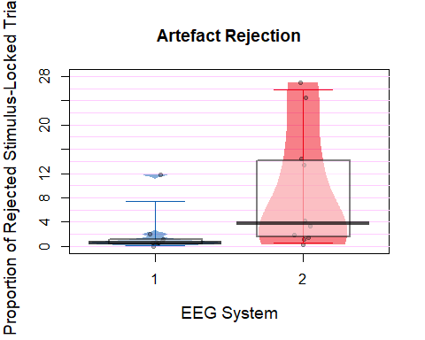

**Bonferroni Corrected Wilcoxon Results:**  
(p value times by 2 as there are 2 tests altogether looking at artefact/component rejection in the dataset)

V = 1, p = 0.007812

## **Stimulus to Noise Ratio (SNR)**

The SNR was also extracted from stimulus-locked trials. A subset of electrodes was chosen which excluded electrodes on the edges of the caps which are generally more prone to noise. The final electrode subset included: F3, Fz, F4, FC5, FC1, FC2, FC6, C3, Cz, C4, CP5, CP1, CP2, CP6, P3, Pz, P4.

* Median for Easy Cap
* Median for Mobita
* Wilcoxon test results
* Pirate Plot

## [1] 0.04575088

## [1] 0.037662

##   
## Wilcoxon signed rank exact test  
##   
## data: df_SNR_final$SNR_mean_E and df_SNR_final$SNR_mean_M  
## V = 48, p-value = 0.03711  
## alternative hypothesis: true location shift is not equal to 0

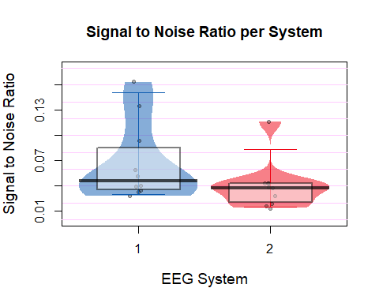

**Bonferroni Corrected Wilcoxon Results:**  
(p value times by 2 as there are 2 tests altogether looking at noise in the signal)

V = 48, p = 0.07422

## **Root-Mean Square (RMS)**

The RMS values were also extracted from stimulus-locked trials. A subset of electrodes was chosen which excluded electrodes on the edges of the caps which are generally more prone to noise. The final electrode subset included: F3, Fz, F4, FC5, FC1, FC2, FC6, C3, Cz, C4, CP5, CP1, CP2, CP6, P3, Pz, P4.

* Median for Easy Cap
* Median for Mobita
* Wilcoxon test results
* Pirate Plot

## [1] 10.80476

## [1] 20.79649

##   
## Wilcoxon signed rank exact test  
##   
## data: df_RMS$RMS_E_subset and df_RMS$RMS_M_subset  
## V = 5, p-value = 0.01953  
## alternative hypothesis: true location shift is not equal to 0

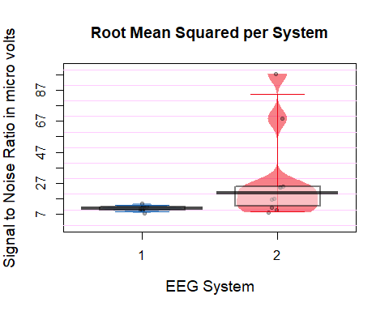

**Bonferroni Corrected Wilcoxon Results:**  
(p value times by 2 as there are 2 tests altogether looking at noise in the signal)

V = 5, p = 0.03906

## **0.1-2Hz**

**Descriptive statistics, Wilcoxon test and plot:**

* Median for EasyCap
* Median for Mobita
* Wilcoxon test result
* Pirate Plot, the box indicates the IQR and median

## [1] 5.305756

## [1] 5.684883

##   
## Wilcoxon signed rank exact test  
##   
## data: E_chans_low_log_c$mean_E and M_chans_low_log_c$mean_M  
## V = 18, p-value = 0.375  
## alternative hypothesis: true location shift is not equal to 0

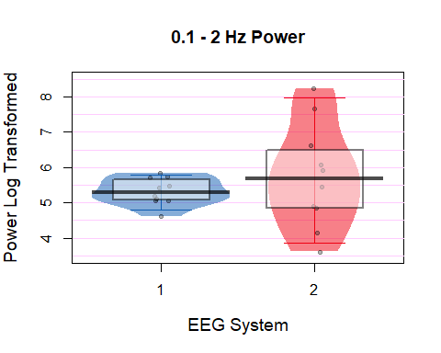 **Bonferroni Corrected Wilcoxon Results:** (p value times by 4 as there are 4 tests altogether looking at frequencies in the range of 0.1-2Hz and 49-51Hz)

V = 30, p = 1.0

## **49-51Hz**

**Descriptive statistics, Wilcoxon test and plot:**

* Median for EasyCap
* Median for Mobita
* Wilcoxon test result
* Piate Plot with IQR and median

## [1] -5.057201

## [1] -5.052275

##   
## Wilcoxon signed rank exact test  
##   
## data: E_chans_high_log_c$mean_E and M_chans_high_log_c$mean_M  
## V = 34, p-value = 0.5566  
## alternative hypothesis: true location shift is not equal to 0

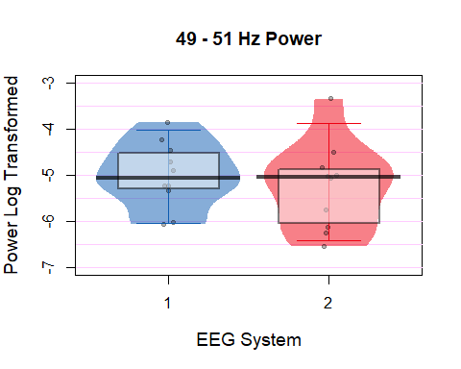

**Bonferroni Corrected Wilcoxon Results:** (p value times by 4 as there are 4 tests altogether looking at frequencies in the range of 0.1-2Hz and 49-51Hz)

V = 34, p = 1.0

**Raw Freq Plot Log-Transformed 0-60Hz**

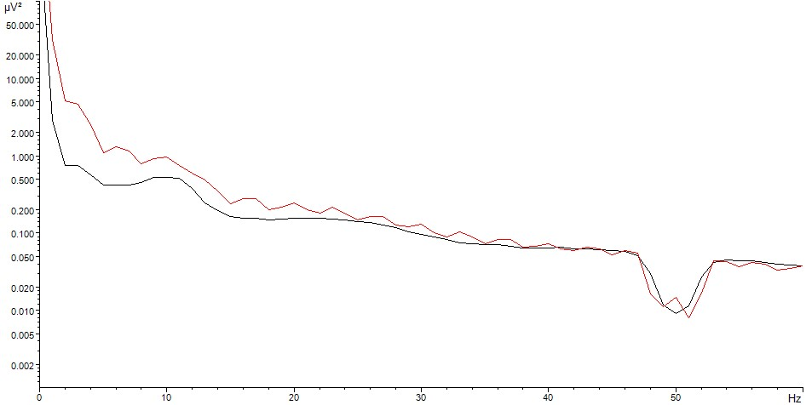

Range_Freq

# Comparison of frequency activity between the two systems

## **Theta analysis**

**1. Electrode matching**

Select the electrodes that were identified to have strongest activity for theta band and which are overlapping between the two systems.  
Select from a subset of frontal elecrodes only:  
F3, Fz, F4, FC5, FC1, FC2, FC6, C3, Cz, C4, CP5, CP1, CP2, CP6, P3, Pz, P4  
The above subset excludes electrodes located on the edges of the cap which are prone to noise and extreme values.

Overlapping electrodes: Fz, F4, FC1, FC2

**2.Results**

* Median for EasyCap
* Median for Mobita
* Spearman Correlation
* Correlation Plot
* Wilcoxon Test
* Pirate Plots

## [1] -0.7805815

## [1] 0.09921781

##   
## Spearman's rank correlation rho  
##   
## data: df_theta_matched$theta_av_E_log and df_theta_matched$theta_av_M_log  
## S = 144, p-value = 0.7329  
## alternative hypothesis: true rho is not equal to 0  
## sample estimates:  
## rho   
## 0.1272727

## `geom_smooth()` using formula 'y ~ x'

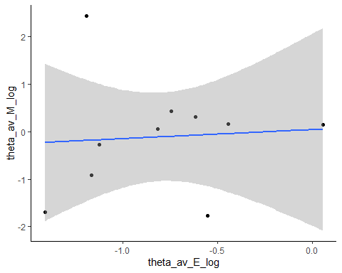

##   
## Wilcoxon signed rank exact test  
##   
## data: df_theta_matched$theta_av_E_log and df_theta_matched$theta_av_M_log  
## V = 12, p-value = 0.1309  
## alternative hypothesis: true location shift is not equal to 0

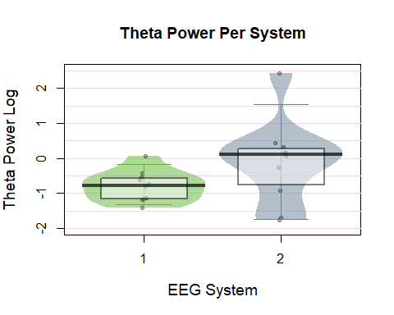

It looks as though there is no relationship in the data. The test also shows no significant correlation.  
P-value with Bonferroni Correction = 1.0  
(multiplied by 8 as there are 4 frequency bands tested with two different tests)

The Wilcoxon test is also non-significant although from the plot is is evident that the values recorded with Mobita are much more variable than those recorded with EasyCap.  
P-value with Bonferroni Correction = 1.0  
(multiplied by 8)

## **Alpha analysis**

**Electrode matching**

Select the electrodes that were identified to have strongest activity for theta band and which are overlapping between the two systems.  
Select from a subset of frontal elecrodes only:  
F3, Fz, F4, FC5, FC1, FC2, FC6, C3, Cz, C4, CP5, CP1, CP2, CP6, P3, Pz, P4  
The above subset excludes electrodes located on the edges of the cap which are prone to noise and extreme values.

Overlapping electrodes: Fz, Pz, P4

**2. Results**

* Median for EasyCap
* Median for Mobita
* Spearman Correlation
* Correlation Plot
* Wilcoxon Test
* Pirate Plots

## [1] -1.150845

## [1] -0.3762333

##   
## Spearman's rank correlation rho  
##   
## data: df_alpha_matched$alpha_av_E_log and df_alpha_matched$alpha_av_M_log  
## S = 64, p-value = 0.06647  
## alternative hypothesis: true rho is not equal to 0  
## sample estimates:  
## rho   
## 0.6121212

## `geom_smooth()` using formula 'y ~ x'

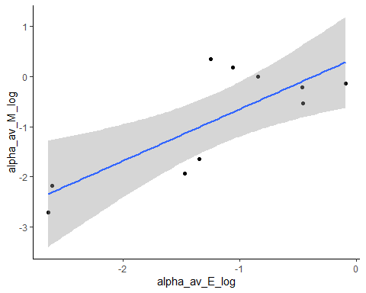

##   
## Wilcoxon signed rank exact test  
##   
## data: df_alpha_matched$alpha_av_E_log and df_alpha_matched$alpha_av_M_log  
## V = 18, p-value = 0.375  
## alternative hypothesis: true location shift is not equal to 0

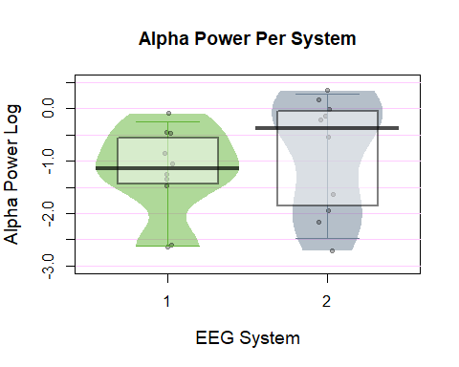

There is a clear positive trend seen in the correlation plot which is great! The result is non-significant.  
P-value with Bonferroni Correction = 0.53176  
(multiplied by 8 as there are 4 frequency bands tested with two different tests)

For Wilcoxon, the test is not significant and the pirate plot does not indicate too much of a difference between the two systems.  
P-value with Bonferroni Correction = 1.0  
(multiplied by 8)

## **Low Beta Analysis**

**1. Electrode matching**

Select the electrodes that were identified to have strongest activity for theta band and which are overlapping between the two systems.  
Select from a subset of frontal elecrodes only:  
F3, Fz, F4, FC5, FC1, FC2, FC6, C3, Cz, C4, CP5, CP1, CP2, CP6, P3, Pz, P4  
The above subset excludes electrodes located on the edges of the cap which are prone to noise and extreme values.

Overlapping electrodes: F4

**2. Results**

* Median for EasyCap
* Median for Mobita
* Spearman Correlation
* Correlation Plot
* Wilcoxcon Test
* Pirate Plots

## [1] -2.353824

## [1] -1.648262

##   
## Spearman's rank correlation rho  
##   
## data: df_lbeta_matched$lbeta_av_E_log and df_lbeta_matched$lbeta_av_M_log  
## S = 68, p-value = 0.08022  
## alternative hypothesis: true rho is not equal to 0  
## sample estimates:  
## rho   
## 0.5878788

## `geom_smooth()` using formula 'y ~ x'

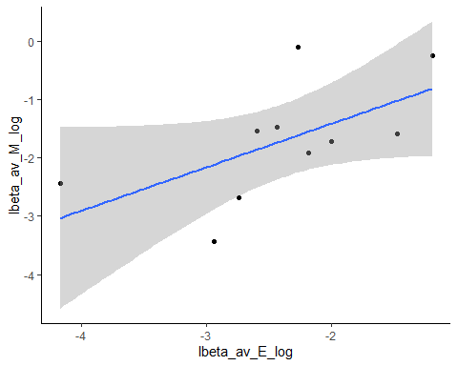

##   
## Wilcoxon signed rank exact test  
##   
## data: df_lbeta_matched$lbeta_av_E_log and df_lbeta_matched$lbeta_av_M_log  
## V = 7, p-value = 0.03711  
## alternative hypothesis: true location shift is not equal to 0

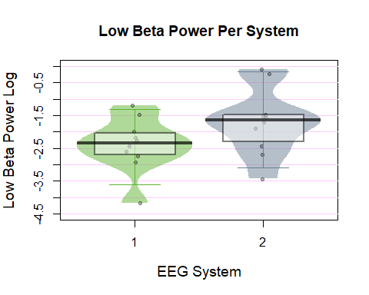

Looks like there is a clear relationship from the correlation plot but the results are non significant.  
P-value with Bonferroni Correction = 0.64176  
(multiplied by 8 as there are 4 frequency bands tested with 2 tests each)

For the Wilcoxon’s test, it looks as though Mobita has consistently higher power and there is a similar variance/distribution in both systems. The result is non-significant after Bonferroni Correction.  
P-value with Bonferroni Correction = 0.29688  
(multiplied by 8)

## **High Beta Analysis**

**Electrode matching**

Select the electrodes that were identified to have strongest activity for theta band and which are overlapping between the two systems.  
Select from a subset of frontal elecrodes only:  
F3, Fz, F4, FC5, FC1, FC2, FC6, C3, Cz, C4, CP5, CP1, CP2, CP6, P3, Pz, P4  
The above subset excludes electrodes located on the edges of the cap which are prone to noise and extreme values.

Overlapping electrodes: CP1, CP2, Pz, P4

**2. Results**

* Median for EasyCap
* Median for Mobita
* Spearman Correlation
* Correlation Plot
* Wilcoxon Test
* Pirate Plots

## [1] -3.669144

## [1] -3.107145

##   
## Spearman's rank correlation rho  
##   
## data: df_hbeta_matched$hbeta_av_E_log and df_hbeta_matched$hbeta_av_M_log  
## S = 60, p-value = 0.05445  
## alternative hypothesis: true rho is not equal to 0  
## sample estimates:  
## rho   
## 0.6363636

## `geom_smooth()` using formula 'y ~ x'

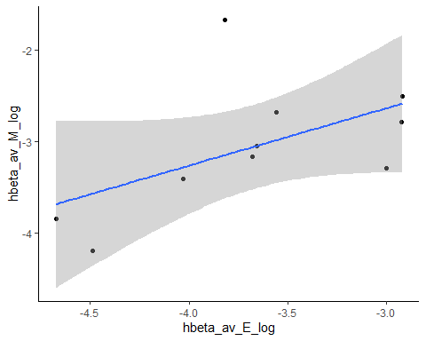

##   
## Wilcoxon signed rank exact test  
##   
## data: df_hbeta_matched$hbeta_av_E_log and df_hbeta_matched$hbeta_av_M_log  
## V = 3, p-value = 0.009766  
## alternative hypothesis: true location shift is not equal to 0

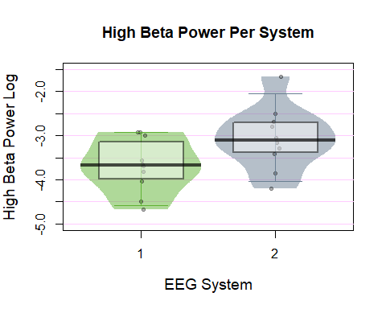

From the correlation plot, it looks like there is a relationship in the data but it is not significant.  
P-value with Bonferroni Correction = 0.4356  
(multiplied by 8 as there are 4 frequency bands and 2 tests used for each)

From the pirate plots, it looks as though activity is stronger in Mobita though variance/distribution is again not too different. The difference is again non-significant here.  
P-value with Bonferroni Correction = 0.078128

## **Correlation plots with topographies**

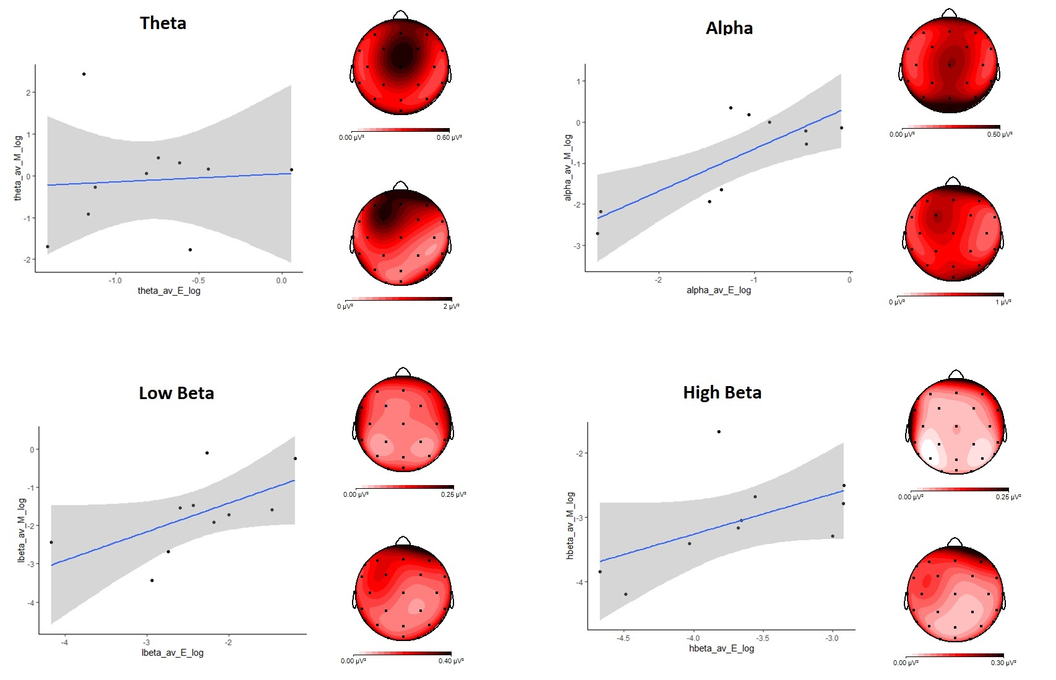

Plots

# Comparison of frequency activity between the two systems

## **P300**

* Median for Easy Cap
* Median for Mobita
* Wilcoxon test results
* Pirate Plot

## [1] 10.80476

## [1] 20.79649

##   
## Wilcoxon signed rank exact test  
##   
## data: df_RMS$RMS_E_subset and df_RMS$RMS_M_subset  
## V = 5, p-value = 0.01953  
## alternative hypothesis: true location shift is not equal to 0

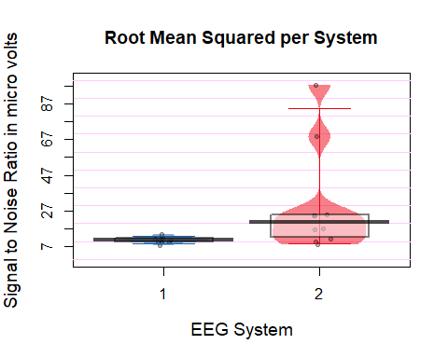

**Bonferroni Corrected Wilcoxon Results:**  
(p value times by 2 as there are 2 tests altogether looking at noise in the signal)

V = 5, p = 0.03906