Technical Report Analysis - Frequency Correlations

Marta Topor

09/03/2021

# Comparison of high and low frequecy noise in raw data

The first part of analysis assesses the noise in the data before any preprocessing was applied. This information can be used to assess the quality of recorded data. We can especially pay attention to low frequency noise which may lead to drifts in the data and 50Hz noise which is an important indication of noise especially for Mobita where impedence could not be tested.

## **0.1-2Hz**

**Results**

* Pirate Plot, the box indicates the IQR and median
* Median for EasyCap
* Median for Mobita
* Wilcoxon test result
* Fligner-Killeen test for homogeneity of variance

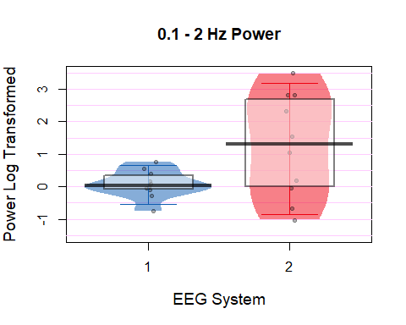

There is a significant difference in variance between EasyCap and Mobita for for the Fligner-Killeen test.  
Bonferroni correction x8 as there are 2 tests for each of the 2 frequency bands at 2 time points (2 * 2 * 2)

**Median for EasyCap:** 0.0345817  
**Median for Mobita:** 1.3085746

**Wilcoxon:** V = 11, p = 0.1054688, Bonferroni p = 0.84375

**Fligner-Killeen:** X2 = 8.8975165, p = 0.0028556, Bonferroni p = 0.0228447

## **49-51Hz**

**Descriptive statistics, Wilcoxon test and plot:**

* Piate Plot with IQR and median
* Median for EasyCap
* Median for Mobita
* Wilcoxon test result
* Fligner-Killeen test

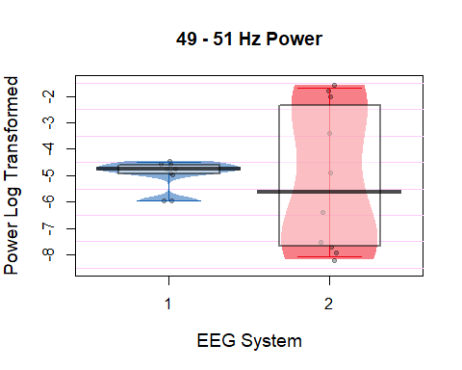

There is a significant difference in variance between EasyCap and Mobita for for the Fligner-Killeen test.  
Bonferroni correction x8 as there are 2 tests for each of the 2 frequency bands at 2 time points (2 * 2 * 2)

**Median for EasyCap:** -4.7607959  
**Median for Mobita:** -5.63999

**Wilcoxon:** V = 30, p = 0.8457031, Bonferroni p = 6.765625

**Fligner-Killeen:** X2 = 11.0140189, p = 9.0425376^{-4}, Bonferroni p = 0.007234

**Raw Freq Plot Log-Transformed 0-60Hz**

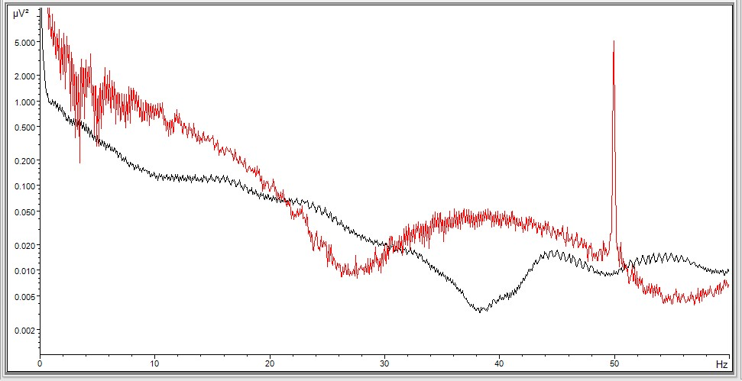

Raw_Freq

# Comparison of noise during and after pre-processing

In this part data will be analysed to compare artefacts which were removed during pre-processing. Then noise metrics SNR and RMS will be compared between the two systems. Lastly, 0.1-2Hz and 49-51Hz power will be compared between the systems again.

## **0.1-2Hz**

**Descriptive statistics, Wilcoxon test and plot:**

* Pirate Plot, the box indicates the IQR and median
* Median for EasyCap
* Median for Mobita
* Wilcoxon test result
* Fligner-Killeen test

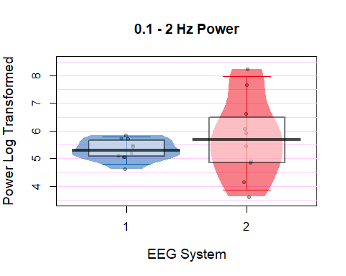

There are no significant results in the data.  
Bonferroni correction x8 as there are 2 tests for each of the 2 frequency bands at 2 time points (2 * 2 * 2)

**Median for EasyCap:** 5.3057559  
**Median for Mobita:** 5.6848829

**Wilcoxon:** V = 18, p = 0.375, Bonferroni p = 3

**Fligner-Killeen:** X2 = 6.8638651, p = 0.0087956, Bonferroni p = 0.0703649

## **49-51Hz**

**Descriptive statistics, Wilcoxon test and plot:**

* Piate Plot with IQR and median
* Median for EasyCap
* Median for Mobita
* Wilcoxon test result
* Fligner-Killeen test

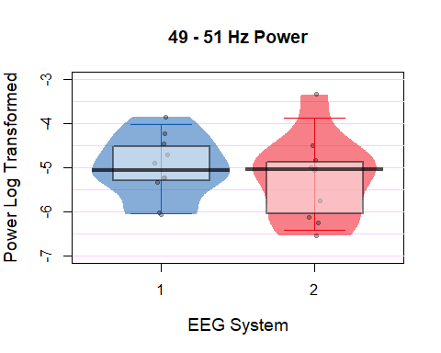

There are no significant results in the data.  
Bonferroni correction x8 as there are 2 tests for each of the 2 frequency bands at 2 time points (2 * 2 * 2)

**Median for EasyCap:** -5.0572005  
**Median for Mobita:** -5.0522749

**Wilcoxon:** V = 34, p = 0.5566406, Bonferroni p = 4.453125

**Fligner-Killeen:** X2 = 0.443075, p = 0.505642, Bonferroni p = 4.0451359

**Raw Freq Plot Log-Transformed 0-60Hz**

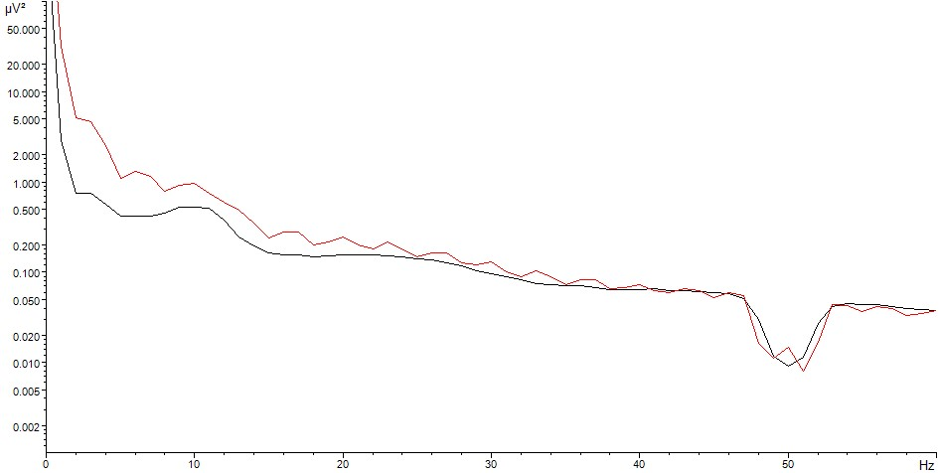

Range_Freq

## **Rejected artefactual trials**

There were three types of trials extracted for the analyses in this study. Stimulus locked trials, response locked trials with correct responses and response locked trials with incorrect responses. Proportion of rejected trials was calculated only for the stimulus-locked trials as the total number of trials was the largest in this type whereas for the response-locked trials, the total number was divided into two types.

* Pirate Plot
* Median for Easy Cap
* Median for Mobita
* Wilcoxon test results
* Fligner-Killeen test

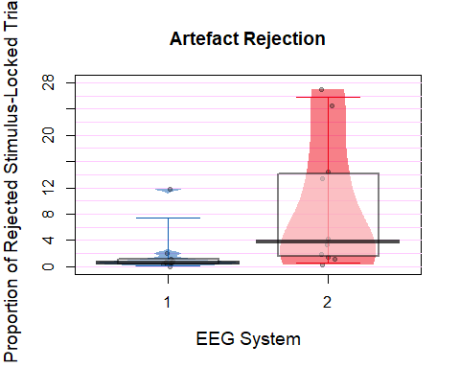

Both, the Wilcoxon and the Fligner-Killeen test are significant.  
Bonferroni correction x2 as there are 2 tests looking at artefact rejection in the dataset.

**Median for EasyCap:** 0.5841695  
**Median for Mobita:** 3.7933191

**Wilcoxon:** V = 1, p = 0.0039063, Bonferroni p = 0.0078125

**Fligner-Killeen:** X2 = 6.4155382, p = 0.0113126, Bonferroni p = 0.0226252

## **Stimulus to Noise Ratio (SNR)**

The SNR was also extracted from stimulus-locked trials. A subset of electrodes was chosen which excluded electrodes on the edges of the caps which are generally more prone to noise. The final electrode subset included: F3, Fz, F4, FC5, FC1, FC2, FC6, C3, Cz, C4, CP5, CP1, CP2, CP6, P3, Pz, P4.

* Pirate Plot
* Median for Easy Cap
* Median for Mobita
* Wilcoxon test results
* Fligner-Killeen test

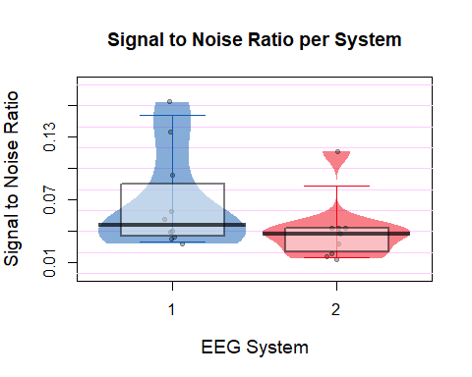

The results are non-significant.  
Bonferroni correction x4 as there are 2 tests and 2 measures of noise.

**Median for EasyCap:** 0.0457509  
**Median for Mobita:** 0.037662

**Wilcoxon:** V = 48, p = 0.0371094, Bonferroni p = 0.1484375

**Fligner-Killeen:** X2 = 1.6691743, p = 0.1963692, Bonferroni p = 0.7854767

## **Root-Mean Square (RMS)**

The RMS values were also extracted from stimulus-locked trials. A subset of electrodes was chosen which excluded electrodes on the edges of the caps which are generally more prone to noise. The final electrode subset included: F3, Fz, F4, FC5, FC1, FC2, FC6, C3, Cz, C4, CP5, CP1, CP2, CP6, P3, Pz, P4.

* Pirate Plot
* Median for Easy Cap
* Median for Mobita
* Wilcoxon test results
* Flinger-Killeen test

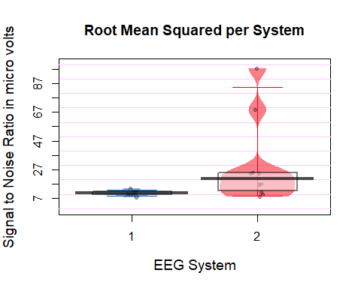

Fligner-Kileen test is significant for RMS between EasyCap and Mobita.  
Bonferroni correction x4 as there are 2 tests and 2 measures of noise.

**Median for EasyCap:** 10.804762  
**Median for Mobita:** 20.796485

**Wilcoxon:** V = 5, p = 0.0195312, Bonferroni p = 0.078125

**Fligner-Killeen:** X2 = 12.7360151, p = 3.586811^{-4}, Bonferroni p = 0.0014347

# Comparison of frequency activity between the two systems

## **Theta analysis**

**1. Electrode matching**

Select the electrodes that were identified to have strongest activity for theta band and which are overlapping between the two systems.  
Select from a subset of frontal elecrodes only:  
F3, Fz, F4, FC5, FC1, FC2, FC6, C3, Cz, C4, CP5, CP1, CP2, CP6, P3, Pz, P4  
The above subset excludes electrodes located on the edges of the cap which are prone to noise and extreme values.

Overlapping electrodes: Fz, F4, FC1, FC2

**2. Results**

* Spearman Correlation
* Pirate Plots
* Median for EasyCap
* Median for Mobita
* Correlation Plot
* Wilcoxon Test
* Fligner-Killeen test

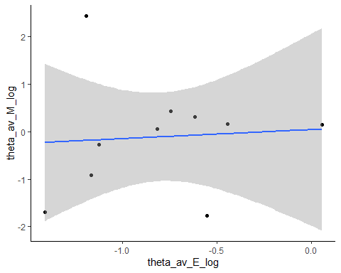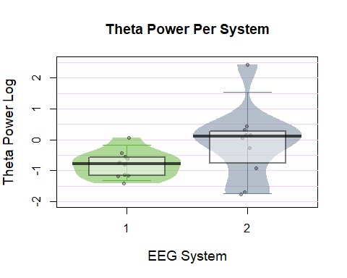

There are no statistically significant results in the data.  
Bonferroni correction x12 as there are 4 frequency bands and 3 tests each.

**Median EasyCap =** -0.7805815

**Median Mobita =** 0.0992178

**Correlation:** r = 0.1272727, p = 0.7328868, Bonferroni p = 8.794642

**Wilcoxon:** V = 12, p = 0.1308594, Bonferroni p = 1.5703125

**Fligner-Killeen:** X2 = 1.0309402, p = 0.3099379, Bonferroni p = 3.7192553

## **Alpha analysis**

**Electrode matching**

Select the electrodes that were identified to have strongest activity for theta band and which are overlapping between the two systems.  
Select from a subset of frontal elecrodes only:  
F3, Fz, F4, FC5, FC1, FC2, FC6, C3, Cz, C4, CP5, CP1, CP2, CP6, P3, Pz, P4  
The above subset excludes electrodes located on the edges of the cap which are prone to noise and extreme values.

Overlapping electrodes: Fz, Pz, P4

**2. Results**

* Correlation Plot
* Pirate Plots
* Median for EasyCap
* Median for Mobita
* Spearman Correlation
* Wilcoxon Test
* Fligner-Killeen test

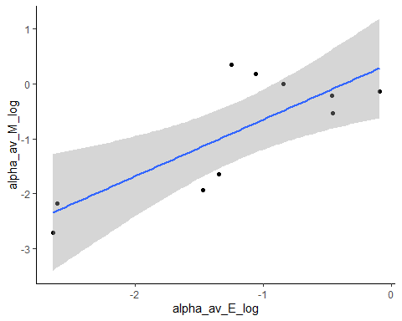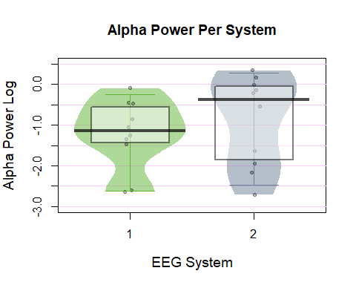

There are no statistically significant results in the data.  
Bonferroni correction x12 as there are 4 frequency bands and 3 tests each.

**Median EasyCap =** -1.1508447

**Median Mobita =** -0.3762333

**Correlation:** r = 0.6121212, p = 0.0664691, Bonferroni p = 0.7976296

**Wilcoxon:** V = 18, p = 0.375, Bonferroni p = 4.5

**Fligner-Killeen:** X2 = 1.2295939, p = 0.267486, Bonferroni p = 3.2098323

## **Low Beta Analysis**

**1. Electrode matching**

Select the electrodes that were identified to have strongest activity for theta band and which are overlapping between the two systems.  
Select from a subset of frontal elecrodes only:  
F3, Fz, F4, FC5, FC1, FC2, FC6, C3, Cz, C4, CP5, CP1, CP2, CP6, P3, Pz, P4  
The above subset excludes electrodes located on the edges of the cap which are prone to noise and extreme values.

Overlapping electrodes: F4

**2. Results**

* Correlation Plot
* Pirate Plots
* Median for EasyCap
* Median for Mobita
* Spearman Correlation
* Wilcoxcon Test
* Fligner-Killeen test

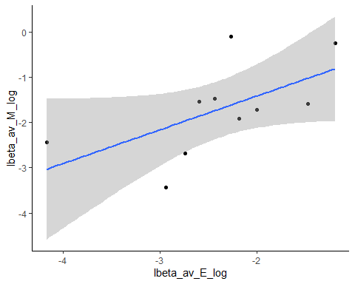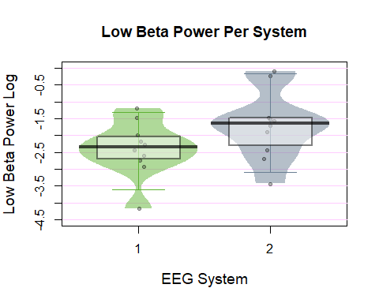

There are no statistically significant results in the data.  
Bonferroni correction x12 as there are 4 frequency bands and 3 tests each.

**Median EasyCap =** -2.3538236

**Median Mobita =** -1.6482623

**Correlation:** r = 0.5878788, p = 0.0802151, Bonferroni p = 0.9625808

**Wilcoxon:** V = 7, p = 0.0371094, Bonferroni p = 0.4453125

**Fligner-Killeen:** X2 = 0.0166712, p = 0.897265, Bonferroni p = 10.7671804

## **High Beta Analysis**

**Electrode matching**

Select the electrodes that were identified to have strongest activity for theta band and which are overlapping between the two systems.  
Select from a subset of frontal elecrodes only:  
F3, Fz, F4, FC5, FC1, FC2, FC6, C3, Cz, C4, CP5, CP1, CP2, CP6, P3, Pz, P4  
The above subset excludes electrodes located on the edges of the cap which are prone to noise and extreme values.

Overlapping electrodes: CP1, CP2, Pz, P4

**2. Results**

* Correlation Plot
* Pirate Plots
* Median for EasyCap
* Median for Mobita
* Spearman Correlation
* Wilcoxon Test
* Fligner-Killeen test

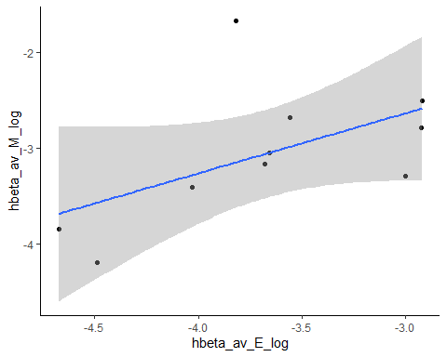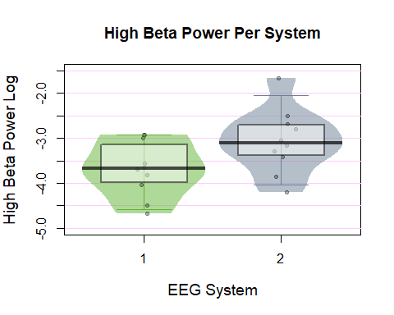

There are no statistically significant results in the data.  
Bonferroni correction x12 as there are 4 frequency bands and 3 tests each.

**Median EasyCap =** -3.6691439

**Median Mobita =** -3.1071446

**Correlation:** r = 0.6363636, p = 0.0544451, Bonferroni p = 0.6533408

**Wilcoxon:** V = 3, p = 0.0097656, Bonferroni p = 0.1171875

**Fligner-Killeen:** X2 = 0.0728059, p = 0.7872944, Bonferroni p = 9.4475326

## **Correlation plots with topographies**

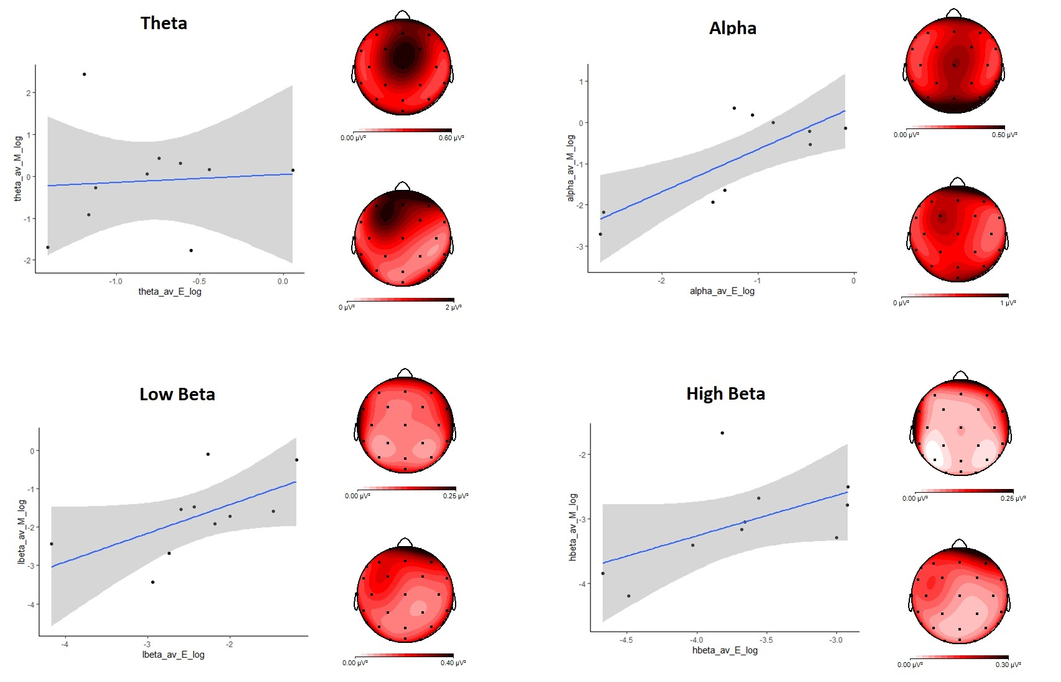 ## **All frequencies pirate plots**

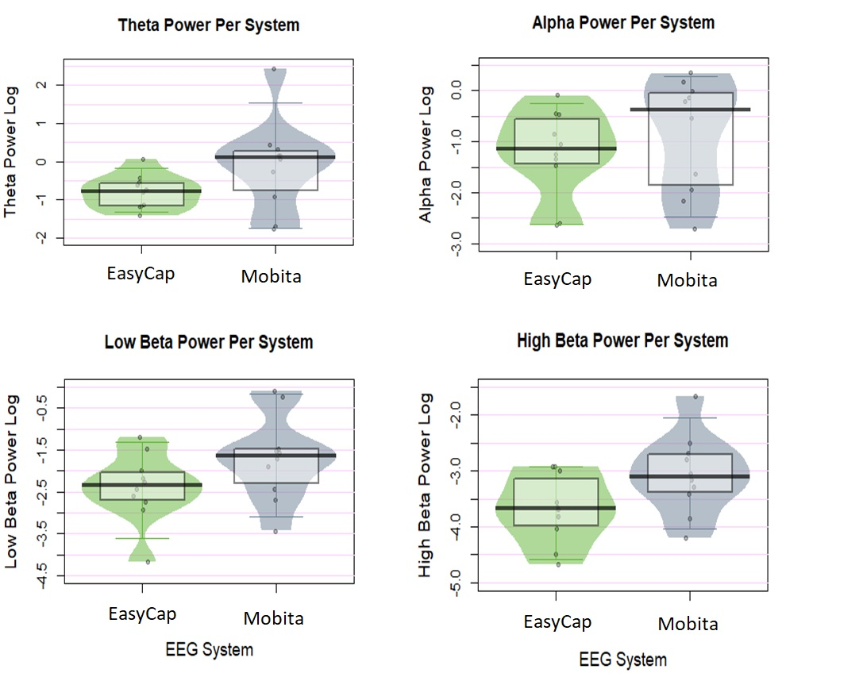

Plots

# Comparison of Event-Related Potentials between the two systems

## **P300**

**Mean Amplitude**

* Correlation Plot
* Pirate Plot
* Median for Easy Cap
* Median for Mobita
* Correlation Test
* Wilcoxon test results
* Fligner-Killeen test

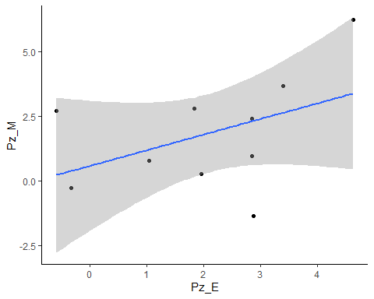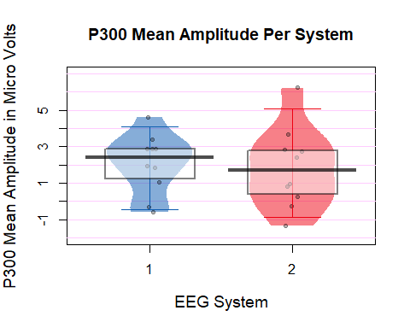 The results are non-significant. Bonferroni correction x14 as there are 2 types of ERPs with 7 tests used for each

**Median EasyCap =** 2.397499

**Median Mobita =** 1.6918165

**Correlation:** r = 0.3333333, p = 0.3488462, Bonferroni p = 4.8838474

**Wilcoxon:** V = 31, p = 0.7695312, Bonferroni p = 10.7734375

**Fligner-Killeen:** X2 = 1.531328, p = 0.2159132, Bonferroni p = 3.0227854

**Latency**

* Pirate Plot
* Median for Easy Cap
* Median for Mobita
* Wilcoxon test results
* Fligner-Killeen test

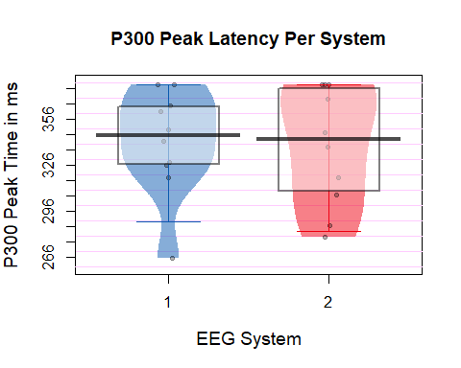

The results are non-significant. Bonferroni correction x14 as there are 2 types of ERPs with 7 tests used for each

**Median EasyCap =** 345.70313

**Median Mobita =** 342.77344

**Wilcoxon:** V = 21, p = 0.7262861, Bonferroni p = 10.1680061

**Fligner-Killeen:** X2 = 1.6883725, p = 0.1938156, Bonferroni p = 2.713419

**Amplitude**

* Pirate Plot
* Median for Easy Cap
* Median for Mobita
* Wilcoxon test results
* Fligner-Killeen test

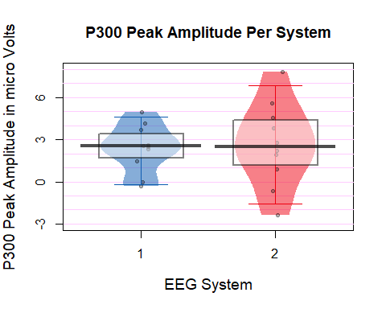

The results are non-significant. Bonferroni correction x14 as there are 2 types of ERPs with 7 tests used for each

**Median EasyCap =** 2.5396665

**Median Mobita =** 2.4892555

**Wilcoxon:** V = 23, p = 0.6953125, Bonferroni p = 9.734375

**Fligner-Killeen:** X2 = 2.8537179, p = 0.0911629, Bonferroni p = 1.2762805

**P300 Plots**  
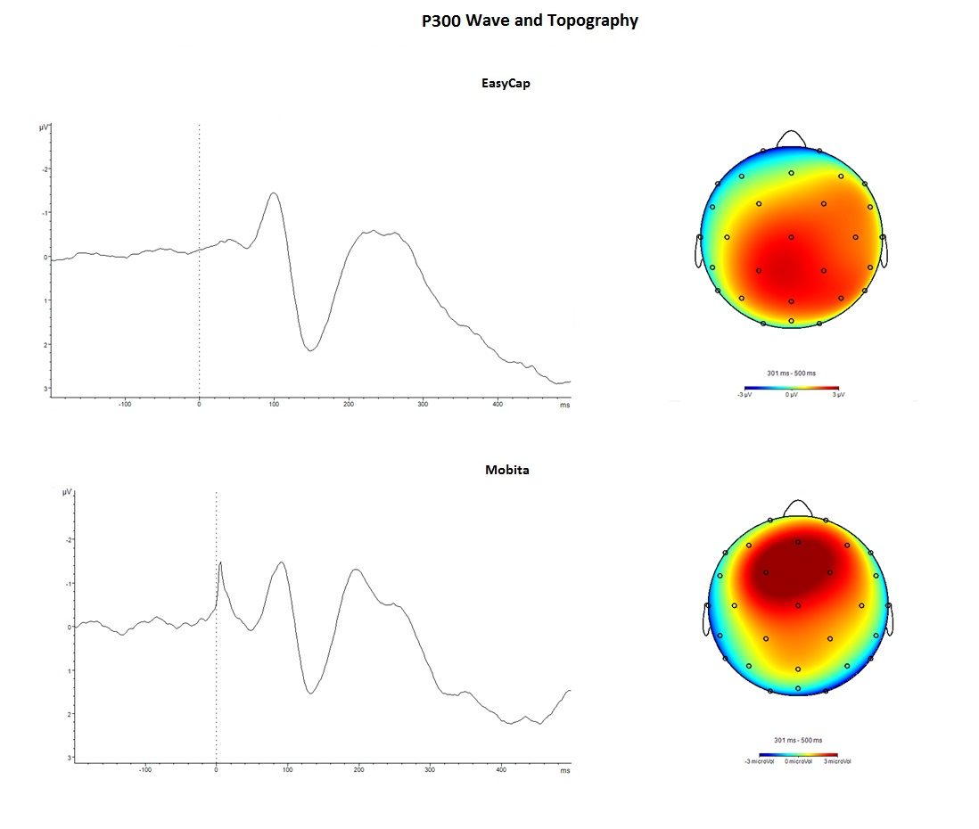

## **Investigating why the P300 is shifed frontally**

**EasyCap and Mobita P300 activity at Fz and Pz**  
EasyCap is in black and Mobita is in red.

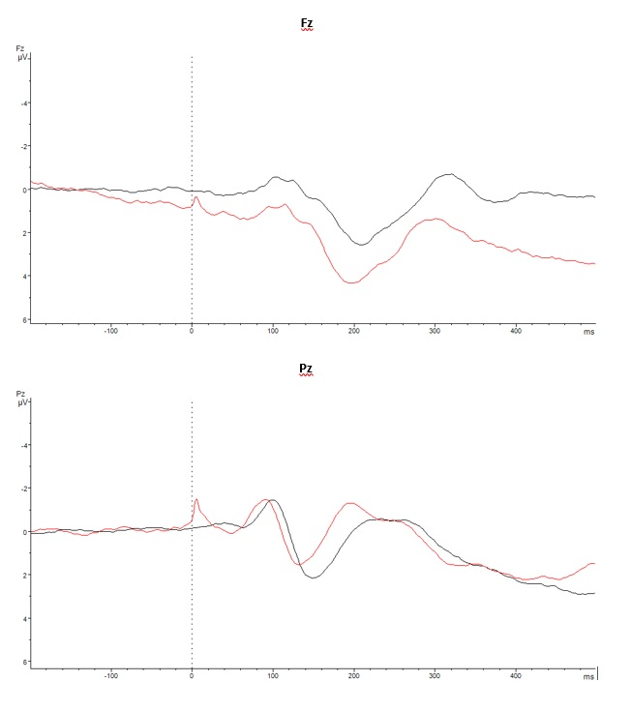

P300 waves

Here the activity looks stronger for Fz in Mobita in comparison to Fz in EasyCap and in comparison to Mobita activity at Pz.

I have checked referencing and it seems that the references are the same. The only difference is that in EasyCap, the mastoid electrodes that were implicitly recorded are included in the mean whereas in Mobita I did not include the masoid electodes for the mean calculation (as I thought they would not be included in EasyCap).

**SNR distribution across different areas of electrodes**  
#The electrodes will be divided into 3 areas and the mean SNR values for those areas will be compared using the Wilcoxon and Fligner-Killeen tests.

Frontal: Fp1, F2p, F7, F3, Fz, F4, F8,  
Central: FC5, FC1, FC2, FC6, C3, Cz, C4, CP5, CP1, CP2, CP6  
Posterior: P7, P3, Pz, P4, P8, O1, O2

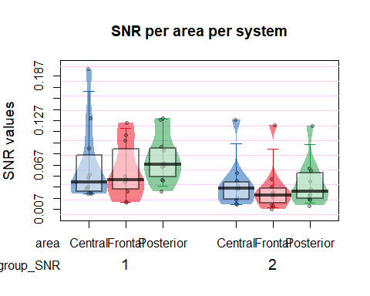

The results from Wilcoxon test are significant for the posterior electrodes. All other tests are non-significant.  
Because there are 4 other tests looking at noise in the data, p-value will be multiplied by 10.  
Bonferroni correction x10.

**Frontal electrodes**  
Wilcoxon: 47, p-value = 0.0488281, Bonferroni p-value: 0.4882812  
Fligner-Killeen: 0.4554226, p-value = 0.499771, Bonferroni p-value: 4.9977105

**Central electrodes**  
Wilcoxon: 46, p-value = 0.0644531, Bonferroni p-value: 0.6445312  
Fligner-Killeen: 0.3278975, p-value = 0.5668998, Bonferroni p-value: 5.6689976

**Posterior electrodes**  
Wilcoxon: 54, p-value = 0.0039063, Bonferroni p-value: 0.0390625  
Fligner-Killeen: 0.091518, p-value = 0.7622562, Bonferroni p-value: 7.6225617

## **ERN**

**Mean Amplitude**

* Correlation Plot
* Pirate Plot
* Median for Easy Cap
* Median for Mobita
* Correlation Test
* Wilcoxon test results

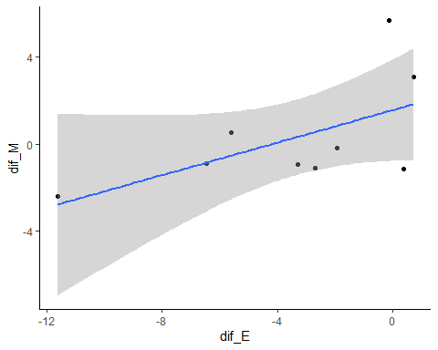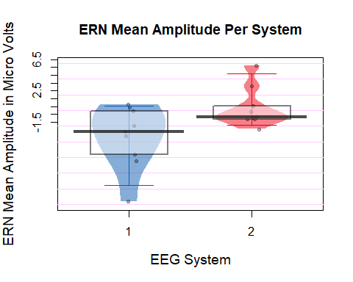

The results are non-significant. Bonferroni correction x14 as there are 2 types of ERPs with 7 tests used for each

**Median EasyCap =** -2.685649

**Median Mobita =** -0.894613

**Wilcoxon:** V = 1, p = 0.0078125, Bonferroni p = 0.109375

**Fligner-Killeen:** X2 = 1.0369341, p = 0.3085356, Bonferroni p = 4.3194984

**Peak Latency**

* Pirate Plot
* Median for Easy Cap
* Median for Mobita
* Wilcoxon test results

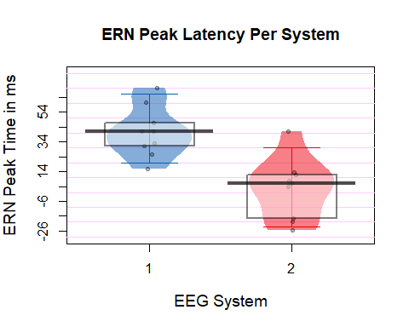

The results are non-significant. Bonferroni correction x14 as there are 2 types of ERPs with 7 tests used for each

**Median EasyCap =** 41.01563

**Median Mobita =** 5.85938

**Wilcoxon:** V = 36, p = 0.0142662, Bonferroni p = 0.1997266

**Fligner-Killeen:** X2 = 0.3146367, p = 0.5748488, Bonferroni p = 8.0478825

**Peak Amplitude**

* Pirate Plot
* Median for Easy Cap
* Median for Mobita
* Wilcoxon test results

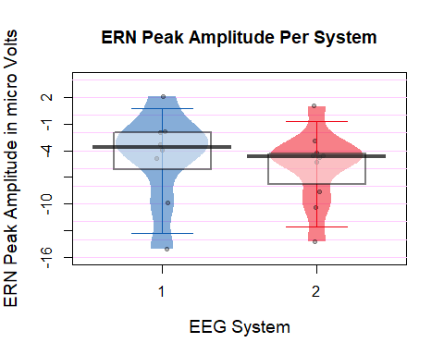

The results are non-significant. Bonferroni correction x14 as there are 2 types of ERPs with 7 tests used for each

**Median EasyCap =** -3.95719

**Median Mobita =** -4.557438

**Wilcoxon:** V = 23, p = 1, Bonferroni p = 14

**Fligner-Killeen:** X2 = 0.5352036, p = 0.4644273, Bonferroni p = 6.5019828

# Exploratory analysis - ERN shifted

Is it the case that the difference disappears once the mean amplitude window is moved back?

## [1] -2.685649

## [1] -2.35449

##   
## Wilcoxon signed rank exact test  
##   
## data: df_ERN_shift$dif_E and df_ERN_shift$dif_M  
## V = 12, p-value = 0.25  
## alternative hypothesis: true location shift is not equal to 0

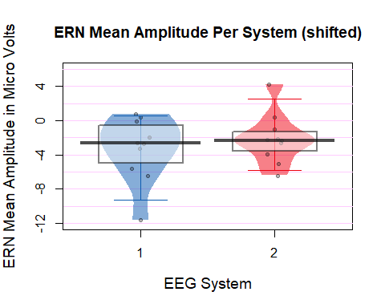

The differences in distribution disappear and the test can no longer provide evidence that there is a difference between the mean ERN amplitudes of both systems.

**ERN Plots**

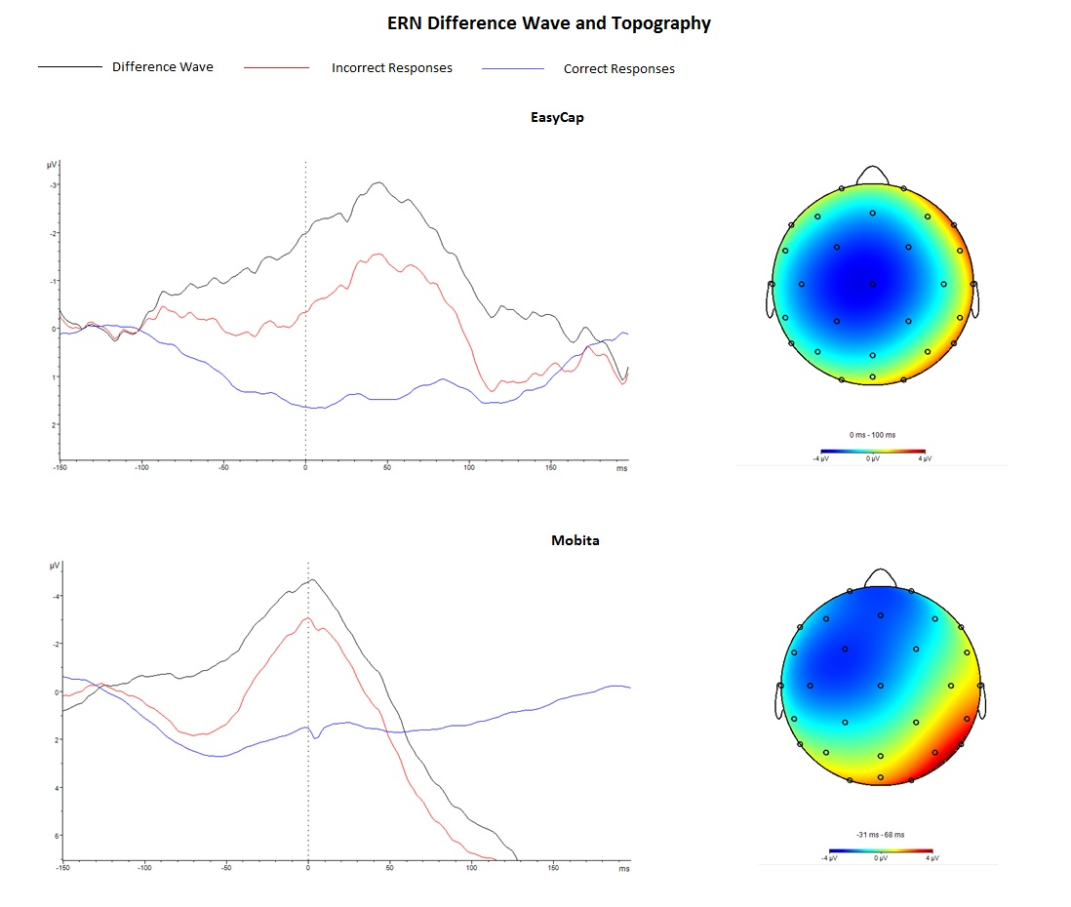

Plots

## **Rejected ICA components**

Firstly, it will be calculated whether there is a significant difference between the number of trials rejected for each system.

* Median for Easy Cap
* Median for Mobita
* Wilcoxon test results

## [1] 2.5

## [1] 2.5

##   
## Wilcoxon signed rank test with continuity correction  
##   
## data: df_preproc$E_Rej_Comp and df_preproc$M_Rej_Comp  
## V = 7.5, p-value = 0.5898  
## alternative hypothesis: true location shift is not equal to 0