# VS Code configuration for C

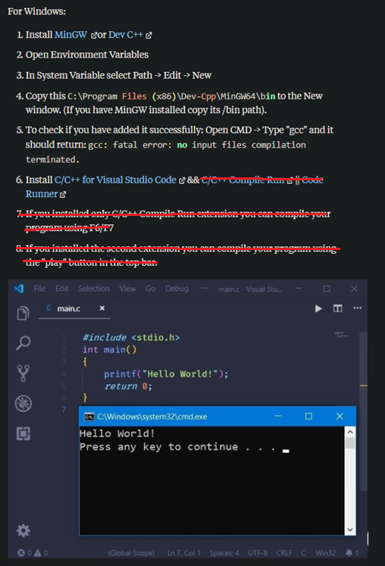

<https://www.quora.com/How-can-I-run-a-C-program-in-a-Visual-Studio-Code>

# Task script

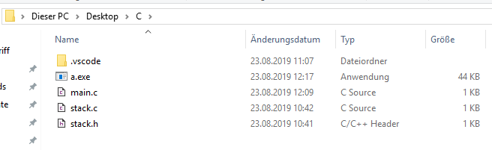

|  |
| --- |
| {  "tasks": [  {  "label": "Compile & Run C File",  "type": "shell",  "command": ".\\a.exe",  "group": {  "kind": "build",  "isDefault": true  },  "presentation": {  "showReuseMessage": false,  "panel": "new"  },  "dependsOn":["Compile C File"]  },  {  "label": "Compile C File",  "type": "shell",  "command": "C:\\MinGW\\bin\\gcc.exe",  "args": [  "-g",  "C:\\Users\\mtosch\\Desktop\\C\\main.c",  "C:\\Users\\mtosch\\Desktop\\C\\stack.c",  "-o",  "C:\\Users\\mtosch\\Desktop\\C\\a.exe"  ],  "options": {  "cwd": "C:\\MinGW\\bin"  },  "group": "build",  "presentation": {  "showReuseMessage": false,  "panel": "new"  }  },  ],  "version": "2.0.0"  } |

* Define task.json from the template above
* Set hotkey for Terminal -> Run Build Task