

Certificate Id: ***«unique_id»***

Registration No.: ***«reg_id»***

*Project completion Certificate*

This is to certify that **«First_Name»** **«Last_Name»** has successfully concluded **«course_type»** with exceptional dedication and proficiency at Digipodium. The training details are as follows:

**Project Title: «project»**

**Technology: «technology»**

**Duration: «duration»**

**«First_Name»** **«Last_Name»** exhibited commendable skills and commitment in contributing to the **«project»** showcasing expertise in **«technology»**.

For any enquiries or additional information regarding «First_Name»’s contributions, please feel free to contact the undersigned.

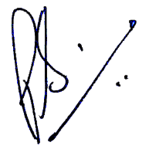

Director

Digipodium

9415082377