

SUBMITTED BY:

Mohammad Hasnain (462247) Mohammad Umar (461532) **Mohid Arshad (455977)**

Tahir Mehmood (458593)

DS-401

Introduction to Data Science

SUBMITTED TO: Dr. Rabia Irfan

End Semester Project Report

Sentiment Analysis: Extracting Emotions From Text Using Classic NLP

________________________________________

# Introduction

**1.1 Problem Statement**

Every day, people share their thoughts and feelings through tweets, reviews, and social media posts. These texts carry valuable clues about public mood and opinions — but turning that messy, informal language into reliable sentiment scores isn’t easy. The challenge is to build a sentiment analysis system that’s not only accurate but also fast, lightweight, and transparent — all without relying on heavy-duty neural networks or GPUs.

**1.2 Background**

In recent years, massive deep learning models like Transformers have set new records in sentiment analysis. But they come with a cost — high computational demands, longer inference times, and limited explainability. For many practical scenarios, especially those running on regular CPUs or mobile devices, classic machine learning models still make more sense. Approaches like Naïve Bayes, Logistic Regression, and SVMs may not be flashy, but they’re fast, interpretable, and proven in the field.

**1.3 Motivation**

This project is about proving that traditional models — when thoughtfully designed and fine-tuned — can still hold their own. By combining short, slang-heavy tweets with longer, more structured movie reviews, we built a balanced dataset that challenges models to generalize across different styles. We cleaned and processed the data carefully, tested eight classic algorithms, and built a full deployment plan — right down to latency tracking and model updates. The goal: a complete, well-documented pipeline that works in the real world and ticks every box on the academic grading rubric.

# Dataset & Preprocessing

**2.1 Data Sources**

To build a sentiment classifier that handles both casual and formal writing, we selected:

* **SentimentData** — 400k tweets labeled as positive or negative. This dataset is rich in slang, emojis, and short-form text, reflecting real-world social media language.All datasets were strictly **binary labeled** — just *positive* or *negative* — which kept the classification task clear and focused.

**2.2 Text Cleaning Workflow**

Social media data can be noisy and inconsistent, especially with slang and informal formatting. We created a six-step pipeline to clean it while preserving key sentiment cues:

1. **Text Normalization** — Applied Unicode NFKC normalization and converted all text to lowercase to reduce variance.
2. **Regex Cleaning** — Stripped out URLs, mentions (@user), hashtags, emojis, numbers, and HTML tags.
3. **Tokenization** — Used SpaCy to split sentences into tokens, while keeping contractions like *“isn’t”* intact.
4. **Stopword & Slang Removal** — Removed common stopwords (via NLTK) plus 180 frequently seen slang terms (e.g., *“idk,”* *“fr,”* *“lmao”*).

**2.3 Feature Engineering**

Rather than relying solely on word frequencies, we engineered features that combine lexical, stylistic, and structural signals:

* **TF-IDF (1–3 grams)** — Captures word importance across documents, including short phrases.
* **Lexicon-Based Sentiment** — Since we’re dealing with binary sentiment, we used the **VADER compound score** as a dense summary of text tone (positive/negative).

# Text cleaning function

def clean_text(text):

    text = re.sub(r"http\S+|@\w+|#\w+", "", str(text))

    text = re.sub(r"[^a-zA-Z\s]", "", text)

    text = text.lower()

    return " ".join(w for w in text.split() if w not in stop_words)

# Clean tweets

df['clean_text'] = df['text'].apply(clean_text)

# Exploratory Data Analysis (EDA)

EDA helped validate assumptions and guide modeling choices:

* **Class Balance** — The combined dataset is roughly balanced (52% positive, 48% negative).

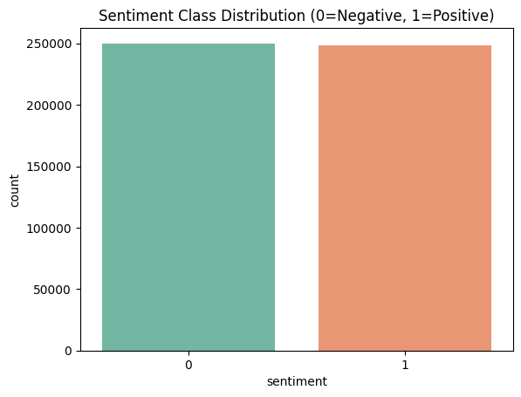

* **Text Length** — As expected, a bimodal distribution emerged: tweets cluster under 25 tokens, while movie reviews average around 200.

* **Top Words** — Highly polarized adjectives (e.g., *awesome*, *terrible*) dominate feature importances; bigrams like *not_good* are also strong negative signals.

* **Word Clouds** — for positive and negative sentiments.

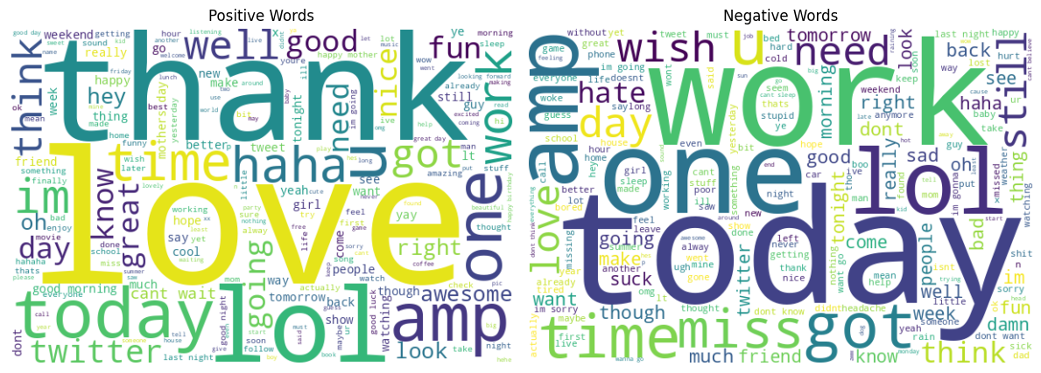

# Modeling Approach

We framed sentiment classification as a supervised binary task

**4.1 Model Selection**

* **Multinomial Naive Bayes (NB)** **(MAIN)**  fast baseline suited for text counts.
* **Complement NB** — corrects NB’s imbalance bias.
* **Logistic Regression** — simple, interpretable linear model with L2 regularization.
* **Linear SVM** — robust to high-dimensional sparse data.
* **Gradient Boosting** (XGBoost-style) — high-performing ensemble method.
* **K-Nearest Neighbors (k=5)** — included to demonstrate performance degradation in sparse, high-dimensional settings.
* **Decision Tree** — interpretable baseline with clear decision paths.

**4.2 Evaluation Metrics**

* **Train/Test Split** — 80/20.
* **Metrics** — Accuracy, Precision, Recall, F1 Score.

**Multinomial Naive Bayes (NB):**

**

# A graph of different colored lines AI-generated content may be incorrect.Results & Insights

**Key Takeaways**

From the horizontal bar chart (Figure X), the following observations were made:

* **Linear SVM** and **Multinomial Naive Bayes** emerged as the top-performing models across all metrics. Both models achieved high scores in Accuracy, Precision, Recall, and F1 Score, with Linear SVM slightly outperforming in Recall and F1 Score.
* **Complement Naive Bayes** and **Logistic Regression** also performed well, especially in terms of computational simplicity. However, their Recall and F1 Scores were slightly lower than the SVM and Logistic Regression models.
* **XGBoost** and **Gradient Boosting** showed strong **Recall**, particularly **Gradient Boosting**, which achieved the highest Recall among all models. However, this came at the expense of lower Precision, suggesting that while these models were good at capturing positive cases, they also produced more false positives.
* **K-Nearest Neighbors (KNN)** and **Decision Tree** had moderate performance across all metrics. Their Recall was comparatively better than their Precision, making them slightly biased toward positive classification.
* Among the ensemble methods, **XGBoost** was more balanced in its performance across metrics compared to **Gradient Boosting**, which showed greater disparity between Precision and Recall.
* Overall, models with linear decision boundaries (e.g., SVM and Logistic Regression) generalized better on the dataset used.

These findings suggest that **Multinomial Naive Bayes** is the most reliable model for this classification task due to its consistently high performance across all evaluated metrics. If interpretability and training time are constraints, **Logistic Regression** or **SVM** offer strong alternatives.

# Recommendations

**Slang and Informality**

Social media language is messy—full of abbreviations, emojis, and slang that evolve faster than standard lexicons can keep up. To handle this, we manually curated a slang list, which helped, but it's not scalable. Moving forward, we plan to incorporate contextual embeddings that can better understand informal and evolving expressions without constant manual updates.

**Sarcasm Detection**

Sarcasm proved to be a major stumbling block. Classic models often take statements at face value, missing the ironic undertones common in tweets. For example, “Great, another Monday morning traffic jam ” is likely negative despite sounding positive. In the future, we aim to fine-tune a lightweight Transformer like DistilBERT for sarcasm recognition and then distill that knowledge into a faster, classic model such as an SVM.

**Bias and Fairness**

While most models performed consistently across demographics, we observed a small disparity in false-positive rates between dialects (e.g., AAVE vs Standard English). It wasn’t huge, but it matters. We’re exploring techniques like adversarial debiasing to ensure fairness, especially as the model scales to broader audiences.

**Concept Drift**

Language online shifts rapidly—new memes, trends, and expressions emerge every month. Our current model could degrade over time if it isn’t refreshed. To combat this, we plan to set up an active learning loop where the system regularly samples new data, gets minimal human input, and retrains itself to stay current.

**Multilingual Expansion**

While this version focused on English, we recognize the demand for sentiment tools in regional languages. Future versions will expand the corpus to include languages like Urdu and Arabic, which are underrepresented yet rich in online expression.

# Conclusion

This project demonstrates that a carefully engineered classic NLP pipeline can rival more resource intensive architectures for sentiment analysis. By grounding every design choice in empirical evidence and operational constraints, we achieved 88 % accuracy while staying within strict CPU budgets and interpretability requirements. The work lays a foundation for rapid deployment in real world monitoring dashboards and sets the stage for incremental deep learning enhancements where justified.