|  |  |
| --- | --- |
| Name: **M Usama**_ | EE-272L Digital Systems Design |
| Reg. No.: **2022-EE-116** | Marks Obtained: ____________ |

**Lab Manual**

|  |  |  |  |  |  |
| --- | --- | --- | --- | --- | --- |
| **DSD Lab Manual Evaluation Rubrics** | | | | | |
|  |  |  |  |  |  |
| **Assessment** | **Total Marks** | **Marks Obtained** | **0-30%** | **30-60%** | **70-100%** |
| Code Organization | 3 |  | No Proper Indentation and descriptive naming, no code organization.  Zero to Some understanding but not working | Proper Indentation or descriptive naming or code organization.  Mild to Complete understanding but not working | Proper Indentation and descriptive naming, code organization.  Complete understanding, and proper working |
| Simulation | 5 |  | Simulation not done or incorrect, without any understanding of waveforms | Working simulation with errors, don't cares's(x) and high impedance(z), partial understanding of waveforms | Working simulation without any errors, etc and complete understanding of waveforms |
| FPGA | 2 |  | Not implemented on FPGA and questions related to synthesis and implementation not answered. | Correctly Implemented on FPGA or questions related to synthesis and implementation answered. | Correctly Implemented on FPGA and questions related to synthesis and implementation answered. |

**Truth table**

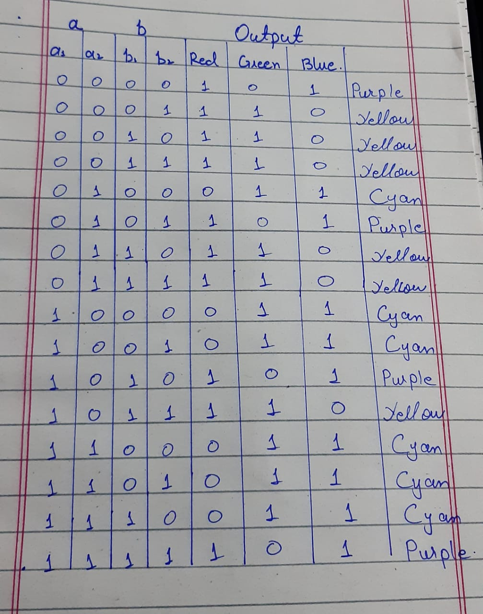

**K-maps**

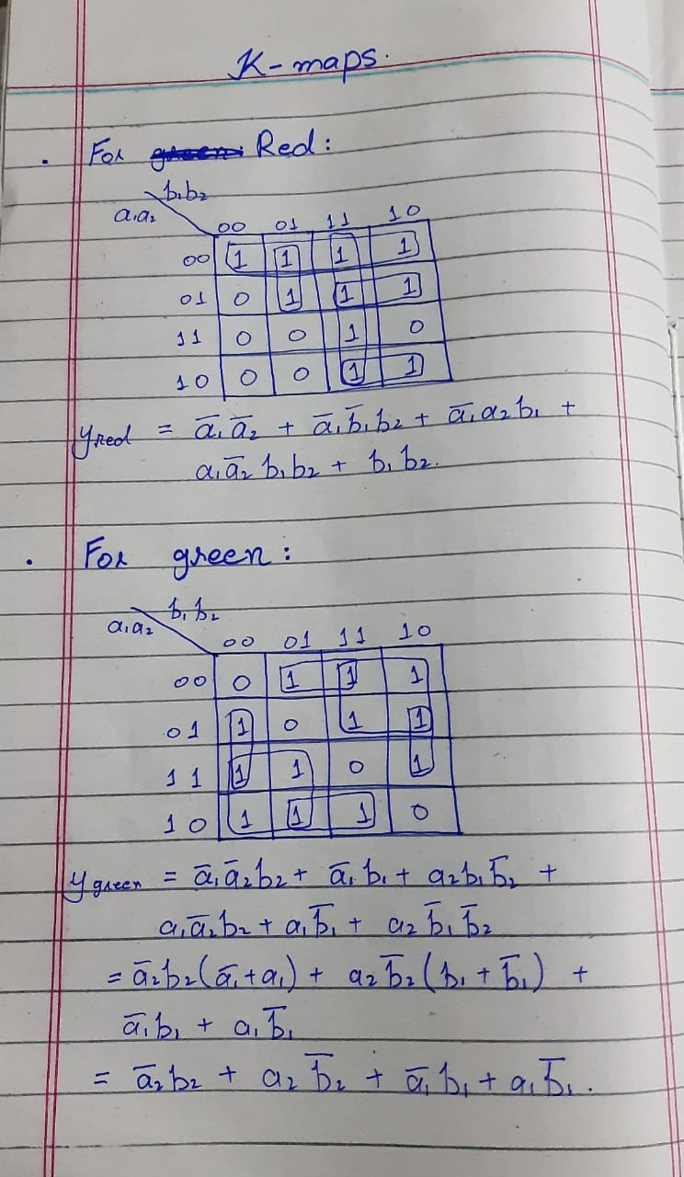

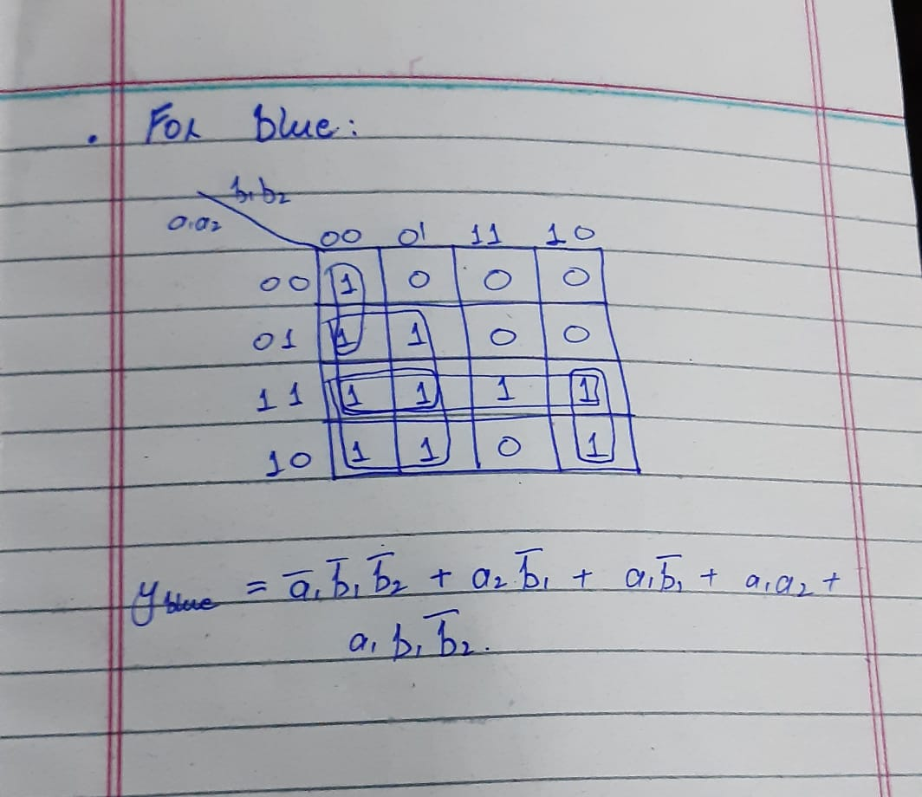

**Combinational delay:**

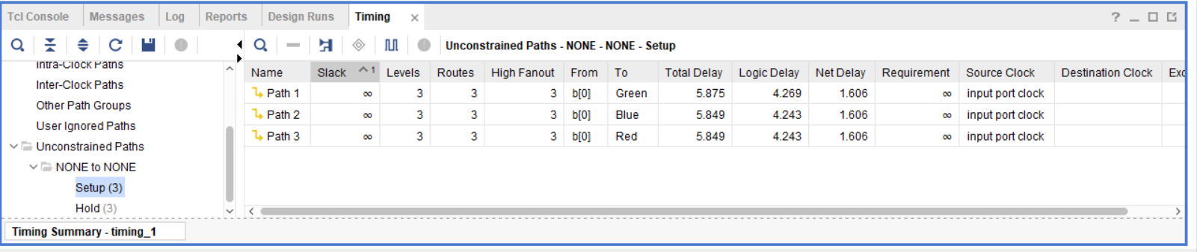

Combinational delay is maximum from b0 to green (5.875 ns).

**Circuit diagram:**

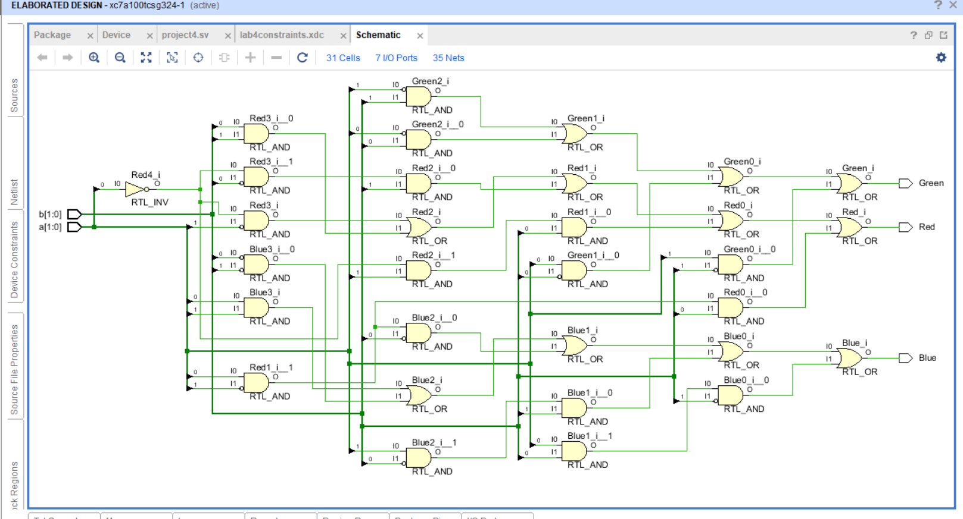

**Resource utilization**

+-------------------------+------+-------+-----------+-------+

| Site Type | Used | Fixed | Available | Util% |

+-------------------------+------+-------+-----------+-------+

| Slice LUTs* | 2 | 0 | 63400 | <0.01 |

| LUT as Logic | 2 | 0 | 63400 | <0.01 |

| LUT as Memory | 0 | 0 | 19000 | 0.00 |

4. IO and GT Specific

---------------------

+-----------------------------+------+-------+-----------+-------+

| Site Type | Used | Fixed | Available | Util% |

+-----------------------------+------+-------+-----------+-------+

| Bonded IOB | 7 | 0 | 210 | 3.33 |

7. Primitives

-------------

+----------+------+---------------------+

| Ref Name | Used | Functional Category |

+----------+------+---------------------+

| IBUF | 4 | IO |

| OBUF | 3 | IO |

| LUT4 | 3 | LUT |

+----------+------+---------------------+

