Business Idea suggestion for TATA GROUP regarding the beverages, automobile and TCS.

Data Scraping:

Tool used is Data- Miner ( google extension)

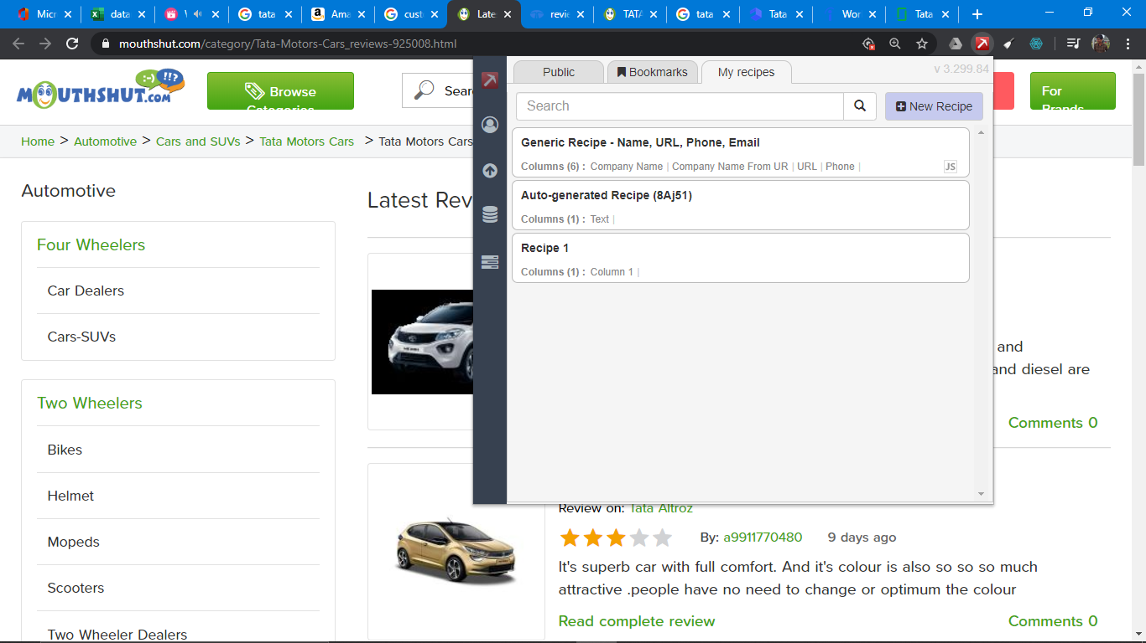

Getting the data from Data- miner:

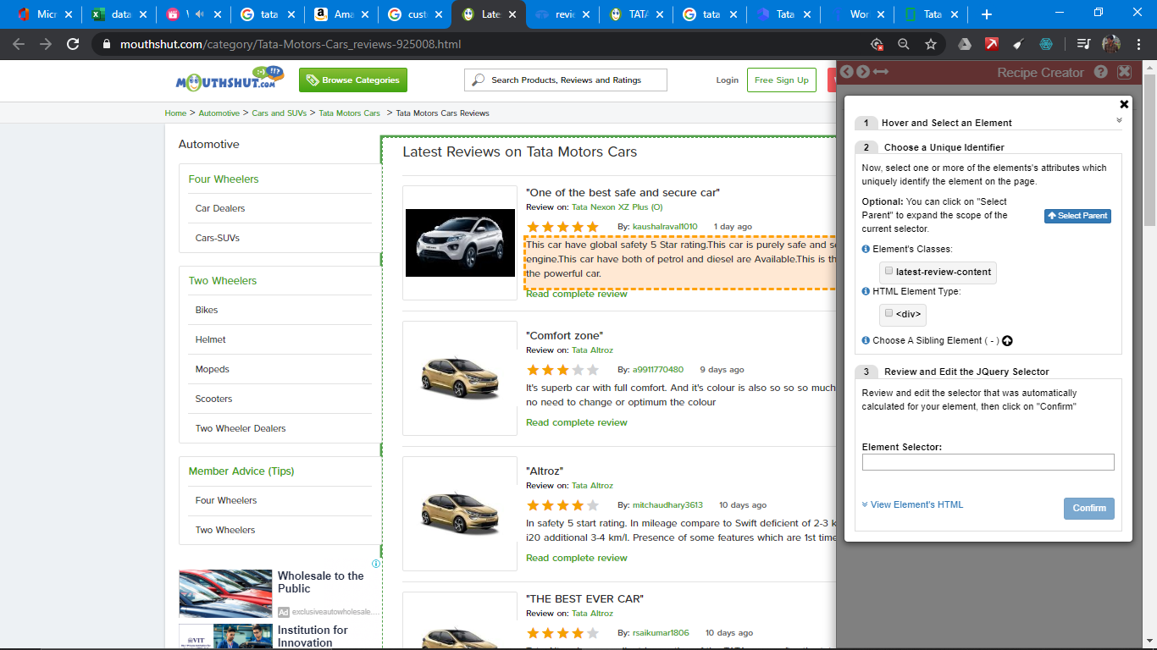

Getting the excel file:

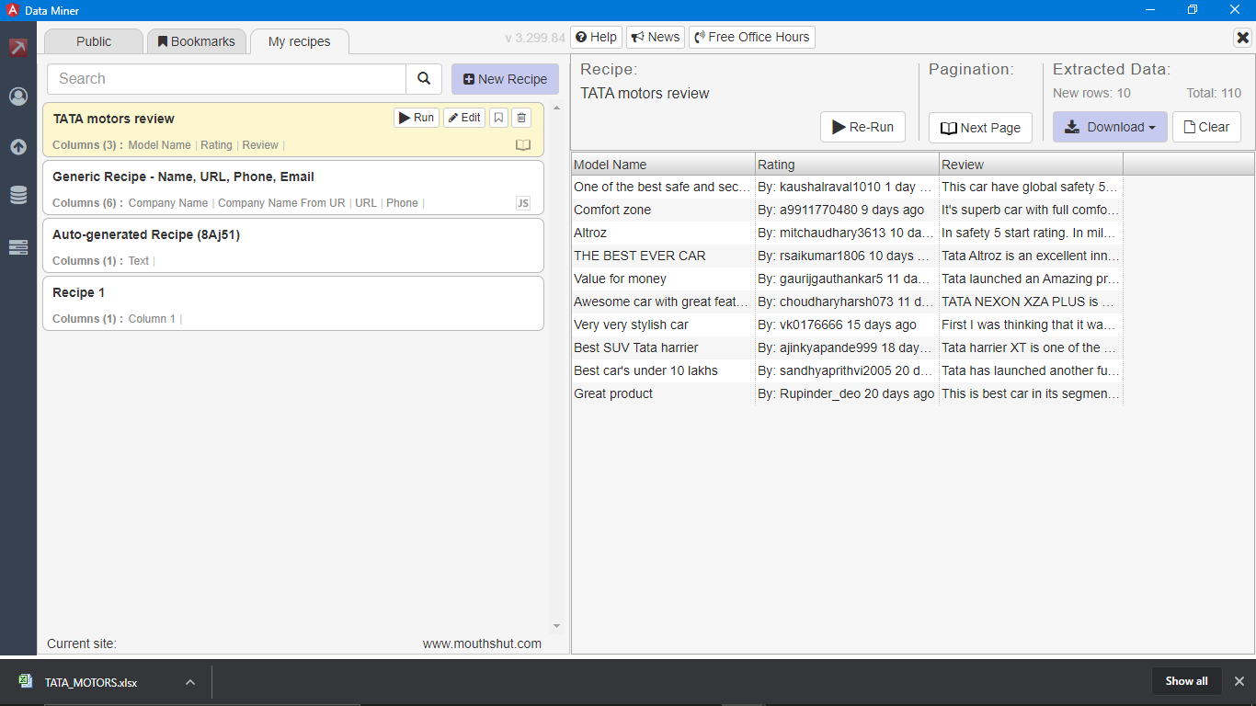

Data File:

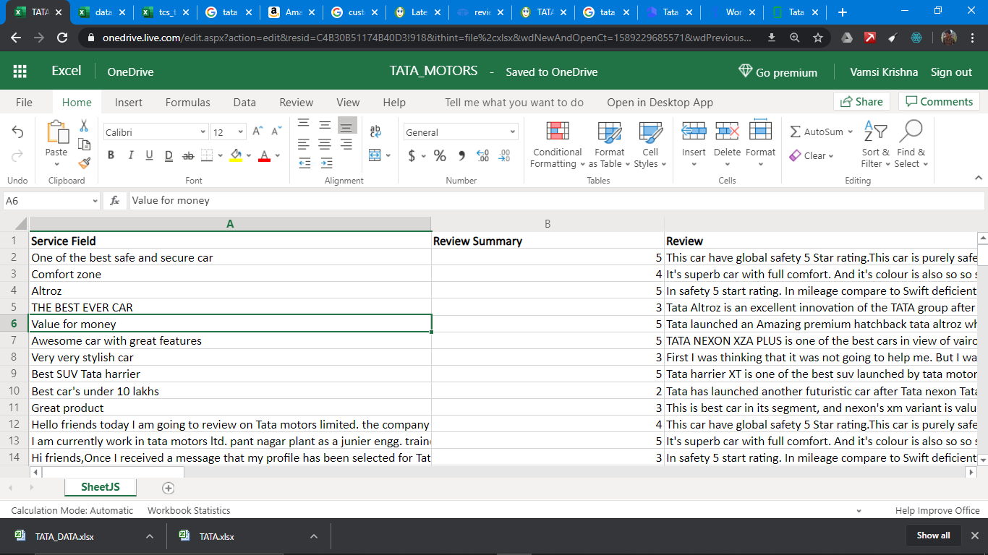

Adding & cleaning of data to Tableau:

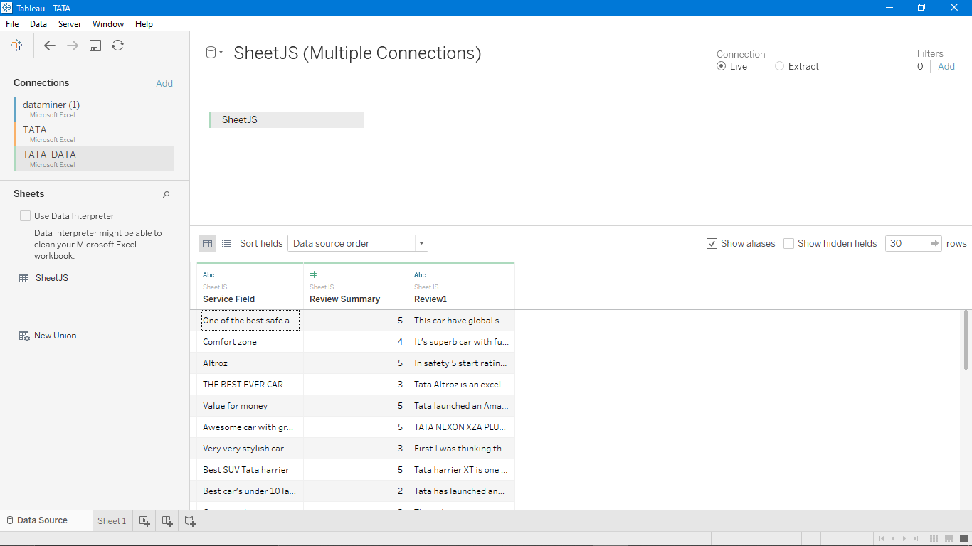

Visualization in Tableau:

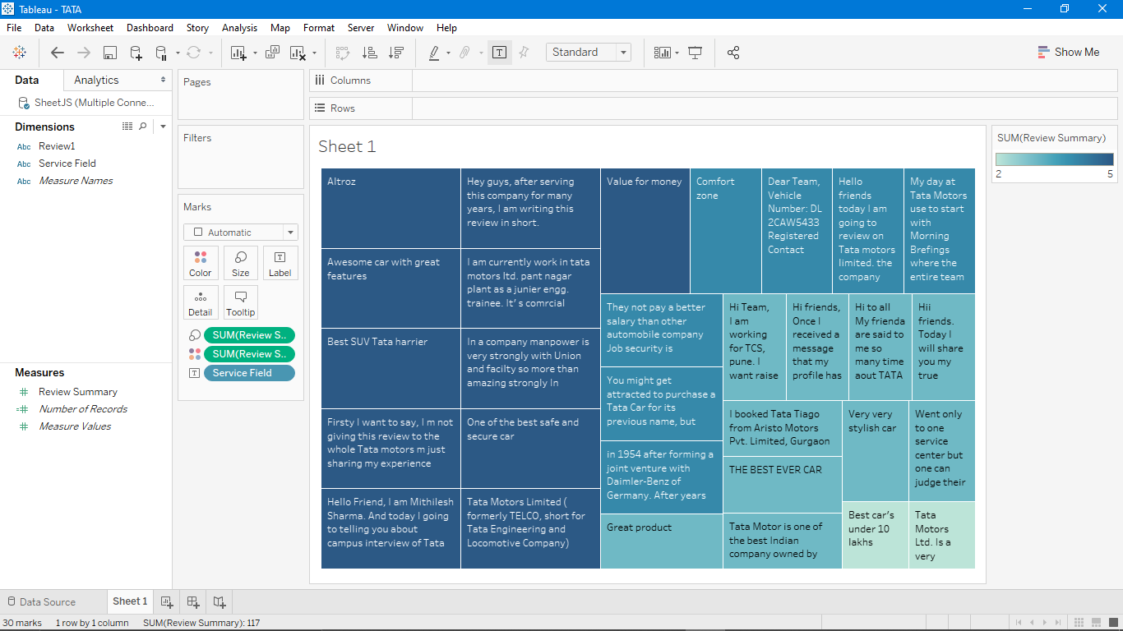

Business value depicted: It is observed that the TATA is having a very good review for its beverages and also the automobile products (Cars, trucks). But the most lagging part for it is the IT sectors many of the employees are giving the negative review in IT sector. And moreover the chart that is displayed in Tableau makes a clear picture from the color differentiation. So the light colored areas are to be nurtured enough for better progress and growth in the industry and market.