Task 1: Build a RESTful API (Node + Express + MongoDB)

Student Name: Preethi Y

Date: 20-06-2026

1. Objective

Developed a RESTful API for Student Management System using Node.js, Express.js and MongoDB. The API supports user authentication and full CRUD operations for students.

2. Technologies Used

Node.js

Express.js

MongoDB (Mongoose)

JWT (JSON Web Token) for Authentication

Postman (for API testing)

3. Project Structure

backend/
├── models/
│ ├── User.js
│ └── Student.js
├── controllers/
│ ├── authController.js
│ └── studentController.js
├── routes/
│ ├── authRoutes.js
│ └── studentRoutes.js
├── middleware/
│ └── authMiddleware.js
├── server.js
└── .env

4. Features Implemented

User Registration

User Login (JWT Authentication)

Protected Routes (only authenticated users can access)

CRUD Operations for Students:

Create Student

Get All Students

Update Student

Delete Student

5. API Endpoints
Method | Endpoint | Description | Protected
POST | /api/auth/register | Register new user | No
POST | /api/auth/login | User login | No
POST | /api/students | Create new student | Yes
GET | /api/students | Get all students | Yes
PUT | /api/students/:id | Update student | Yes
DELETE | /api/students/:id | Delete student | Yes

6. Screenshots

Project folder structure in VS Code

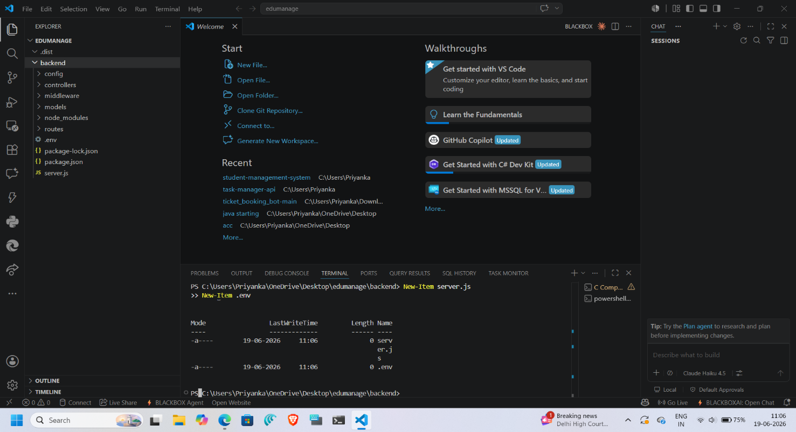

Server running successfully in terminal

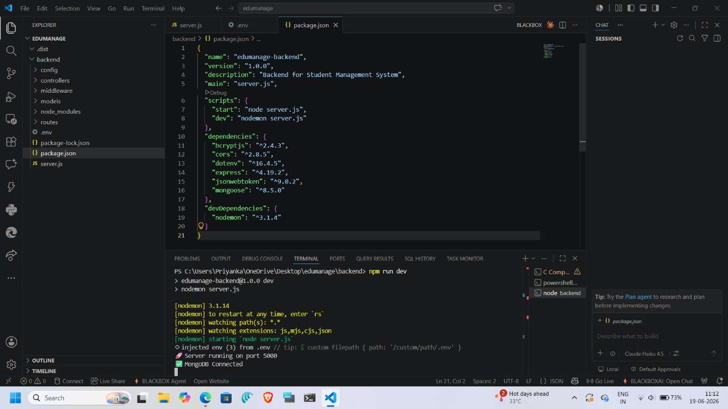

Successful Register API (Postman)
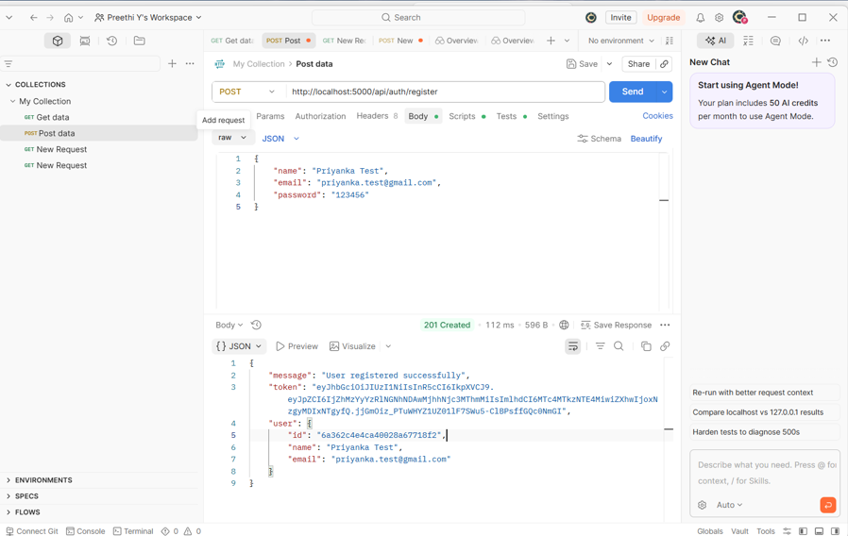

Successful Login API (Postman)

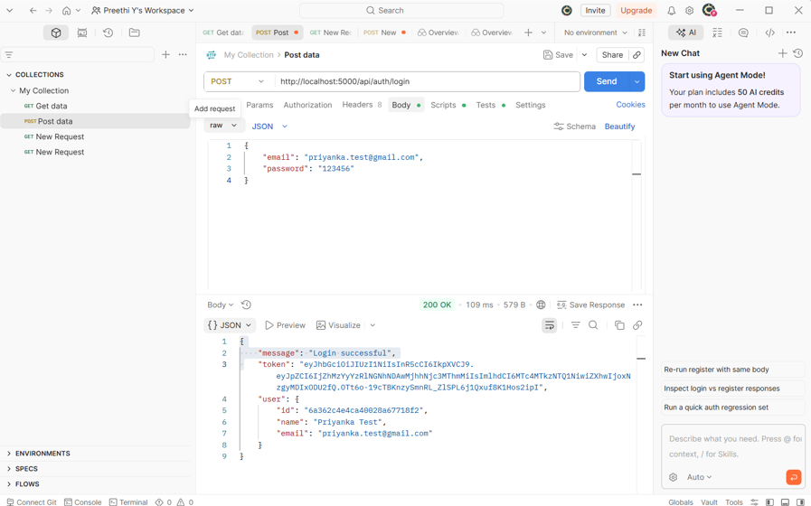

Successful Create Student (with Authorization header)
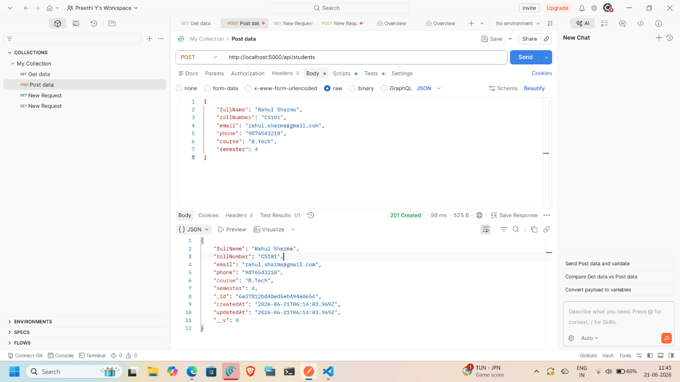

Successful Get All Students
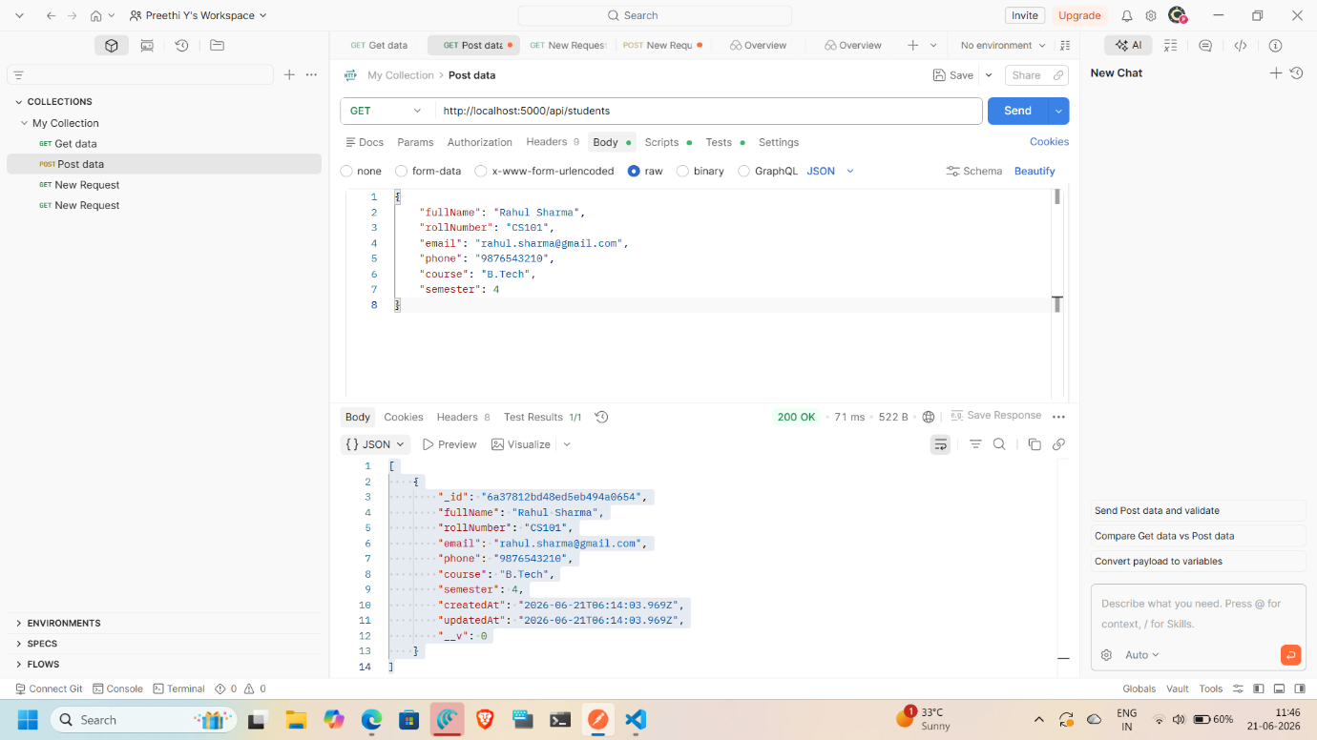

Successful Update Student
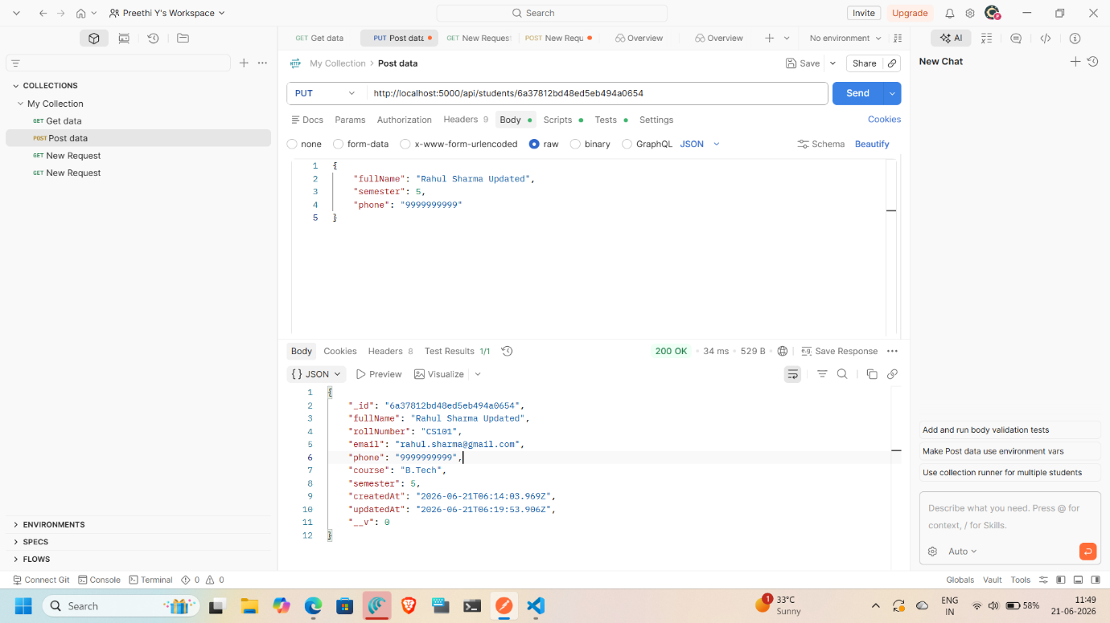

Successful Delete Student
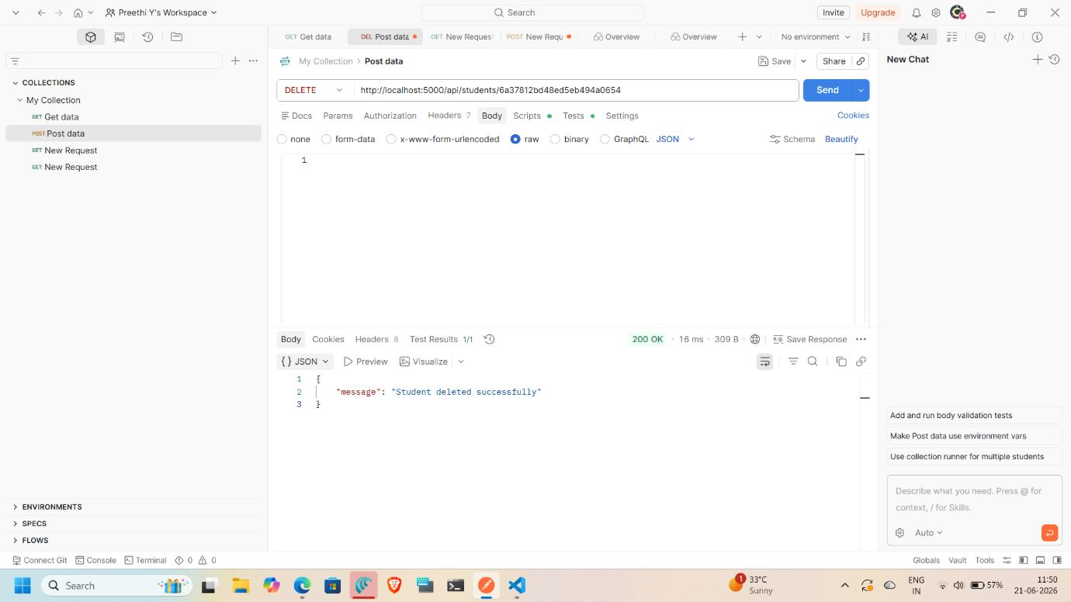

7. Conclusion

Successfully built a secure RESTful API for Student Management System with proper authentication and CRUD functionality using MERN stack backend technologies.

