Pyspark Training

Pyspark manages an file with multiple worker node that’s the reason it is fast and can handle large data easily
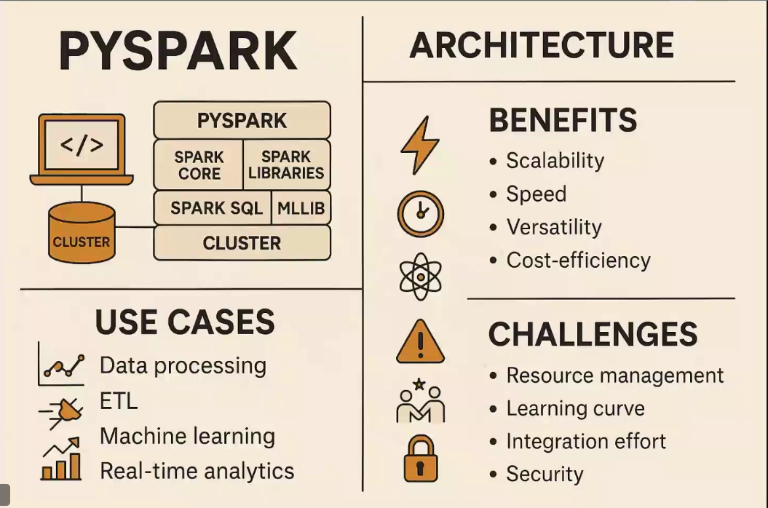

- What is Big Data and PySpark
Big Data – Massive and complex data that is hard to store, eg: social media, time series data like from iot devices those are many data to handle
To handle data like this we have an python api for apache spark, it spreads the workload to many clusters to ease the work
- Spark Basic Architecture
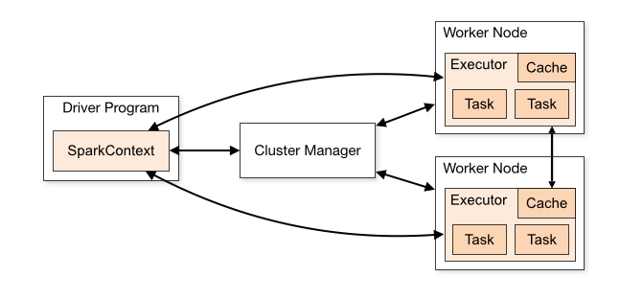
The Apache Spark framework uses a master-slave architecture that consists of a driver, which runs as a master node, and many executors that run across as worker nodes in the cluster. Apache Spark can be used for batch processing and real-time processing as well.
- Cluster Manager, Driver, Worker Node, Context
The Spark driver – Driver Node
The driver is the program or process responsible for coordinating the execution of the Spark application. It runs the main function and creates the SparkContext, which connects to the cluster manager.
The Spark executors
Executors are worker processes responsible for executing tasks in Spark applications. They are launched on worker nodes and communicate with the driver program and cluster manager. Executors run tasks concurrently and store data in memory or disk for caching and intermediate storage.
The cluster manager
The cluster manager is responsible for allocating resources and managing the cluster on which the Spark application runs. Spark supports various cluster managers like Apache Mesos, Hadoop YARN, and standalone cluster manager.
SparkContext
SparkContext is the entry point for any Spark functionality. It represents the connection to a Spark cluster and can be used to create RDDs (Resilient Distributed Datasets), accumulators, and broadcast variables. SparkContext also coordinates the execution of tasks.
Task
A task is the smallest unit of work in Spark, representing a unit of computation that can be performed on a single partition of data. The driver program divides the Spark job into tasks and assigns them to the executor nodes for execution.
https://medium.com/@amitjoshi7/spark-architecture-a-deep-dive-2480ef45f0be
- Modes of Execution
Execution Modes
Cluster mode
Cluster mode is probably the most common way of running Spark Applications. In cluster mode, a user submits a pre-compiled JAR, Python script, or R script to a cluster manager. The cluster manager then launches the driver process on a worker node inside the cluster, in addition to the executor processes. This means that the cluster manager is responsible for maintaining all Spark Application–related processes.

Client mode
Client mode is nearly the same as cluster mode except that the Spark driver remains on the client machine that submitted the application. This means that the client machine is responsible for maintaining the Spark driver process, and the cluster manager maintains the executor processes.

Local mode
Local mode is a significant departure from the previous two modes: it runs the entire Spark Application on a single machine. It achieves parallelism through threads on that single machine. This is a common way to learn Spark, test your applications, or experiment iteratively with local development.

