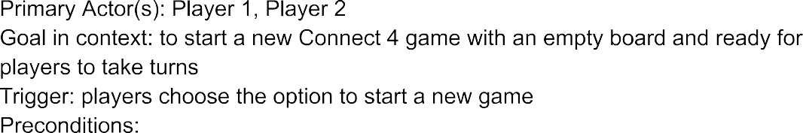
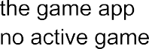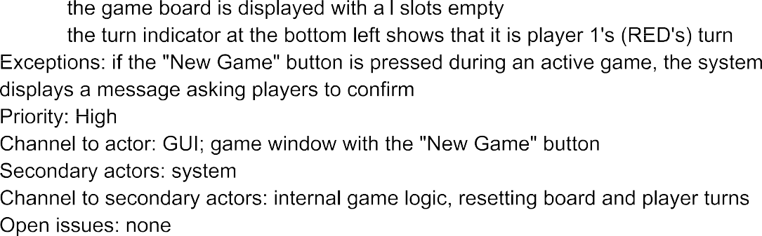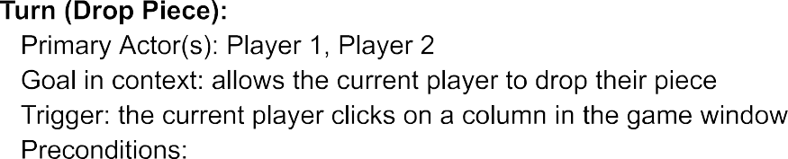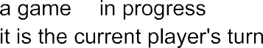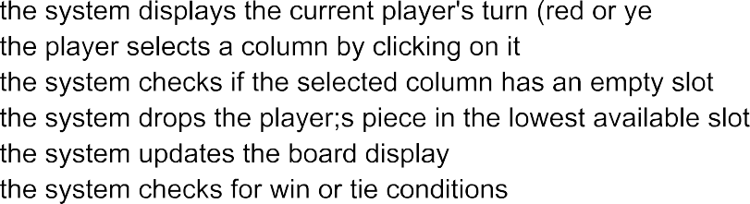
amirkhan
2024-11-12 22:00:52
--------------------------------------------
Quick Summary/General Overview of Use Case Descriptions:
The use cases provide a good layout for implementing game features (more specifically the wide variety of options that are given to the player), but they lack consistency in detail and often miss important information for handling edge cases or invalid moves. Some are more detailed than others, but some others could also benefit from clearer steps on preconditions, actions, and player feedback. Adding consistent, detailed feedback for players like notifications, visual highlights, and prompts or pop ups would make the development of the games easier, and also the gameplay would be more enjoyable. Also the structure of the use cases is somewhat disorganized. Organizing each one by Frontend, Networking, and Backend components would clarify which parts of the system are involved and help developers understand the responsibilities of each area. This structure would create a more organized and useful document, making it easier to build a smooth, reliable gameplay experience.

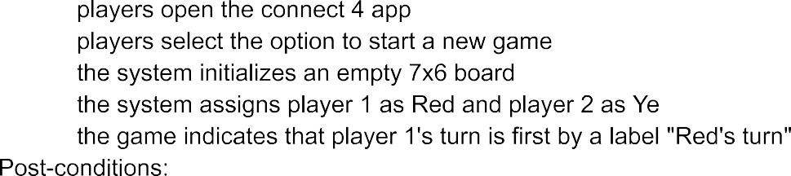



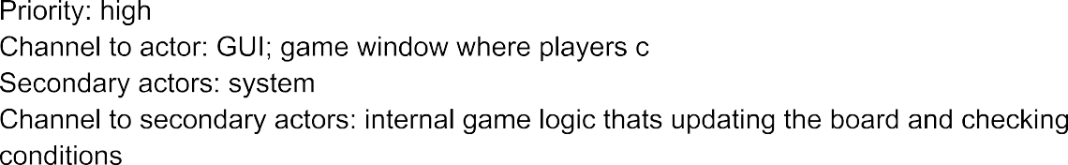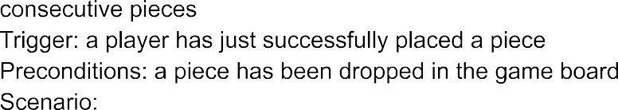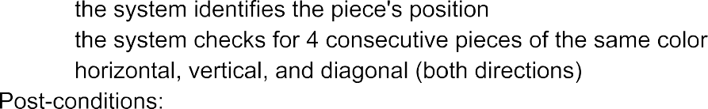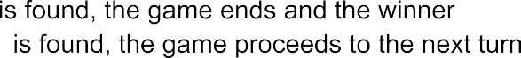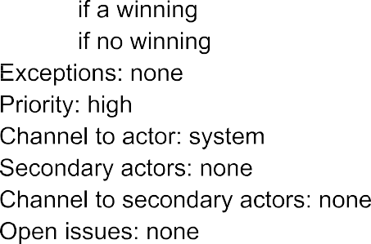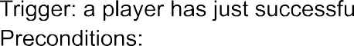
amirkhan
2024-11-12 22:00:58
--------------------------------------------
Critique (Strength/Weakness): This use case effectively captures the logic for identifying consecutive pieces in all directions. However, it lacks detail on post win actions, such as notifying players or stopping further gameplay
Suggestions: Should include steps to handle post win scenarios, such as notifying players, stopping the game, and offering the option to start a new game. It dshould also specify when this check is triggered (for example, after every move)

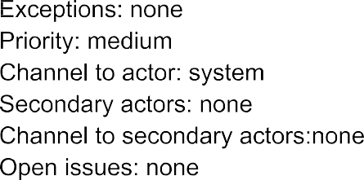
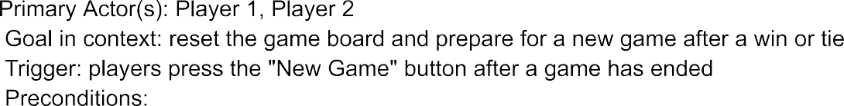
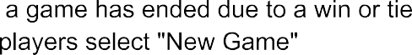
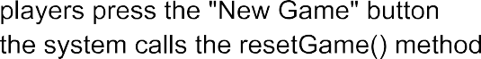
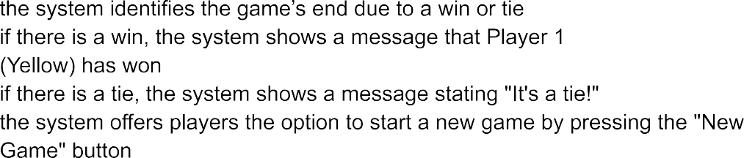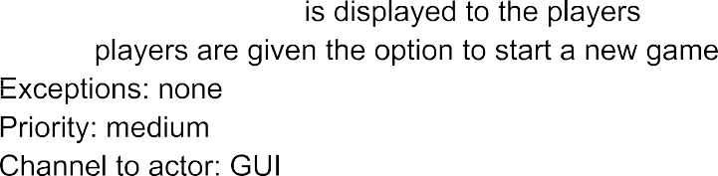
amirkhan
2024-11-12 22:01:07
--------------------------------------------
Critique (Strength/Weakness): The use case describes displaying the game result after a win or tie, but its unclear how the result is communicated to players in the GUI. It lacks clarity on options for players after the result is displayed.
Suggestions: Add details on the format and positioning of messages shown to players (for example, pop ups or banners) and also specify options like starting a new game or exiting after the result is displayed.

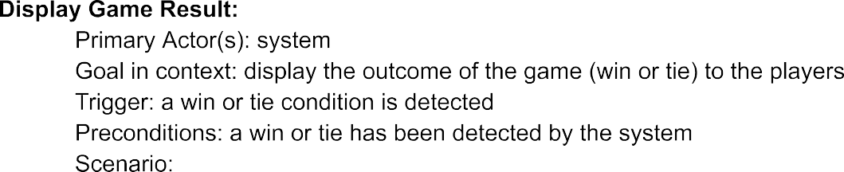

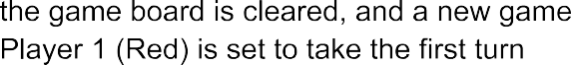
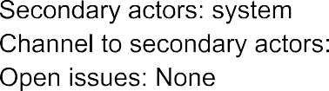
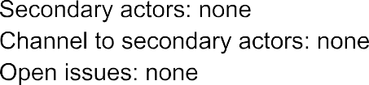
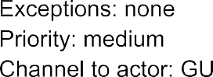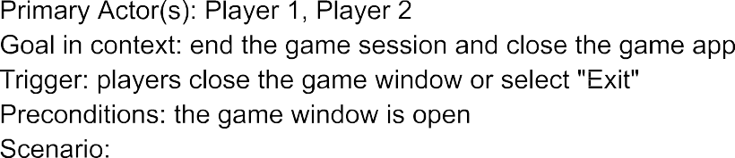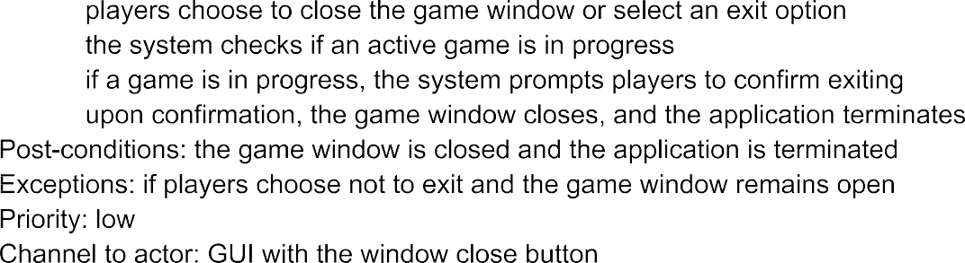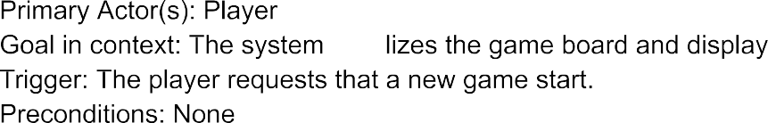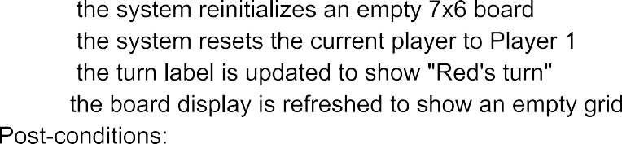

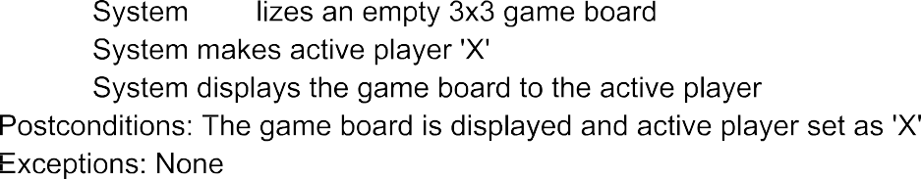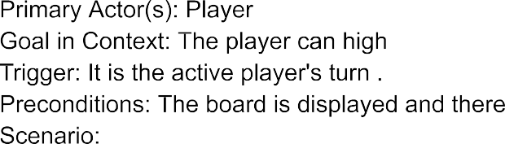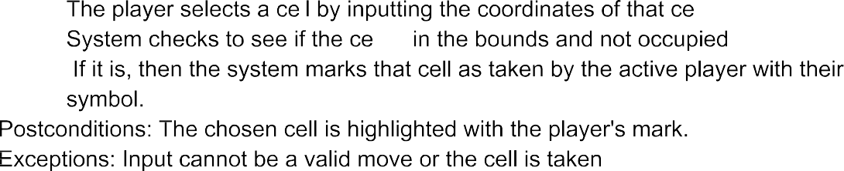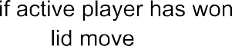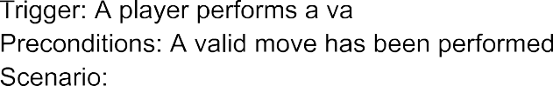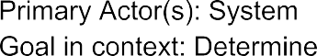
amirkhan
2024-11-12 22:01:14
--------------------------------------------
Critique (Weakness/Strength): The use case outlines the basic move mechanics but it lacks handling for invalid moves such as selecting an already occupied cell. It also does not mention any feedback provided to the player if an invalid move is attempted. Suggestions: Add steps to check for invalid moves and specify how the system communicates these to the player
amirkhan
2024-11-12 22:01:19
--------------------------------------------
Critique (Strength/Weakness): The conditions for declaring a draw are stated, but the use case lacks post draw actions, such as options for players to or exit or play against a new opponent
Suggestions: Include options for players after a tie, such as prompts to play again (but against a new opponent) or exit. Also should ensure that the system communicates the draw status clearly through the interface

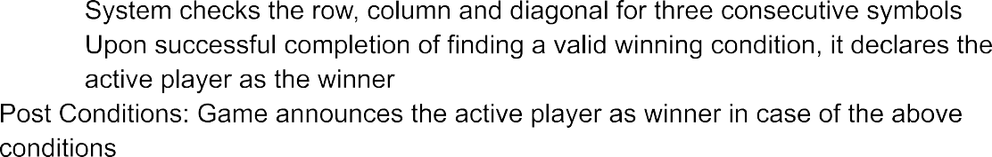

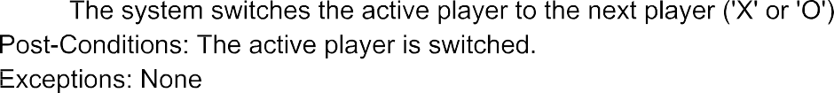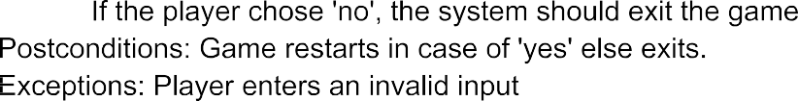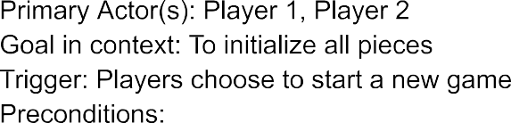
amirkhan
2024-11-12 22:01:24
--------------------------------------------
Critique (Strength/Weakness): The use case addresses switching turns but doesnt include precondition checks to ensure the last move was valid. Its also vague on how the turn change is communicated to the players.
Suggestions: Include precondition checks to confirm the validity of the last move before switching turns. Also, describe how the interface updates to show the active player.
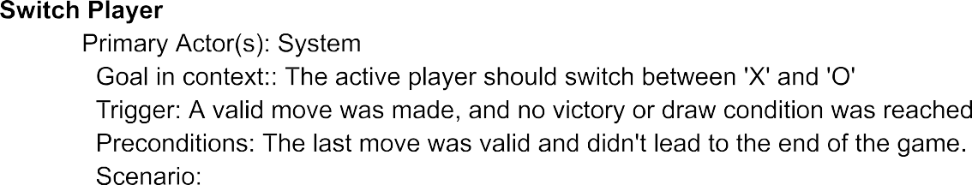

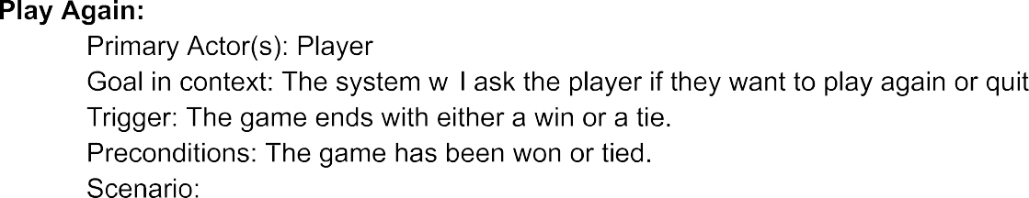

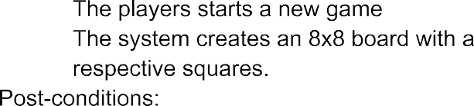

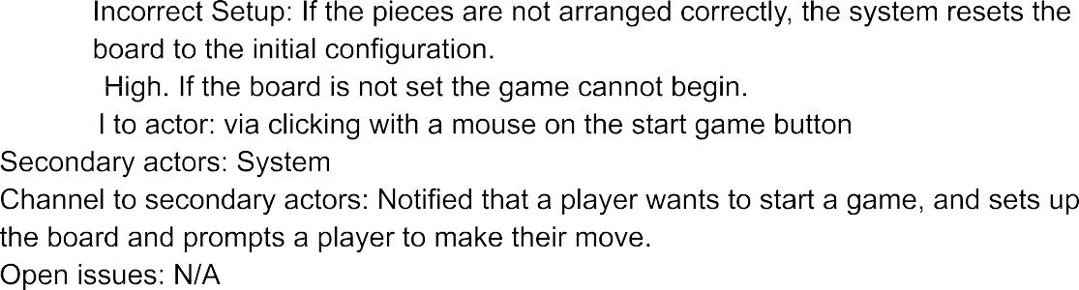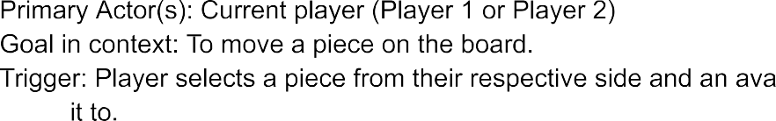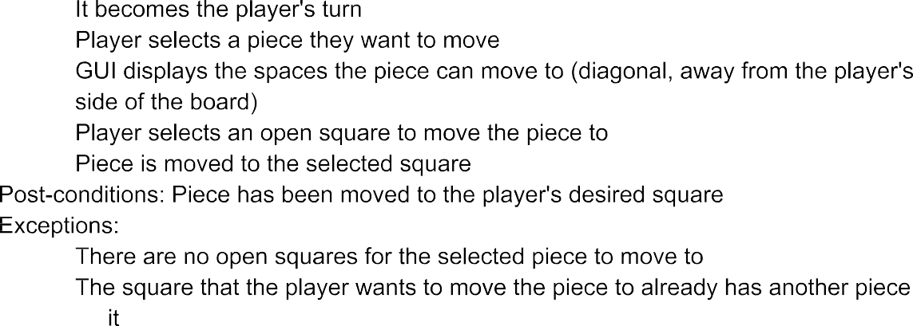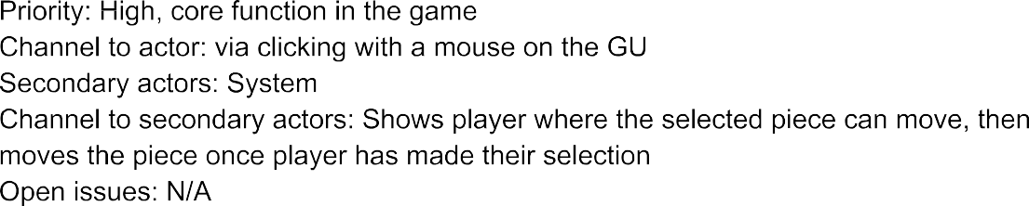
amirkhan
2024-11-12 22:01:32
--------------------------------------------
Critique (Strength/Weakness): The use case explains how a player selects and moves a piece, but it doesnt address invalid moves, such as attempting to move to an occupied or unavailable square. Theres also a lack of detail on how the GUI provides feedback to the player during the selection and movement process.
Suggestions: Specify that the system should check the target square before moving the piece and include error handling for invalid moves, such as showing a message or highlighting available squares in real time. Also should describe how the GUI provides feedback when a piece is selected (like highlighting it) and how the player can see available moves.



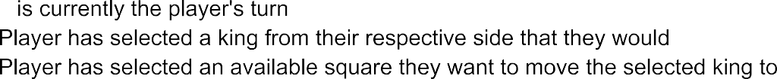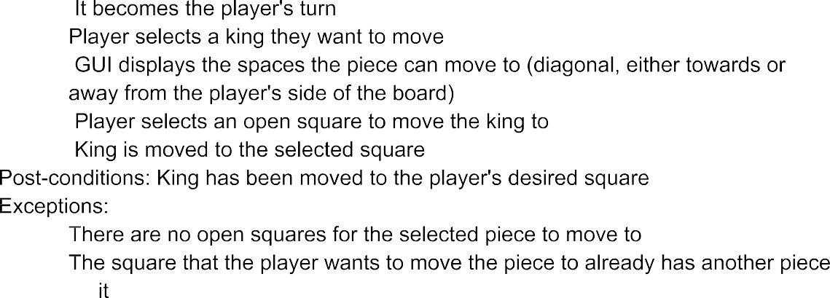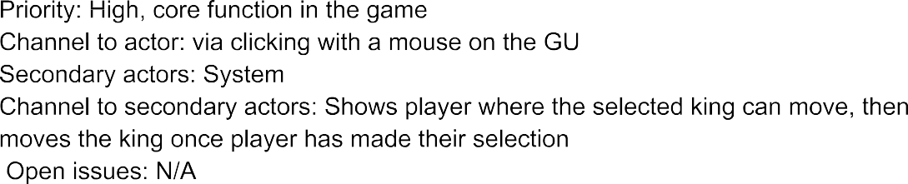

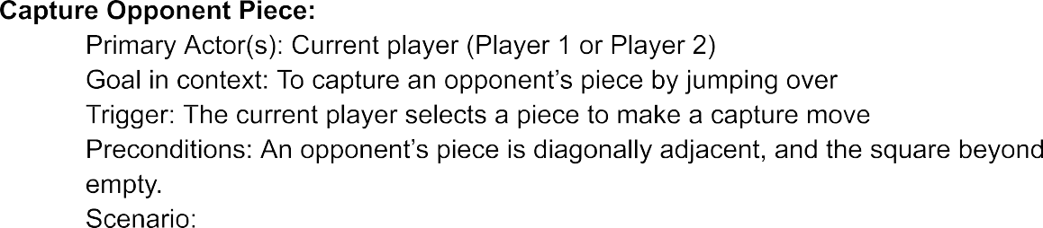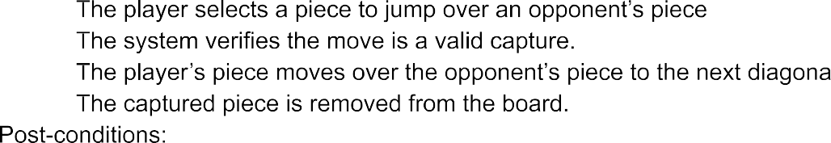

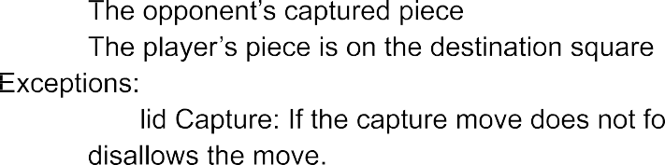

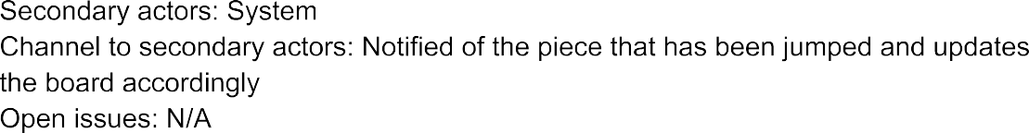
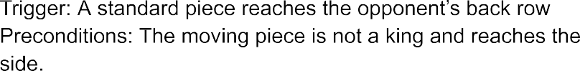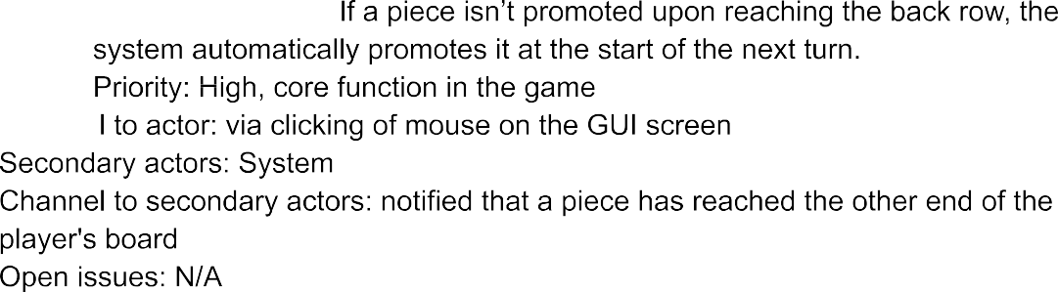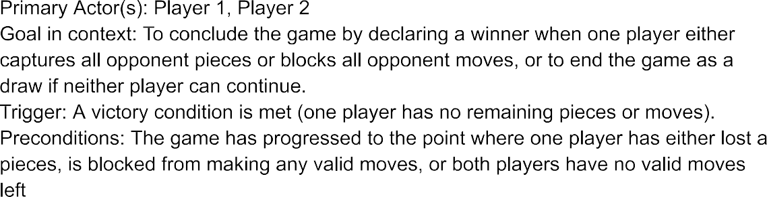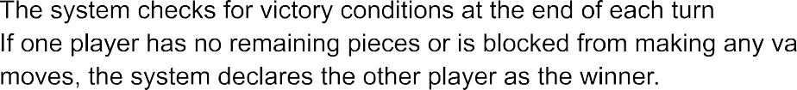
amirkhan
2024-11-12 22:01:44
--------------------------------------------
Critique (Strength/Weakness): This use case outlines various end game conditions, but it doesnt clearly distinguish the difference between different types (win by capture, win by blocking, or draw). The steps could be more detailed in terms of each scenarios handling.
Suggestions: Break down the end conditions into specific categories with corresponding steps. Include system actions for each, such as notifying players and displaying end of game options.
amirkhan
2024-11-12 22:01:40
--------------------------------------------
Critique (Strength/Weakness): The promotion of a piece to a king is explained, but theres no information or mention on how the system visually signals the promotion to the player. Allso the new movement capabilities of the king are not explained in the user interface. (Not necessary, but should be added for detail)
Suggestions: Include details on how the system changes the appearance of the promoted piece (such as adding a crown icon) to signify its new status as a king. Also specify how the GUI or player instructions communicate the kings new movement abilities, perhaps by highlighting available move directions after the promotion or providing a brief tutorial pop up

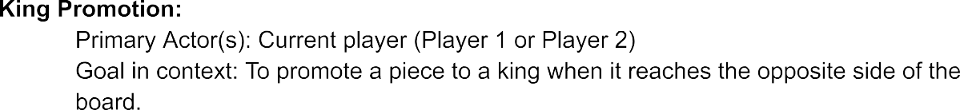

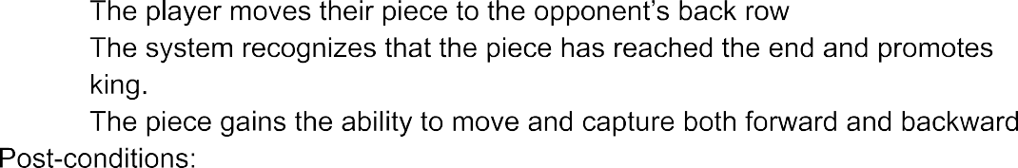

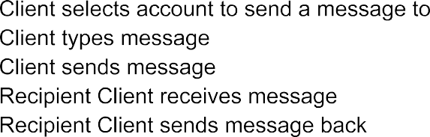
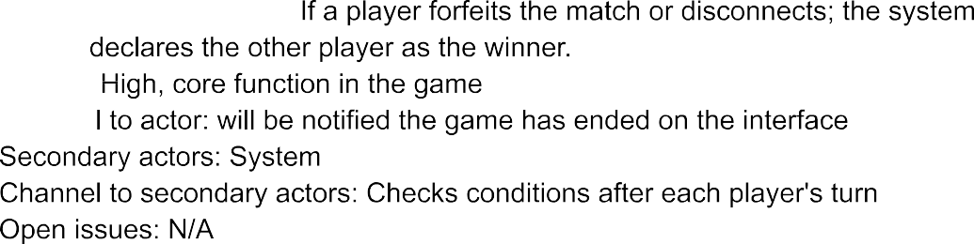

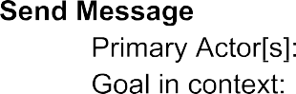



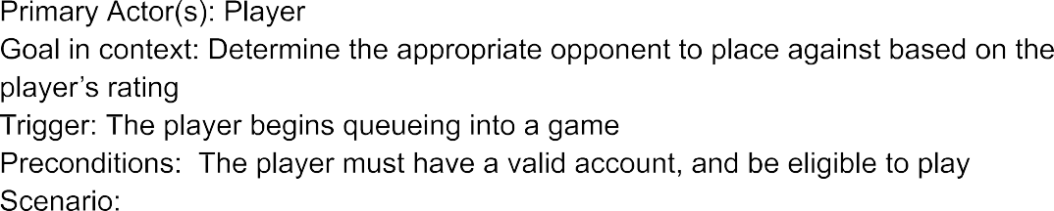
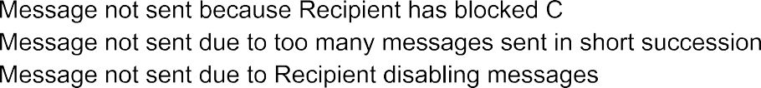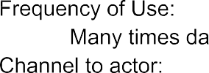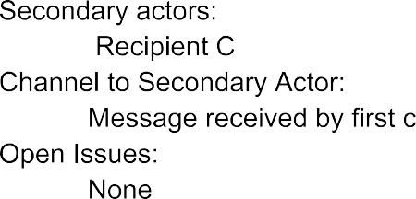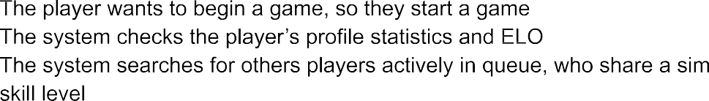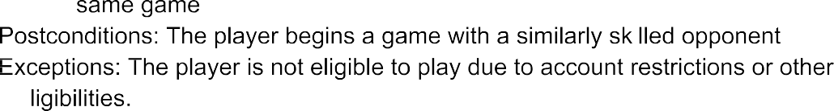

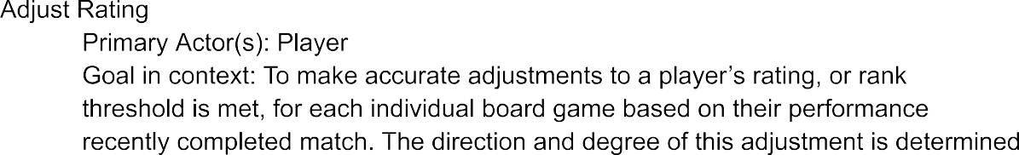

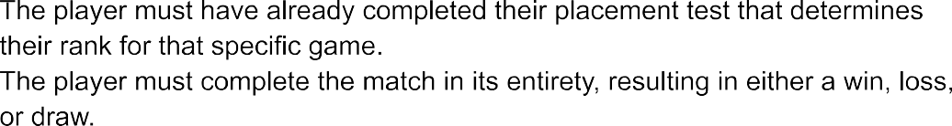
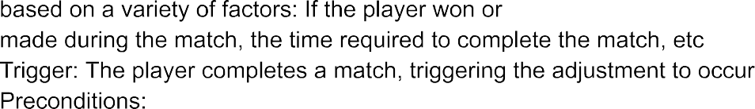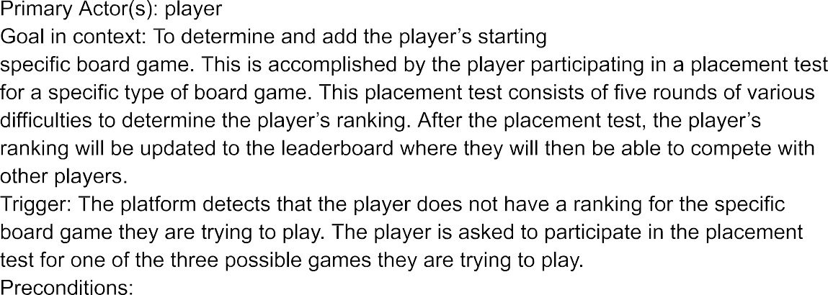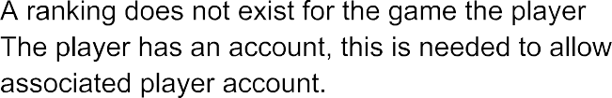

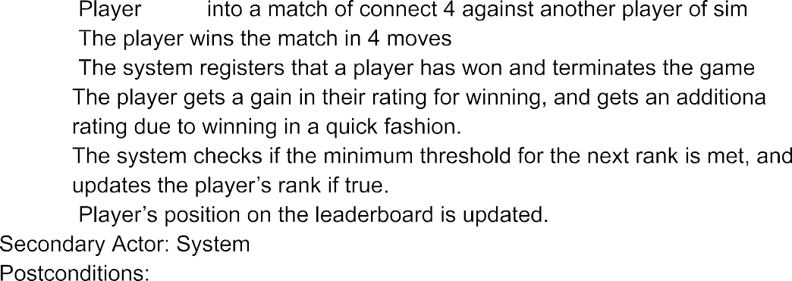

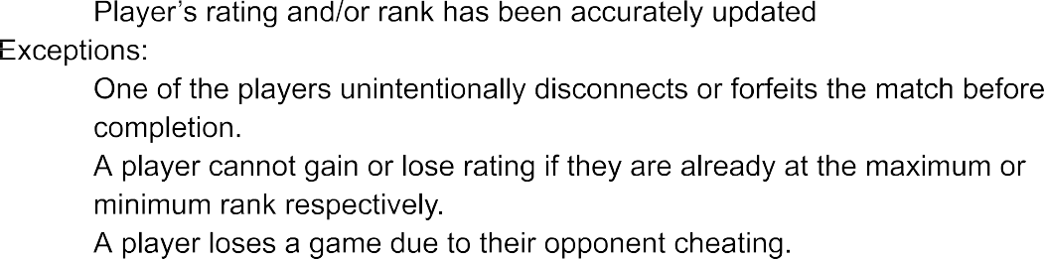

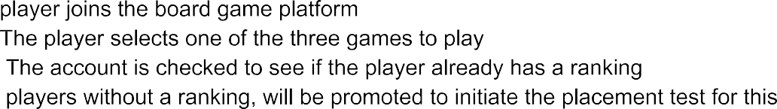
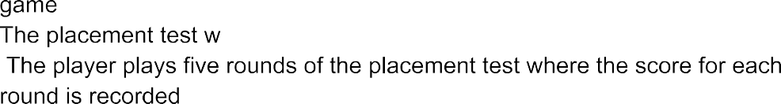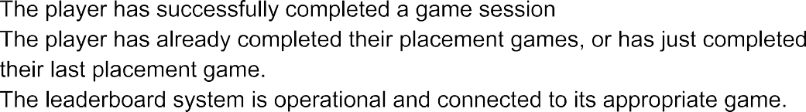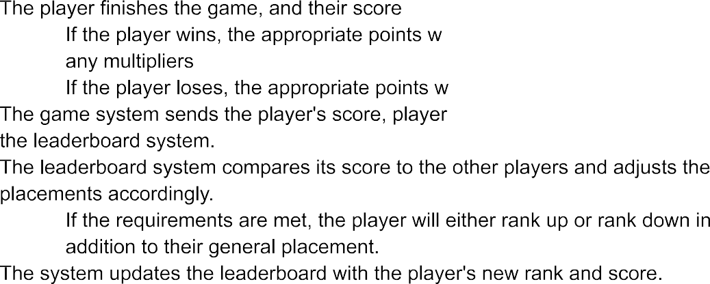


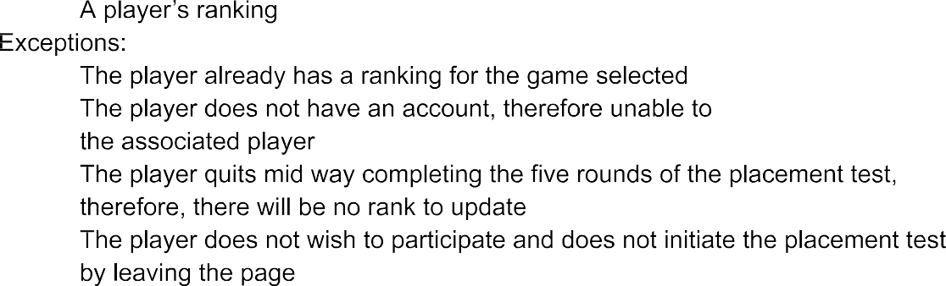

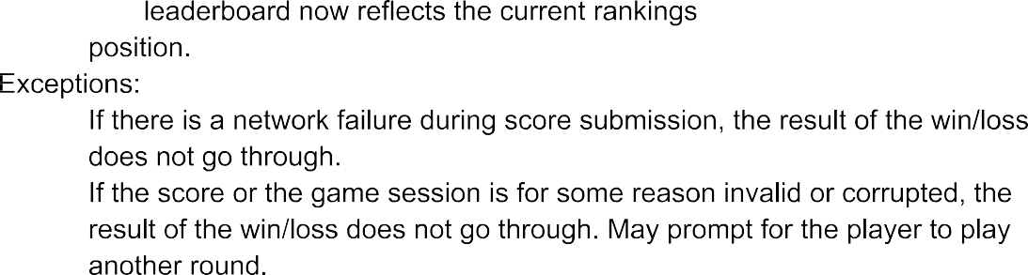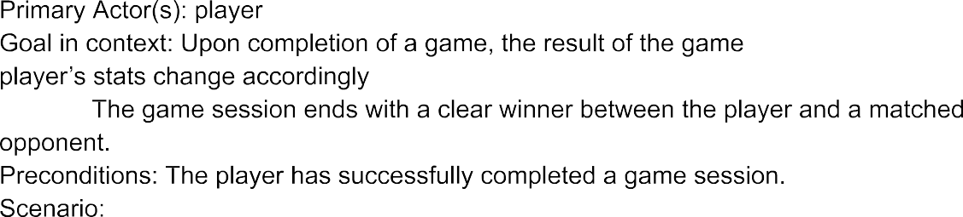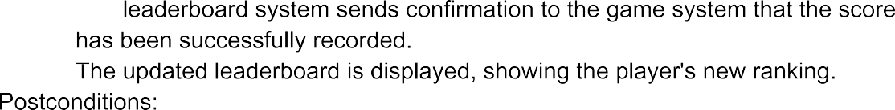

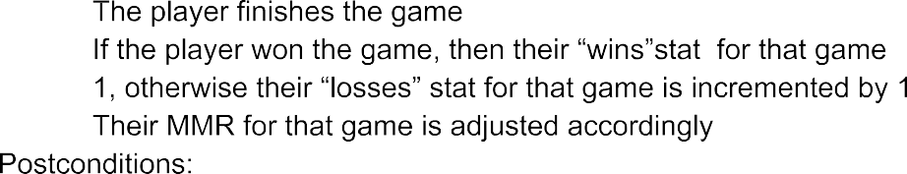



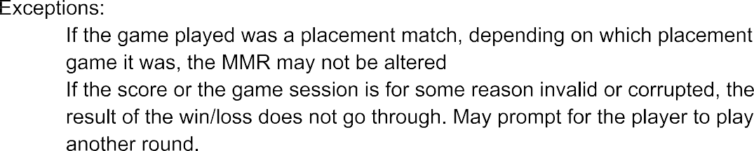

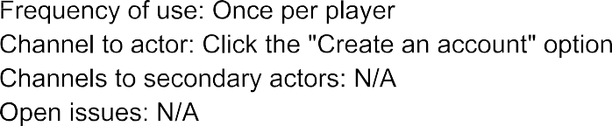
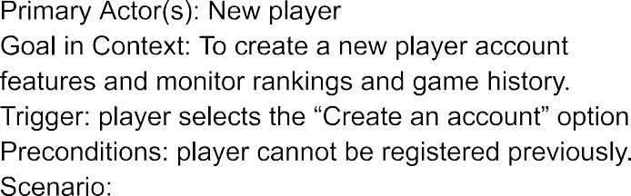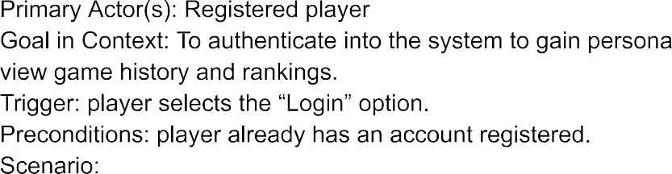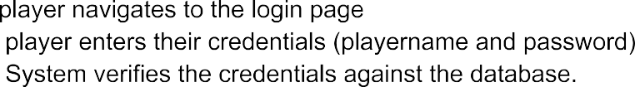

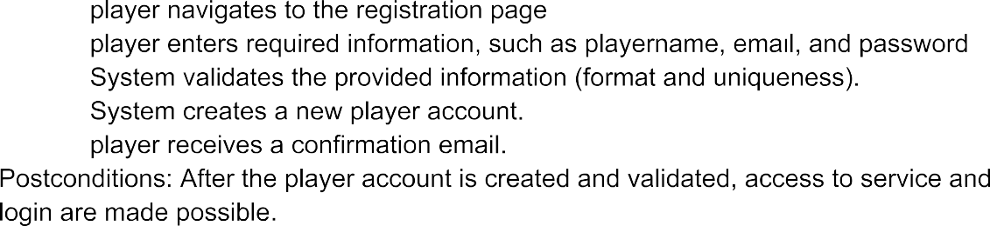

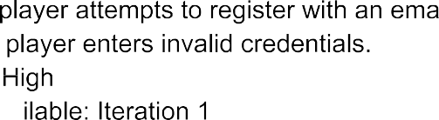

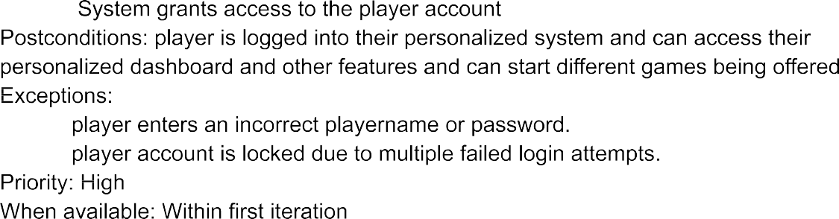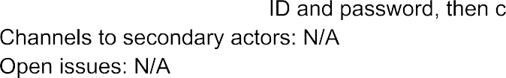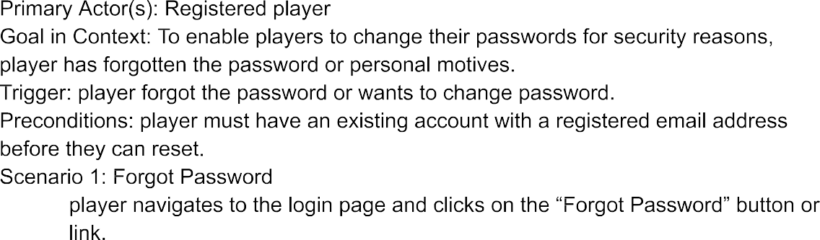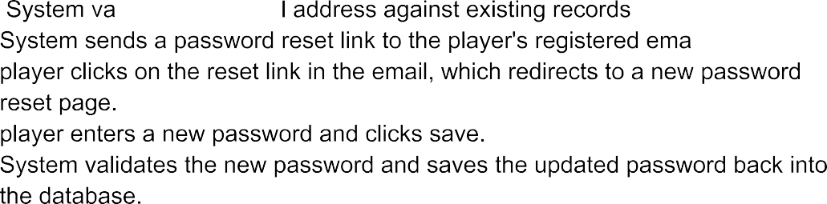

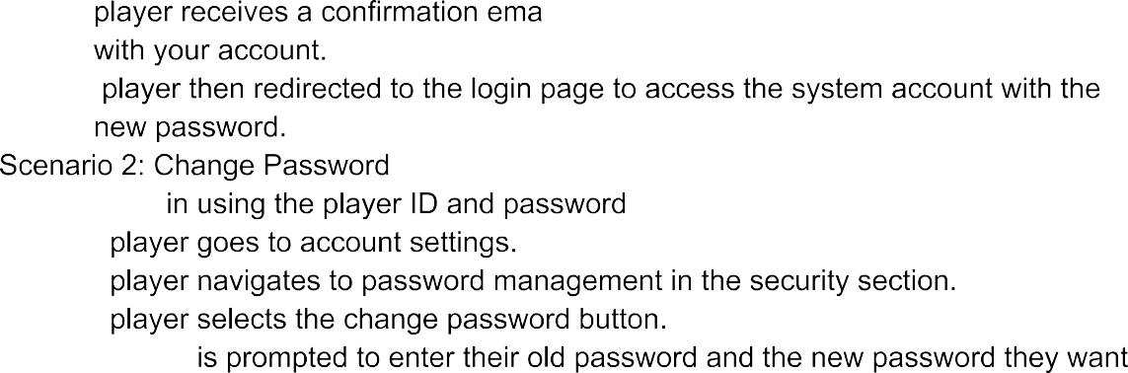


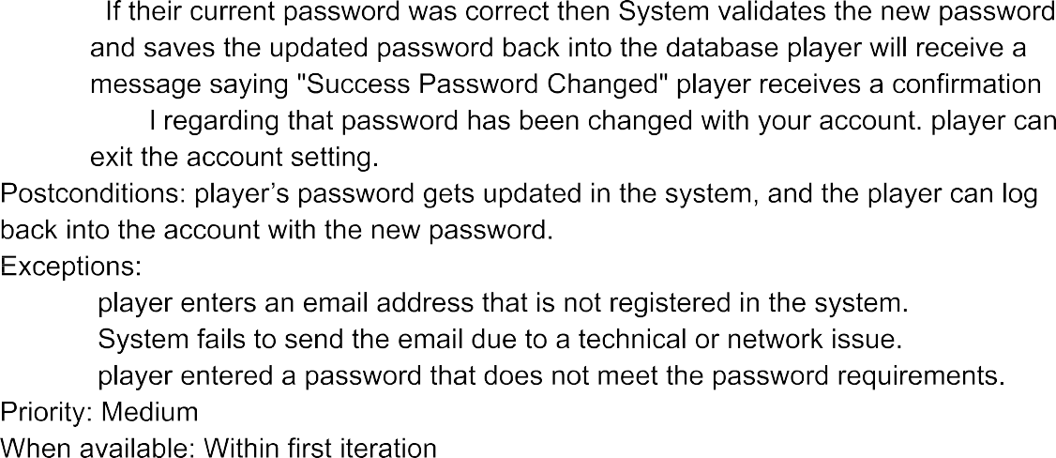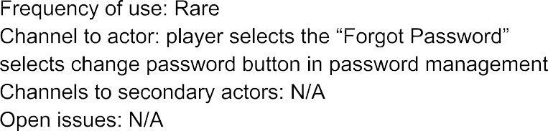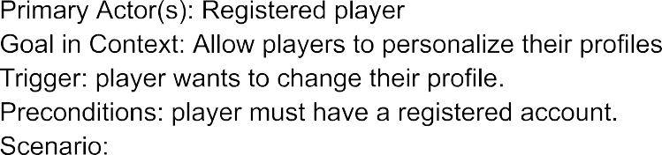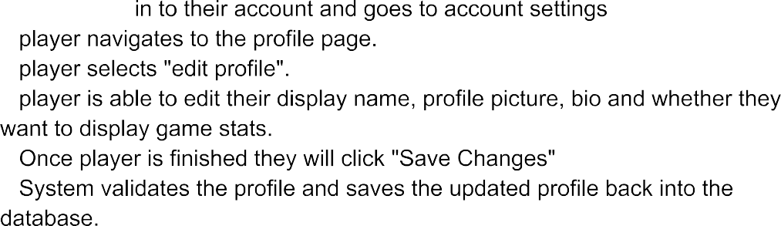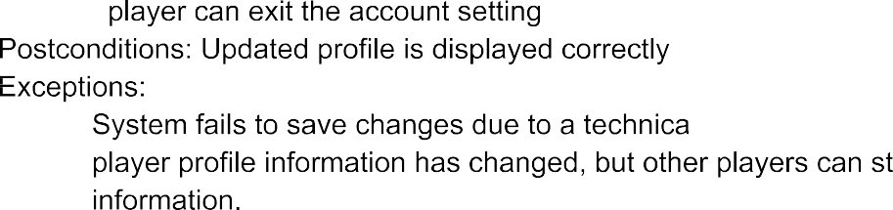


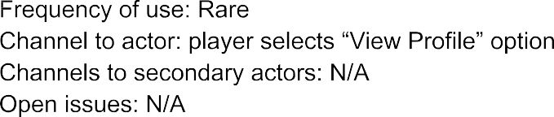
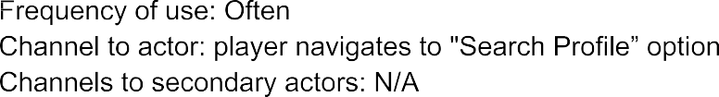
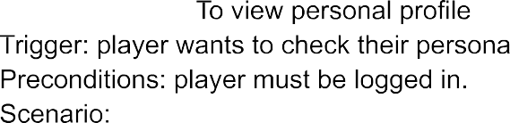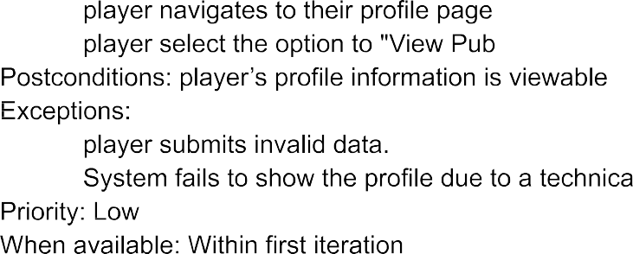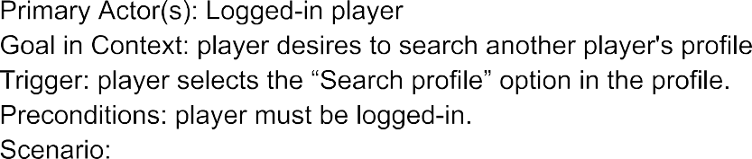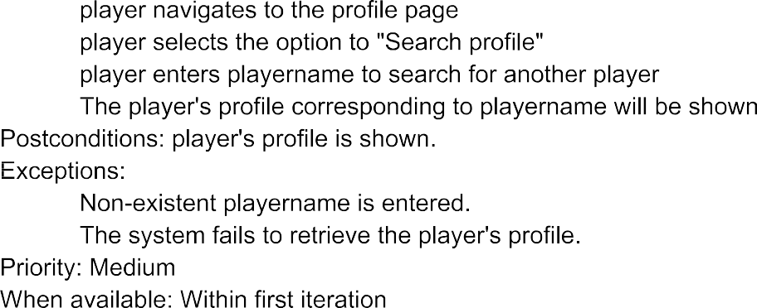

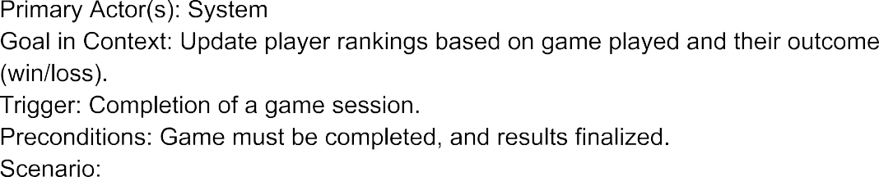

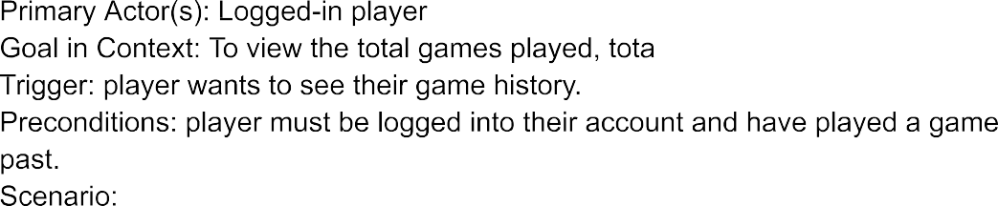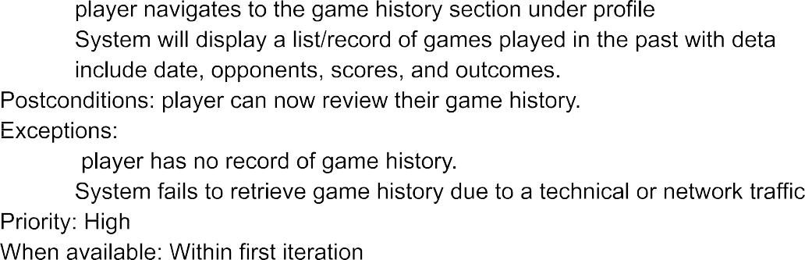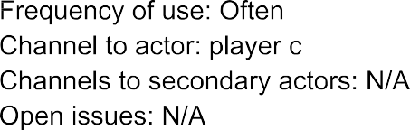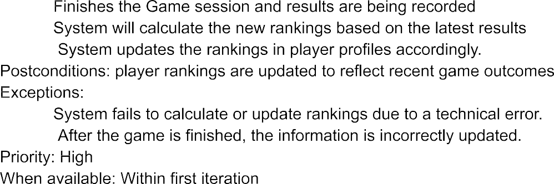


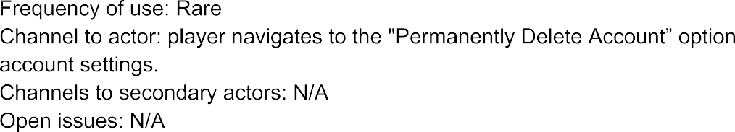
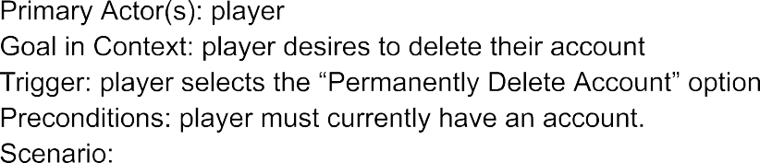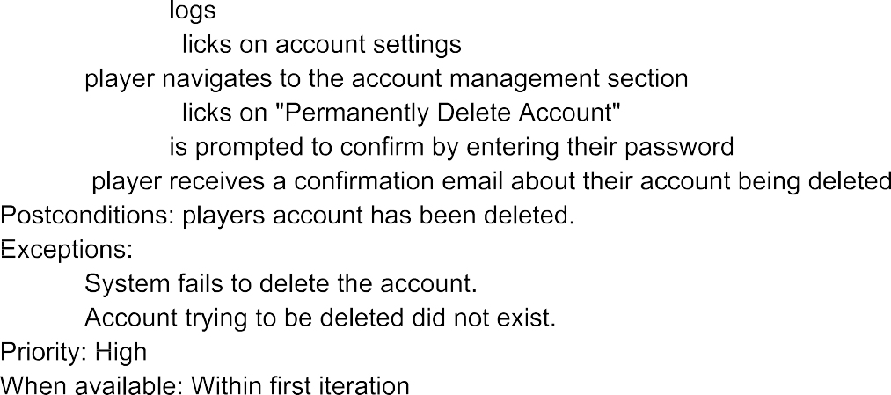



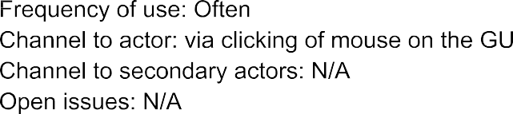

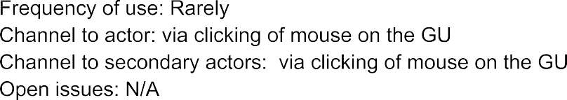

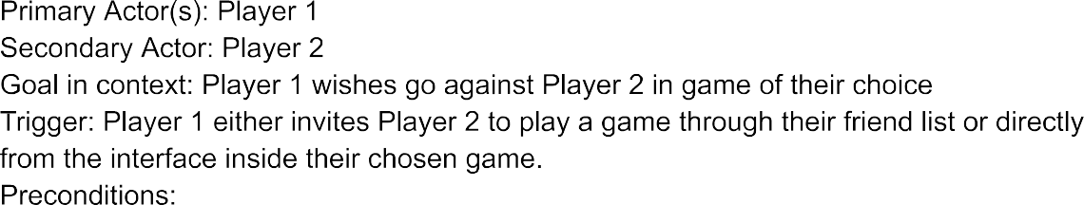
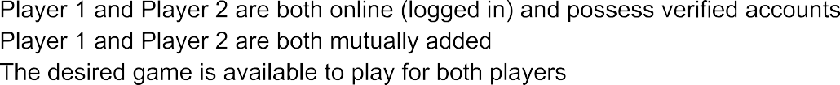

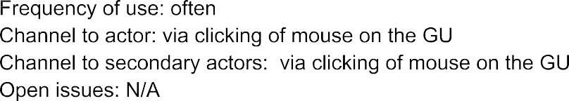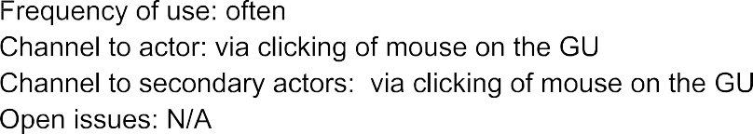





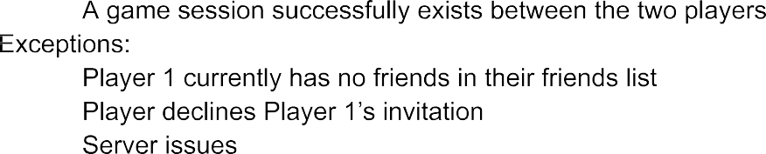

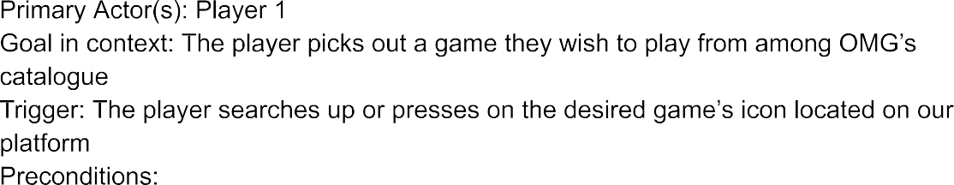
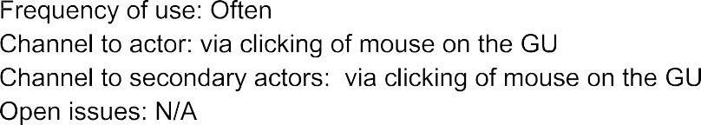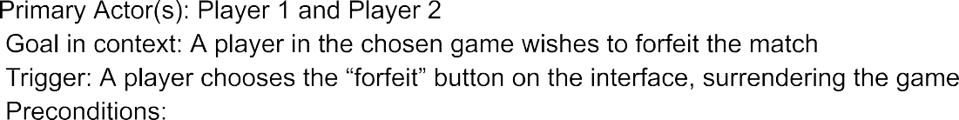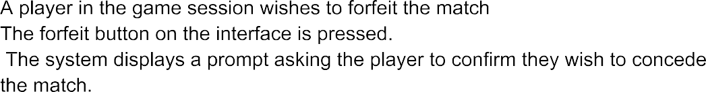






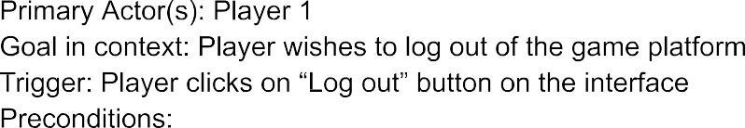
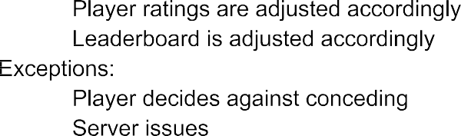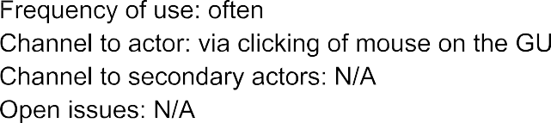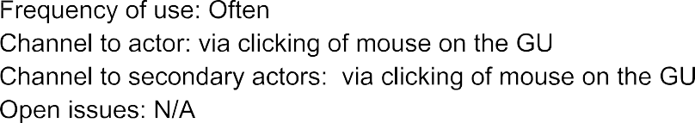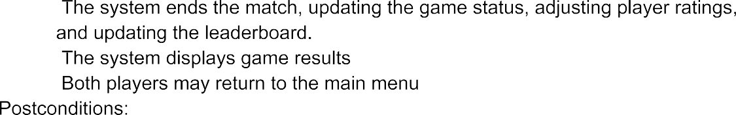

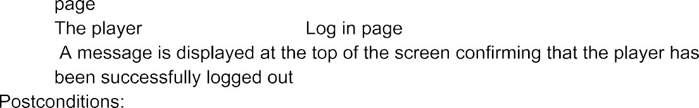
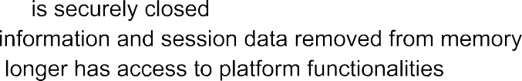

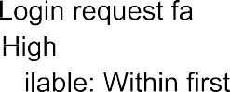

amirkhan
2024-11-12 22:00:27
--------------------------------------------
- Lack of Direction/flow, no clarity in regards to which use cases are frontend, backend, or networking, as they all differ in functionality. I'm assuming this diagram might be frontend since it says "GUI", but theres no display of specific GUI features in the diagram like "pop up display showing LOSS after player loses", so it is unclear.
- Lack of information on relationships (arrows starting from player 1). It shouldn't be assumed that everything is <<include>> since some options like Search profile or Send message are not mandatory, so these relationships should be specified.
- After a game is complete, doesn't have an option for return to main menu, or to find a new session (different player). It is really inconvenient to have to close the program and restart it to exit out of the game queue, or want to play against a different opponent.
- View profile doesn't include enough features such as view accolades, view top performances, view win loss ratio, and other features to make the gameplay more enjoyable. Having only Delete account is really vague and doesnt add any excitement to View personal profile. Part of a good gaming experience is being able to view your personal stats or progress to see your performance
- For Choose a Game, it doesn't specify which games (tic tac toe, checkers, or connect 4), these should have their own circles in the diagram since they vary in nature and might have certain relationships that other games dont require.
- Some arrows are pointing the wrong way, for example the <<extends>> from Start Game to Make a move, the arrow should be pointing towards Make a move since it is an extension of Start game, not the other way around, which also by the way should be <<include>> since making a move is not optional


