Software Testing Assignment

**Assignment 1.** Coverage Criteria Task

Test and Complete the CodA project (<https://m-zakeri.github.io/CodA/>)

Modules to be developed and tested for C++ and Java programs:

* CFG extractor
* Prime path extractor
* Test path generator
* Random test data generator
* Coverage report generator
* Compare coverage achieved by **CodA** with JDART (JAVA) and CREST/CROWN (C++) results.

Works in two groups: Group 1: C++ language, Group 2: Java language

**Note:** The tools itself is developed in Python 3.

**Assignment 2.** GUI Testing Task

Test scenario: (test data + event sequence + results/ oracle)

Example of test scenarios:

* Shopping app:
  + Add items with the highest discount rate to shopping baskets
  + Compute total order fee
* Calendar app (<https://www.time.ir/>):
  + Test time conversion functionalities.

See more example tasks with descriptions:

* Sharif Task (ERPNEXT) - attached
* Payever Task – attached in the following
* SchoolMate – GUI lecture slides

Example of OpenSource Web apps:

* ERPNEXT (<https://erpnext.com/>, Python),
* bigbluebutton (<https://demo.bigbluebutton.org/> , Java),
* OpenWGA (<https://www.openwga.com/>, Java)
* CloudStack (<https://cloudstack.apache.org/>, Java)
* Find more: <https://github.com/sdil/open-production-web-projects>

**Attachments**



AUTOMATION QA TASK

**TOTAL TIME: 240 MINUTES**

For this test, you will perform automated tests on our configured registration process and validate its different expected results.

**Important: Please write the tests in javascript/typescript with selenium.**

**Preferably you make use of Mocha/Chai for testing purposes. Please make use of Page Object Model and Page Factory!**

**DO NOT WRITE YOUR TEST IN JAVA**. WE WILL **IMMEDIATELY DECLINE** YOUR TEST. **ONLY JAVASCRIPT / TYPESCRIPT WITH SELENIUM**.

**The basic steps flow to test the steps:**

1. Visit <https://commerceos.staging.devpayever.com/registration/>{value}

2. Fill out the user information

3. Click ‘next’

4. Fill out the business information

5. Register the account

6. Click on get started

7. View the dashboard

(Please read the next page)

The test-cases that should be automated and validated are as followed:

**Test Case 1**



1. Test {value} = fashion, perform step 1 with value "fashion"

2. After step 7, validate the following apps to be present on the dashboard:

- Transactions, Checkout, Connect, Products, Shop, Message, settings

**Test Case 2**



1. Test {value} = fashion, perform step 1 with value "santander"

2. After step 7, validate the following apps to be present on the dashboard:

- Transactions, Checkout, Connect, Point of Sale, Settings

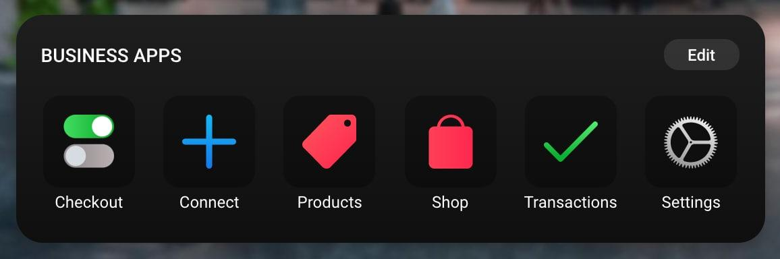

**Video to see the steps that have to be automated:**

<https://drive.google.com/file/d/1RFPhrgUnTJ7-49w9UwDn-KARgJ7LOrnu/view?usp=sharing>

After you have finished the task, please make a .zip file and upload it using the form link in your email.  
  
Good luck!