Task 2: Documentation Top 50 Actresses And Actors
Table Of Content
Overview 1
Dataflow 1
Modules 3
ui.py 3
actor_data.py 4
tmdb_connection.py 5
User Interface 6
To Do 6

Overview
The software “Hollywood Actors and Actresses” should read the IMDb Top 50 actors list and save
it. After that, it should request the movies by the actor's name from the TMDB database. The result
should be saved and displayed in a user interface in a table format. The data frame should also be
saved as a .csv file.

Dataflow

This is the flowchart for the application:
The application starts by invoking the create_ui function, which serves as the main entry point. Inside create_ui, a dataframe is created by importing the top 50 actresses and actors. The create_ui function then calls the update function to fetch any missing data from the TMDB database. The update function iterates over each actress or actor already present in the dataframe. For each individual:
- It checks every movie they were cast in.
- Retrieves any missing information about the actors or their movies.
The retrieved and updated information is displayed in a user-friendly interface in the form of a table.

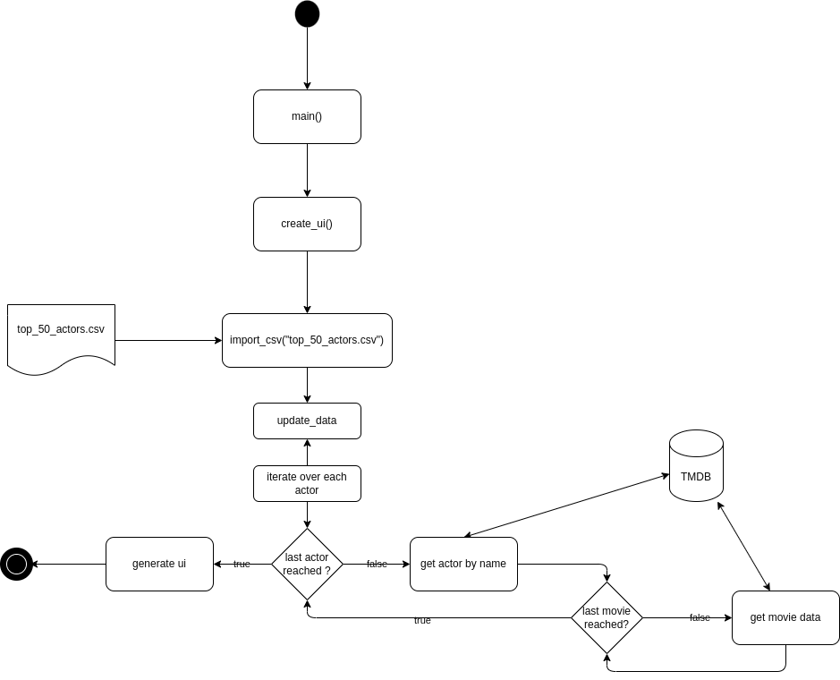

Modules
Because there are only two different classes in that project, I did not draw a class diagram. The project is organized in Input (csv and TMDB) , Data (Dataframe) and Output (UI).

ui.py
This module is responsible for creating the user interface of the application using the Tkinter library. The top actresses and actors are displayed in a table, which is implemented using the Treeview component. Additionally, this module serves as the main file of the project, where the program is initiated.
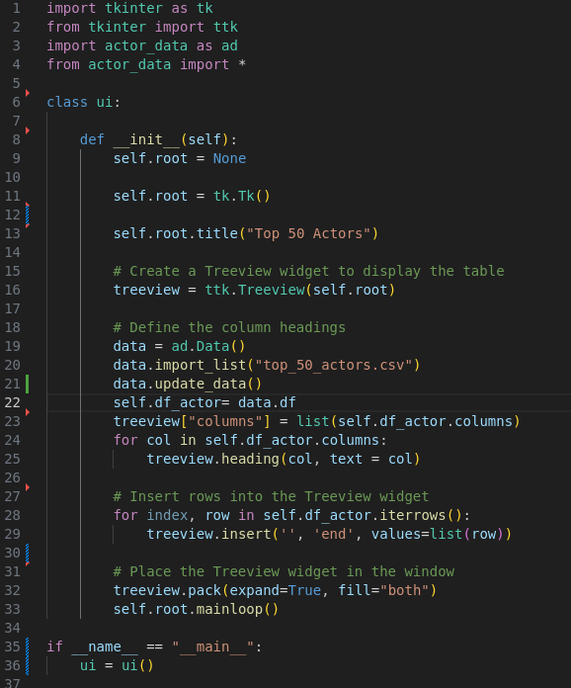

actor_data.py
The actor_data module contains a class designed to manage the dataframe that stores all actor data.
- The import_list function initializes the dataframe by reading data from the file top_50_actors.csv.
- The update_data function retrieves missing information from the TMDB database. It accomplishes this by leveraging functions provided in the tmdb_connect.py module.
- list_to_string converts a list to a string
- movie_list_to_string converts the movie list to a string with the movie names
- get_avg_rating calculates the average rating of all the films, the actress or actor was in cast

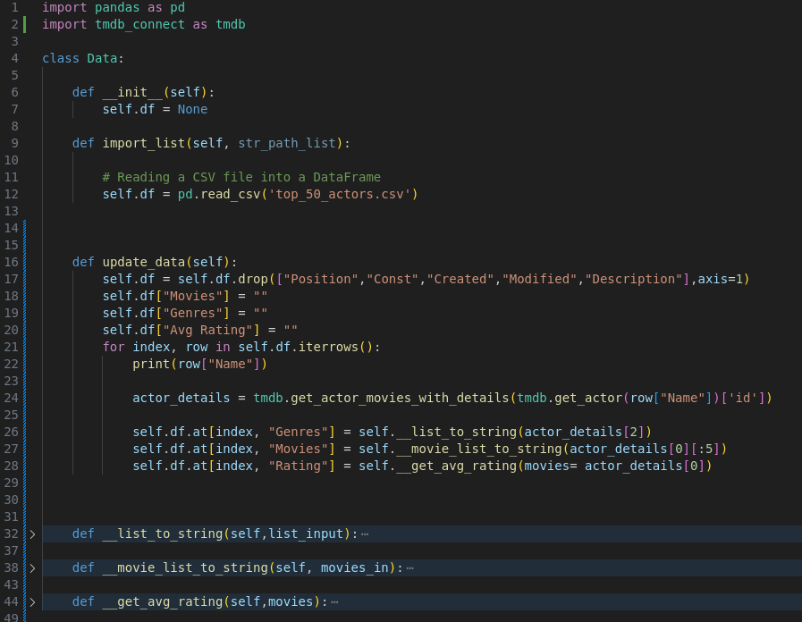

tmdb_connection.py
This module implements functions to retrieve data from the TMDB database using the simple_tmdb library. An API key, generated from TMDB's developer portal, is used for authentication.
- The search_actor function retrieves the TMDB ID of a specified actor or actress.
- The get_actor_movies_with_details function fetches detailed movie data for a given actor or actress, filling in any missing information.
- The get_actor function allows users to enter the name of an actor or actress and returns their details from the TMDB database.

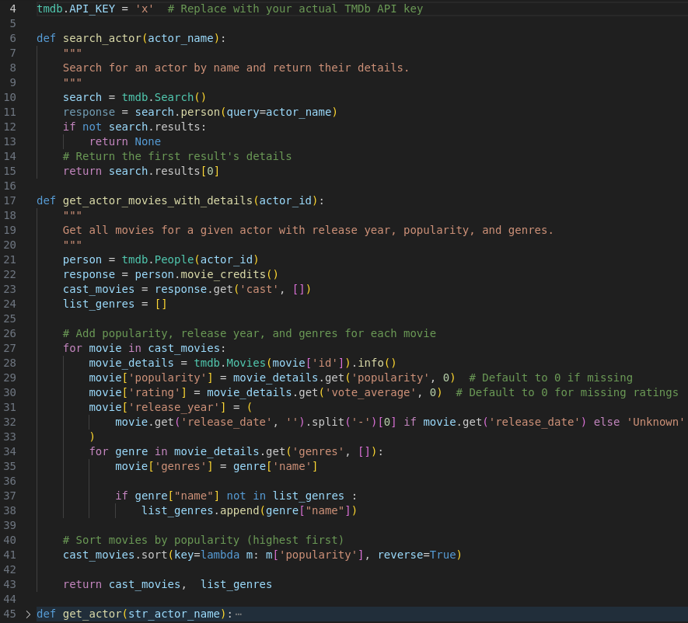

User Interface
The user interface shows the top 50 actress and actors in a table with their important information. The UI must be update, because it is not very user-friendly yet.

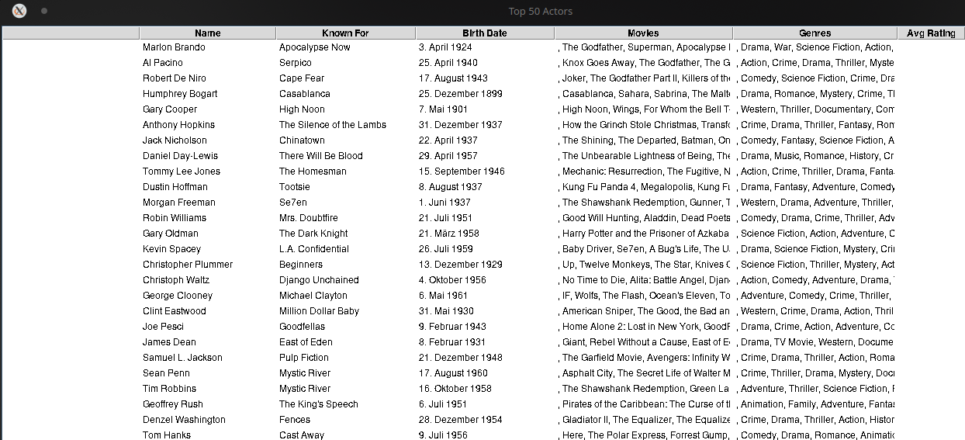

To Do
The project is not finished yet. There are still some things to do:
- Update the User Interface. The User Interface is not really user-friendly.
- Get awards from the TMDB database
- Show movie year
- Get all time movies

