########################################################################

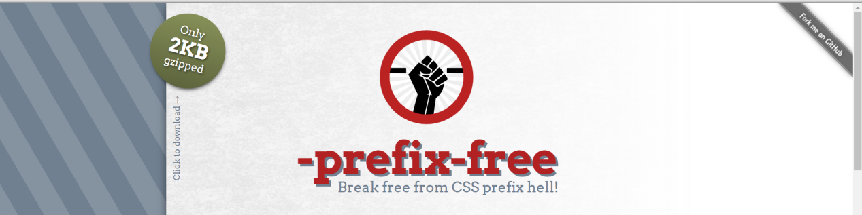

# **prefix Css3 & transtion**

# <http://leaverou.github.io/prefixfree/>

MS

########################################################################

ده المرجه الاساسى من الw3c

<http://leaverou.github.io/prefixfree/>

########################################################################

<https://css-tricks.com/almanac/properties/t/transition/>

**transtionT**

-webkit-transition: all 500ms ease-out 1s;  
-moz-transition: all 500ms ease-out 1s;  
-o-transition: all 500ms ease-out 1s;  
transition: all 500ms ease-out 1s;

  transition: width 2s, height 4s;

.example {

transition: [transition-property] [transition-duration] [transition-timing-function] [transition-delay];}

div {

transition: background-color 0.5s ease;

background-color: red;}div:hover {

background-color: green;}

div {

transition: all 0.5s ease;

background: red;

padding: 10px;}div:hover {

background: green;

padding: 20px;}

.example {

-webkit-transition: background-color 500ms ease-out 1s;

-moz-transition: background-color 500ms ease-out 1s;

-o-transition: background-color 500ms ease-out 1s;

transition: background-color 500ms ease-out 1s;

}

background-color: green;

}

[](https://frontendmasters.com/?utm_source=css-tricks%26utm_medium=website%26utm_campaign=css-tricks-tags-sidebar)

# -prefix-free

## Break free from CSS prefix hell!

[Only2KBgzipped](https://raw.github.com/LeaVerou/prefixfree/gh-pages/prefixfree.min.js" \o "Click to download)**[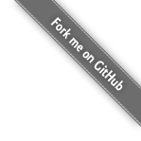](https://github.com/LeaVerou/prefixfree)**

**-prefix-free** lets you use only unprefixed CSS properties everywhere. It works behind the scenes, adding the current browser’s prefix to any CSS code, only when it’s needed.

Learn more:

* **[Home](http://leaverou.github.io/prefixfree/)**

* **[Test drive](http://leaverou.github.io/prefixfree/" \l "test-drive)**

* **[FAQ](http://leaverou.github.io/prefixfree/" \l "faq)**

* **[Plugins](http://leaverou.github.io/prefixfree/" \l "plugins)**

“[-prefix-free is] fantastic, top-notch work! Thank you for creating and sharing it.”

— **[Eric Meyer](https://twitter.com/meyerweb/status/124618575263711232" \t "http://leaverou.github.io/prefixfree/_blank)**

# Features

* Processes every stylesheet in <link> or <style> elements and adds a vendor prefix where needed
* Processes elements with a style attribute and adds a vendor prefix where needed
* Takes care of **new** <link> or <style> elements, style attribute changes and CSSOM changes (**[requires plugin](http://leaverou.github.io/prefixfree/" \l "dynamic-dom)**)
* Lets **jQuery**’s .css() method get and set unprefixed properties (**[requires plugin](http://leaverou.github.io/prefixfree/" \l "jquery)**)

# Limitations

* Prefixing code in @import-ed files is not supported
* Prefixing **cross-origin** linked stylesheets is not supported, unless they are **[CORS-enabled](http://enable-cors.org/" \t "http://leaverou.github.io/prefixfree/_blank)**
* Unprefixed linked stylesheets won’t work **locally** in Chrome and Opera. **[You can change that for yourself](http://leaverou.github.io/prefixfree/" \l "local-xhr)** though.
* Unprefixed **values** in inline styles (in the style attribute) won’t work in IE and Firefox < 3.6. **Properties** as well in Firefox < 3.6.

# Demo?

Check **[this page’s stylesheet](http://leaverou.github.io/prefixfree/css/style.css)** ;-)

You can also visit the **[Test Drive](http://leaverou.github.io/prefixfree/" \l "test-drive)** page, type in any code you want and check out how it would get prefixed for the current browser.

# How to use

Just include prefixfree.js anywhere in your page. It is recommended to put it right after the stylesheets, to minimize FOUC

That’s it, you’re done!

# Browser support

The target browser support is **IE9+**, **Opera 10+**, **Firefox 3.5+**, **Safari 4+** and **Chrome** on desktop and **Mobile Safari**, **Android browser**, **Chrome** and **Opera Mobile** on mobile.

If it doesn’t work in any of those, it’s a bug so please **[report it](https://github.com/LeaVerou/prefixfree/issues)**. Just before you do, please make sure that it’s not because the browser doesn’t support a CSS3 feature at all, even with a prefix.

In older browsers like IE8, nothing will break, just properties won’t get prefixed. Which wouldn’t be useful anyway as IE8 doesn’t support much CSS3 ;)

**[@prefixfree](https://twitter.com/prefixfree" \t "http://leaverou.github.io/prefixfree/_blank)** ✿ **[Commits feed](https://github.com/LeaVerou/prefixfree/commits/gh-pages.atom" \t "http://leaverou.github.io/prefixfree/_blank)** ✿ Made by **[Lea Verou](http://lea.verou.me/)** with care