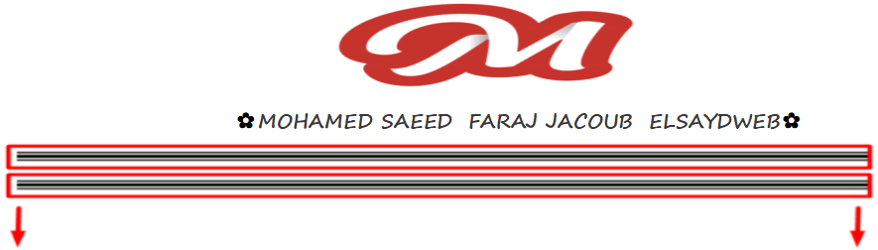



<div id="body">  
 <h6 class="vc">Offer</h6>  
 <div>

/\*---------\*/  
.vc {  
 background: #ffcc00;  
 color: #fff;  
 width: 58px;  
 text-align: center;  
 /\*padding: 6.5px 18px;\*/  
 position: relative;  
}  
.vc:after {  
 width: 0;  
 height: 0;  
 border: 12.5px solid transparent;  
 position: absolute;  
 content: "";  
 border-top-color: #ffcc00;  
 right: -23px;  
 top: 4px;  
 border-left-color: #ffcc00;  
}  
.vc:before {  
 width: 0;  
 height: 0;  
 border: 13px solid transparent;  
 position: absolute;  
 content: "";  
 border-bottom-color: #ffcc00;  
 right: -23px;  
 top: 3px;  
}  
/\*---------\*/

وده مثال يوضحو

<https://codepen.io/ajarudingunga/pen/qGZxZJ>

