Project Proposal: supermarket receipt visualizer

Input: scanned receipt from supermarket

Output: pie chart to see distribution of items categories (fruit/veggy, dairy products, sweets, drinks, etc)

Database in the background will be fed to collect, item, category and price.

With NLP I am planning to identify the categories.

With pytesseract I will extract text from receipt image

With matplotlib I will do visualisation

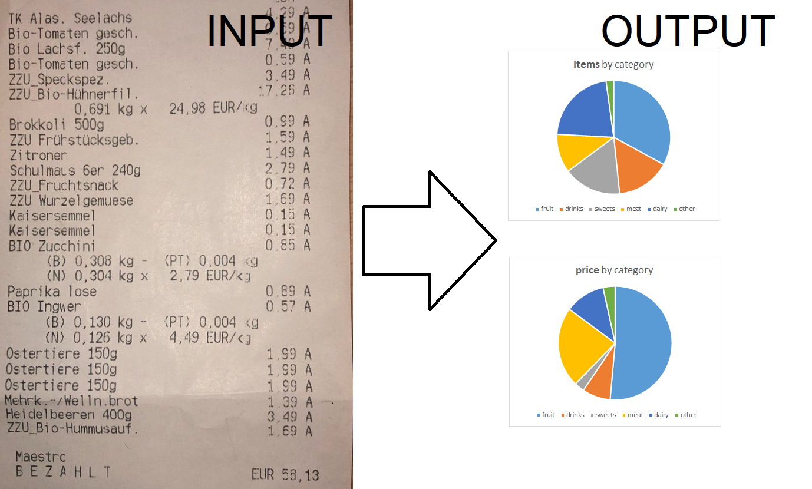

I deem this project useful to have an overview on shopping behaviour in terms of preferences on certain categories. We can assume a relationship between shopping behaviour and consummation. I hope to create awareness on shopping and hence consumption behaviour to support creating a healthier lifestyle by adapting groceries.

**Submission Project II**

Due 1 June 2021 23:59

**Instructions**

Please add your code for the second assignment to Github and post the**URL to the repository**here. Make sure I have access to the repository by adding me as the team member.

**Criteria for grading your project:**

1. **Scope**of the project -- have you implemented, what you promised?
2. **Quality**-- how is the code? Structure and organization of modules?
3. **Documentation**-- how easy is it for somebody else to understand your code? Is it well commented?
4. **Testing**-- how well has it been tested? Pytest is mandatory -- but are there enough test cases?
5. **Presentation**-- You have 3 minutes during the last lecture to demonstrate your project.