WEB DESIGNING LAB

WS-8

19PW15

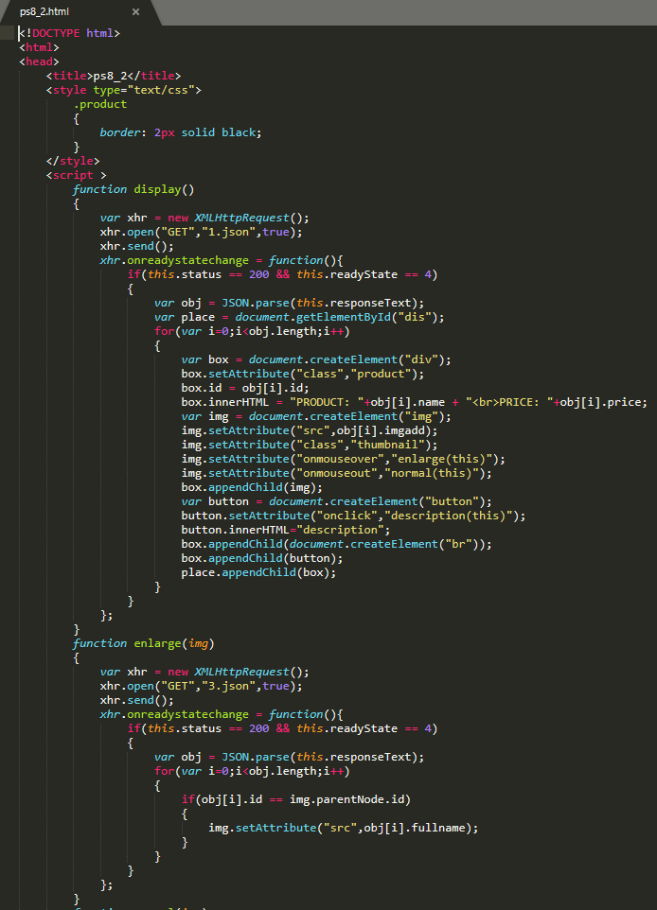

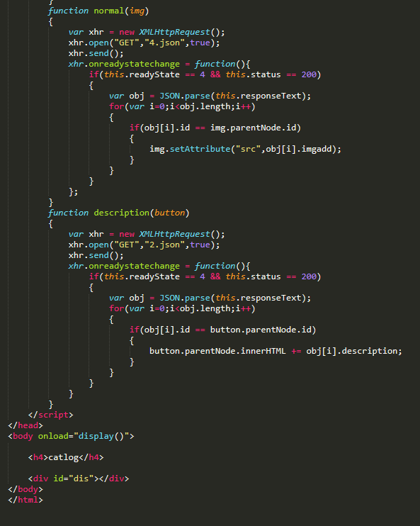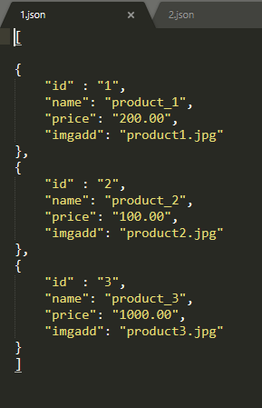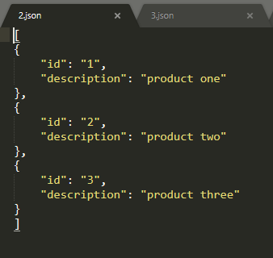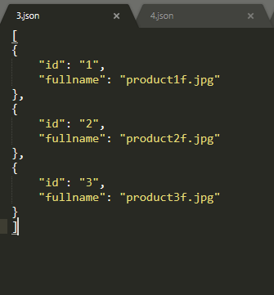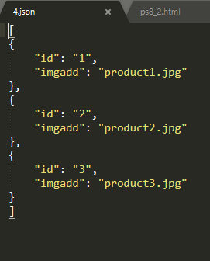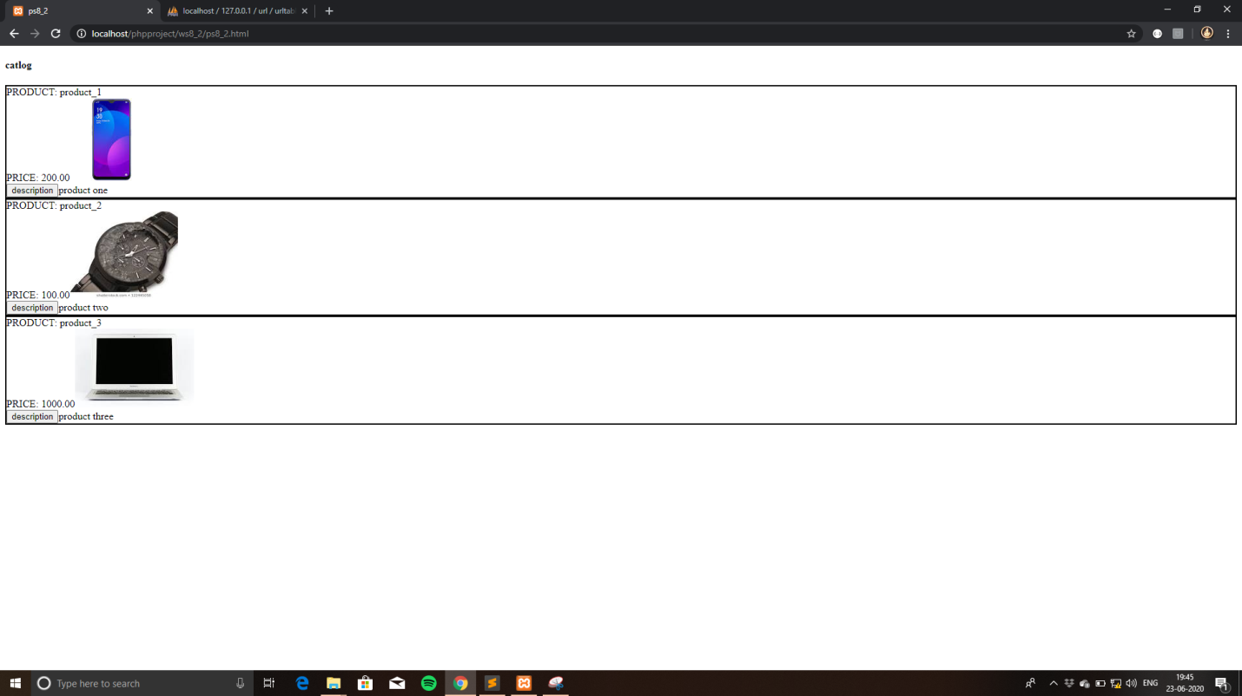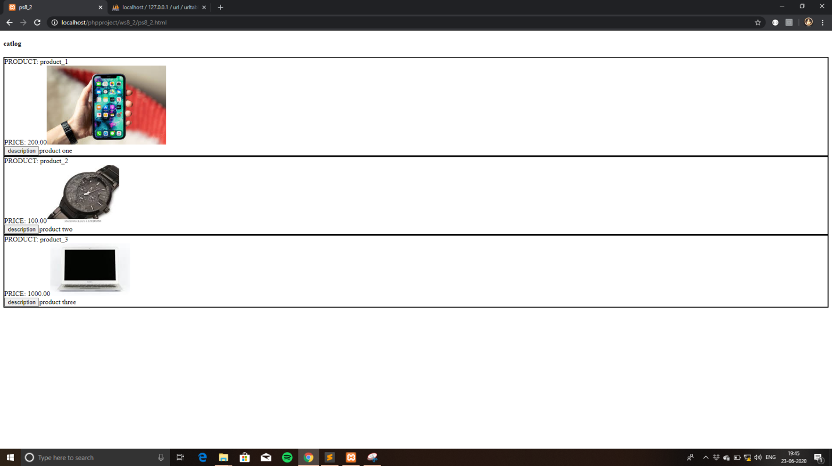

1.HTML FILE

<!DOCTYPE HTML>

<HTML>

    <head>

        <title>

            ws8_1

        </title>

        <link rel="stylesheet" href="https://maxcdn.bootstrapcdn.com/bootstrap/3.4.1/css/bootstrap.min.css">

      <script src="https://ajax.googleapis.com/ajax/libs/jquery/3.5.1/jquery.min.js"></script>

      <script src="https://maxcdn.bootstrapcdn.com/bootstrap/3.4.1/js/bootstrap.min.js"></script>

        <script src="ws8_1.js"></script>

        <style>

            #box

            {

                background-color: skyblue;

                width: 50%;

                border-radius: 2%;

                a:link{

                    color: black !important;

                }

                a:hover{

                    color: black!important;

                }

                a:active{

                    color: black !important;

                }

                a:visited{

                    color: black !important;

                }

            }

        </style>

    </head>

    <body onload="load()">

        <h1>Address Book</h1>

        <button onclick="search()">Search</button>

        <button onclick="add()">Add an Entry</button>

        <div id="search" method="post" >

            <p>Search by last name:<input type="text" id = "search_1" onkeyup="sendDetails()"></p>

            <div id="contact_list"  align = "center">

            </div>

        </div>

        <div id = "add">

            <p>First Name:<input type="text" name="first"  class="add" required></p>

            <p>Last Name:<input type="text" name="last"  class="add" required></p>

            <h4>Address:</h4>

            <p>Street:<input type="text" name="street"  class="add" required></p>

            <p id = "city">City:<input type="text" name="city_input"  class="add" id = "city_input" hidden></p>

            <p id = "state">State:<input type="text" name="state_input"  class="add" id = "state_input" hidden></p>

            <p>Zipcode:<input type="number" name = "zipcode" id = "zipcode"  class="add" onblur="getDetails()" required></p>

            <div class="text-error "></div>

            <p>Telephone:<input  name="phone" placeholder="123-45-678" pattern="[0-9]{3}-[0-9]{2}-[0-9]{3}"  class="add" required></p>

            <button  onclick="sendForm()">ADD</button>

        </div>

    </body>

</html>

Javascript file:

//Applicatoin key - 3esPZwojMkZ30rA1w5O5v2U1xDRz46DTlVKUAit5lGSNuGXThZzxXEjJnQbhptQO

var city;

var state;

var present_value;

function load()

{

    search();

}

function generate(parsed)

{

    $("#contact_list").html("");

    for (var i = 0; i < parsed.length; i++)

    {

        if (parsed[i].last.includes(present_value))

        {

            var box = $("<div></div>");

            box.attr("id", "box");

            box.attr("align", "center");

            var a = $("<a></a>");

            a.append($("<h3></h3>").text(parsed[i].first + "   " + parsed[i].last));

            a.attr("href", "#collapse" + i);

            a.attr("data-toggle", "collapse");

            var collapse = $("<div></div>");

            collapse.addClass("collapse");

            collapse.attr("id","collapse" + i);

            var street = $("<p></p>").text( parsed[i].street+ "   "  + parsed[i].zipcode);

            var city = $("<p></p>").text( parsed[i].city);

            var state = $("<p></p>").text( parsed[i].state);

            var number = $("<p></p>").text( parsed[i].t_number);

            collapse.append(street);

            collapse.append(city);

            collapse.append(state);

            collapse.append(number);

            box.append(a);

            box.append(collapse);

            $("#contact_list").append(box);

        }

    }

}

function search()

{

    document.getElementById('search').style.visibility = "visible";

    document.getElementById('add').style.visibility = "hidden";

}

function add()

{

    $("#contact_list").html("");

    document.getElementById('search').style.visibility = "hidden";

    document.getElementById('add').style.visibility = "visible";

}

function getDetails()

{

    var clientKey ="js-WbIEl7R6bwKV40RZXPKJtOkHPrmrVQnstd8tEc2EW0PrLZu78pCUN7Qls0f3Ikju";

    var zipcode = document.getElementById('zipcode').value;

    var xhr = new XMLHttpRequest();

    var url = "https://www.zipcodeapi.com/rest/"+clientKey+"/info.json/" + zipcode + "/radians";

    xhr.open("GET", url, true);

    xhr.send();

    xhr.onreadystatechange =function()

    {

      if(this.readyState == 4)

      {

        var output = this.status + this.responseText;

        if (this.status == 200)

        {

            var data = JSON.parse(this.responseText);

            document.getElementById('city').innerHTML += data.city;

            document.getElementById('city_input').value = data.city;

            city = data.city;

            document.getElementById('state').innerHTML += data.state;

            document.getElementById('state_input').value = data.state;

            state = data.state;

        }

        else {

            document.getElementById('text-error').innerHTML = this.responseText;

        }

      }

    };

}

function sendForm()

{

    var inputs = document.getElementsByClassName("add");

    console.log(inputs);

    var data = "";

    data += ("first="+inputs[0].value);

    data += ("&last="+inputs[1].value);

    data += ("&street="+inputs[2].value);

    data += ("&city="+inputs[3].value);

    data += ("&state="+inputs[4].value);

    data += ("&zipcode="+inputs[5].value);

    data += ("&phone="+inputs[6].value);

    const searchExp = /\s/g;

    data = data.replace(searchExp, '+');

    console.log(data);

    var xhr = new XMLHttpRequest();

    xhr.open("POST", "ws8_1.php", true);

    xhr.setRequestHeader('Content-type', 'application/x-www-form-urlencoded');

    xhr.send(data);

    xhr.onreadystatechange = function()

    {

        if(this.readyState == 4 && this.status == 200)

        {

            console.log("Posted successfully");

            console.log(this.responseText);

        }

    };

}

function sendDetails()

{

    var input = document.getElementById("search_1");

    console.log(input.value);

    var data = "search=" + input.value;

    present_value = input.value;

    console.log(data);

    var xhr = new XMLHttpRequest();

    xhr.open("POST", "ws8_1.php", true);

    xhr.setRequestHeader('Content-type', 'application/x-www-form-urlencoded');

    xhr.send(data);

    xhr.onreadystatechange = function()

    {

        if(this.readyState == 4 && this.status == 200)

        {

            console.log("Posted successfully");

            var parsed = JSON.parse(this.responseText);

            generate(parsed);

        }

    };

}

Php file:

<?php

    $valid = true;

    if(isset($_POST['first']))

    {

        $conn= mysqli_connect("localhost", "root", "root", "mydb");

        if(!$conn)

        {

            echo "Connectoin Failed:" . mysqli_connect_error() ;

        }

        else

        {

            $sql= "INSERT INTO address (first, last, street, city, state, zipcode, t_number) VALUES ('$_POST[first]','$_POST[last]','$_POST[street]', '$_POST[city]', '$_POST[state]', '$_POST[zipcode]','$_POST[phone]')";

            if (mysqli_query($conn, $sql))

            {

                echo "New record created successfully";

            }

            else

            {

                echo "Error: " . $sql. "<br>" . mysqli_error($conn);

            }

            mysqli_close($conn);

        }

    }

    if (isset($_POST['search'])) {

        $conn= mysqli_connect("localhost", "root", "root", "mydb");

        if(!$conn)

        {

            echo "Connectoin Failed:" . mysqli_connect_error() ;

        }

        else {

            $retval = $conn->query("SELECT * FROM address");

            $table = [];

            while($row = mysqli_fetch_assoc($retval))

            {

                array_push($table, $row);

            }

            echo json_encode($table);

        }

    }

?>

Output files:

