**Entities**

are specific objects or things in the mini-world that are represented in the database

**Attributes**

are properties used to describe an entity

Simple – cant be divided further

Composite - can be divided use {} to represent

Single valued – only one value

Multi valued – more than one value

Null can be used in 2 cases

case 1 - value is existing but not known ex. height

case 2 – value is not known if exists or not ex. Phone number

Complex Attributes – composite and multivalued are nested

An attribute of an entity type for which each entity must have a unique value is called a key attribute of the entity type

In ER diagrams

Entity type - rectangular box

Attributes - ovals and are attached to their entity type by straight lines

Composite attributes - ovals are attached to their component attributes by straight lines

Multivalued attributes - double ovals

Derived Attributes - dashed ovals

Key attribute – underlined

A relationship relates(associates) two or more distinct entities with a specific meaning

Relation type Is the schema of the relation

Relation set is the present set of entity pairs which are in the relation

Degree of a relationship – Number of participating entities

Recursive relationships are the relationships in which a entity is related to itself

Constraints - limit the possible combinations of entities that may participate in the corresponding relationship set

One-to-one (1:1)

An entity in *A* is associated with ***at most* one entity in *B***, and an entity in *B* is associated with ***at most* one entity in *A***

One-to-many (1:N)

An entity in *A* is associated with any number **(zero or more) of entities in *B***. An entity in *B*, however, can be associated with ***at most* one entity in *A***

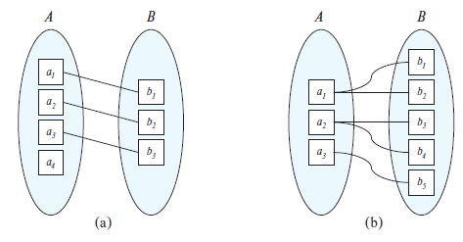

Many-to-one (N:1)

An entity in *A* is associated with ***at most* one entity in *B***. An entity in *B*, however, can be associated with any number **(zero or more) of entities in *A***

Many-to-many (M:N)

An entity in *A* is associated with any number **(zero or more) of entities in *B***, and an entity in *B* is associated with any number **(zero or more) of entities in *A***

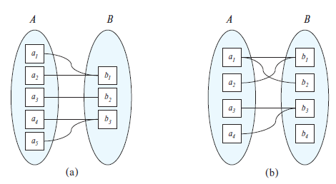

not gonna put notes on participation constraints

Min-Max notation: pair of numbers (*m,n*) placed on the line connecting an entity to the relationship.

Relationships can have attributes (will go to the n side)

Entity types that do not have key attributes of their own - **weak entity types**

represented like this

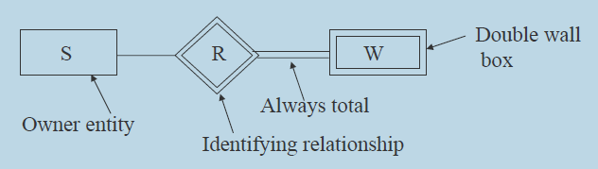

**In general, an n-ary relationship is not equivalent to ‘n’ binary relationships**