19PW15 MATLAB WS-4

%1

x = [1 3 5 7 9 11];

eval(x)

eval(6)

%1

function y = eval (x)

y = 1:length(x);

for i = 1:length(x),

y(i) = ((x(i).^4)\*sqrt((3\*x(i))+5))/(((x(i).^2)+1)^2);

endfor

endfunction

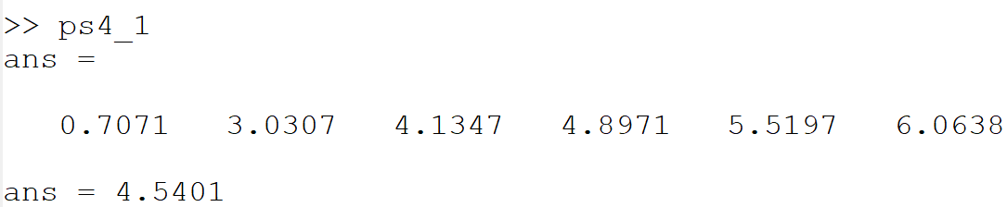

%2

x = [80 75 91 60 79 89 65 80 95 50 81];

[avg,sd] = avgandsd(x);

avg

sd

%2

function [avg,sd] = avgandsd(x)

sum = 0;

sumation = 0;

for i = x

sum = sum + i;

endfor

avg = sum/length(x);

for j = x

sumation = sumation + (j - avg)^2;

endfor

sd = sqrt(sumation/length(x));

endfunction

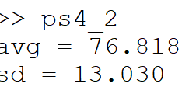

%3

x = [-2.5 3];

y = fun3(x)

x1 = -3:0.01:4;

plot(x1,fun3(x1))

%3

function y = fun3(x)

y = 1:length(x);

for i = 1:length(x),

y(i) = -0.2\*(x(i).^4) + (exp(-0.5\*x(i))\*(x(i).^3)) + (7\*(x(i).^2));

endfor

endfunction

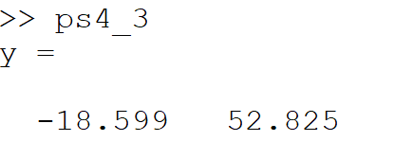

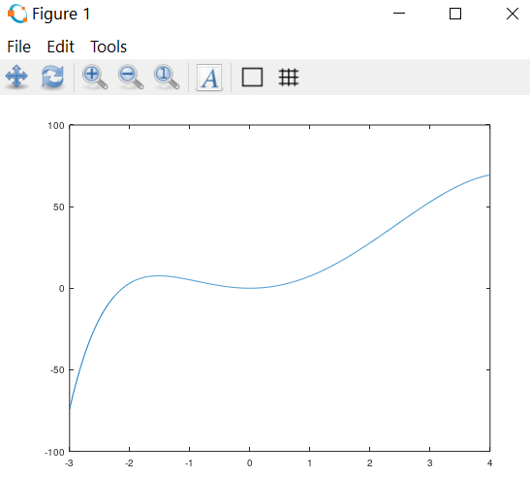

%4

prompt = "Enter the equation as a vector";

limit=input('Enter limit=');

p = 1:limit;

n=1;

disp("enter the vector");

while n<=limit

p(n)=input(' ');

n=n+1;

end;

r = roots(p)

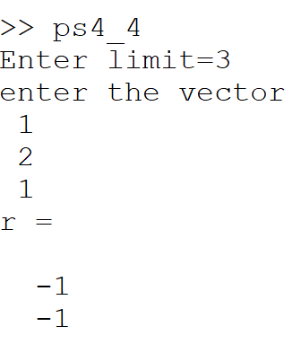

%5

x = input("entert the number");

if (rem(x,2) == 0)

disp("even")

else

disp("odd")

endif

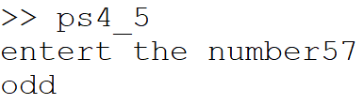

%6

x = input("enter 1-addition 2-subtraction 3-multiplication 4-division : ");

n1 = input("input the number 1 :");

n2 = input("input the number 2 :");

switch(x)

case 1

n1+n2

case 2

n1-n2

case 3

n1\*n2

case 4

n1/n2

otherwise

disp("enter valid numbers")

endswitch

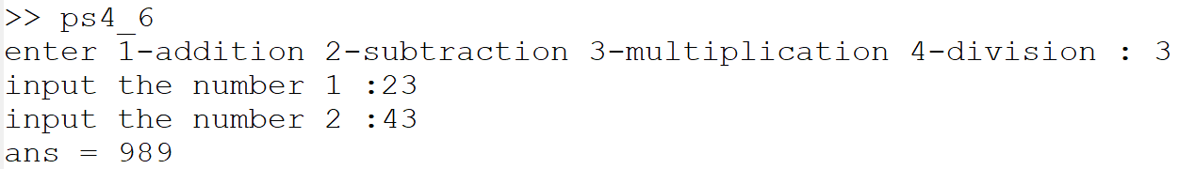

%7

x = input("entert the number");

if (x > 0)

disp("positive")

elseif (x<0)

disp("negative")

else

disp("equal to zero")

endif

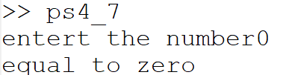

%8

x = input("entert the temperature in Kelvin");

if (x-273 < 32 )

disp("ICE")

elseif(x-273 < 212 && x-273 >=32)

disp("WATER")

else

disp("STEAM")

endif

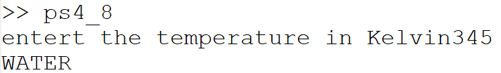

%9

x = input("enter the number");

pri = 0;

for i = 2:(x-1),

if (i != x)

if (rem(x,i) == 0)

pri = 1;

endif

endif

endfor

if (pri == 0 && x > 1)

disp("prime")

elseif(pri == 1 && x > 1)

disp("not prime")

else

disp("enter nos greater than 1")

endif

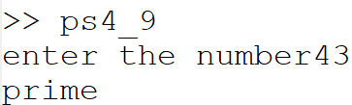

%10

for i = 1:20,

disp(i);disp(" x 13 =");disp(i\*13);

endfor

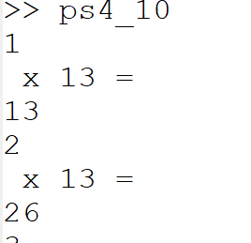......

%11

for i = 1:4,

strin = '';

for j = 1:i,

strin = strcat(strin,"\*");

endfor

disp(strin)

endfor

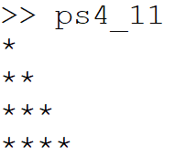

%12

for i = 1:5,

strin = '';

for j = 1:i,

strin = strcat(strin,"\*");

endfor

if(rem(i,2) != 0)

disp(strin)

endif

endfor

for k = 3:-1:1,

strin = '';

for l = 1:k,

strin = strcat(strin,"\*");

endfor

if(rem(k,2) != 0)

disp(strin)

endif

endfor

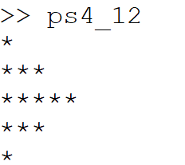

%13

x = input("Enter the number");

mult = 1;

for i = 1:x,

mult = mult\*i;

endfor

printf("The factorial of the number entered is : %d", mult)

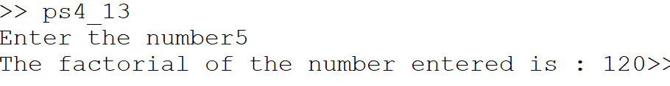

%14

len = input("enter the number : ");

for i = 1 : 100

if(fib(i) > len)

break;

endif

printf("%d, ", fib(i));

endfor

%14

function f = fib(n)

if (n <= 1)

f = n;

else

f = fib(n - 1) + fib(n - 2);

endif

endfunction

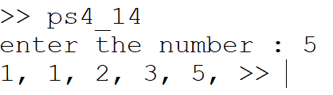

%15

sum = 0;

for i = 2:20,

sum = sum + (i\*i);

endfor

disp(["the total is = ",num2str(sum)])

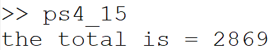

%16

sum = 0;

for i = 1:501,

if(rem(i,2) != 0)

sum = sum + i;

endif

endfor

disp(["the total is = ",num2str(sum)])

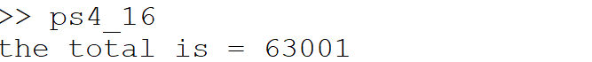

%17

x = 1:1:30;

y = 1:1:30;

y(1) = 1000 + 1000\*0.08;

for i = 2:30,

y(i) = y(i-1) + (y(i-1)\*0.08);

endfor

plot(x,y)

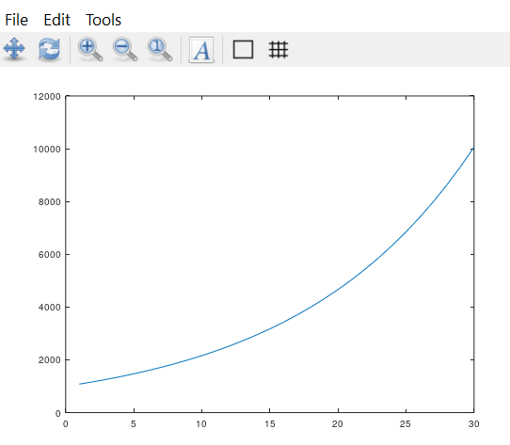

%18

amount = 5000;

i = 0;

while (amount < 1000000)

amount = (amount\*1.09);

i = i+1;

endwhile

printf("He will retire after %d years",(i-1));

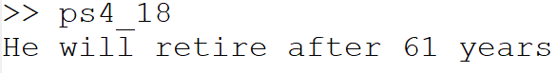

%19

x= input("Enter the speed in miles per hour");

printf("The speed in meter per seconds is %5.2f",mphTOmets(x));

function mps = mphTOmets (mph)

mps = mph/2.237

endfunction

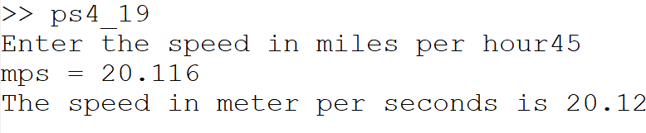

%20

printf(["The area of the triangle is = ",num2str(triangle(3,8,10))]);

disp(["The area of the triangle is = ",num2str(triangle(7,7,5))]);

function area = triangle (a, b, c)

s = (a+b+c)/2;

area = sqrt(s\*(s-a)\*(s-b)\*(s-c));

endfunction



%21

m = input("Enter the number of students :");

for i=1:m

for j=1:10

R(i,j)=input('elements : ');

end

end

R=reshape(R,m,10)

g = fgrade(R)

function g = fgrade (R)

g = 1:size(R,1);

for i = 1:size(R,1)

hw = 0;

min = R(i,1);

for j = 1:10

if(j<6)

if(min > R(i,j))

min = R(i,j);

endif

hw = hw + R(i,j);

endif

endfor

hw = ((hw - min)/5)\*1.5;

mid = ((R(i,7))\*0.15)+((R(i,8))\*0.15)+((R(i,9))\*0.15);

final = R(i,10)\*0.40;

avgmid = (R(i,7)+R(i,8)+R(i,9))/3;

if(avgmid > R(i,10))

g(i) = avgmid\*0.85 + hw;

else

g(i) = mid + hw + final;

endif

endfor

endfunction

A]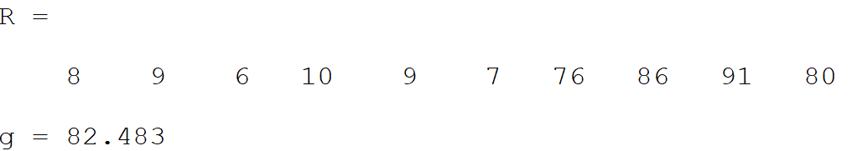

B]

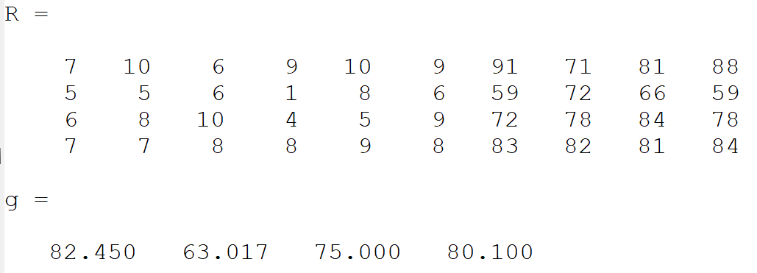

%22

sum = 0;

j = 0;

for i = 1:2:9999,

if(rem(j, 2) == 0)

sum = sum + (i\*i);

else

sum = sum - (i\*i);

endif

j = j + 1;

endfor

disp(["The sum of the series is : ",num2str(sum)]);

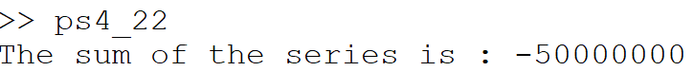

%23

n = input("Enter n : ");

for i = 2:2:n,

sqrt(i)

endfor

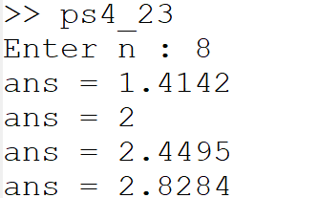

%24

sum = 0;

for x = 2:999,

pri = 0;

for i = 2:(x-1),

if (i != x)

if (rem(x,i) == 0)

pri = 1;

endif

endif

endfor

if (pri == 0)

sum = sum + x;

endif

endfor

disp(["The sum of the prime nos is : ",num2str(sum)]);



%25

sum = 0;

for x = 2:50,

pri = 0;

for i = 2:(x-1),

if (i != x)

if (rem(x,i) == 0)

pri = 1;

endif

endif

endfor

if (pri != 0)

sum = sum + x;

endif

endfor

disp(["The sum of the prime nos is : ",num2str(sum)]);



%26

while true

x = randi([3,10]);

if(x != 5)

disp(num2str(x));

else

break

endif

endwhile

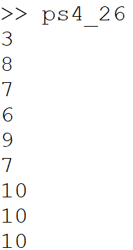

%27

i = 1;

x = 1:10;

while (i<11),

x(i) = randi([3,10]);

i = i+1;

endwhile

x

