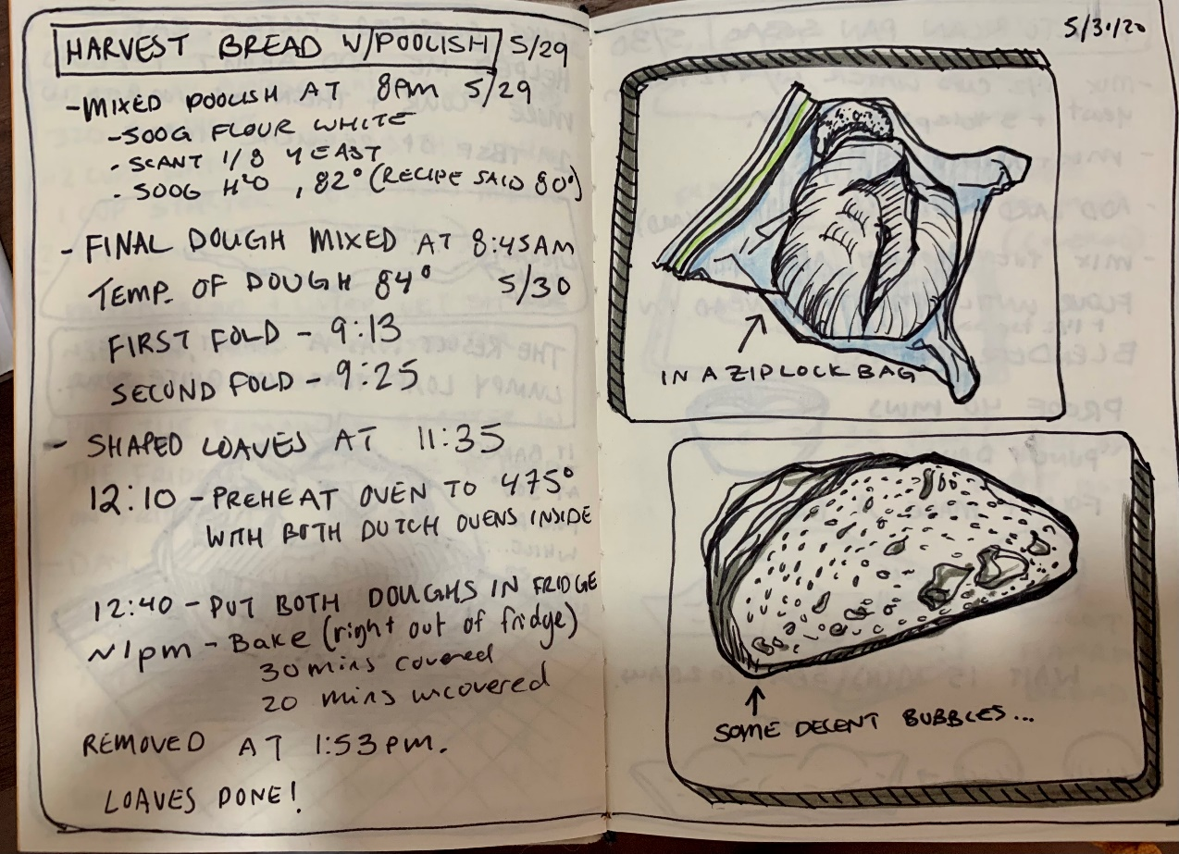

Harvest Bread with Poolish

*ingredients*

Flour - 500g

Water - 390g

Salt – 10.5g

Yeast – 1.7g

*shaping*

folds - yes

fold count - 2

kneading - no

*time spent*

pre-fermentation – 12.5 hours

bulk-fermentation – 2 hours

proof time – 1 hour

bake time – .75 hours (45mins)

*final product*

crust – crisp

rise – decent, some large bubbles and height

taste – like a healthy wheat bread with the lightness of white bread

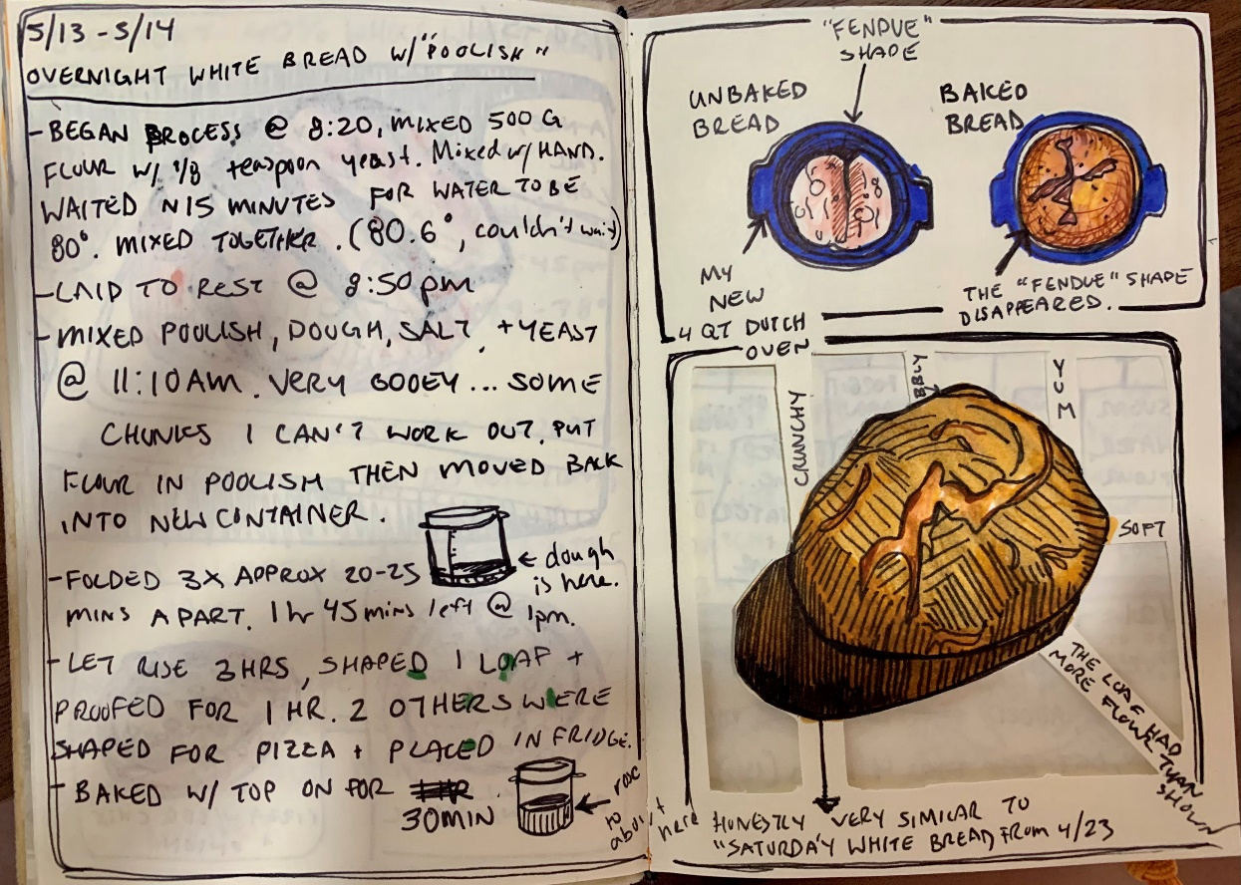

White Bread with Poolish

*ingredients*

Flour - 500g

Water - 375g

Salt – 10.5g

Yeast – 1.7g

*shaping*

folds - yes

fold count - 3

kneading - no

*time spent*

pre-fermentation – 12 hours

bulk-fermentation – 2.5 hours

proof time – 1 hours

bake time – .75 hours (45mins)

*final product*

crust – softer than normal, still a little crisp

rise – ‘fendue’ shape of loft was lost in baking, otherwise normal rise

taste – similar to regular white bread, slightly tangier due to longer fermentation

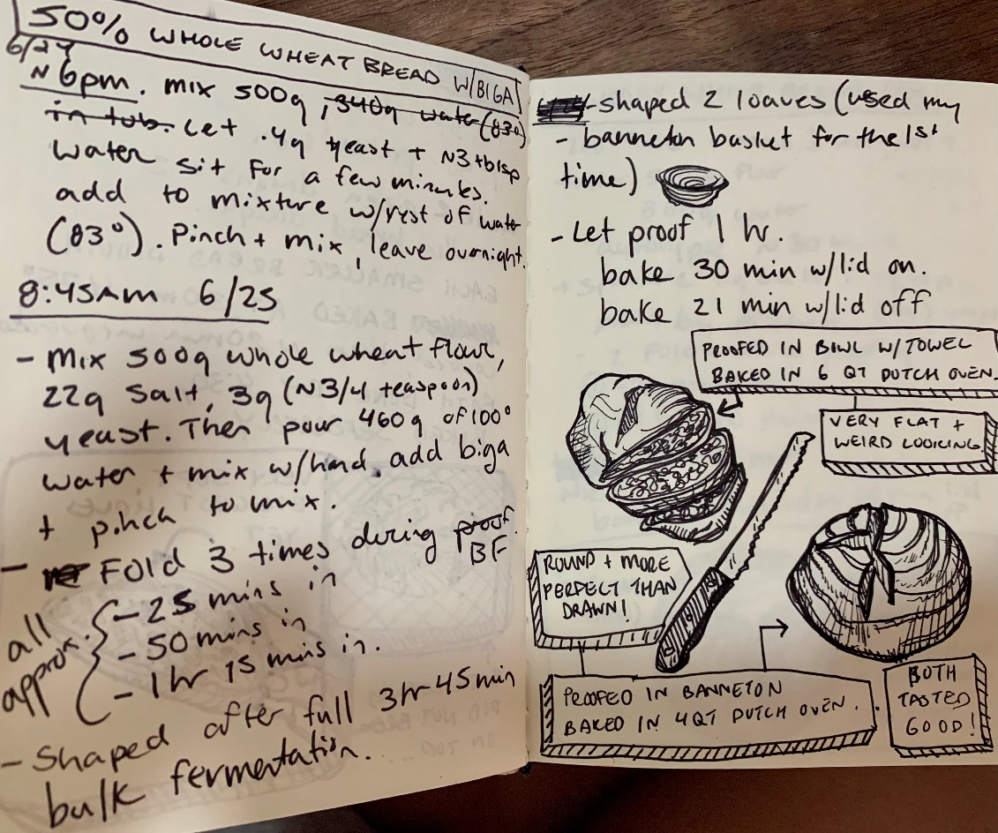

50% whole wheat bread

*ingredients*

Flour - 500g

Water - 400g

Salt - 22g

Yeast - 3g

*shaping*

folds - yes

fold count - 3

kneading - no

*time spent*

pre-fermentation – 0 hours

bulk-fermentation – 5 hours

proof time – 14 hours

bake time – .75 hours (45mins)

*final product*

crust – crisp, shaped by banneton basket

rise – round and perfect

taste – hearty, dense, dry after a day or so