“Київський фаховий коледж зв’язку”

Циклова комісія Комп’ютерної інженерії

**ЗВІТ ПО ВИКОНАННЮ**

**ЛАБОРАТОРНОЇ РОБОТИ №3**

з дисципліни: «Операційні системи»

**Тема: «Знайомство з базовими командами CLI-режиму в Linux»**

Виконав(ла/ли) студент(ка/и)

групи КСМ-03а Притула В. Трегуб О. Гоголь А.

Перевірив викладач

Сушанова В.С.

Київ 2022

Мета роботи:

1. Знайомство з базовими командами CLI-режиму в Linux.
2. Знайомство з базовими текстовими командами в термінальному режимі роботи в різних ОС.

Матеріальне забезпечення занять

1. ЕОМ типу IBM PC.

2. ОС сімейства Windows (Windows 7).

3. Віртуальна машина – Virtual Box (Oracle).

4. Операційна система GNU/Linux – CentOS.

**Виконала Гоголь Анастасія**  
  
Завдання для попередньої підготовки.

1. Прочитайте короткі теоретичні відомості до лабораторної роботи та зробіть невеликий словник базових англійських термінів з питань призначення команд та їх параметрів.

|  |  |
| --- | --- |
| Термін англійською | Термін українською |
| Options | Параметри |
| Internal commands | Внутрішні команди |
| Built-in commands | Вбудовані команди |
| External commands | Зовнішні команди |
| Aliases | Псевдоніми |
| Control statements | Контрольні твердження |
| Quotation marks | Лапки |

2. Вивчіть матеріали онлайн-курсу академії Cisco “NDG Linux Essentials”:

- Chapter 5 - Command Line Skills

- Chapter 6 - Getting Help

3. Пройдіть тестування у курсі NDG Linux Essentials за такими темами:

- Chapter 05 Exam

- Chapter 06 Exam

4. Дайте визначення наступним поняттям:

- A command interpreter is a program that provides user interaction with the operating system. The command interpreter usually supports a command line, environment variables, a history of executed commands, and its own configuration files.

- The shell is the command line interpreter that translates commands entered by a user into actions to be performed by the operating system.

- A command is a software program that, when executed on the CLI, performs an action on the computer.

5. Дайте відповіді на наступні питання:

- Яку базову інформацію надає рядок запрошення prompt?

The command prompt provides some useful information to the user. The command prompt provides some information about the Linux system, about some user data (username, hostname, home directory of the current user).

- Для чого команді потрібні параметри та аргументи?

An argument can be used to specify something for the command to act upon.  Options can be used with commands to expand or modify the way a command behaves.

- Яке призначення команд ls, які параметри та аргументи вона може мати? Наведіть 3 приклади.

Is - utility that prints the contents of a file system directory and information about files to standard output. The ls command first lists all files (not directories) listed on the command line, and then lists all files in the directories listed on the command line.

The some ls command arguments:

ls /: The / argument is used to list all files and folders in the root directory.

ls . .: The . . argument is used to list down the files and folders in the parent directory of the current directory.

ls ~: The ~ argument is used to list all files and folders in the home directory.

ls –a: The -a argument is used to list down any hidden folders or files.

ls –R/: The -R argument is used to recursively list down all the folders and files in all the directories and sub-directories of the system.

Is­ –l: List files and directories in Long Listing Format.

Is­ -n –: List UID and GID number of Owner and Groups to which the files and directories are belongs.

The ls command supports the following options:

ls -a: List all files including hidden files. These are files that start with “.”.

ls -A: List all files including hidden files except for “.” and “..” – these refer to the entries for the current directory, and for the parent directory.

ls -R: List all files recursively, descending down the directory tree from the given path.

ls -l: List the files in long format i.e. with an index number, owner name, group name, size, and permissions.

ls – o: List the files in long format but without the group name.

ls -g: List the files in long format but without the owner name.

ls -i: List the files along with their index number.

ls -s: List the files along with their size.

ls -t: Sort the list by time of modification, with the newest at the top.

ls -S: Sort the list by size, with the largest at the top.

ls -r: Reverse the sorting order.

Exampels:

By default, the ls command prints the results in alphabetical order, and so by adding the -r option, it prints the results in reverse alphabetical order.



You can use ls command with argument -l to get more advance information related files and directories like Owner, Group, Size etc…

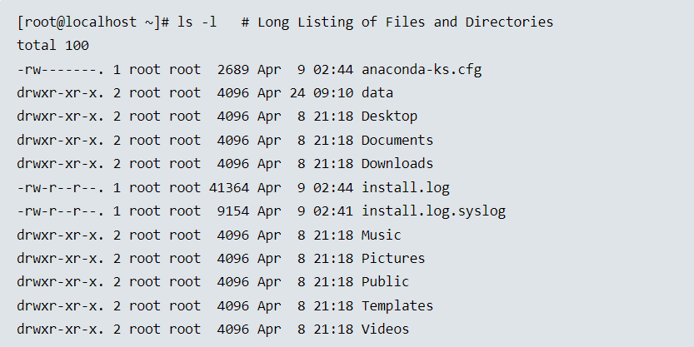

You can check hidden files and directories by using Linux ls command with argument -a.

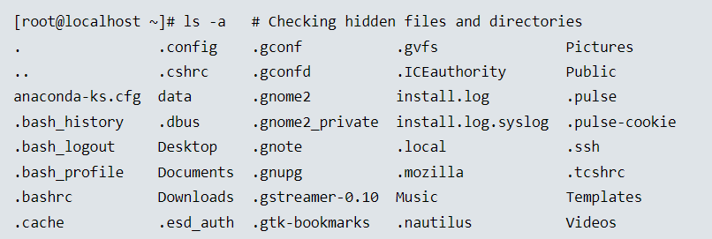

- Яким чином можна використати історію команд, які переваги це надає?

You can use the history in order not to re-enter the entire command (which is executed in the terminal). An advantage of history is that it makes this very command easier to execute.

- Яке призначення команди echo?

The echo command is used to display output in the terminal.

- Охарактеризуйте поняття змінної в оболонці Bash, які типи змінних вона підтримує?

Variables: Used to store information for the Bash shell and for the user. These variables can be used to modify how commands and features work as well as provide vital system information.

There are two types of variables used in the Bash shell: local and environment.

Local or shell variables exist only in the current shell, and cannot affect other commands or applications.

Environment variables, also called global variables, are available system-wide, in all shells used by Bash when interpreting commands and performing tasks.

- Яке призначення команд env, export та unset?

The env command allows you to display your current environment or run a specified command in a changed environment.

The export command is used to turn a local variable into an environment variable. The export command can also be used to make a variable an environment variable upon its creation by using the assignment expression as the argument.

Exported variables can be removed using the unset command.  
  
  
  
Виконав Притула Владислав  
  
  
 1. Опрацюйте всі приклади команд, що представлені у лабораторній роботі курсу NDG Linux Essentials - Lab 5: Command Line Skills та Lab 6: Getting Help. Створіть таблицю для опису цих команд***

|  |  |
| --- | --- |
| Назва команди | Її призначення та функціональність |
| ls | Виводить інформації про каталоги та файли. За замовчуванням без аргументів відображає інформацію для поточного каталогу |
| ls -l | Використанні параметру **-l** в команді **ls** дозволяє відобразити інформацію про файли, розташовані в поточному робочому каталозі, у довгому форматі, який надає більш розширену додаткову інформацію |
| ls -l /tmp | Використання аргументу **/tmp** в поєднанні з параметром **-l** в команді **ls** дозволяєвідобразити детальну інформацію про файли в каталозі /tmp. |
| whoami | The output of the whoami command, sysadmin, displays the user name of the current user. Although in this case your username is displayed in the prompt, this command could be used to obtain this information in a situation when the prompt did not contain this information. |
| uname | Execute the uname command again twice in the terminal, once with the option -n and again with the option --nodename. This will display the network node hostname, also found in the prompt. |
| pwd | The current directory in the example above is /home/sysadmin. This is also referred to as your home directory, a special place where you have control of files and other users normally have no access. By default, this directory is named the same as your username and is located underneath the /home directory. |
| history | To view a limited number of commands, the history command can take a number as a parameter to display exactly that many recent entries. |
| !9 | To execute a command again, type the exclamation point and the history list number. For example, to execute the 9th command in your history list |
| echo Hello Student | The echo command can be used to print text and the value of a variable, and to show how the shell environment expands metacharacters (more on metacharacters later in this lab) |
| echo $PATH | The PATH variable is displayed by placing a $ character in front of the name of the variable. |
| which date | The output of the which command tells you that when you execute the date command, the system will run the command /bin/date. The which command makes use of the PATH variable to determine the location of the date command. |
| type command | The type command identifies the cd command as an internal command |
| which ls | External commands are binary executables stored in directories that are searched by the shell. If a user types the ls command, the shell searches through the directories that are listed in the PATH variable to try to find a file named ls that it can execute. Use the which command to display the full path to the ls command. |
| Aliases | Aliases can be used to map longer commands to shorter key sequences. When the shell sees an alias being executed, it substitutes the longer sequence before proceeding to interpret commands. |
| date | Execute commands in the bash shell by typing the command and then pressing the Enter key. |
| man date | To learn more about commands, access the manual page for the command with the man command. |
| /file | Searches are not case sensitive and do not "wrap" around from the bottom to top, or vice versa. Start a forward search for the word "file" by typing: |
| man -k password | In some cases you may not remember the exact name of the command. In these cases you can use the -k option to the man command and provide a keyword argument. For example, execute the following command to display a summary of all man pages that have the keyword "password" in the description: |
| apropos password | Note that the apropos command is another way of viewing man page summaries with a keyword. Type the following command: |
| man -f passwd | There are often multiple man pages with the same name. For example, the following command shows three pages for passwd. Execute the following command to view the man pages for the word passwd: |
| whatis passwd | Instead of using man -f to display all man page sections for a name, you can also use the whatis command: |
| info date | Almost all system features (commands, system files, etc.) have man pages. Some of these features also have a more advanced feature called info pages. For example, execute the following command: |
| date --help | Another way of getting help is by using the --help option to a command. Most commands allow you to pass an argument of --help to view basic command usage: |

2.1 2.2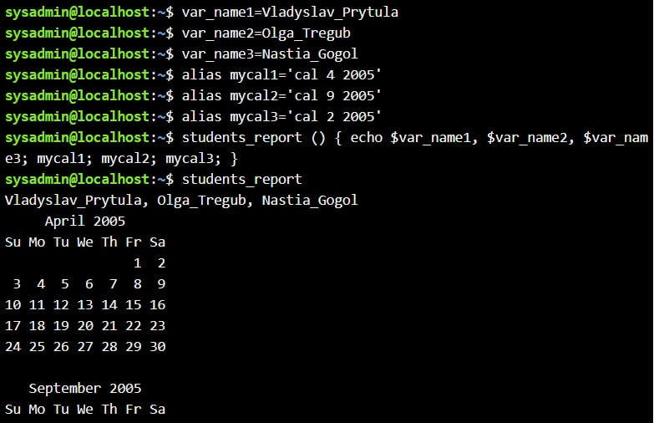  
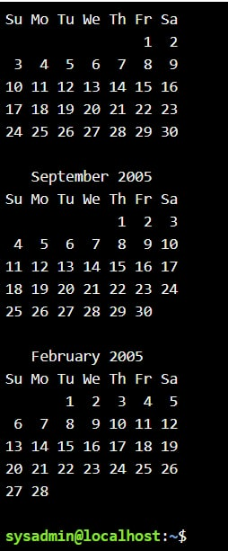  
2.3  
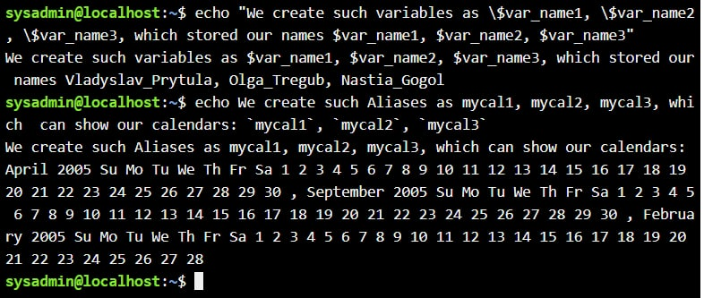  
  
  
2.4  
  
2.5

