Трегуб Ольга, КСМ-02А

Control questions

**1.** How can you view the path to the user's home directory using the echo command? There are 2 ways, give both examples in terminal.

Use the following echo command to display all filenames in the current directory that match the glob pattern *:

echo *

Your output should be similar to the following:

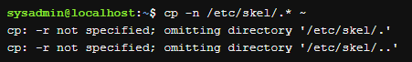

The asterisk * matches "zero or more" characters in a file name. In the example above, this results in matching all filenames in the current directory.

The echo command, in turn, displays the filenames that were matched.

**2.** Is it possible to view the contents of the root directory while in the user's home directory without going to the root directory? Demonstrate this on the command line.

In any Linux file system, there is always only one root directory, denoted by /. A Linux user always works with a single directory tree, even if different data is located on different media: hard, network or removable drives.

Mount and unmount procedures are used to mount and unmount file systems on different devices in one common tree. Once file systems on different media are connected to a common tree, the data contained on them is available as if they were all a single file system: the user may not even know on which device which files are stored.

The position of any directory in the directory tree is precisely and unambiguously described using the full path. The full path always starts from the root directory and consists of the listed all vertices encountered while moving along the branches of the tree up to and including the searched directory.

The organization of file system directories in the form of a tree does not allow looping. That is, a directory cannot contain a directory that contains itself. Due to this restriction, the full path to any directory or file in the file system will always be finite.

**3.** How can you add information to an empty file in the terminal?

There are several ways of creating a new file, including using a program designed to edit a file (a text editor).

There is also a way to create an empty file that can be populated with data at a later time. This feature is useful for some operating systems as the very existence of a file could alter how a command or service works. It is also useful to create a file as a "placeholder" to remind you to create the file contents at a later time.

To create an empty file, use the touch command as demonstrated below:

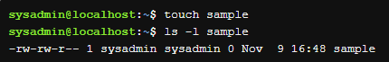

**4.** How to copy and delete an existing directory? Will there be a difference in commands if the directory is not empty at the same time?

You can delete directories using the rm command. However, the default behavior (no options) of the rm command is to not delete directories:



To delete a directory with the rm command, use the -r recursive option:

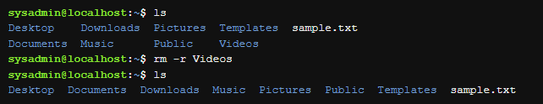

When a user deletes a directory, all of the files and subdirectories are deleted without any interactive question. It is best to use the -i option with the rm command.

You can also delete a directory with the rmdir command, but only if the directory is empty.



By default, the cp command will not copy directories; any attempt to do so results in an error message:  
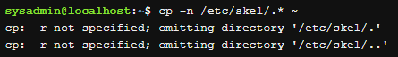

However, the recursive -r option allows the cp command to copy both files and directories.

cp -r source_directory destination_directory

Be careful with this option. The entire directory structure will be copied which could result in copying a lot of files and directories!

The options -r and -R serve the same purpose. However, -R can be used with most commands, while -r can have different meanings with some commands. For example, while cp -r means copy recursively (both files and directories), ls -r means reverse sort.

**5.** In which of the following examples does a file move occur? renaming it? both actions at the same time?

- mv /work/tech/comp.png. /Desktop moving

- mv /work/tech/comp.png. /work/tech/my_car.png renaming

- mv /work/tech/comp.png. /Desktop/computer.png moving and renaming occurs at the same time